**JMETER**

The **Apache JMeter** application is open source software, a 100% pure Java application designed to load test functional behaviour and measure performance. It was originally designed for testing Web Applications but has since expanded to other test functions.

Key Points

* JMeter is Performance test application
* It is built using Java
* Free & Open Source
* Supports Recording
* CLI (Command Line Options)
* View Reports

# **BASICS**

# **Introduction**

# **Load Testing**

Applying simulated load to the system and measuring the overall impact on the system about how the system performs

# **Performance Testing**

Monitoring & measuring the performance of the system regardless of the load.

# **Stress Testing**

Stress testing (sometimes called torture testing) is a form of deliberately intense or thorough testing used to determine the stability of a given system, critical infrastructure or entity. It involves testing beyond normal operational capacity, often to a breaking point, in order to observe the results

# **Installing JMeter & JRE**

**Step 1 :** Check if Java is installed on your system

How to check : CMD >> java -version

If not installed :

**JRE(Either JRE or JDK) :**

Go to Site - <https://www.oracle.com/uk/java/technologies/downloads/#jre8-windows>

Based on the OS you have(Windows , Linux , IOS) download the latest JRE Version (.exe)

*Note : You will be required to accept the terms & have a Oracle account*

***JRE Version 8 is the minimum requirement for JMeter***

**Step 2 :** Download Jmeter

**Apache JMeter :**

Go to Site - <https://jmeter.apache.org/download_jmeter.cgi>

Click on the Binaries link - [apache-jmeter-5.5.zip](https://dlcdn.apache.org//jmeter/binaries/apache-jmeter-5.5.zip)[sha512](https://www.apache.org/dist/jmeter/binaries/apache-jmeter-5.5.zip.sha512)[pgp](https://www.apache.org/dist/jmeter/binaries/apache-jmeter-5.5.zip.asc)

**Step 3 :** Unzip & place Jmeter folder at any location

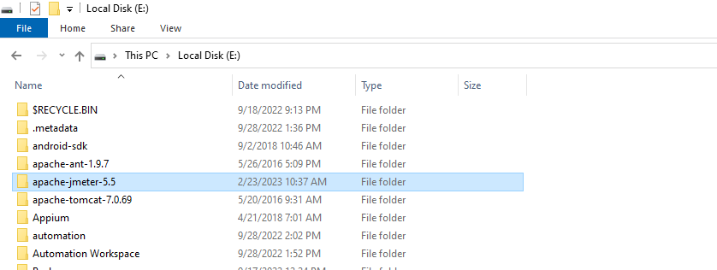

Folder structure :

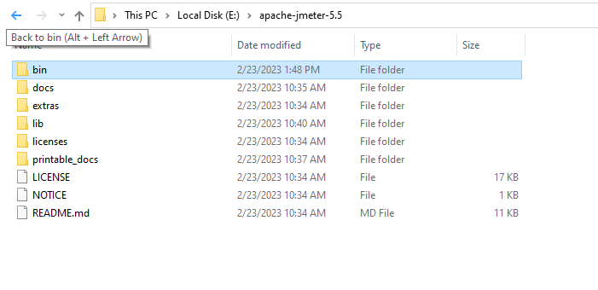

**Step 4 :** Start Jmeter

Windows :

* Navigate to the Bin Directory of your Apache Jmeter folder.
* Double click on Apache Jmeter jar
* Apache Jmeter UI would look like

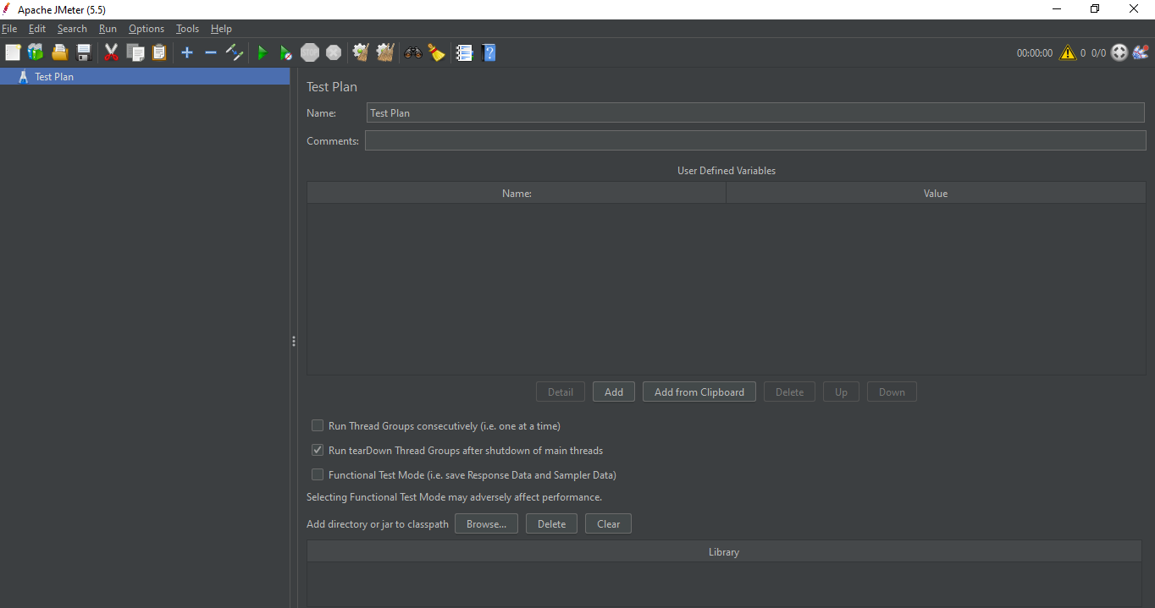

# **JMeter GUI Overview**

There are below sections in JMeter GUI :

1. Menu Bar

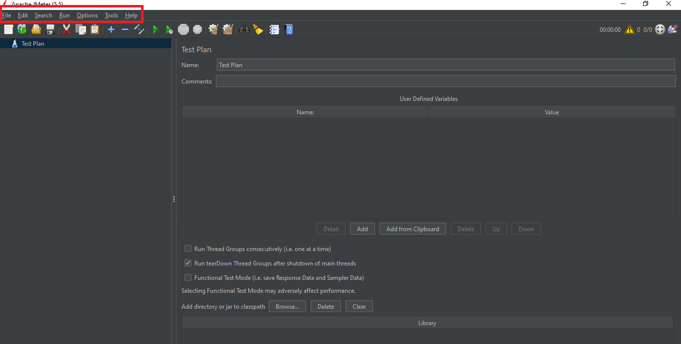

1. Main Tool Bar

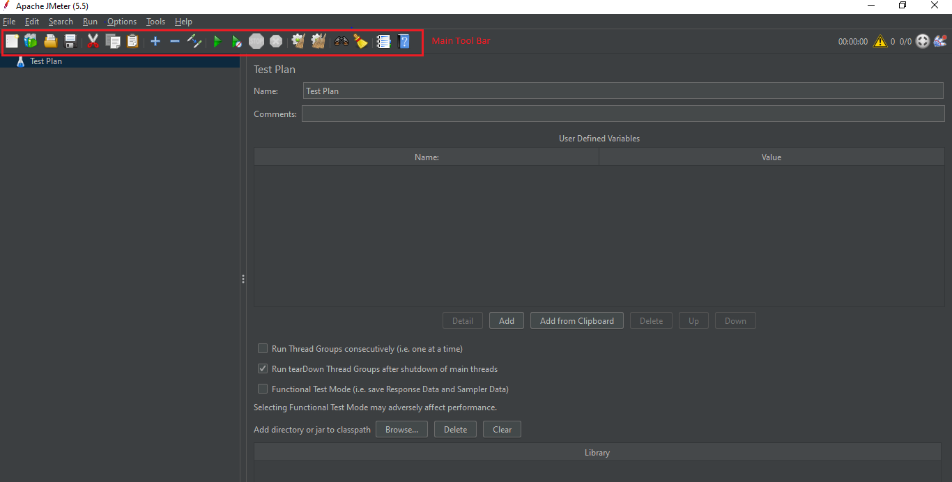

1. Test Plan Tree View :

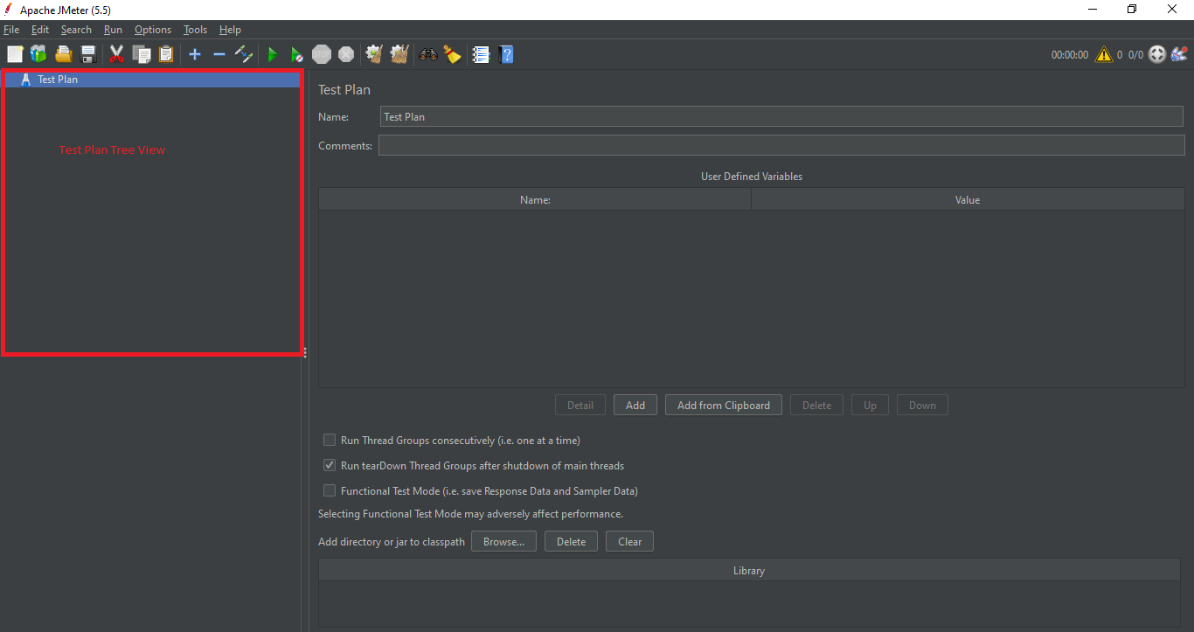

1. Editor Section :

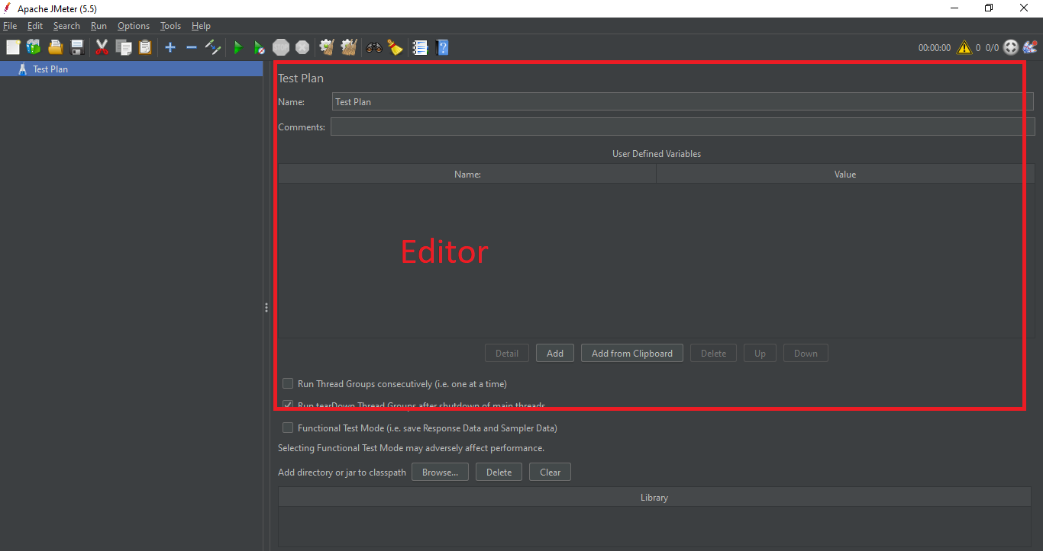

1. Time | Logs | Users :

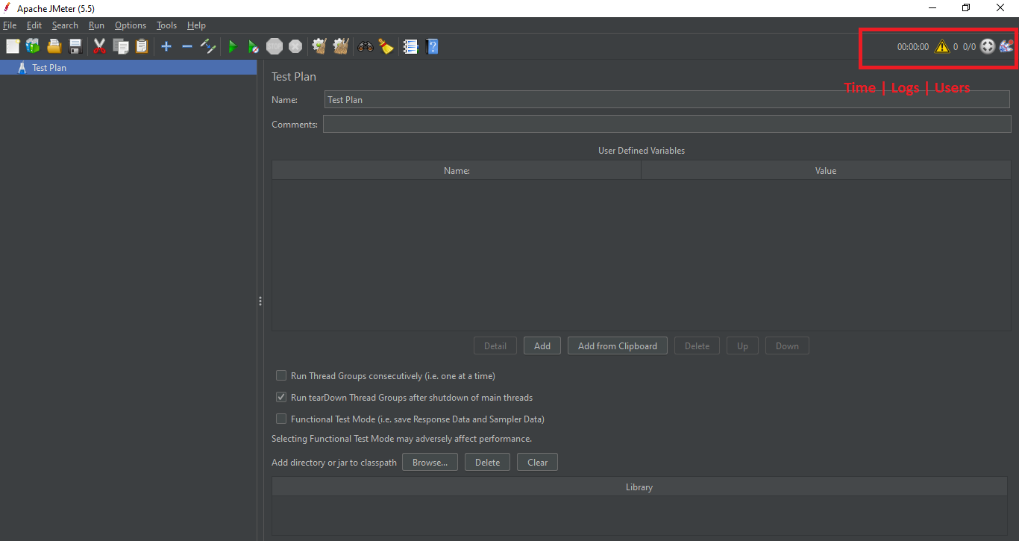

# **Creating 1st JMeter Test [Basic]**

**Step1 -** Start JMeter

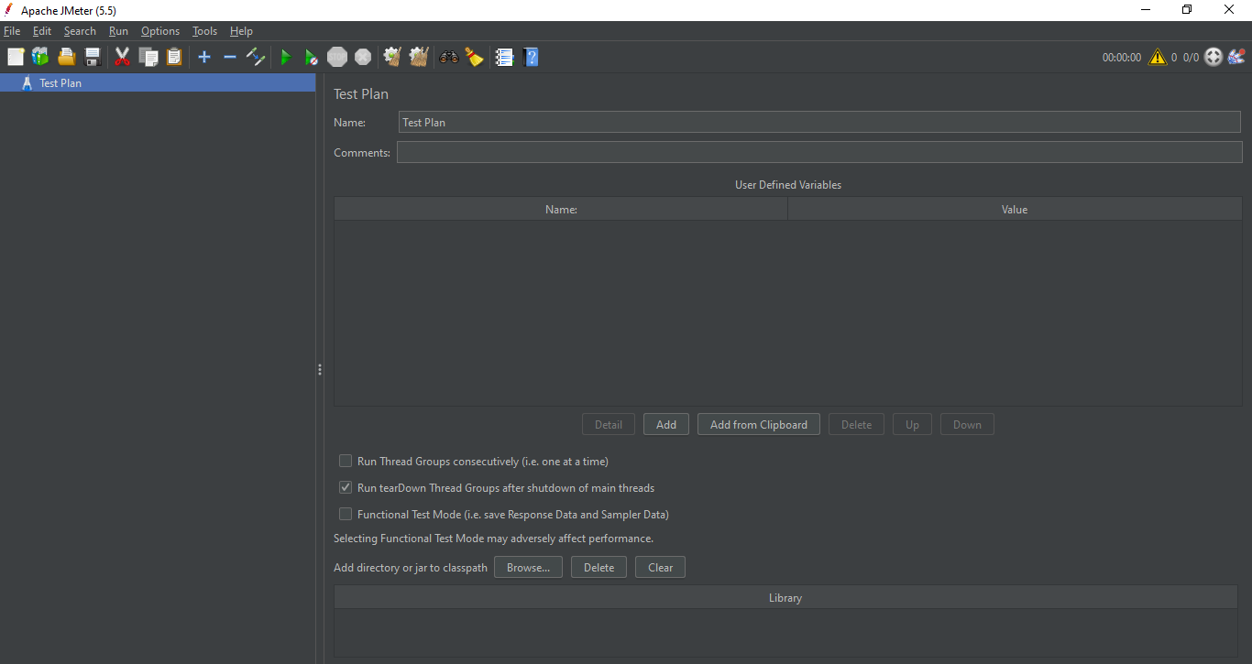

## **Step 2 -** Create a Test Plan

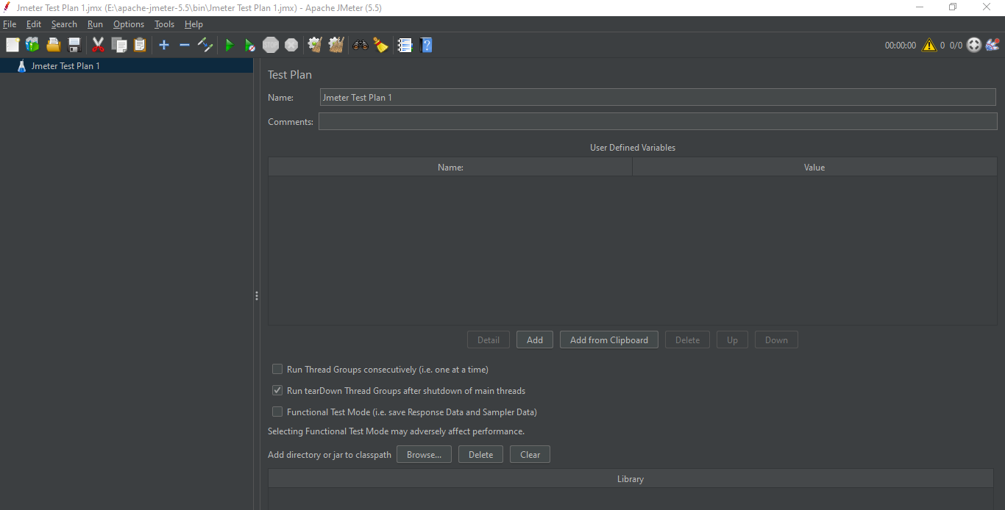

## **Step 3 -** Create a Thread Group (Users)

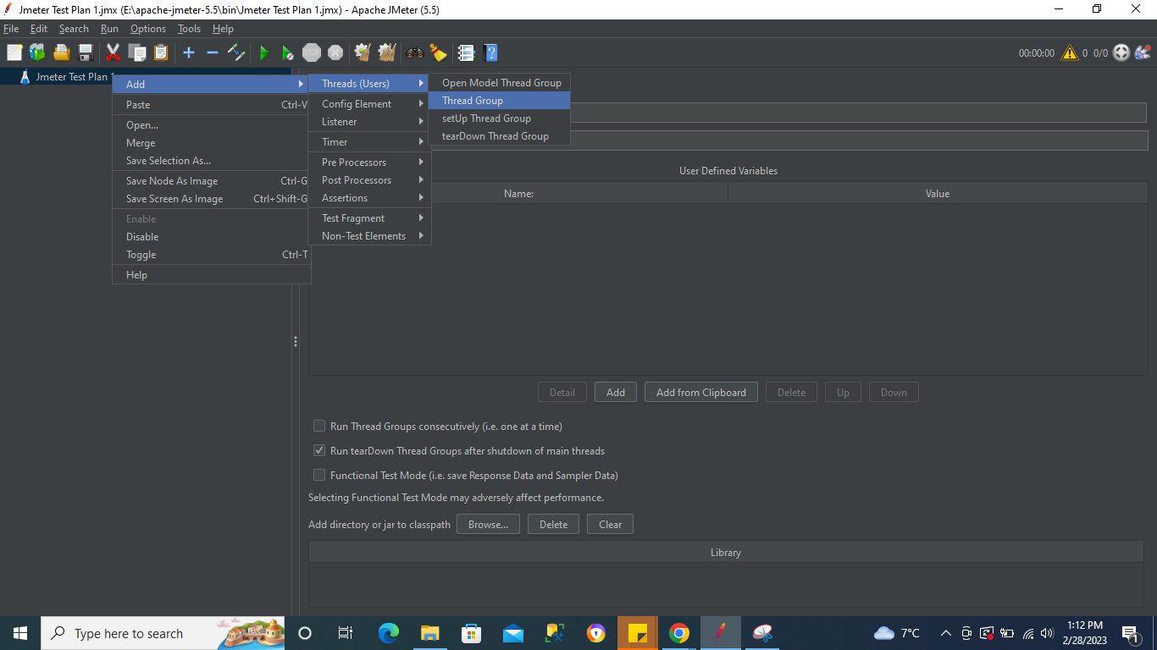

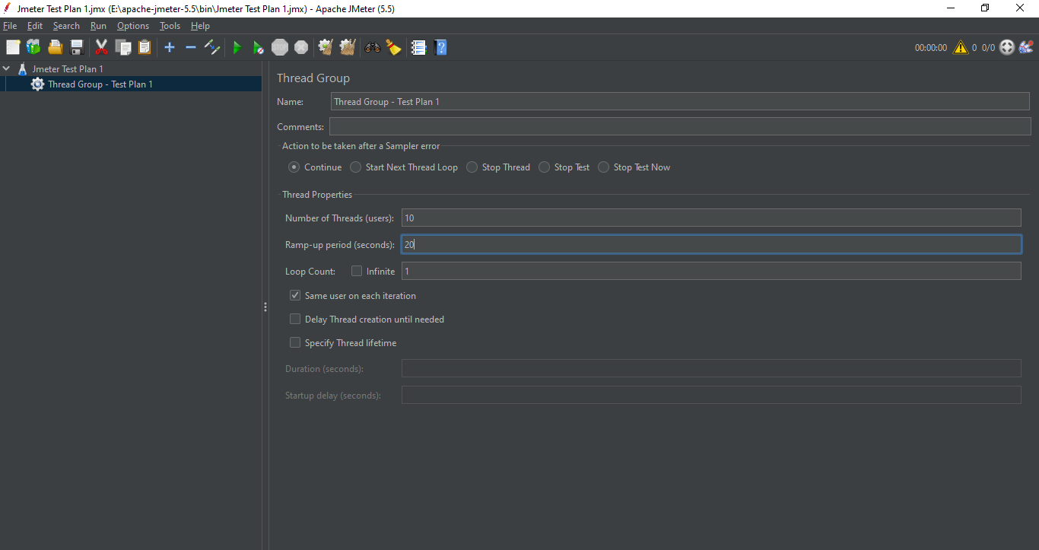

**Number of Threads (Users) :** This defines the number of users to be added while performing load test

**Ramp - up period (Seconds) :** Ramp-up is the amount of time it will take Apache JMeter™ to add all test users (threads) to a test execution. Or in other words, how long it will take for JMeter to start execution of all the threads. For example: 10 target threads with 20 seconds ramp-up: JMeter will add one user after each two seconds.

**Loop Count :** Loop count means we can set the number of iterations for every user as per our requirement.

## **Step 4 -** Add a Sampler (Http)

## Samplers -

Samplers in JMeter are the actual requests which are sent to the server. **Samplers are added to the Thread Groups.** Samplers in JMeter have different types of requests, users can choose from them as per their requirement and send the request to the server.

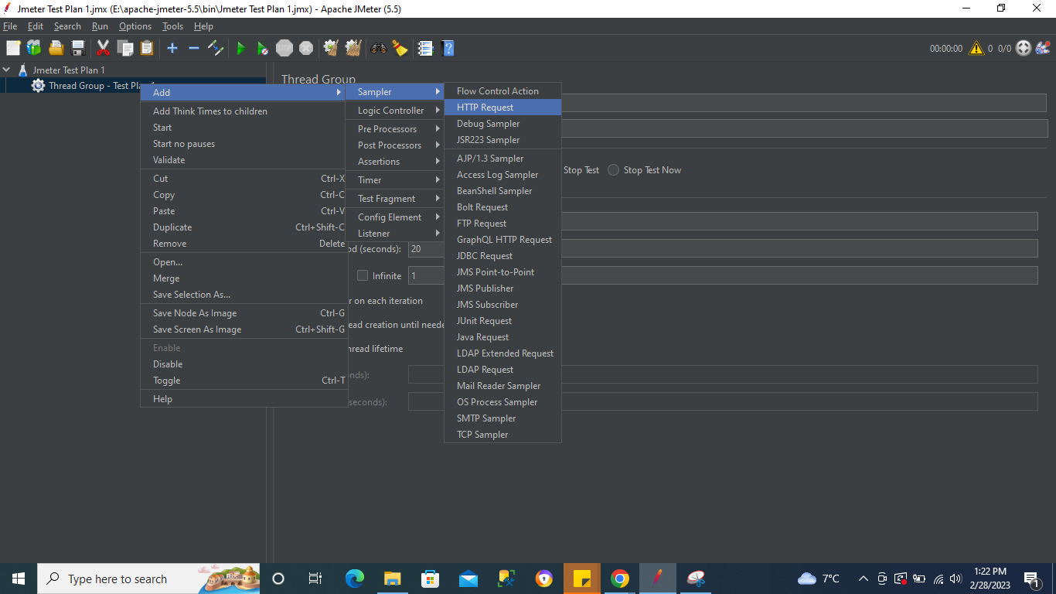

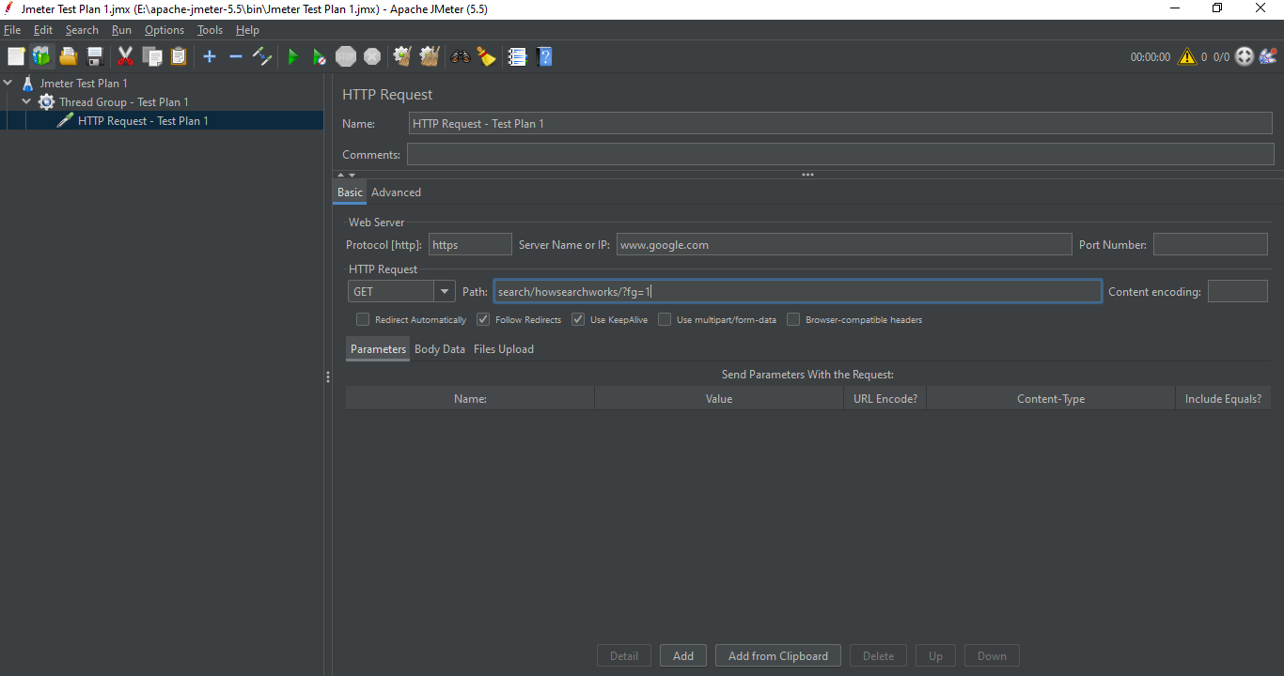

Save the Test Plan

**Step 5 -** Add Listeners

## **Listener :** A listener is a component that shows the results of the samples. The results can be shown in a tree, tables, graphs or simply written to a log file. To view the contents of a response from any given sampler, add either of the Listeners "View Results Tree" or "View Results in table" to a test plan.

***Note - We can add multiple Listeners***

**Adding Listener 1**

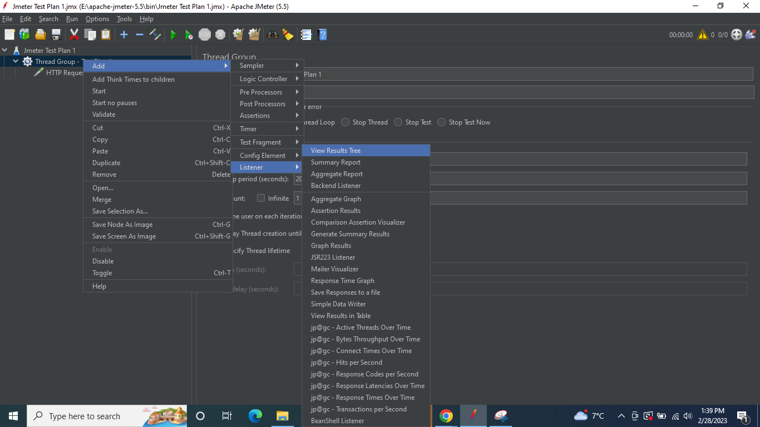

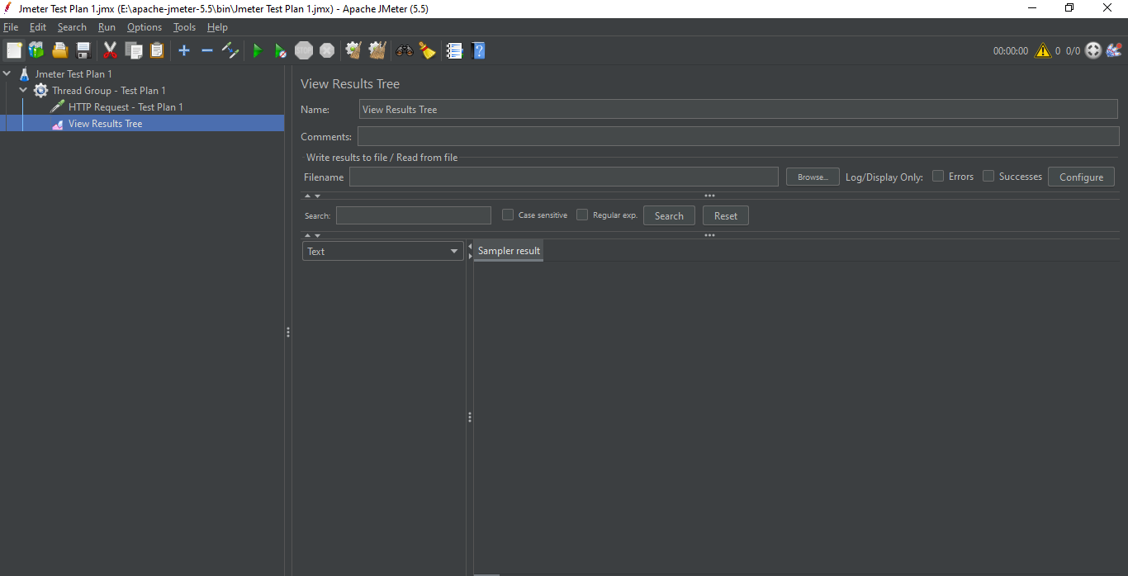

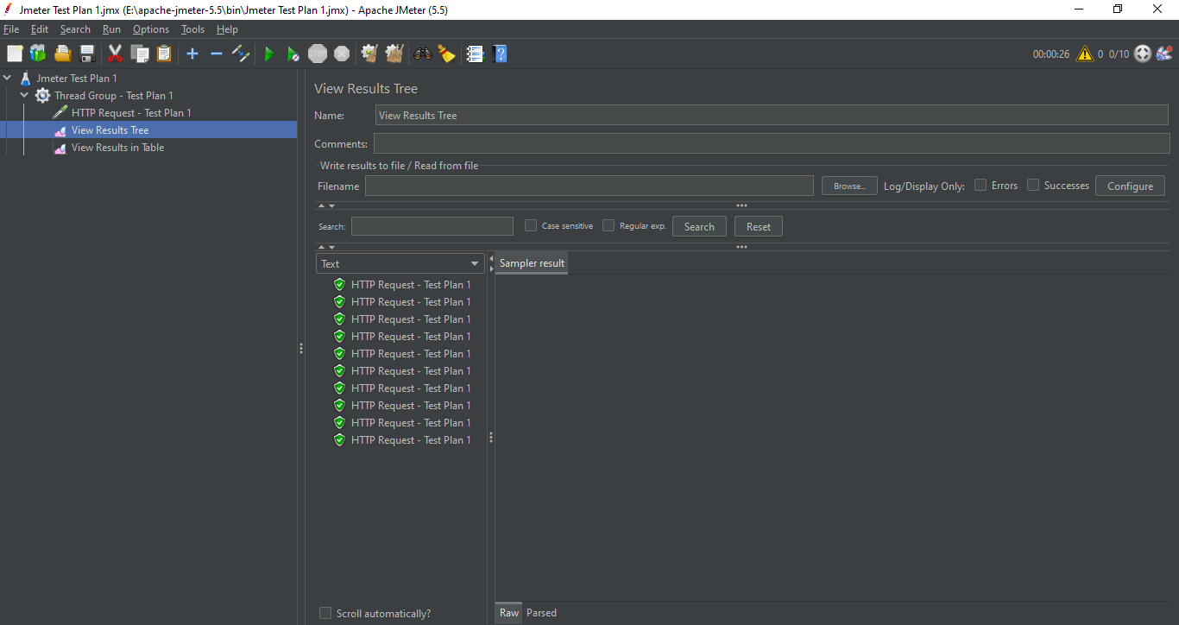

**Adding Listener 2**

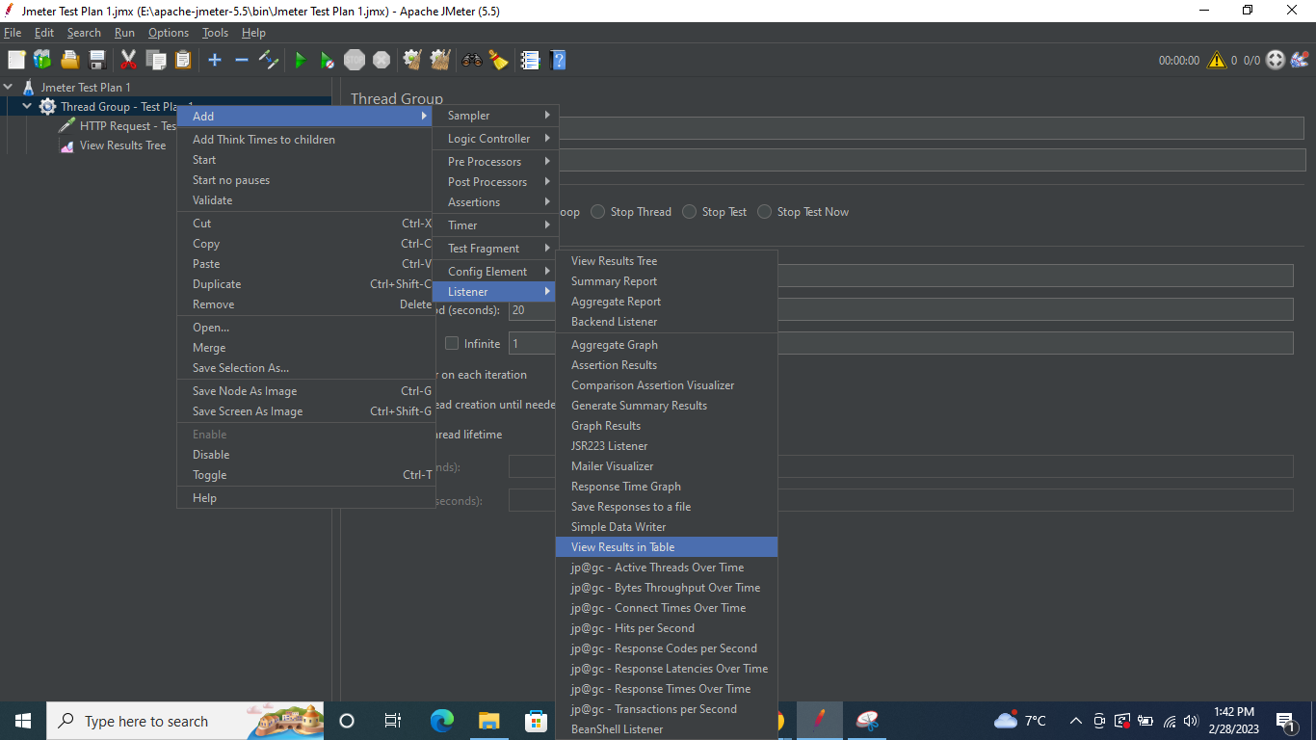

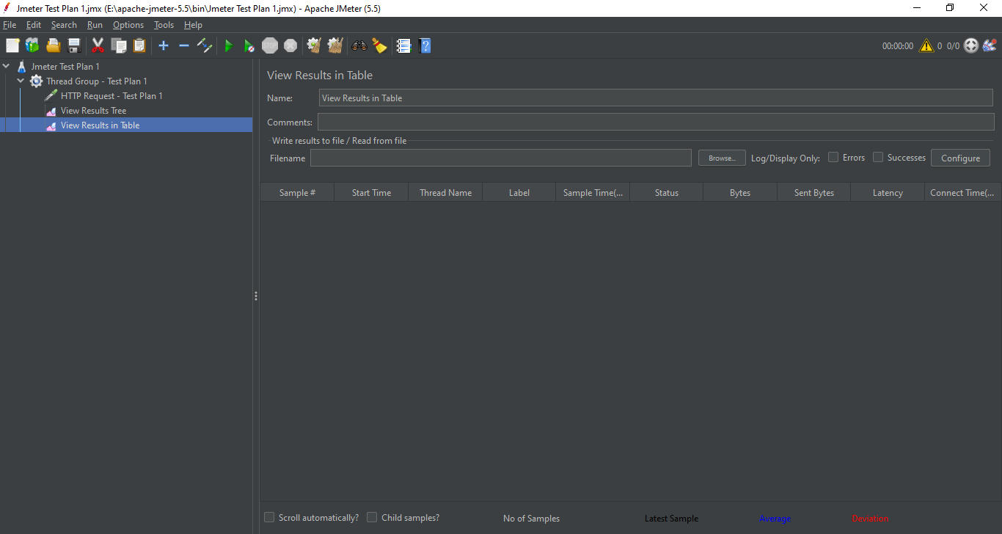

Save the Test Plan

**Step 6 -** Run the Test

Click on Run Button (Green arrow button)

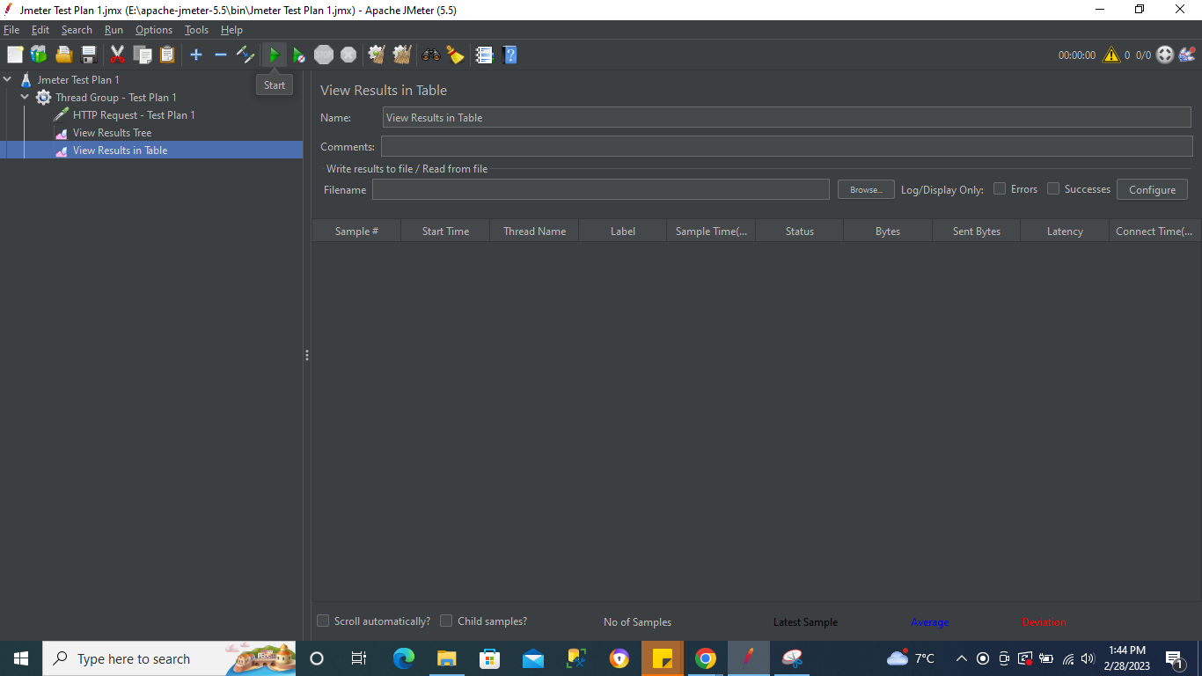

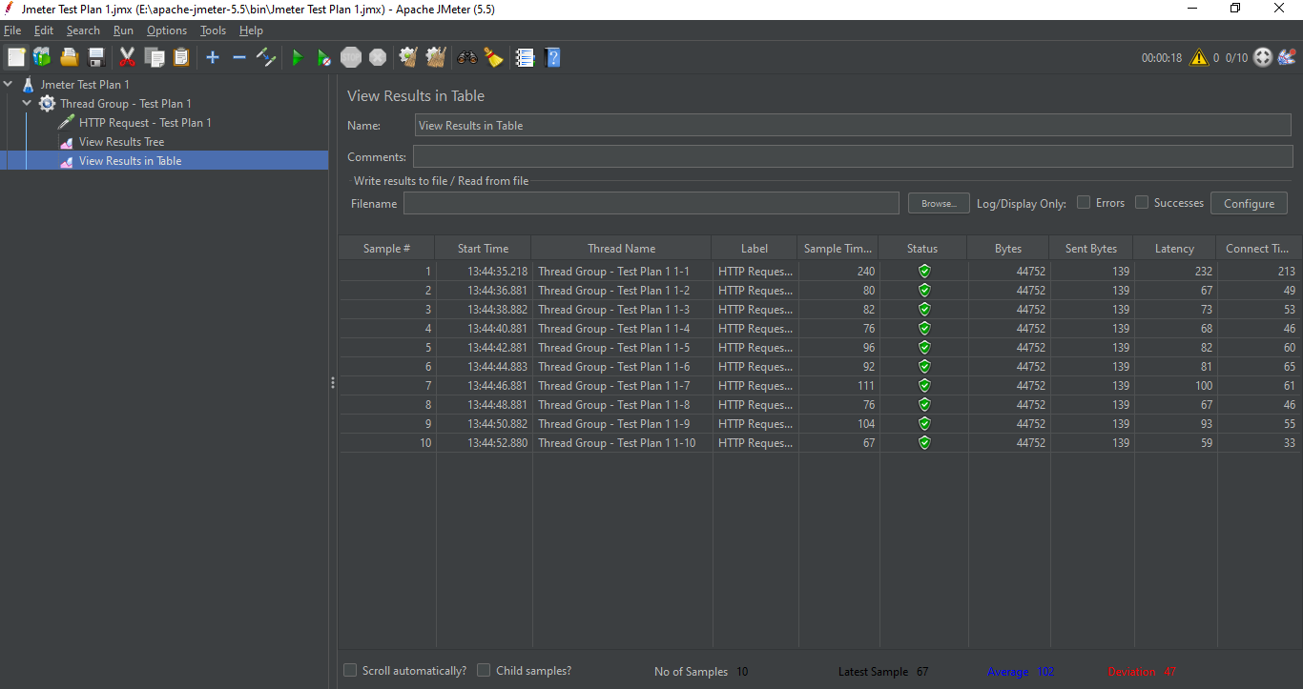

# **JMeter Listeners (Reporting)**

* A listener is **a component that shows the results of the samples**. The results can be shown in a tree, tables, graphs or simply written to a log file. To view the contents of a response from any given sampler, add either of the Listeners "View Results Tree" or "View Results in table" to a test plan.
* Used for Reporting.

## **View Results in Table**





**Column 1 : Sample # ->** Represents the sample number

**Column 2 : Start Time ->** Start time of every sample

**Column 3 :Thread Name ->** Thread name shall be same as the name of Thread Group name mentioned earlier.

The numbers in this column represent the Thread/User & Iteration

Ex : Thread Group - Test Plan 1 **1|2**

Thread Group - Test Plan 1 = Thread Group Name

1 of **1|**2 represents Iteration number

2 of 1**|2** represents Thread group or User number

**Column 4 :Label ->** Label name is the sampler request Label

In our Example - **HTTP Request - Test Plan 1** is the sampler label name

**Column 5 :Sample Time (ms)** **->** Time taken by sampler in milliseconds

**Column 6 : Status ->** Status mostly describes if the test is passed or failed. In case of assertions added , it will display status accordingly

**Column 7 : Bytes ->** This is the size of the response

**Column 8 : Sent Bytes ->** This is the bytes sent to the server

**Column 9 : Latency ->** Latency is the time when we started getting the 1st byte of the response from the server in milliseconds

Ex : The time started at 0 ms & completed at 1000 ms

0ms —----------------------------**500ms**----------------------------------- 1000ms

0ms —------------------------------------------------------------------------ 1000ms

500 ms is the time when server actually started giving response & entire response was completed at 1000ms

500ms is the latency in this case.

**Column 10 : Connect Time (ms) ->** Time it took to connect to the server

**File Name :** You can download the results in csv or xml file using this field & also configure the table columns using the configure button & checking the checkboxes as per requirement

## **View Results Tree**



Post running the test plan



After clicking on the individual result , it will display the detailed result for that sampler.

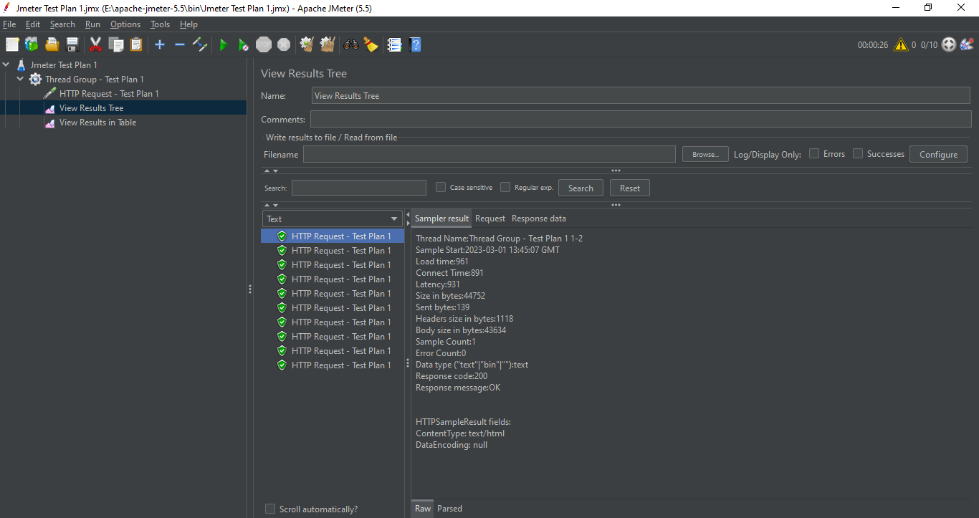

***Note - Never use the reports that hold/display too much data while performing actual performance testing as this can be time consuming. Instead use simple table resorts & export in csv. We can disable the listeners while doing performance testing by right click on the listener & disable it.***

**File Name :** You can download the results in csv or xml file using this field & also configure the table columns using the configure button & checking the checkboxes as per requirement

## **Aggregate Report**

This report will display the result in a single record per request irrespective of the number of threads.

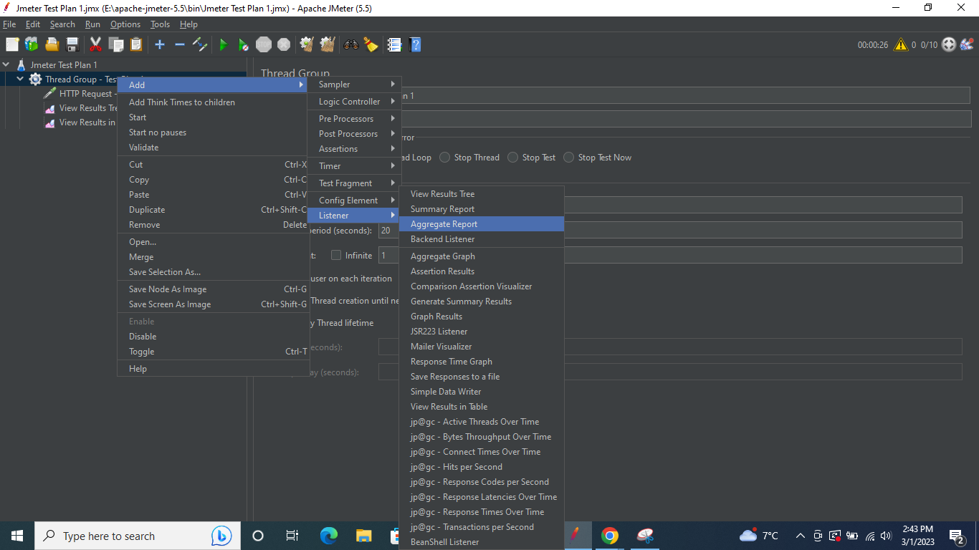

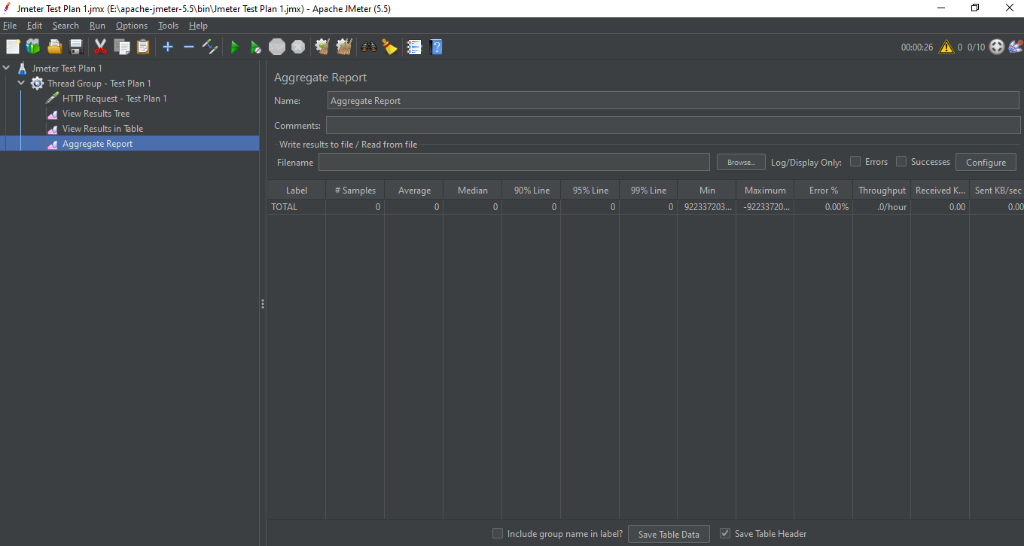

Post running the test plan

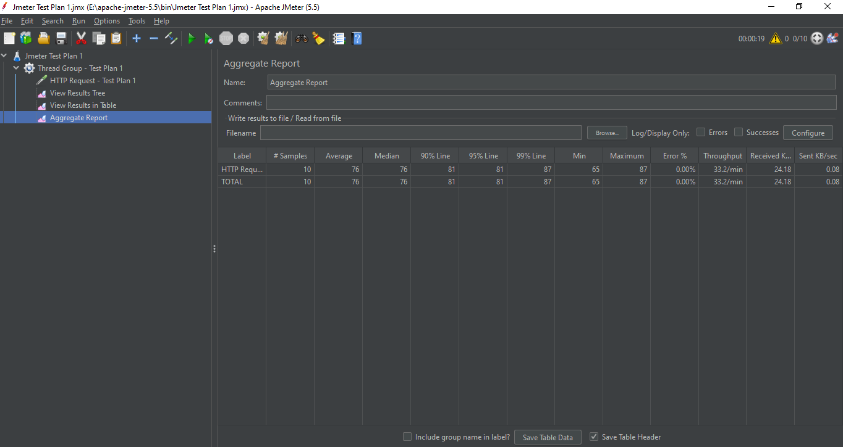

**Column 1 : Label ->** Sampler name

**Column 2 : # Samples ->** Number of Samplers

**Column 3 : Average ->** Average time in milliseconds

**Column 4 : Median ->** Median is the half way time taken to get the response i.e. for ex, we got a half response before 50 ms & other half after 50 ms

**Column 5 : 90 % Line ->** 90 % of the response was within the mentioned time in the report (in ms)

**Column 6 : 95 % Line ->** 95 % of the response was within the mentioned time in the report (in ms)

**Column 7 : 99 % Line ->** 99 % of the response was within the mentioned time in the report (in ms)

**Column 8 : Min ->** Minimum time taken by any request in all the samplers

**Column 9 : Maximum ->** Maximum time taken by the request [ 99% Line & Maximum will mostly have same time mentioned in the report]

**Column 10 : Error % ->** In case of any errors, we can get the error % here

**Column 11 : Throughput ->** No of requests per minute Matrix

**Column 12 : Received KB/Sec ->** This defines how many kilobytes per second received by the Client.

**Column 13 : Sent KB/Sec ->** This defines how many Kilobytes per second are sent to the server.

**File Name :** You can download the results in csv or xml file using this field & also configure the table columns using the configure button & checking the checkboxes as per requirement

## **Graph Results**

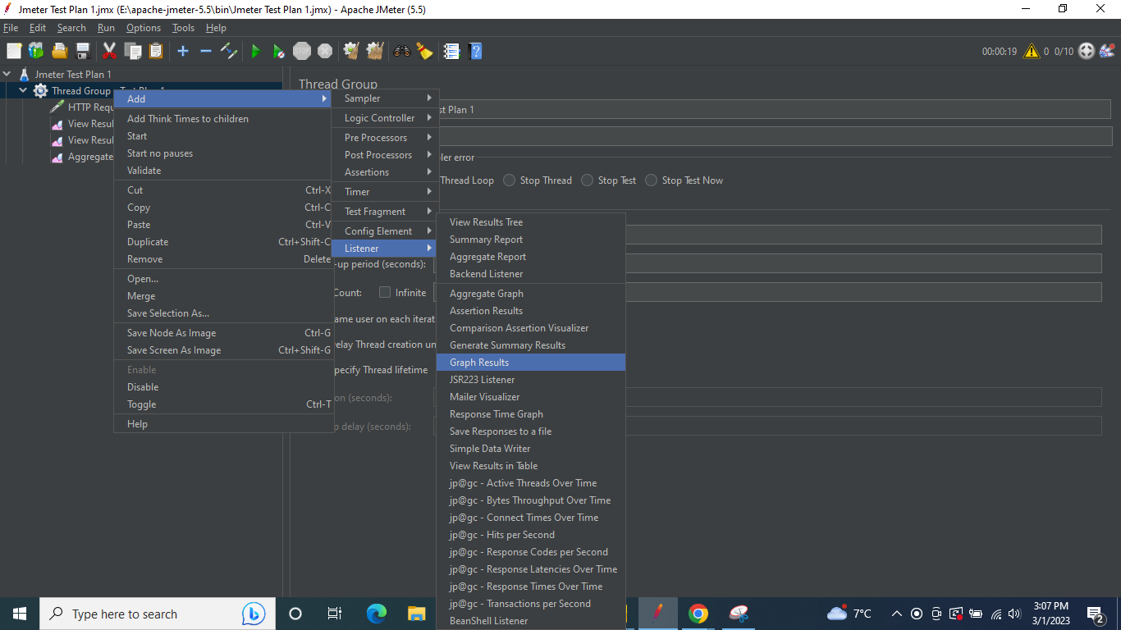

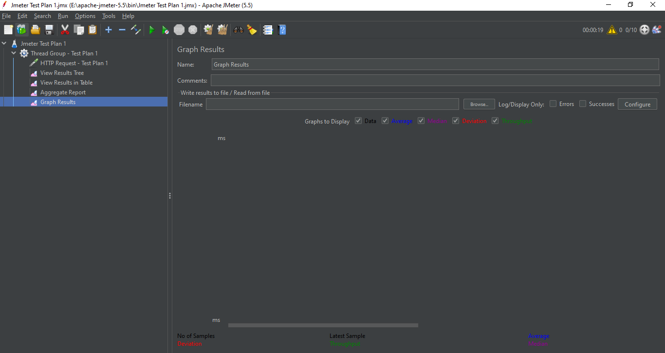

Post running the test plan

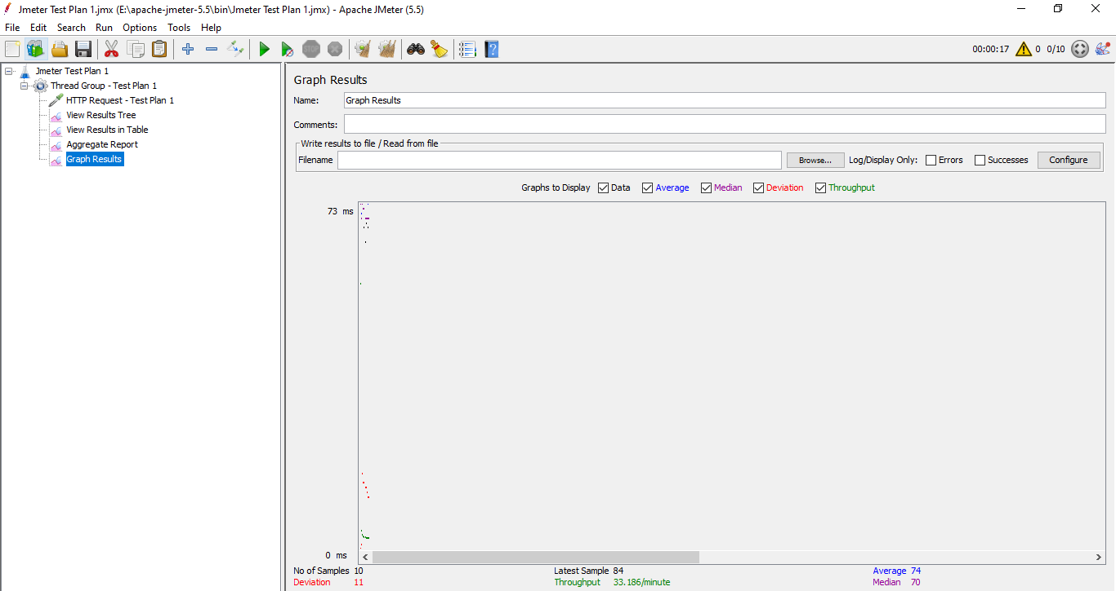

As per colour code mentioned for Data , Average , Median, Deviation & Throughput , the graph will be displayed.

**The graph lines show the response time of all the requests (Data), the average response time (Average), the median of response time (Median), deviation in the response time (Deviation) and no. of samples per minute (throughput).**

## **Summary Report**

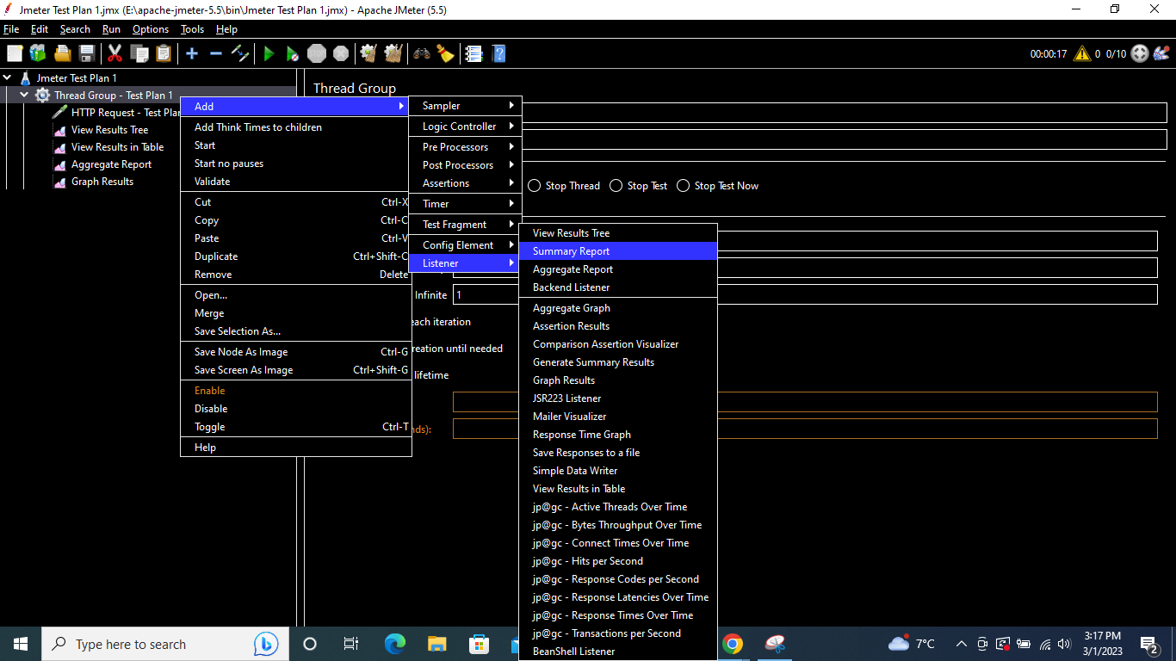

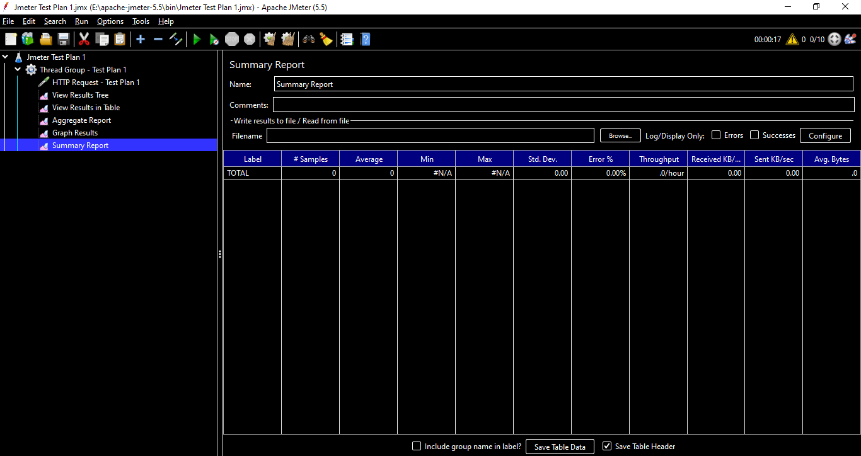

Post running the test plan

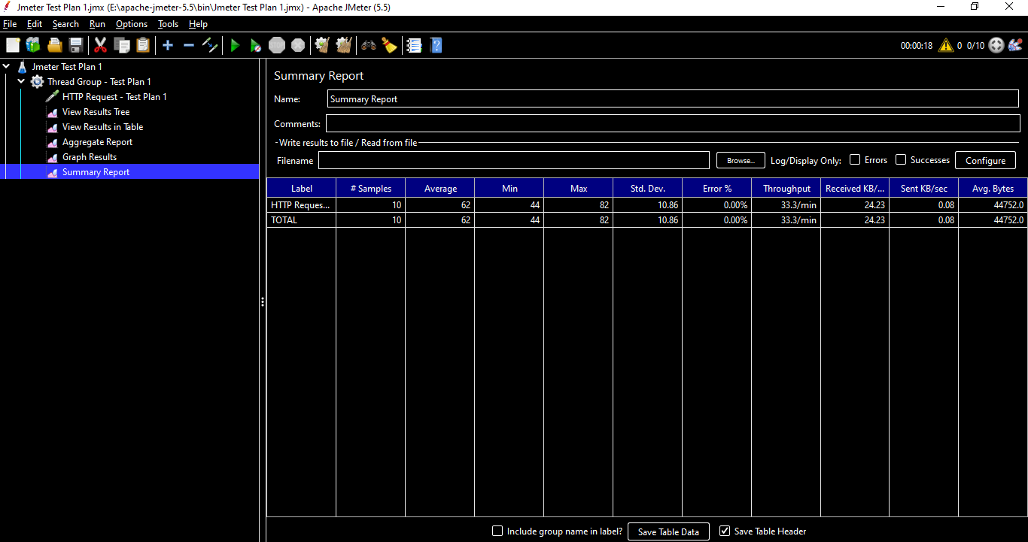

This report is similar to Aggregate Report but with limited columns.

This report also displays 1 record per sampler.

**Column 1 : Label ->** Sampler name

**Column 2 : # Samples ->** Number of Samplers

**Column 3 : Average ->** Average time in milliseconds

**Column 4 : Min ->** Minimum time taken by any request in all the samplers

**Column 5 : Max ->** Maximum time taken by the request

**Column 6 : Std. Dev. ->**  It shows how much variation there is from the average, or mean

**Column 7 : Error % ->** In case of any errors, we can get the error % here

**Column 8 : Throughput ->** No of requests per minute Matrix

**Column 9 : Received KB/Sec ->** This defines how many kilobytes per second received by the Client.

**Column 10 : Sent KB/Sec ->** This defines how many Kilobytes per second are sent to the server.

**Column 11 : Avg Bytes ->** Average bytes is the average value of the sample response in bytes

## **Simple Data Writer**

In this listener , we don’t have a table or graph to display our results, we just have an option to write the results into a file.

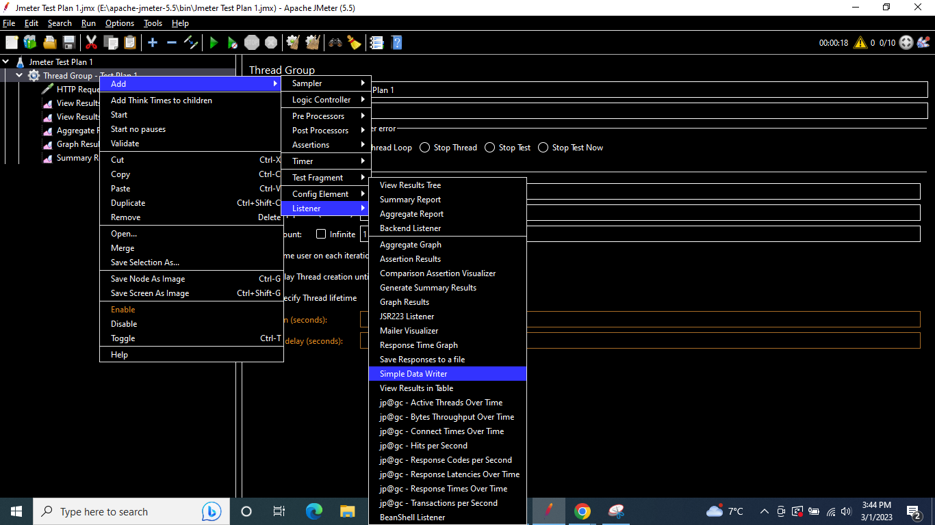

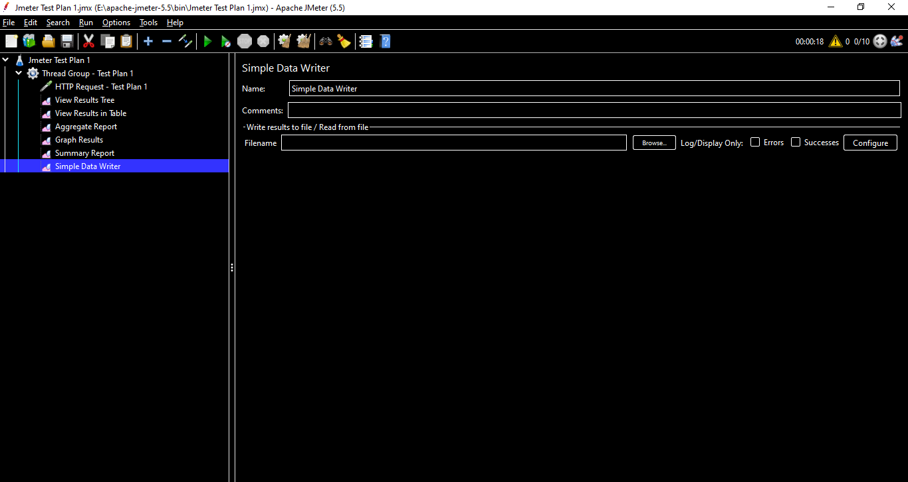

Add a path & run the test plan

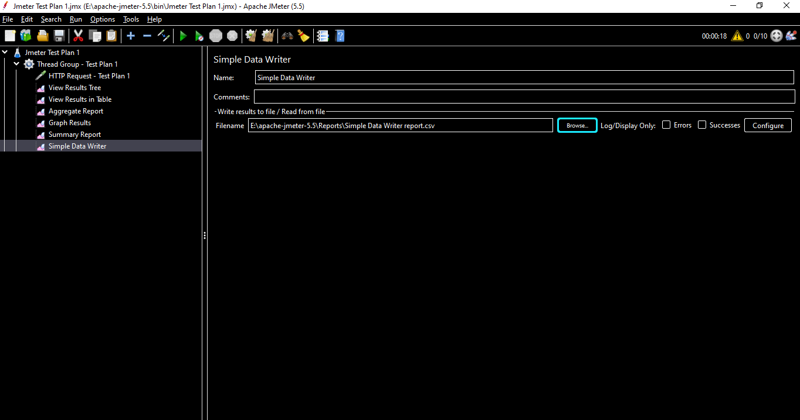

Post running the test plan

The report will get generated at the mentioned file location

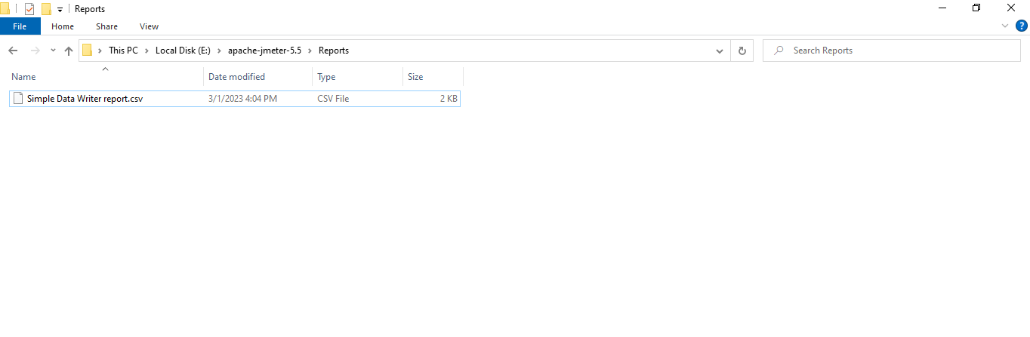

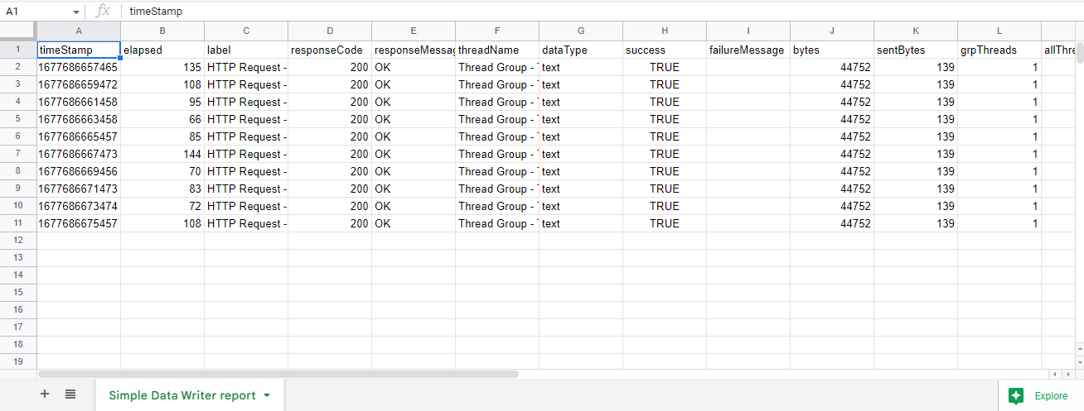

# **Assertions**

* Assertion in JMeter is **used to validate the response of the request that you have sent to the server**.
* Assertion is a process where you verify expected results with the actual result of the request at run time.
* If you need to apply assertion on a particular Sampler, then add it as a child of that Sampler.
* Assertions can be applied at different levels like at Test Plan level or a sampler.
* The Assertion added at Test Plan level will be applicable to all the samplers in the test plan
* The Assertions added at Sampler/Request level will be applicable only to that Sampler/Request

**Types of Assertions**

## **Response Assertions** [At request/Sampler Level]

Assertion in JMeter is **used to validate response of the request, that you have sent to the server**.

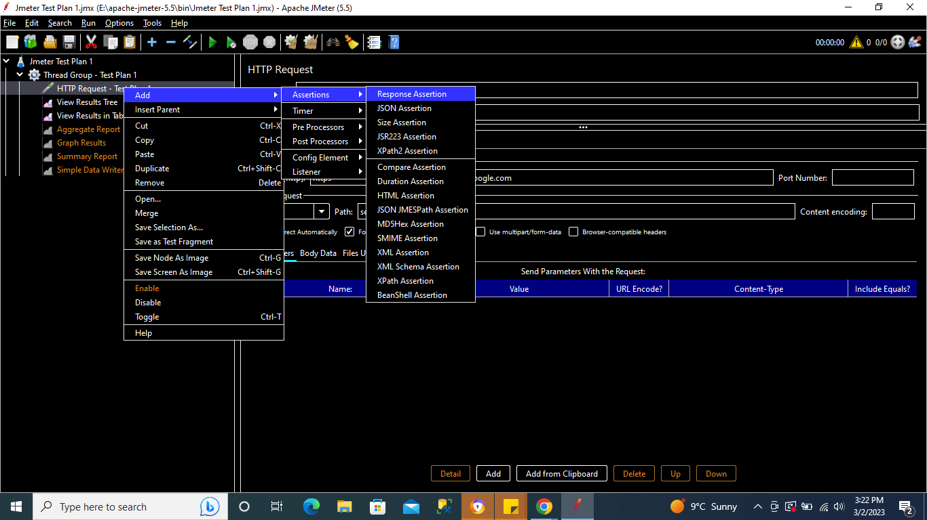

We are checking below if the response equals 200

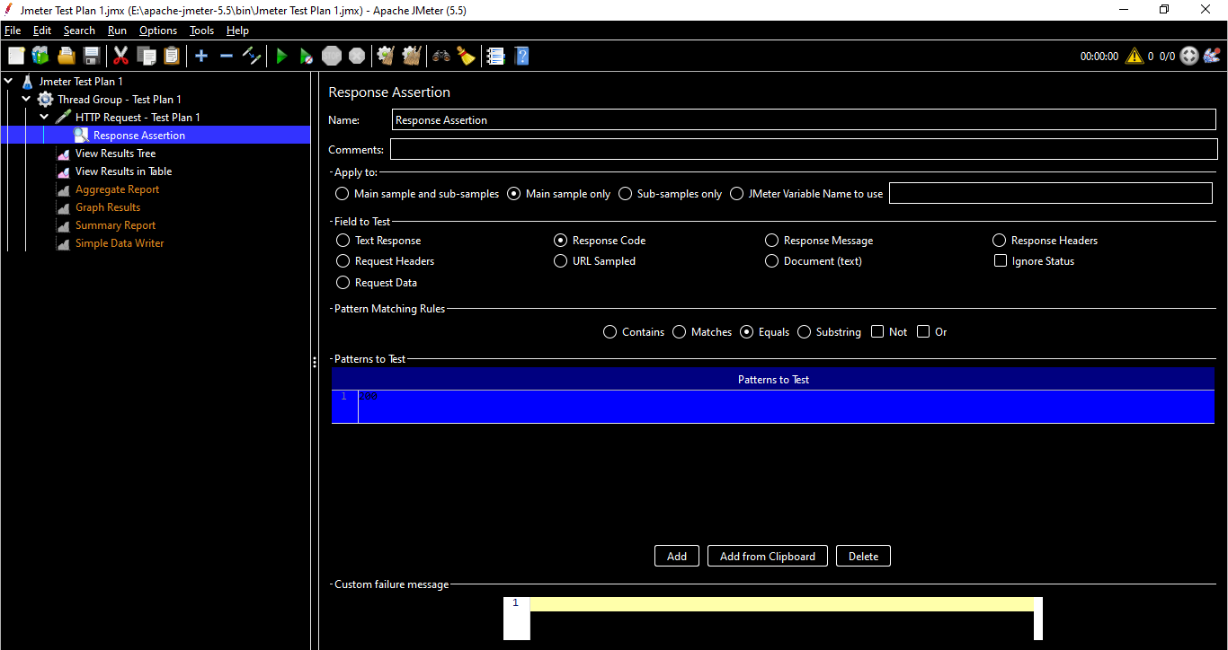

Save & run the test plan

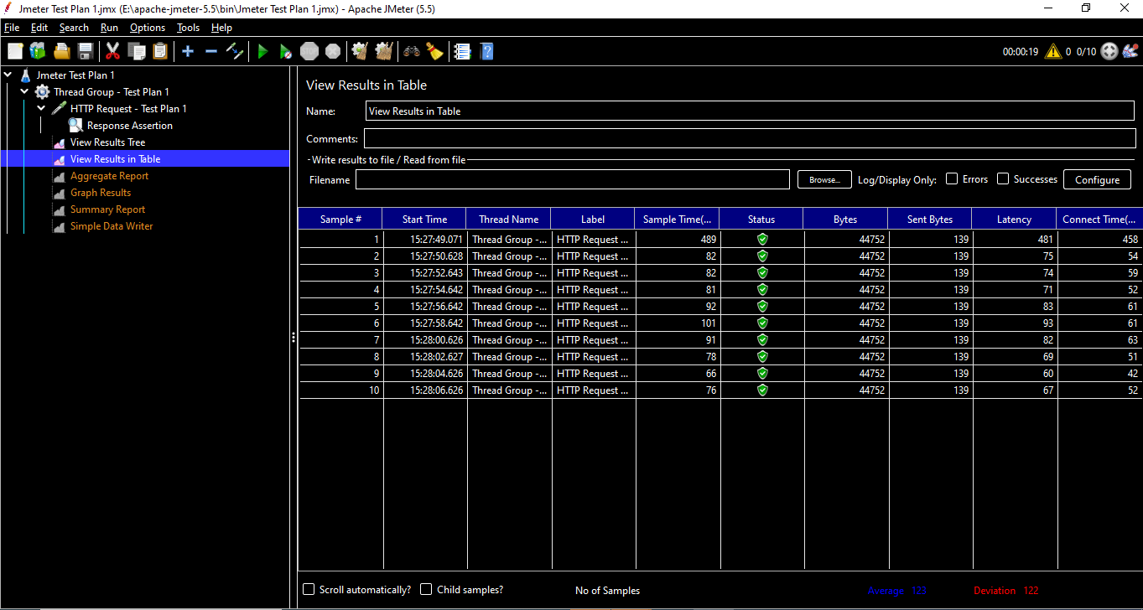

Everything will be passed in our listeners but we change the response code to different like 201 & run the test plan , then we should be able to see the assertion results under the reports as below :

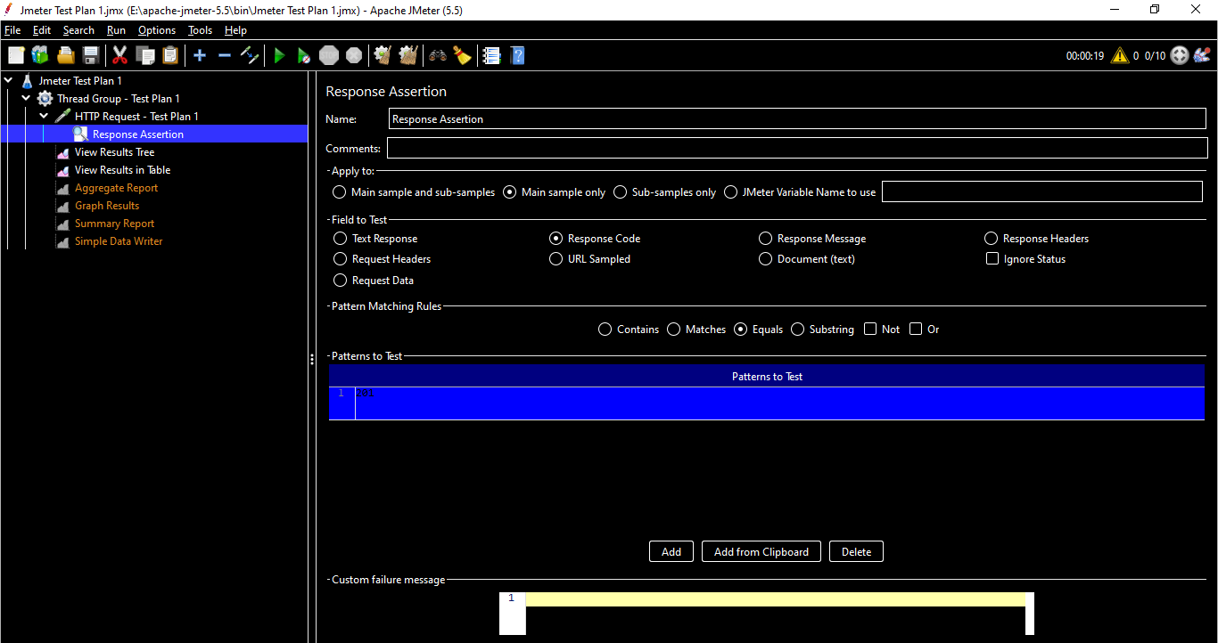

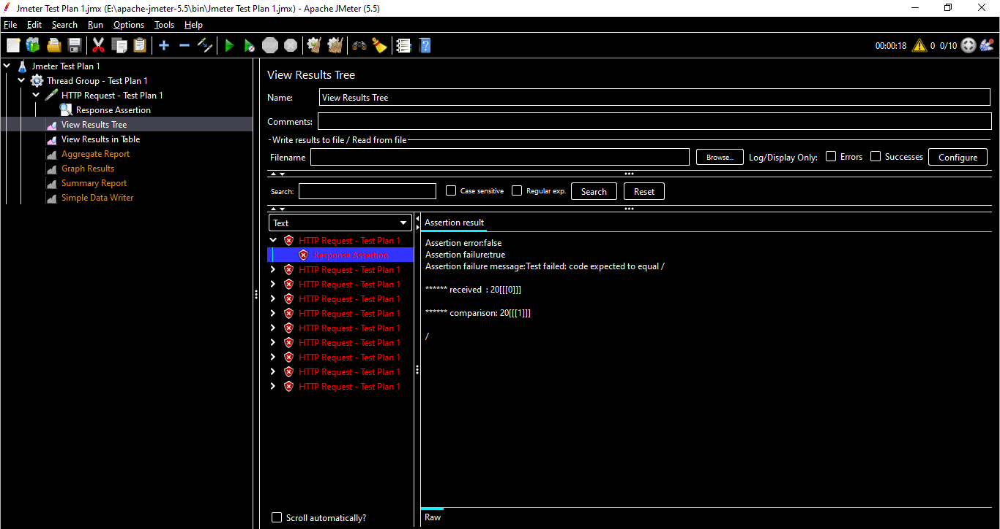

This is the most widely used assertion & we can assert the texts in the response as well.

*Note : We can add* ***Assertion Results*** *listener to check the assertions results*

## Duration Assertions

Duration Assertion is used to verify that server response is received within a specified time constraint or not. It will mark the sample request as failed, if the response takes longer than the given amount of time.

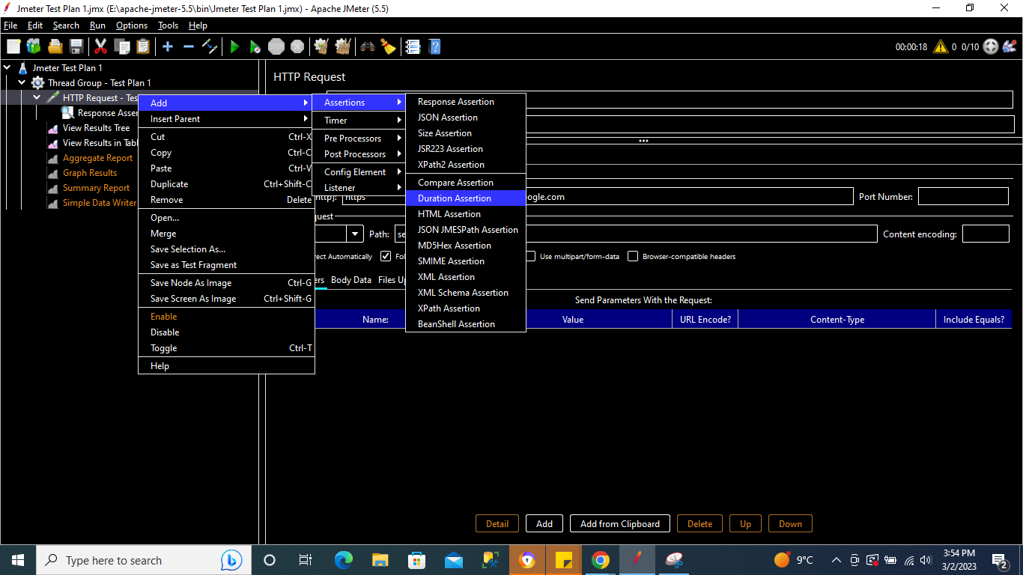

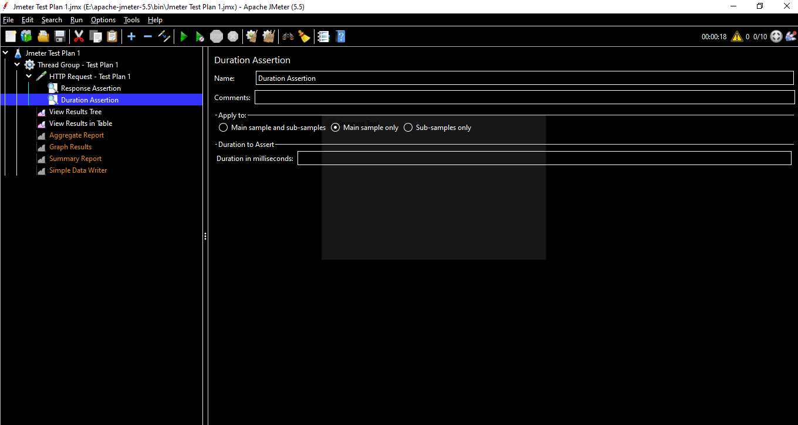

Suppose we add a duration as 1500 ms knowing that few requests take more than 1500 ms to get the response , in that case that particular request should be failed

Ex : Add Duration as 95 ms & run the test plan

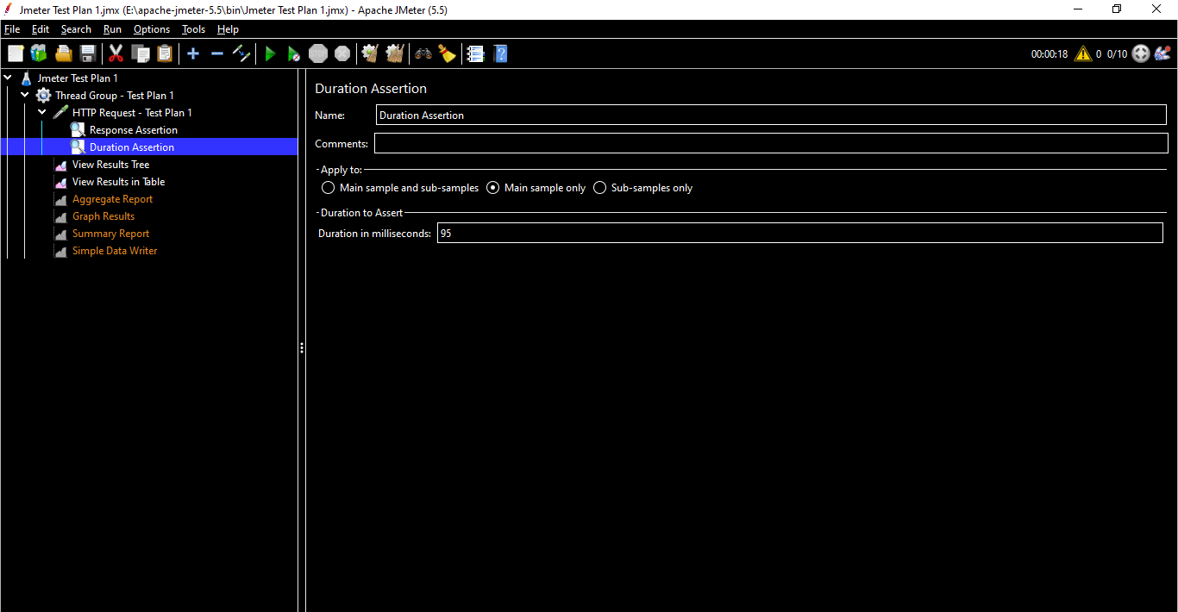

The 4th request took longer than 95 ms to get the response & hence the test failed for this request.

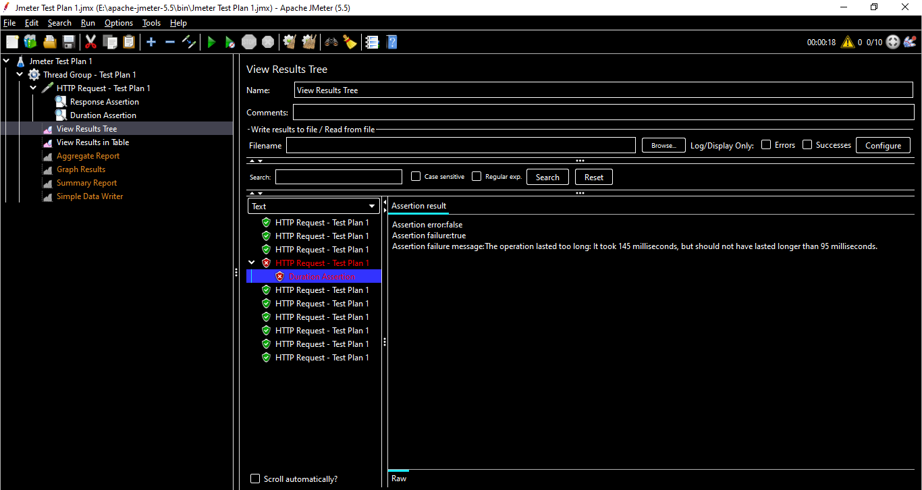

## Size Assertions

Size Assertion is used to verify the server response contains expected number of Bytes or not

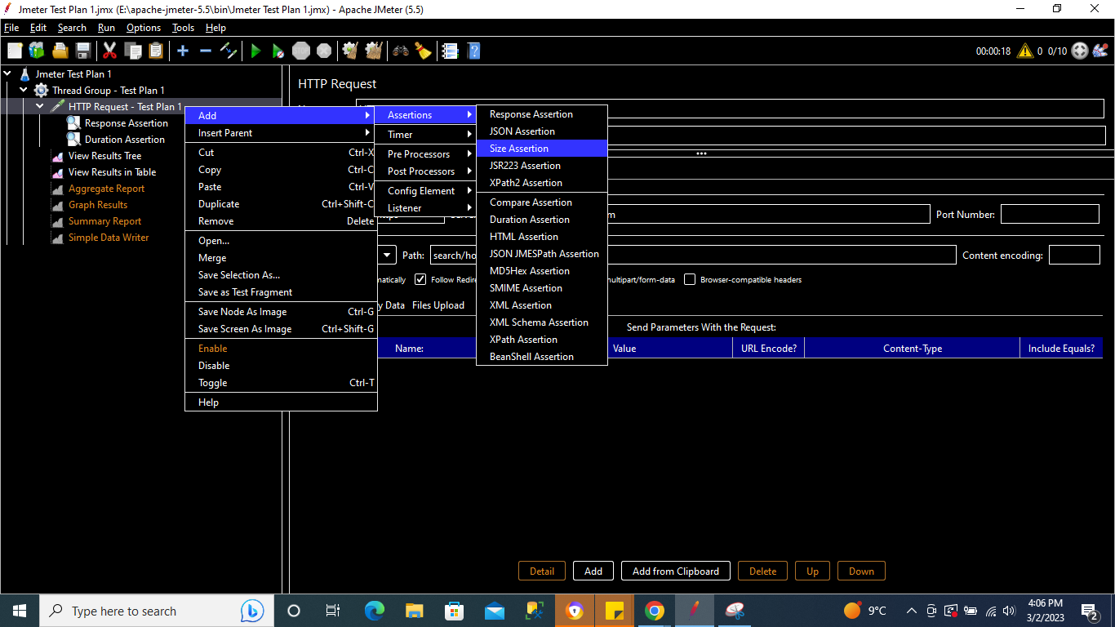

As seen in previous results the maximum bytes we got for each request was 44752 Bytes , hence using Size Assertion we can check if the Bytes we are expecting should be = , < , > , <= , >= != etc. In below case we are adding maximum bytes as 4400 ***(which is less than 44752 & hence the test should fail)*** & selecting comparison <= .

Run the test plan & check the result.

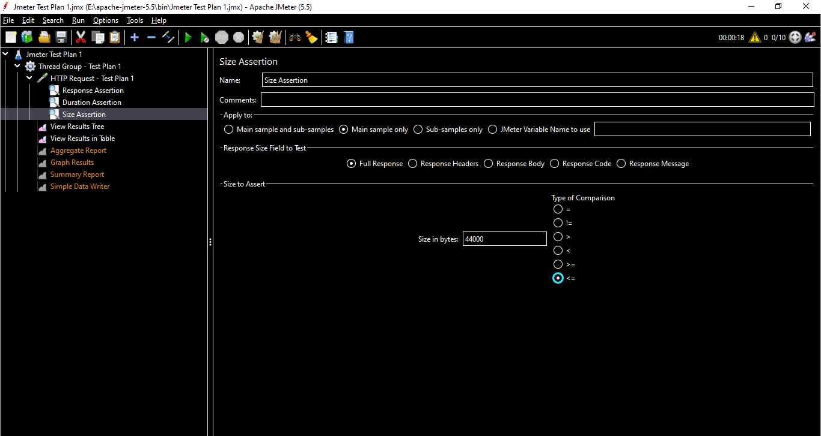

All the requests failed as the bytes were above 4400 as expected.

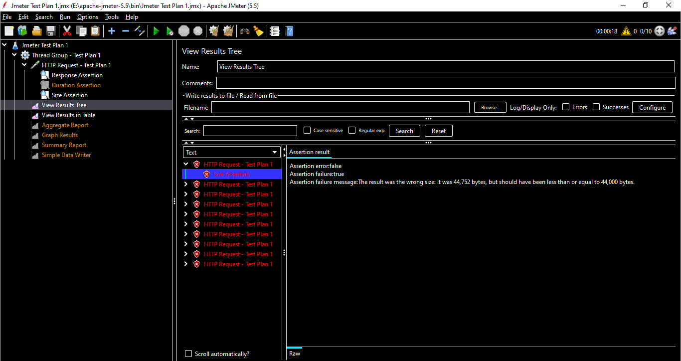

## HTML Assertions

HTML Assertion is used to verify that the response contains correct HTML syntax or not using JTidy (HTML Syntax Checker). It will fail the test in case of improper HTML syntax response.

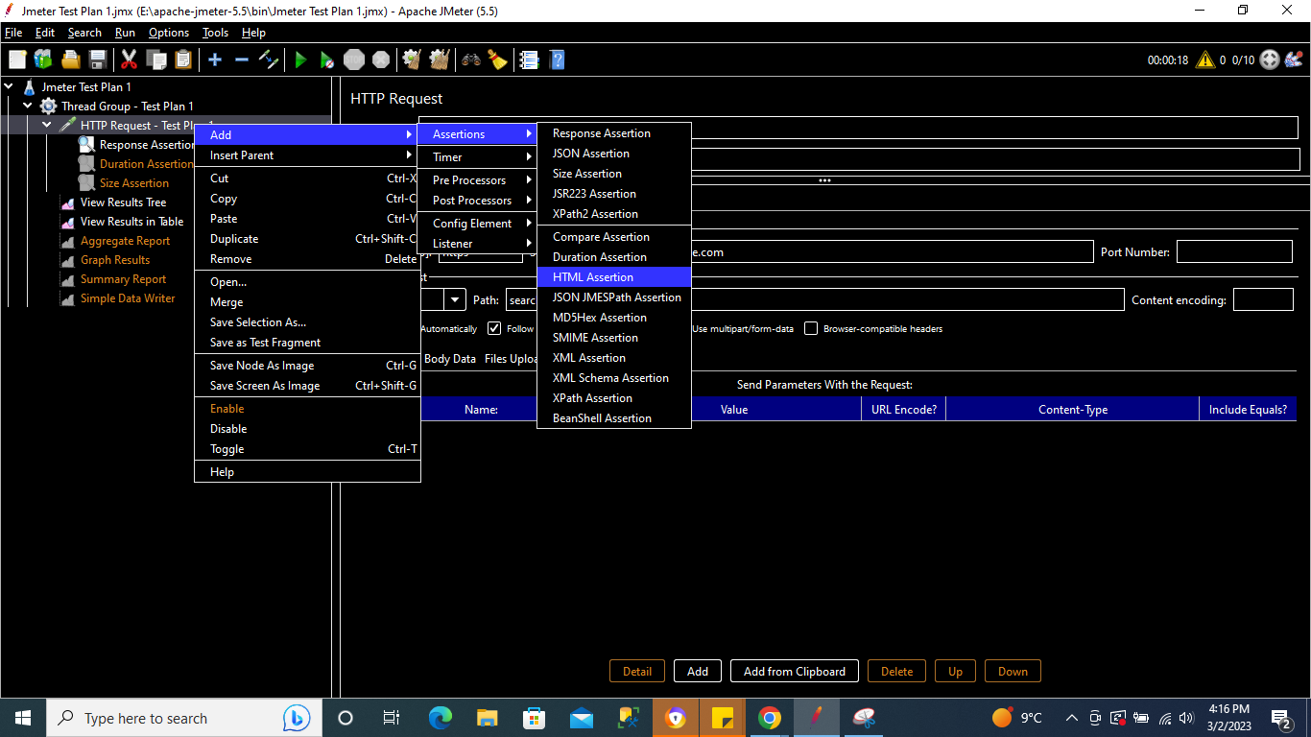

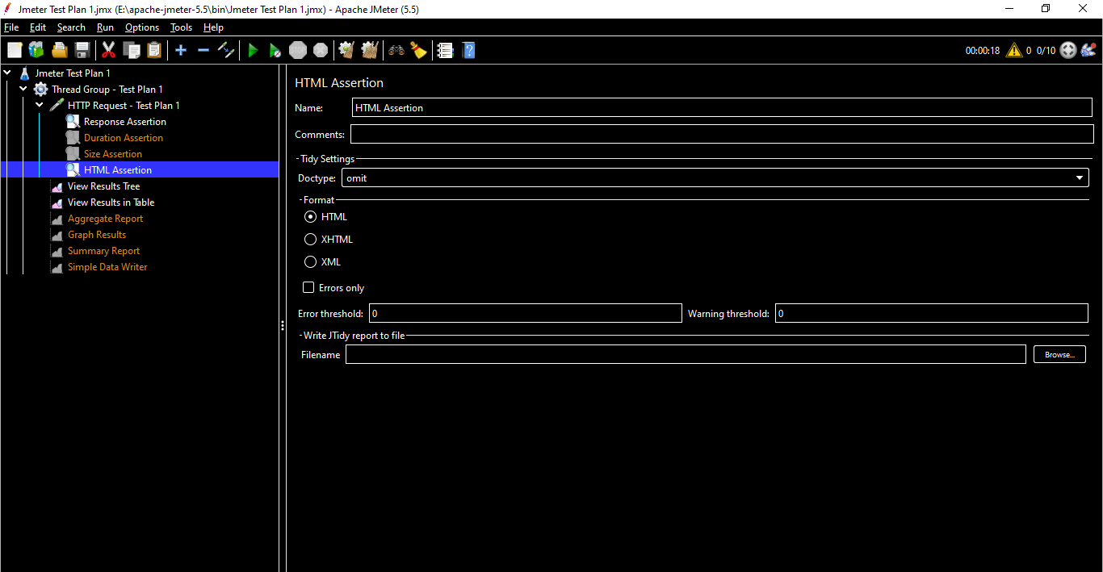

**Error Threshold :** To provide the count of errors which can be ignored and considered the request as pass.

**Warning Threshold :** The number of warnings which can be ignored and considered the request as pass.

If we give Error Threshold = 30 & Warning Threshold = 200 , then the request should fail.

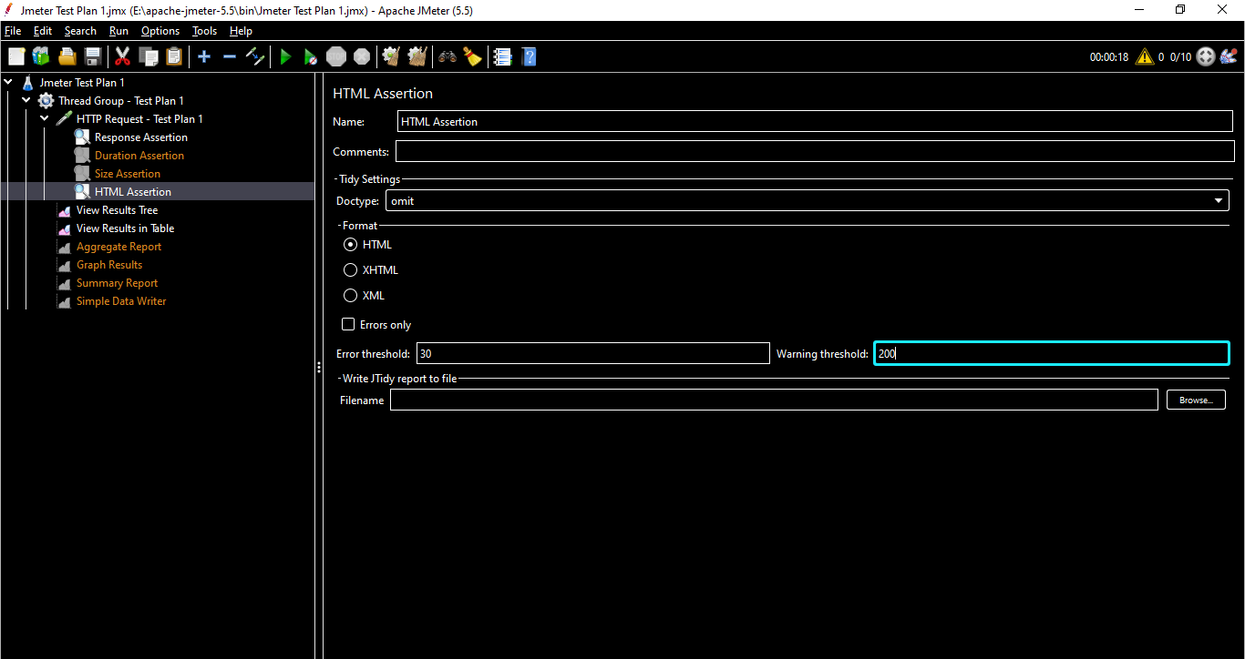

Run the test plan

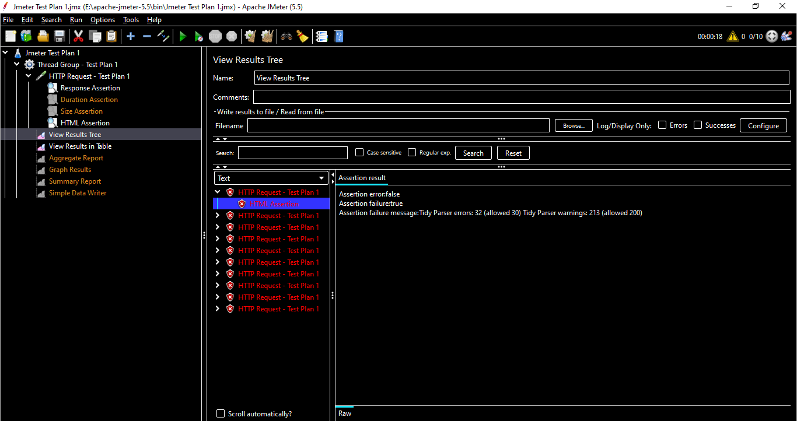

Mostly HTML Assertions are not used.

**Format :**

**HTML :** In case our application needs to interact with third party applications then we need to use the HTML Assertion & the Error/Warning Threshold can be discussed with the team.

**XHTML :** XHTML is a stricter, more XML-based version of HTML & can be used instead of HTML based on requirement & similarly for **XML**

## XML JSON Assertions

XML Assertion is mainly used to validate the format of XML embedded in the response & is mostly used for APT/Webservice testing

<Will be covered in later sections>

## XPATH Assertions

The XPath Assertion **allows an XPath evaluation against a Web server response to ensure the specified entity is present or an element attribute value matches expectations**.

<Will be covered in later sections>

# **JMeter HTTP(s) Test Script Recorder**

**What -** HTTP(s) Test Script Recorder is **an element in JMeter that helps us to record our HTTP request**. So instead of manually adding our request in an HTTP sampler, we can very quickly do a recording and everything will get added.

**Why -** HTTP(S) Test Script Recorder can be used to record all the requests which your web or mobile application is making to the server. As the name suggests, it will capture only the HTTP(s) requests.To avoid adding the requests manually we can use HTTP(s) Test Script Recorder to record the events using a recorder. To save time we can use it.

**How -** Right Click on Test Plan >> Add >> Non-Test Elements >> HTTP(s) Test Script Recorder

## **How to add & use Recording Controller**

Add a Thread Group & inside Thread Group add a Logic Controller i.e. Recording Controller

**Why do we need a Recording Controller ?? -** JMeter can record your Testing steps; a recording controller is a placeholder to store these recording steps.

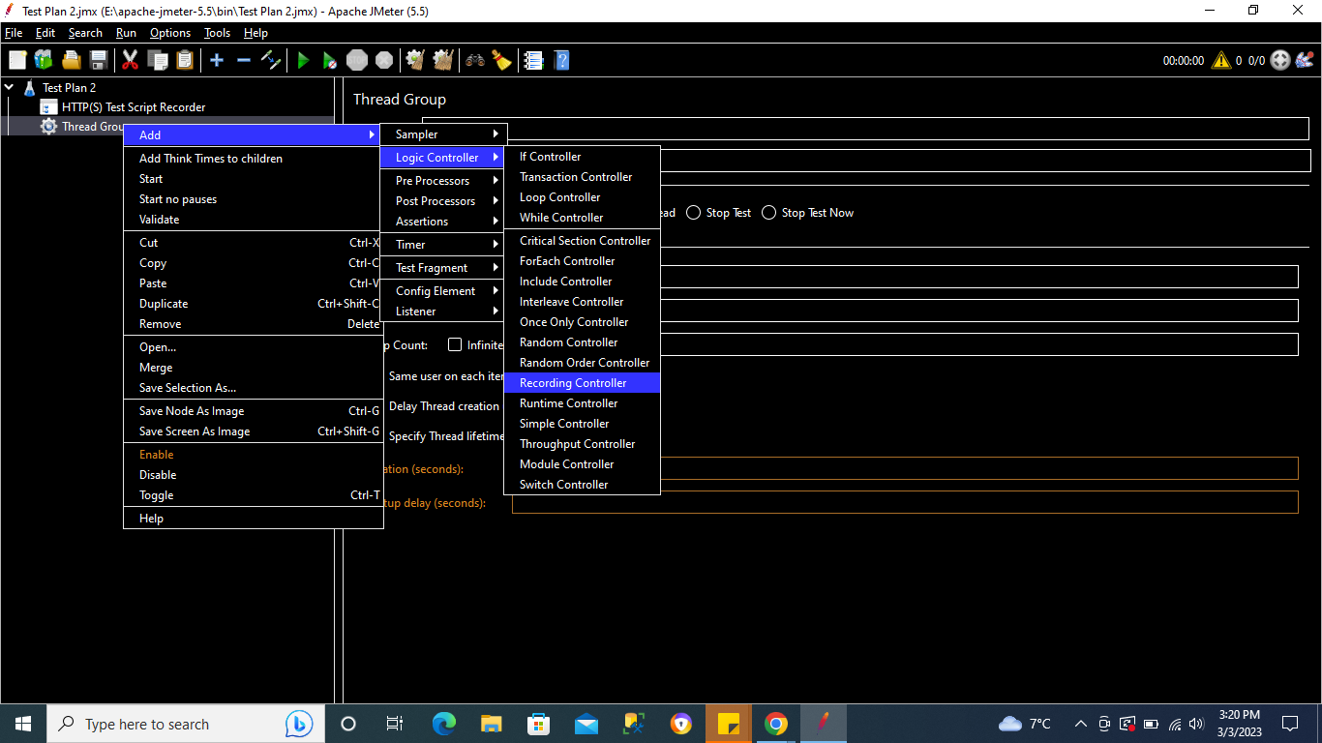

We can add multiple Recording Controllers based on our number of pages/recordings.

We can categorise our events/recordings into different folders using multiple Recording Controllers.

In our example , we will add 3 Recording Controllers to perform 3 actions.

We are considering below site for our practice :

[https://www.gov.uk](https://www.gov.uk/)

3 Recording controllers for below 3 actions shall be added :

1. [Find a job](https://www.gov.uk/find-a-job)
2. [Coronavirus (COVID-19)](https://www.gov.uk/coronavirus)
3. [Universal Credit account: sign in](https://www.gov.uk/sign-in-universal-credit)

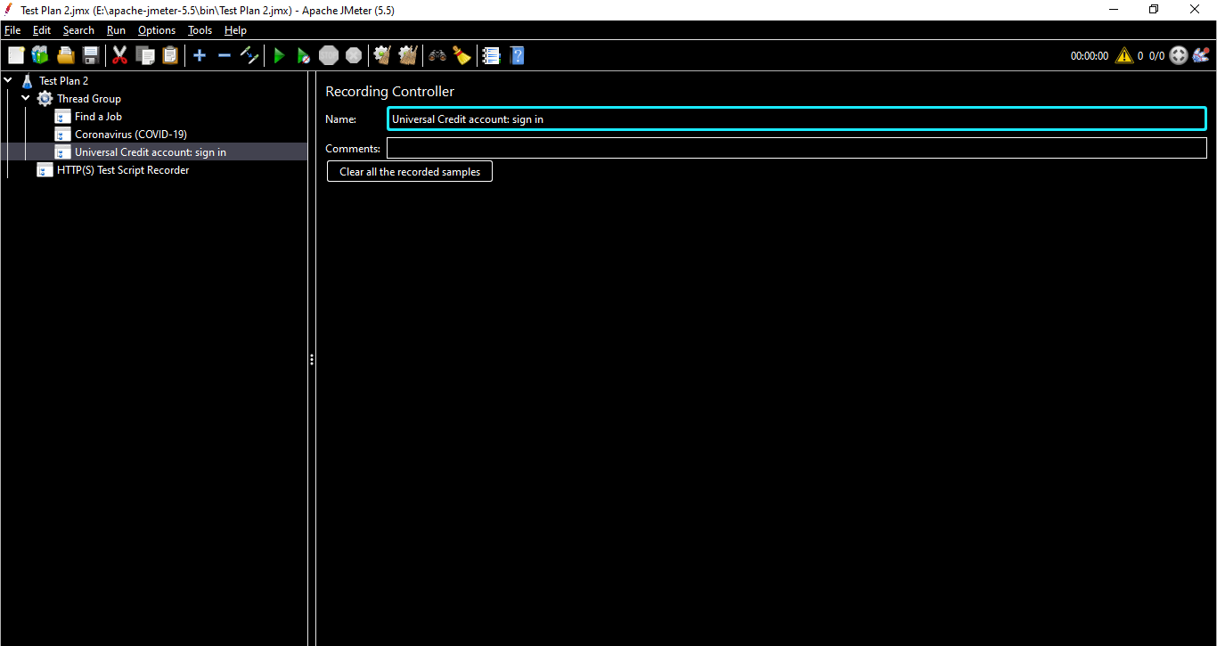

**How to add & use Test ScriptRecorder**

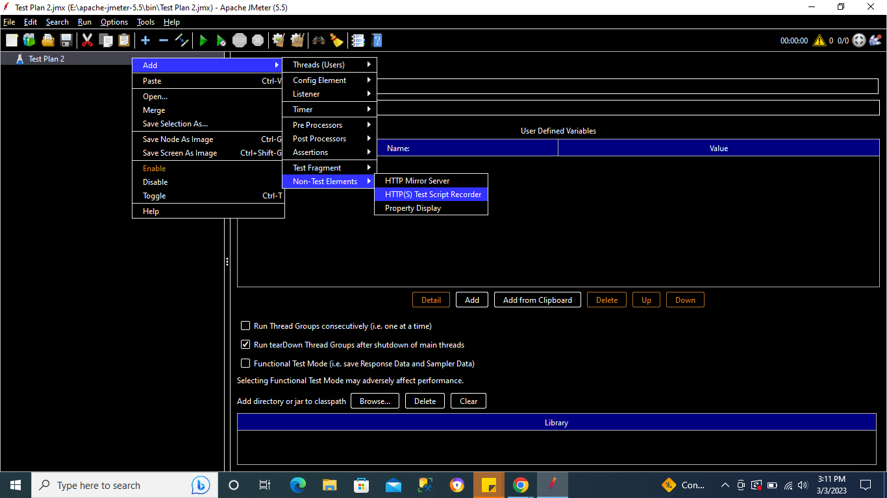

Navigate to HTTP(s) Test Script Recorder.

Under Target Controller , we can select our 1st Recording Controller to record **“Find a Job”** action.

## **How to use proxy on Firefox, Chrome and System**

**Why do we use proxy in JMeter?**

The Proxy Server allows JMeter to watch and record user activity while they are browsing web application with a normal browser.

Go to your browser >> Click on Ellipses on the top right corner of the browser

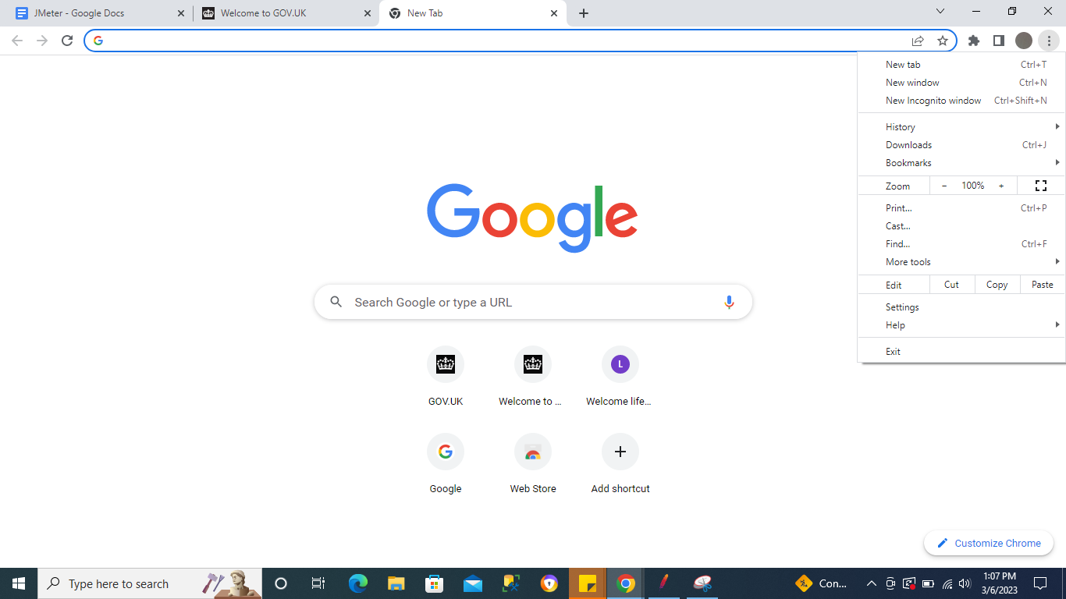

Click on Settings & type proxy

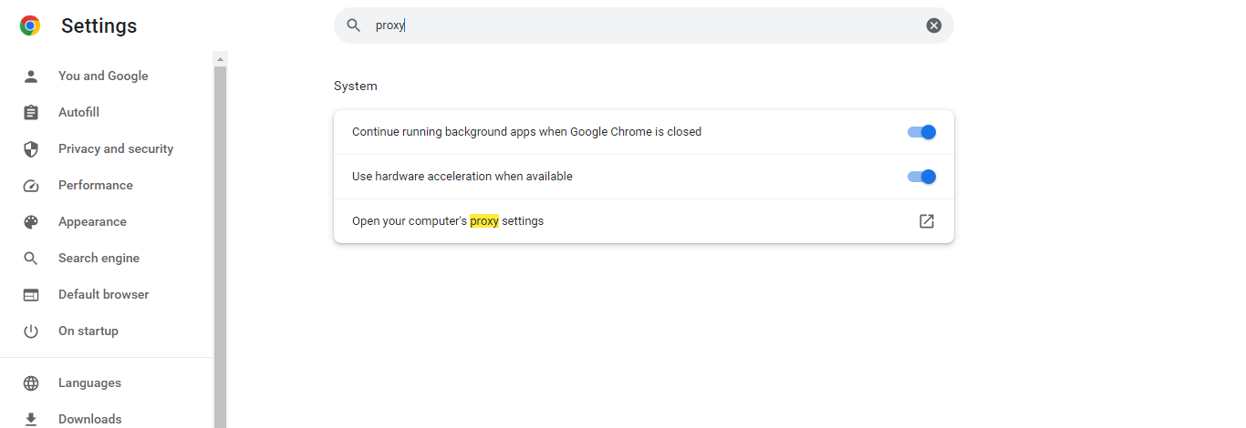

Click on **Open your computer's proxy settings** & this will open your windows setting window

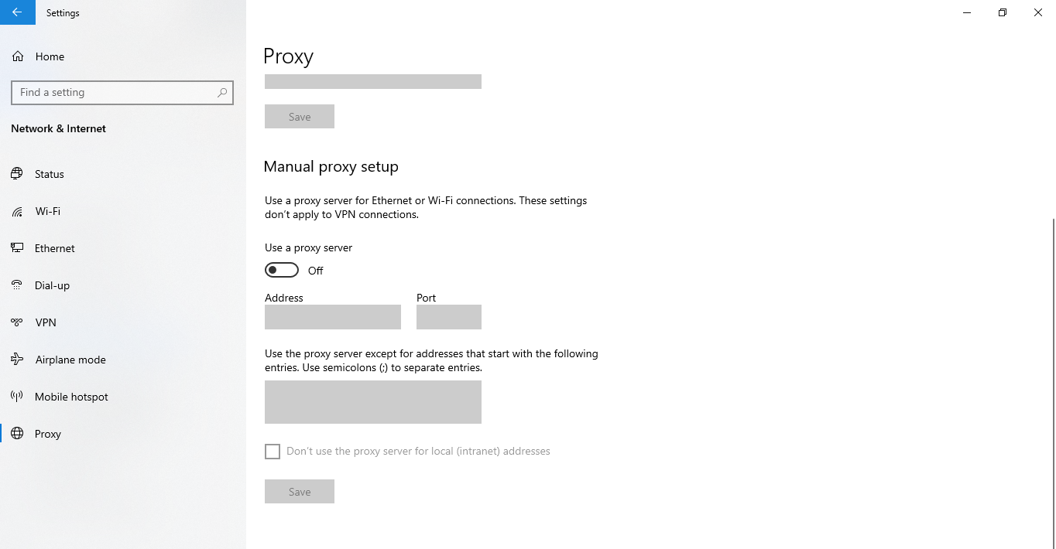

Turn on the Use a proxy server toggle & click on Save.

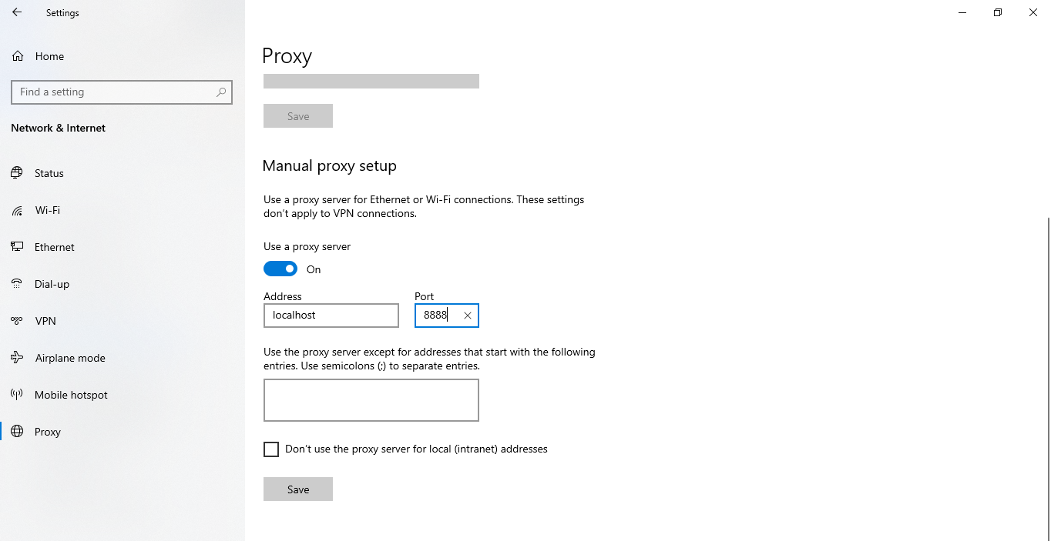

You can also open this setting by searching for a proxy on your system.

***Note : Jmeter & system proxy details(host , port details) should be same.***

## **How to add SSL Certificate**

**Why SSL Certificate is needed -**

JMeter needs to use a certificate to authenticate the connection between the client (browser, device, application) and the server. JMeter generates its own certificate with a validity period of seven days. Generally this certificate is not trusted by the browsers.

Go to your browser >> Click on Ellipses on the top right corner of the browser



Click on Settings & type certificate

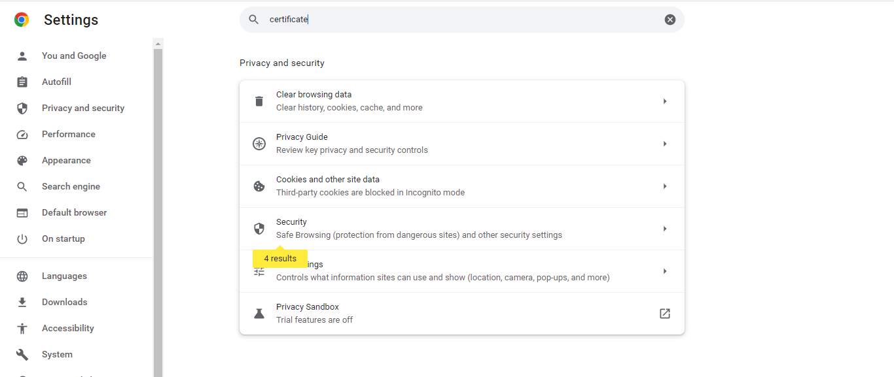

Click on Security & click on Manage device certificates

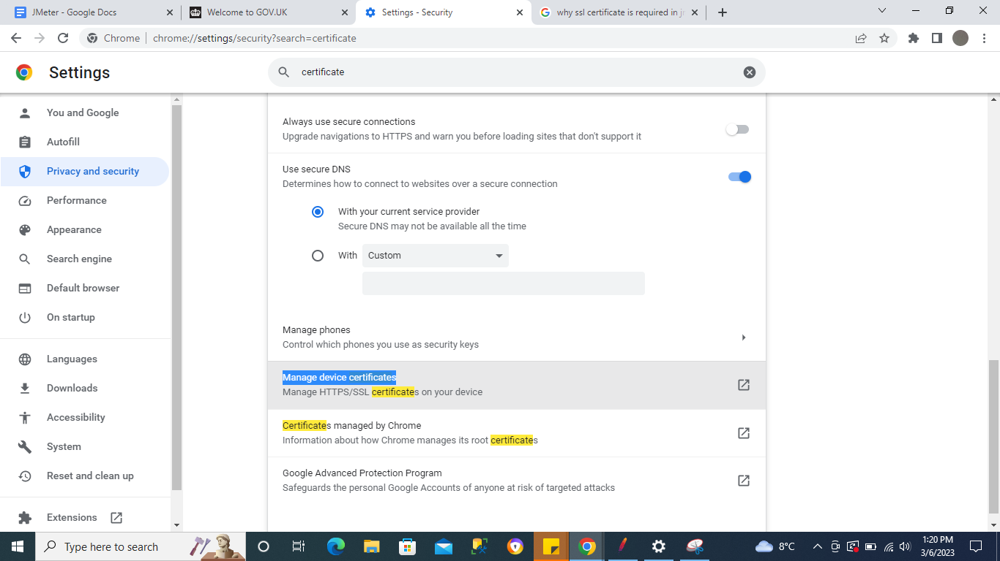

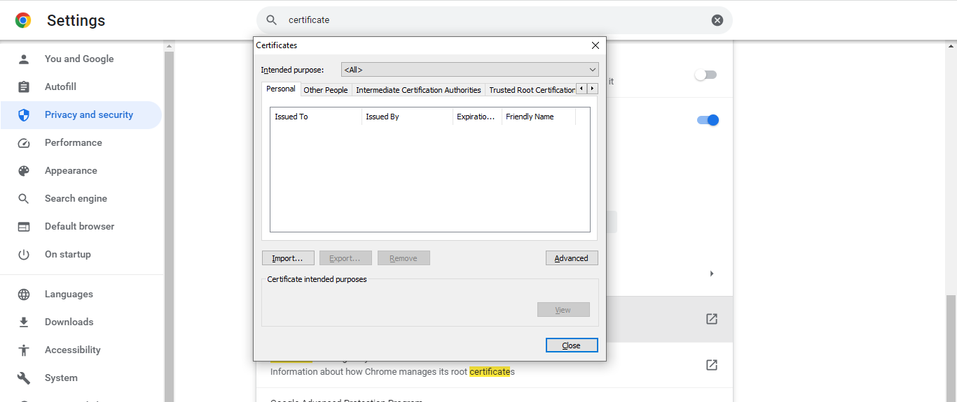

Import the certificate from JMeter Bin folder

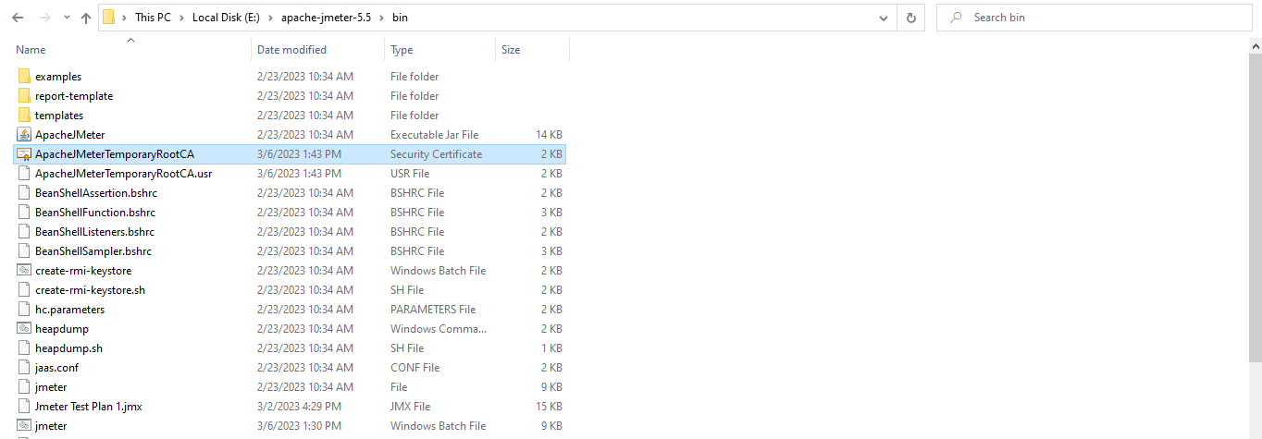

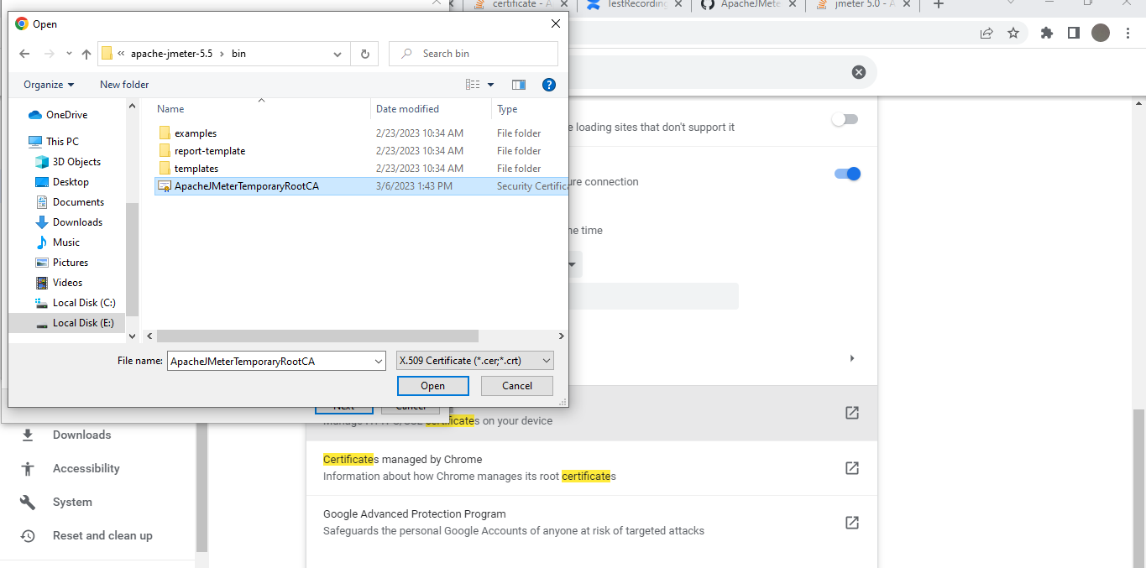

***IMP*** *Note - If you do not find the certificate in bin folder then try below steps :*

1. *Go to HTTP(s) Test Script Recorder*
2. *Select the desired Script recorder*
3. *Click on Start*
4. *Once you start the recording and the pop-up for the certificate appears, refresh the bin directory and you will be able to see the certificate.*

## **How to record your test on JMeter | How to start Recording**

If we go to browser & check for the url we want to do test on , it will give below error as we have enabled the system proxy.

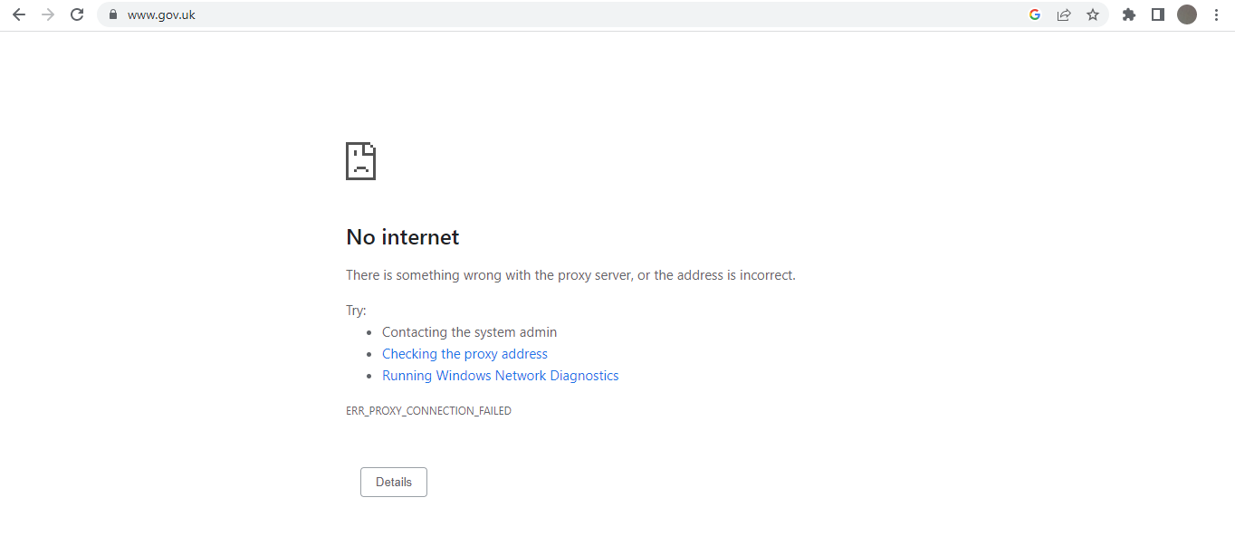

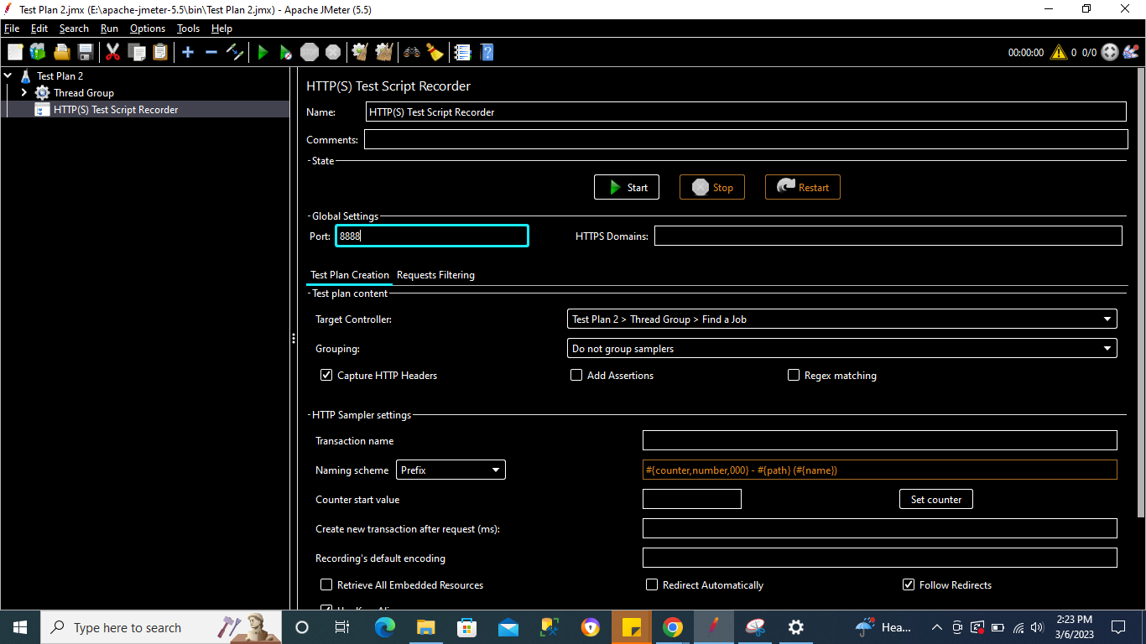

Click on Start button

It will ask to add Certificate which we have already added

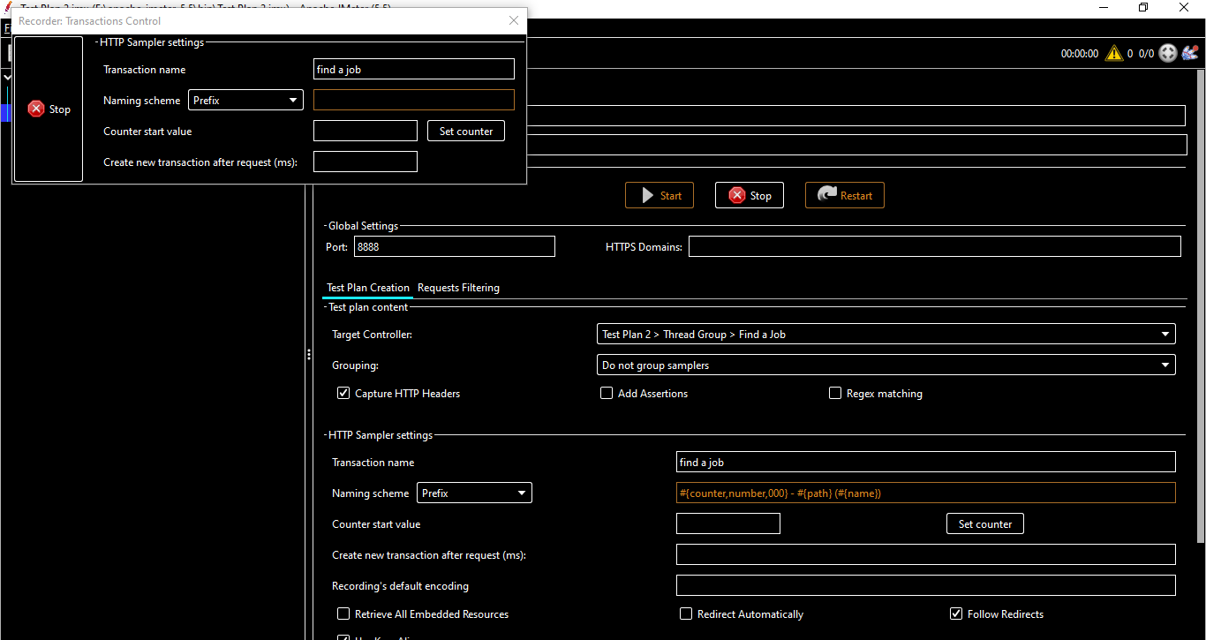

Likewise do for other pages & add Listeners & click on Play button.

You can see the results in the results

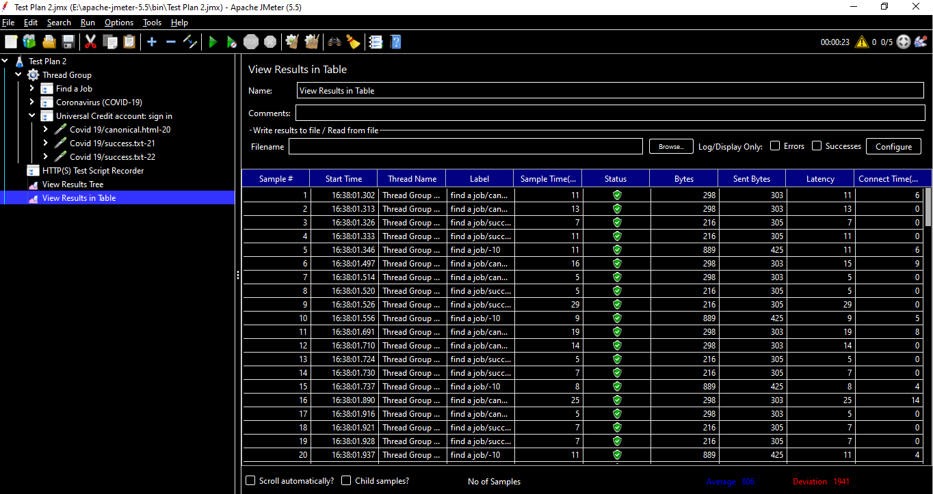

***Note - The recording might or might not work on chrome browser , try running on Firefox incase the proxy displays error.***

## **How to use Recording Template**

The recording template will put in place a few items that are staples in JMeter tests.

You can add Templates by clicking on Template icon

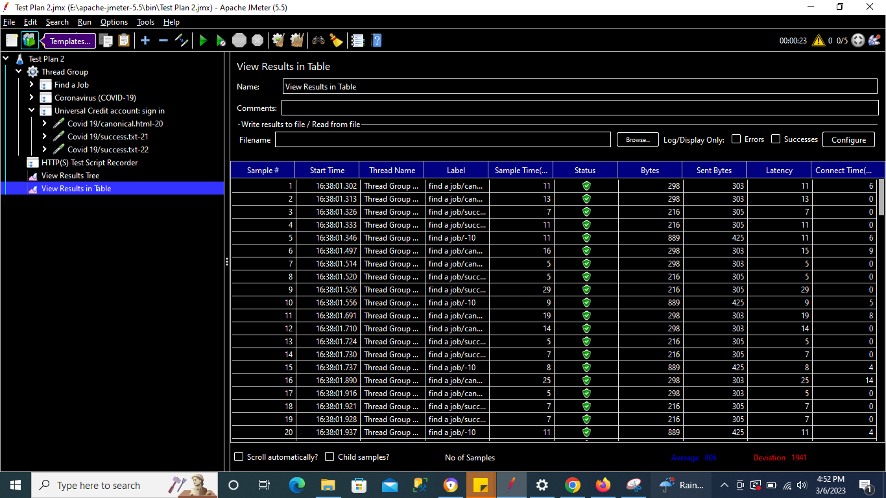

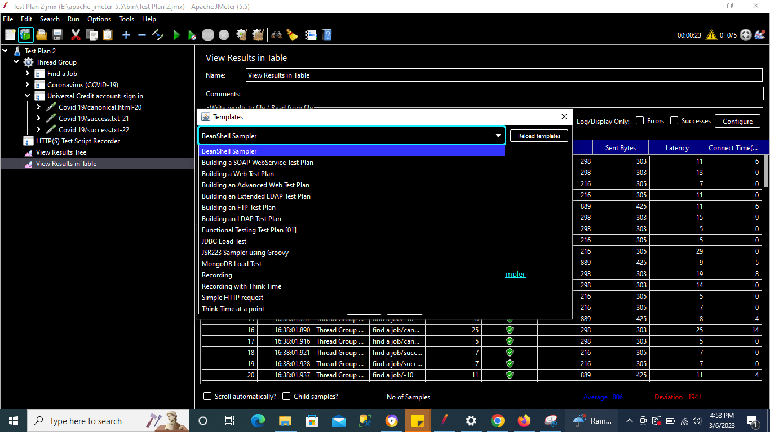

**Recording Template -** Will start recording with the interval given

**Recording Rethink Template -** Will start recording & will take break in between just like real life environment

Select Recording Rethink Template

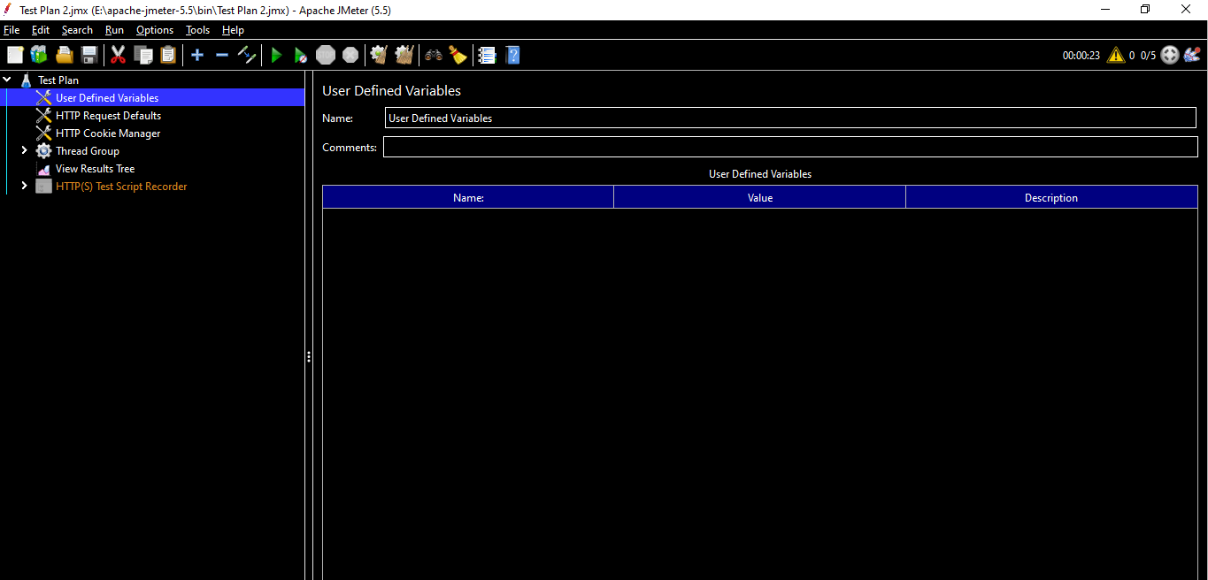

We got a Test Plan added & all the required elements.

# **How to use Blazemeter to Record JMeter Tests**

* BlazeMeter is a special product for exhaustive integrated load testing and all possible performance tests based on a group of cloud systems.
* Using [BlazeMeter](https://www.blazemeter.com/product/blazemeter), you can scale your load up much, much further, testing thousands or even millions of virtual users in the cloud.

## **Step 1 - Create Blazemeter Account**

Go to Blazemeter site

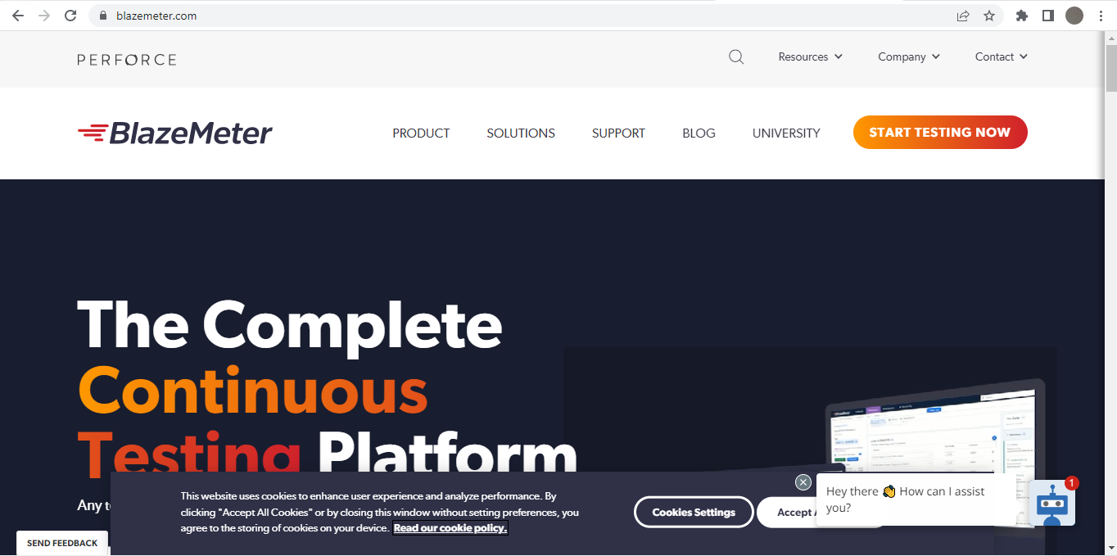

Click on **START TESTING NOW** button

Register your details & then Sign in

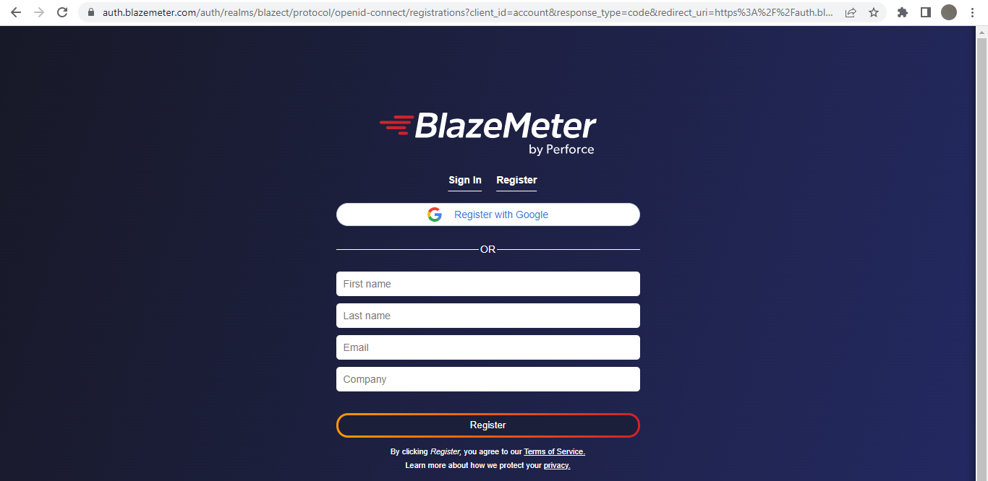

After registering the Blazemeter Home Screen will look like :

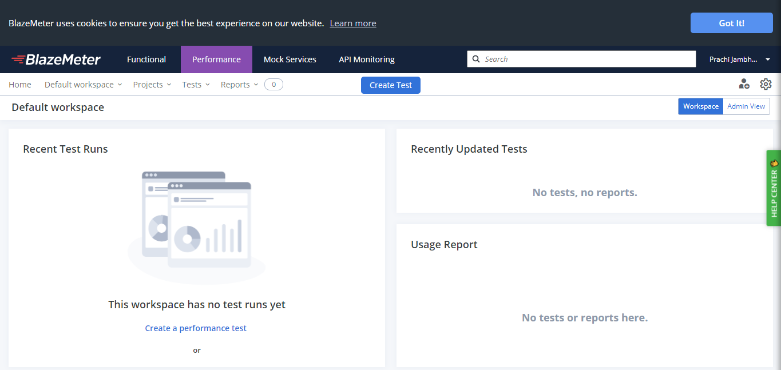

## **Step 2 - Get Blazemeter Extension**

Go to WebStore on Google & search for Blazemeter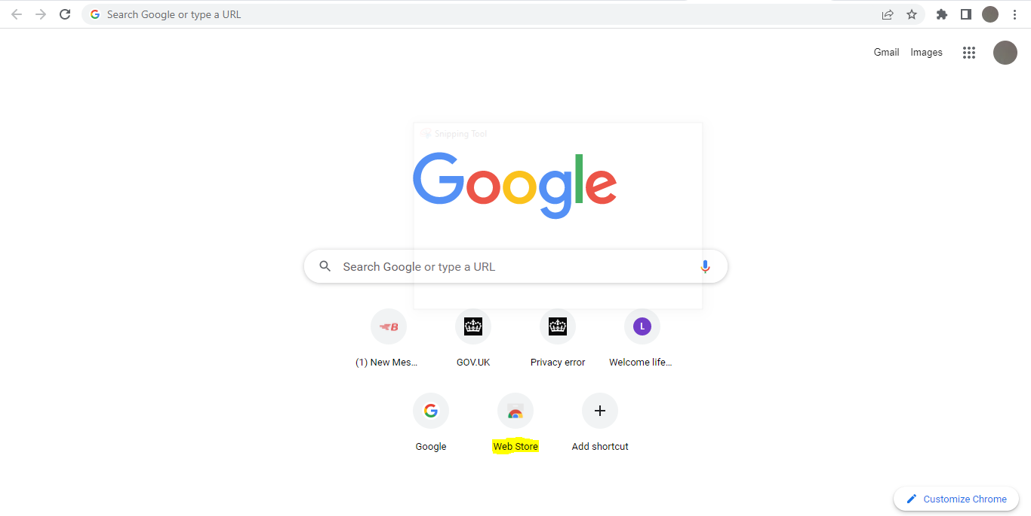

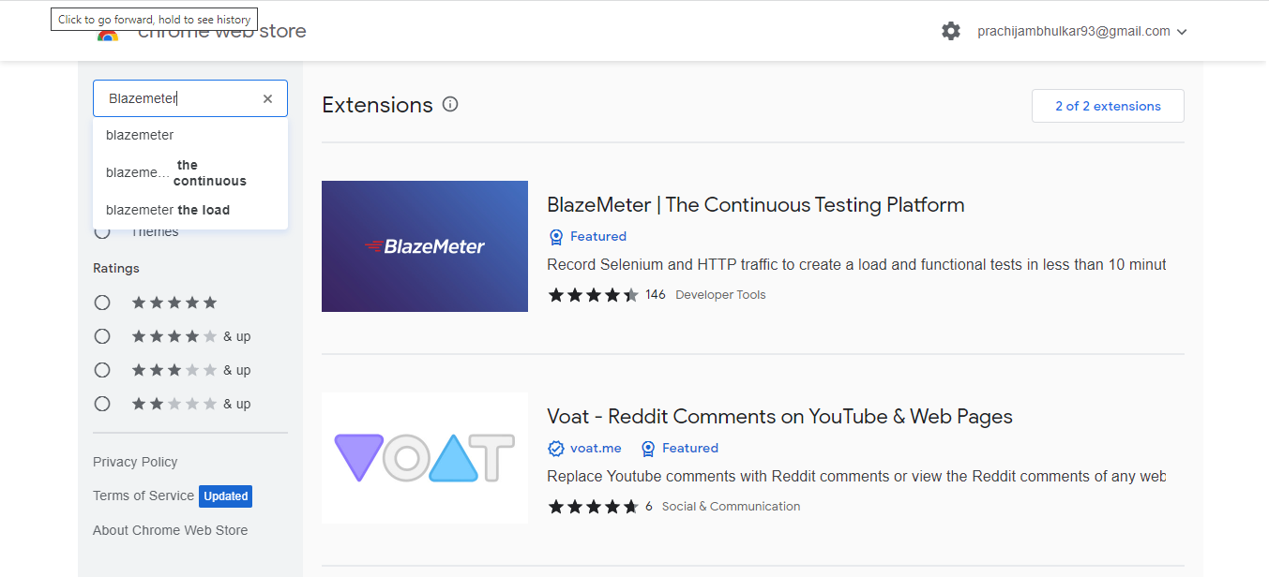

Click on the Blazemeter Extension

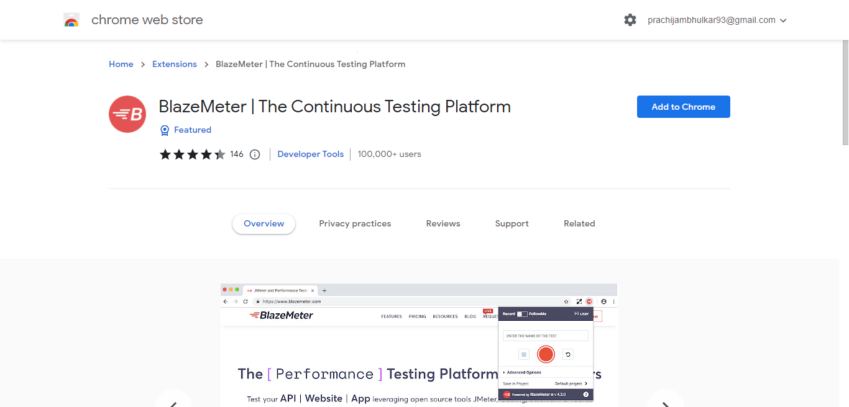

Click on **Add to Chrome**

Once you add the Blazemeter Extension you can see it in the Extensions of your Chrome Browser

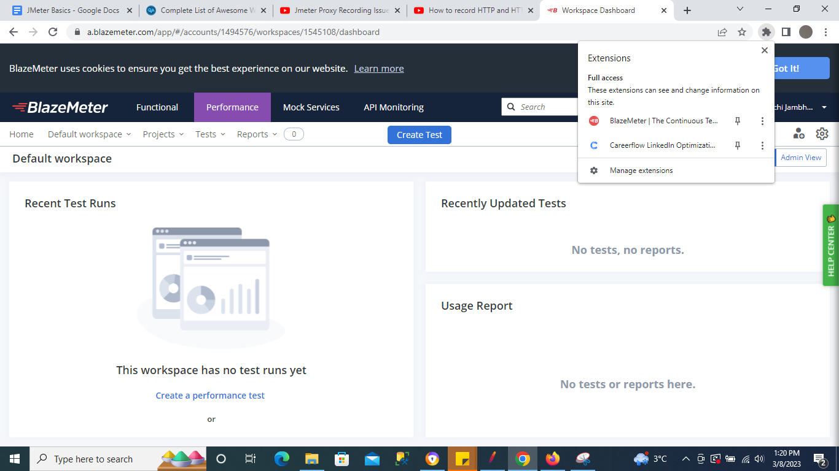

## **Step 3 - Logging to Blazemeter**

If post clicking on Blazemeter Extension it asks for login, you can login your Blazemeter Credentials (You will also receive a mail on creation of your Blazemeter Account)

## **Step 4 - Record Test**

Go to your site where you need to do recording & create a test plan.

Click on Blazemeter Extension

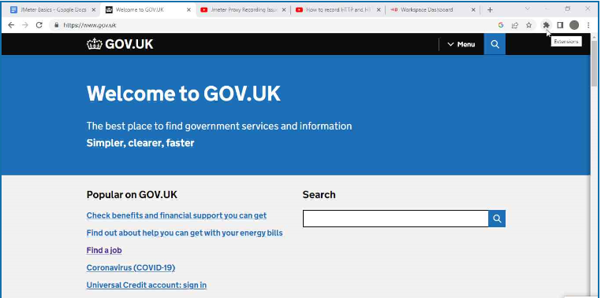

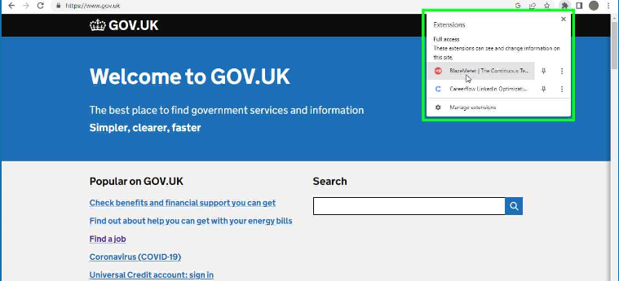

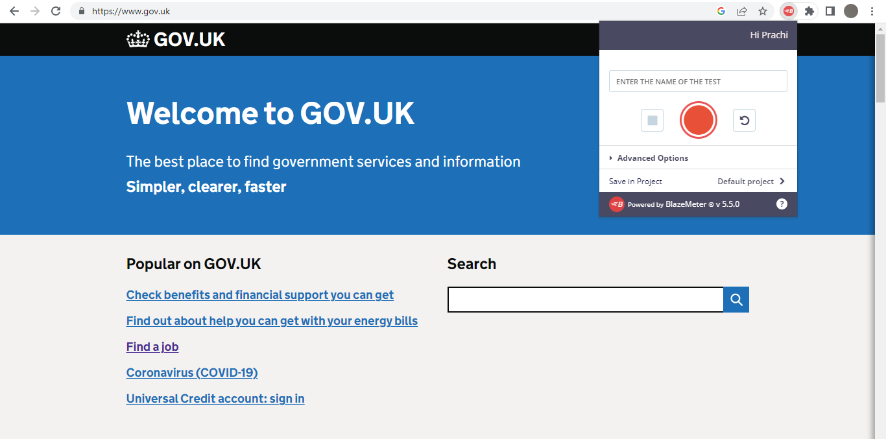

Click on Start Button

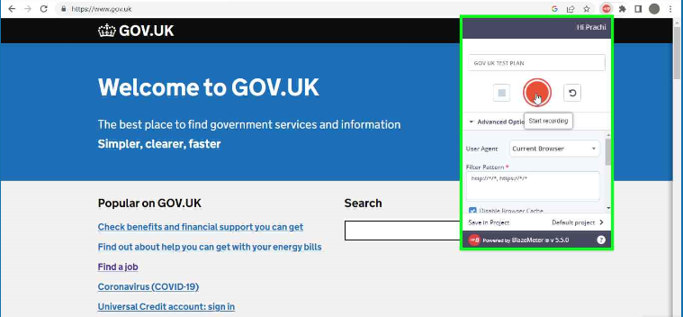

Click on Link 1

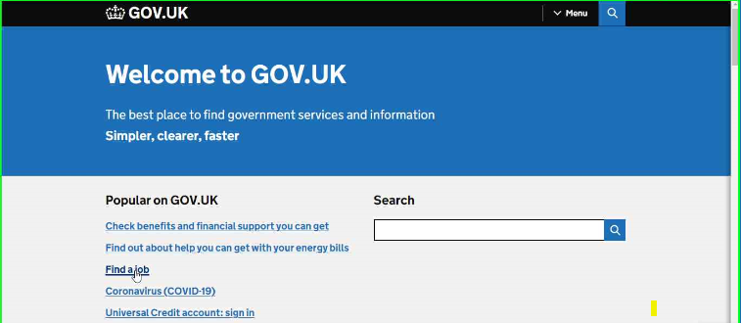

See the count increases in Blazemeter Extension recording

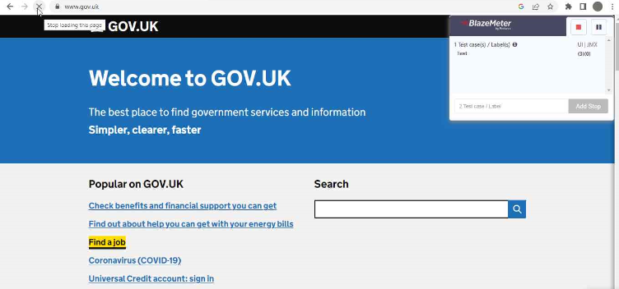

Similarly click on Link 2 & Link 3 & check the count increases & then stop the recording

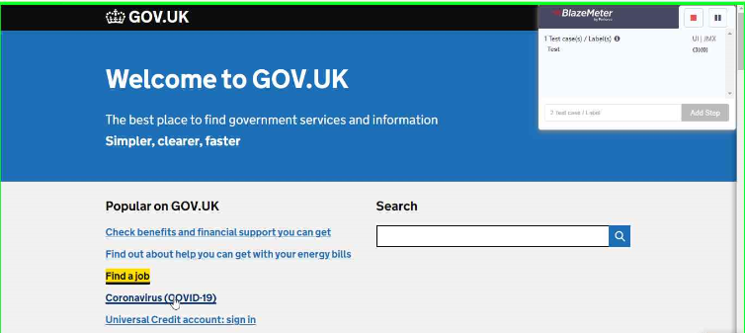

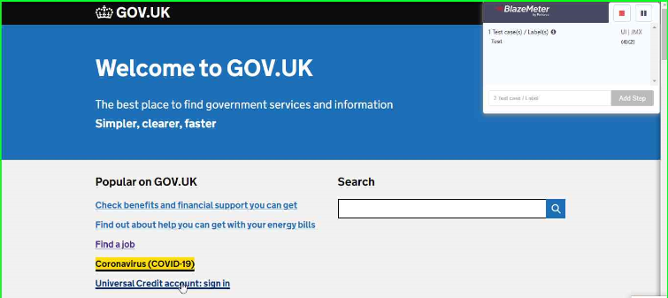

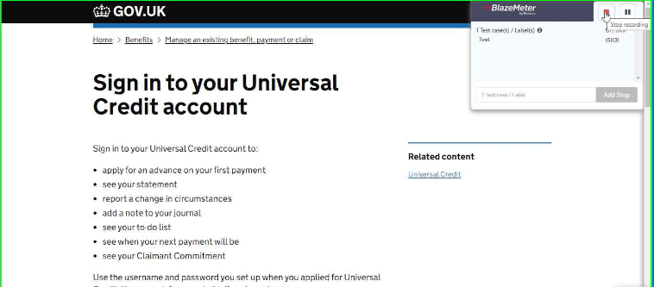

Post you are done with recording , click on Blazemeter Extension & you will get options to Run , Edit & Save the recording

## 

For running the recording we get multiple options as below

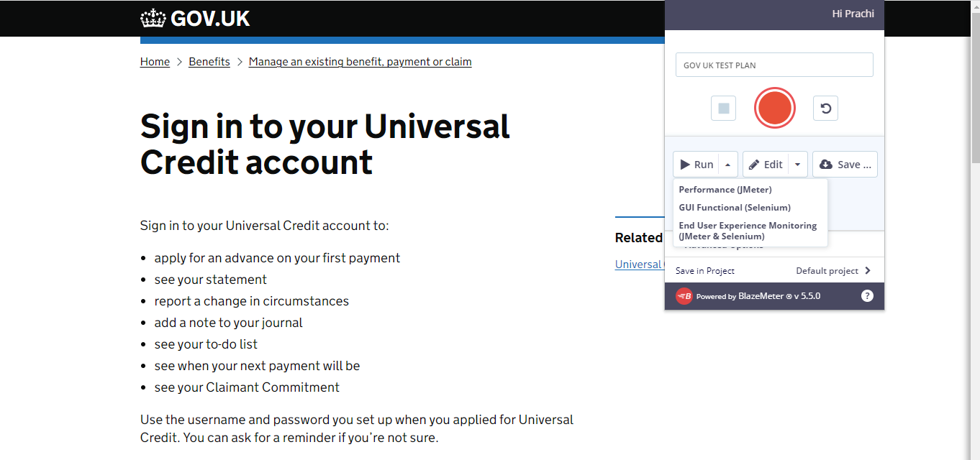

Click on Run

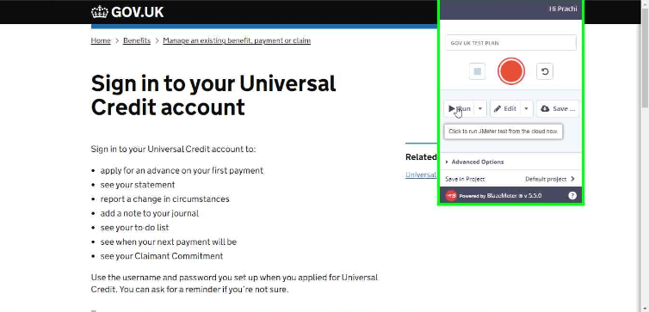

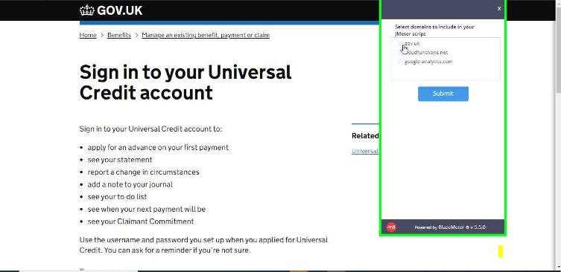

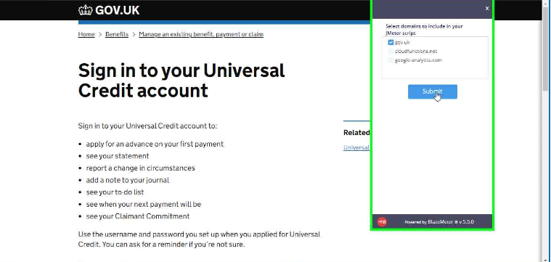

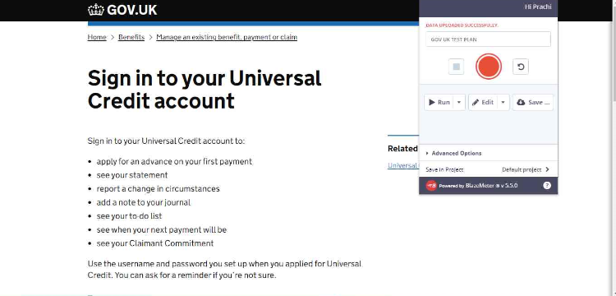

Once the recording starts to run , it will redirect the user to Blazemeter Dashboard automatically

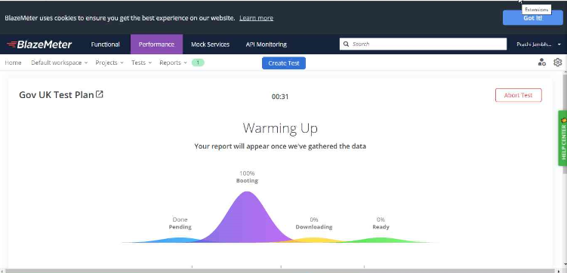

## **Step 5 - Save JMX**

There are two ways to save the Blazemeter Recording as JMX file so as to import in JMeter & run

**Method 1**

Click on Extension & click on Edit

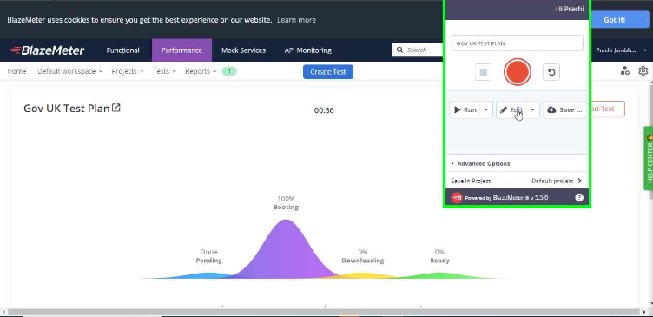

Click on JMX on the EDITOR Screen & this will download the JMX file of the Recording

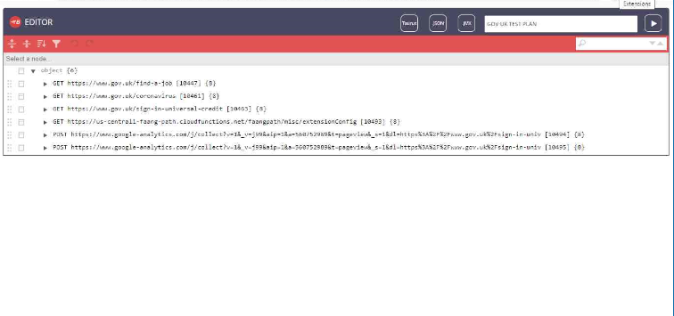

**Method 2**

Click on Extension & click on SAVE button

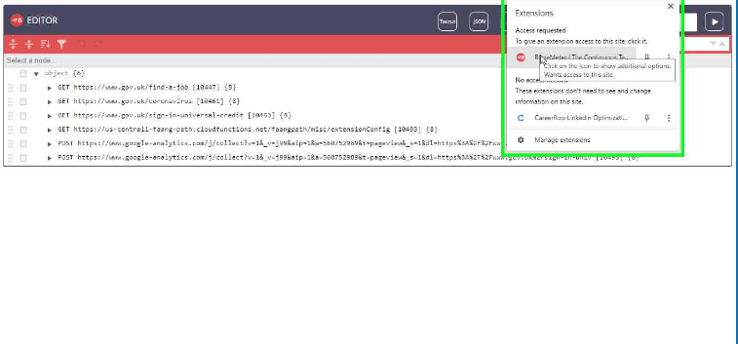

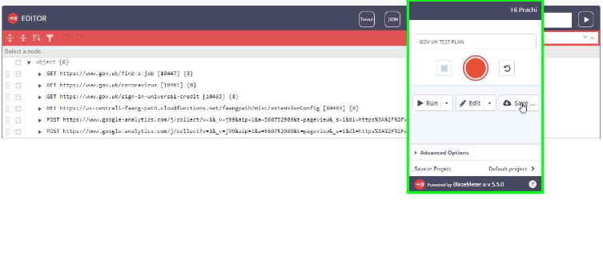

Select the Extension type as JMX

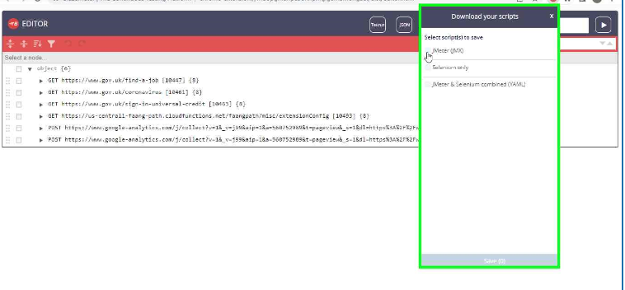

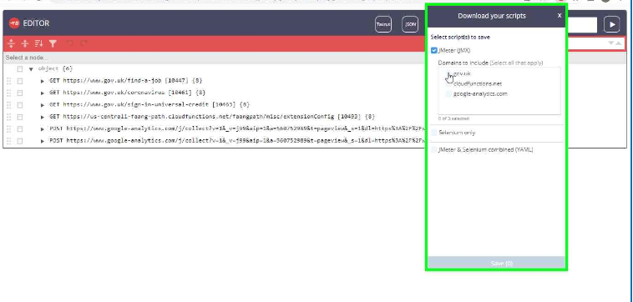

Click on SAVE button

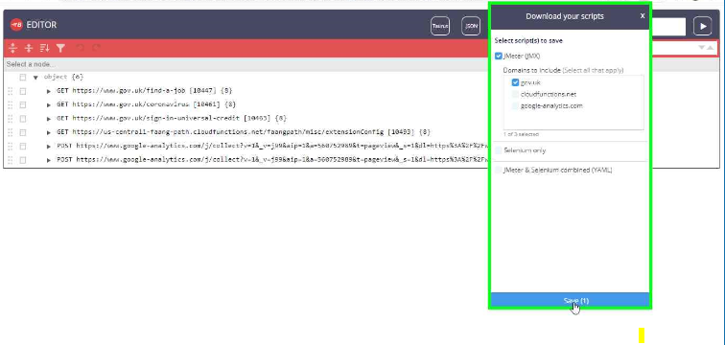

This will save a copy of JMX file on our local

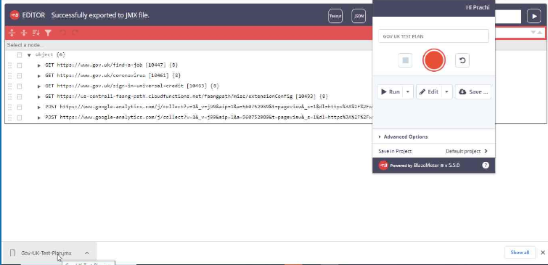

## **Step 6 - Add JMX in JMeter and Run**

Go to JMeter & Click on Open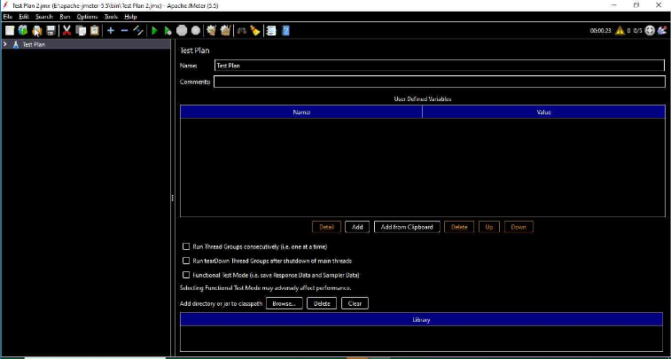

Import the downloaded JMX file

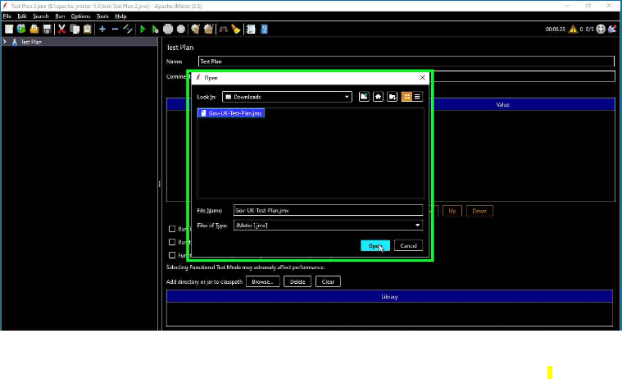

The Test Plan will be created in JMeter for the imported JMX.

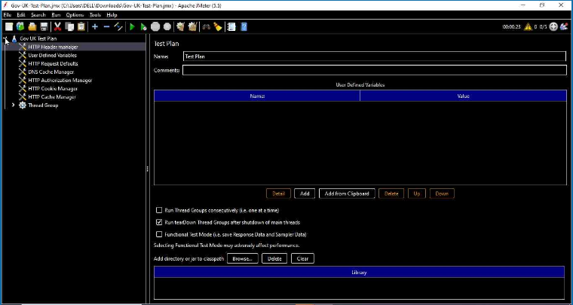

Add a Listener to the Thread Group as below

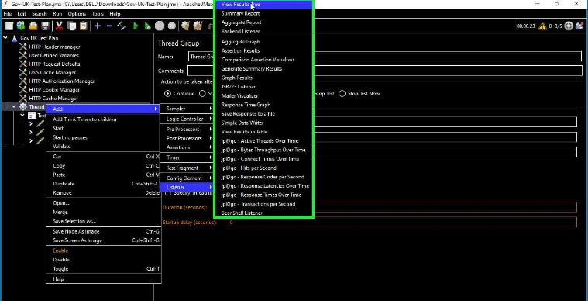

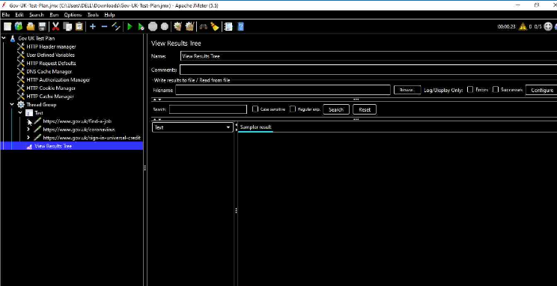

Run the Test Plan & check the results in View Results Tree Listener

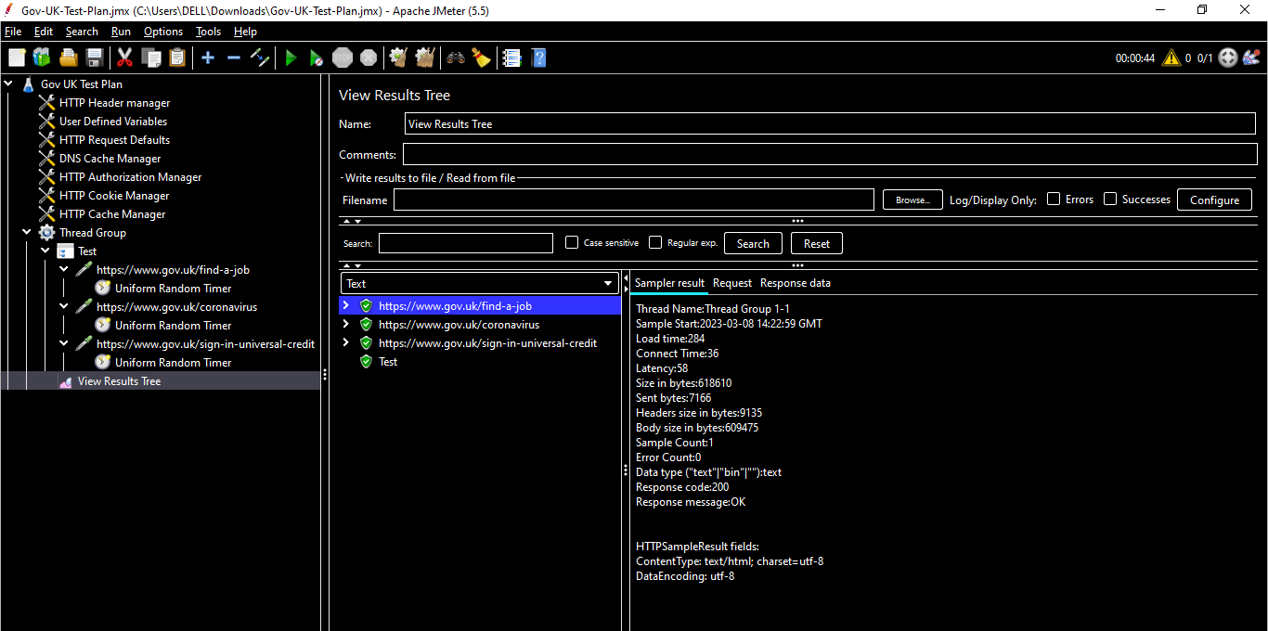

***NOTE : You can also try by increasing the thread group count & running the test plan again***

# **Config Elements**

**What is -** Configuration Elements allow you to create defaults and variables to be used by Samplers. They are used to add or modify requests made by Samplers. They are executed at the start of the scope of which they are part, before any Samplers that are located in the same scope.

EX - If we add a Config Element at a Test Plan level , then the added Config Element will run before any other requests added at Test Plan level

# **CSV Data Set Config**

**Why to use -** The “CSV Data Set Config” enables using CSV files as an external data source, where you can keep unique user data like names, emails and passwords. With the help of this config element, JMeter is able to read the CSV file line by line, and then use split parameters to allocate different values for different threads.

**When to use** - The CSV data set config in JMeter is used to view the lines from the given file and can be divided into variables per the requirement. It is also used to test random and unique values. Generating unique random values on run-time is costly in terms of memory and CPU. So the user can create the data before the test.

## **Step 1 - Add CSV Data Set Config**

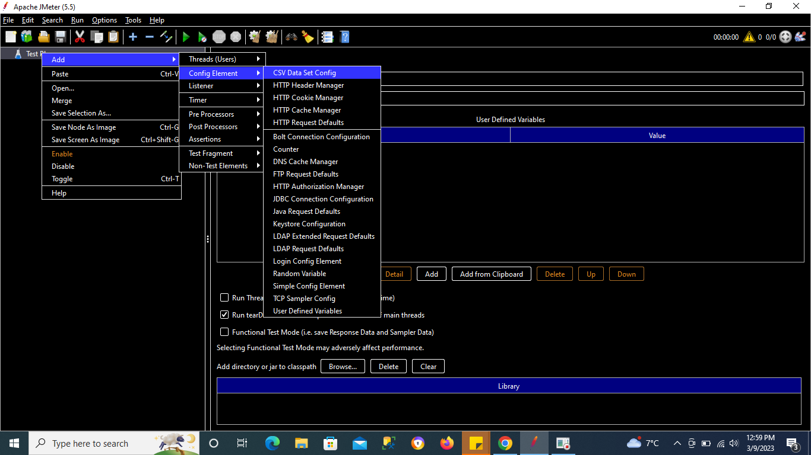

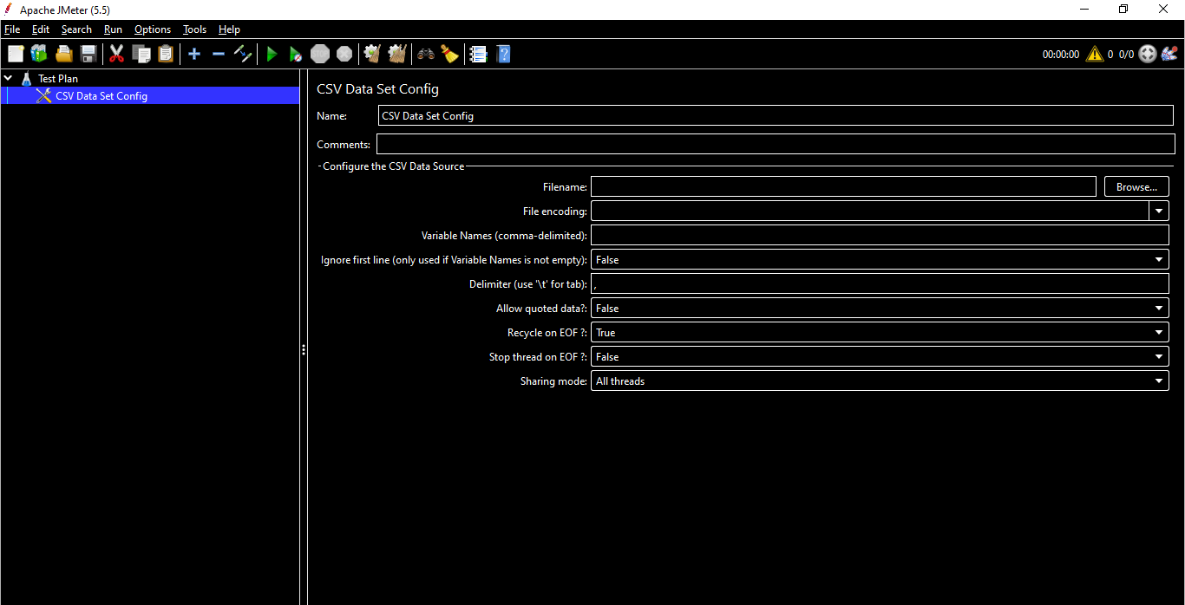

## **Step 2 - Create a CSV file & add data**

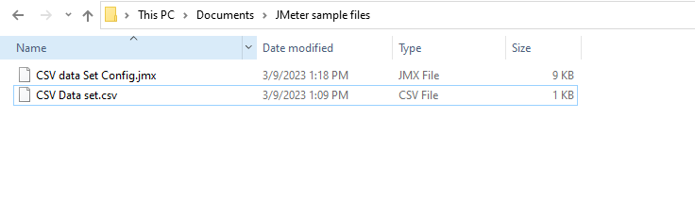

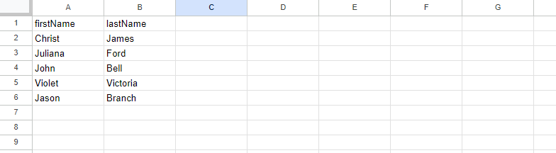

## **Step 3 - Refer the CSV file in JMeter’s CSV Data set config**

Go to JMeter & click on Browse of the CSV Data set config File Name

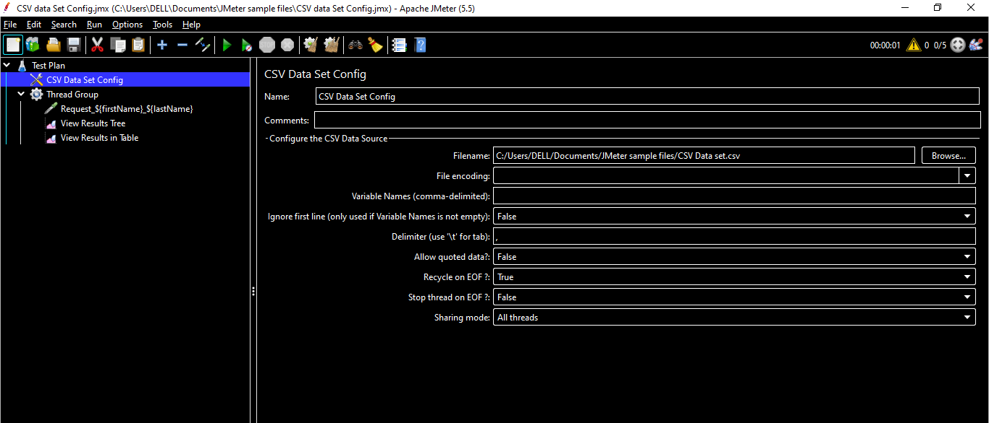

Add a simple java request sampler (Not a practical example, just for practice)

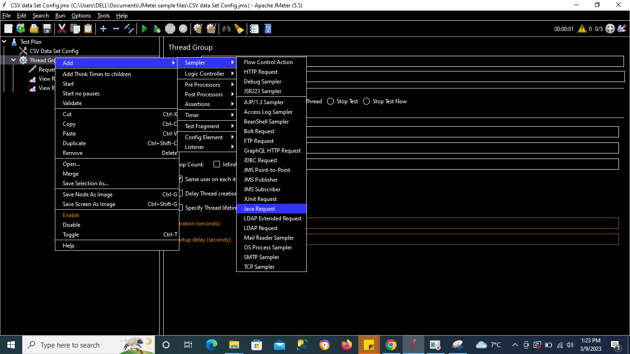

## **Step 4 - Refer values from CSV file using syntax $**

To refer the elements from our CSV file we need to use the syntax ${firstName}_${lastName}

Syntax :

${variablename}

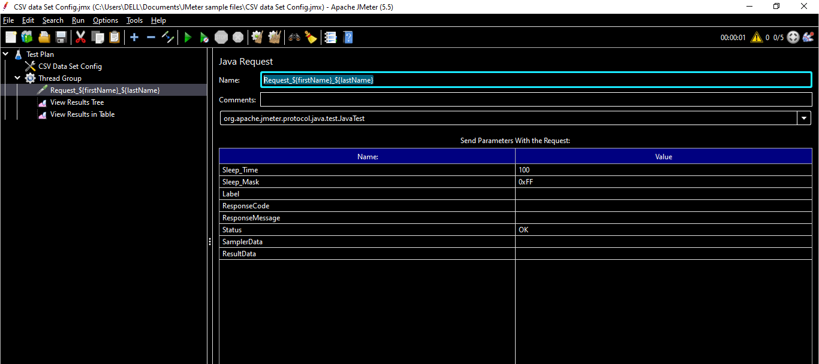

## **Step 5 - Add Listeners to the Test Plan**

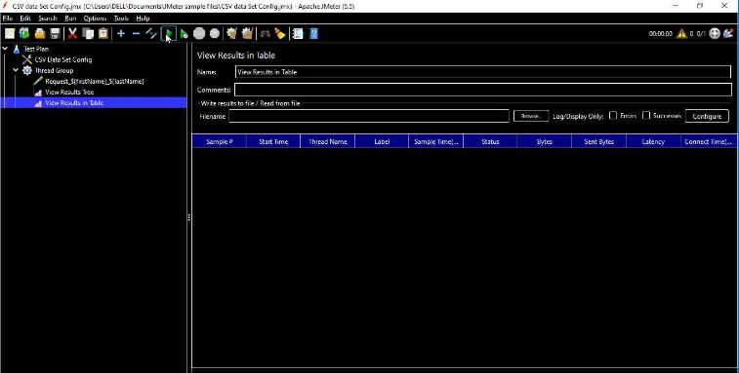

## **Step 6 -Increase the thread count to 5 as we have 5 records in the CSV file & run the Test Plan**

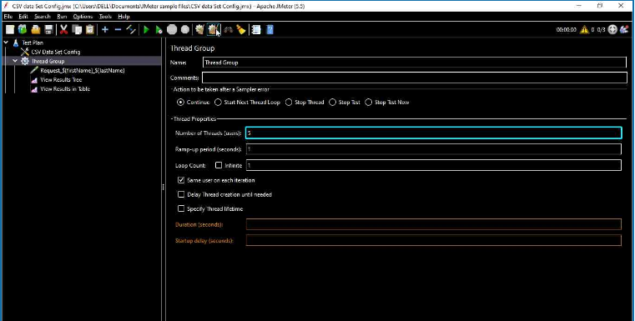

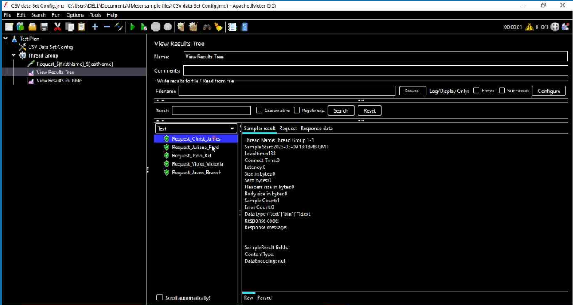

## **Understanding CSV Data Set Config elements**

**File Encoding** - The encoding to be used to read the file, if not the platform default. Generally this is left blank & is used only if there is any kind of encoding required for the data based on the requirements

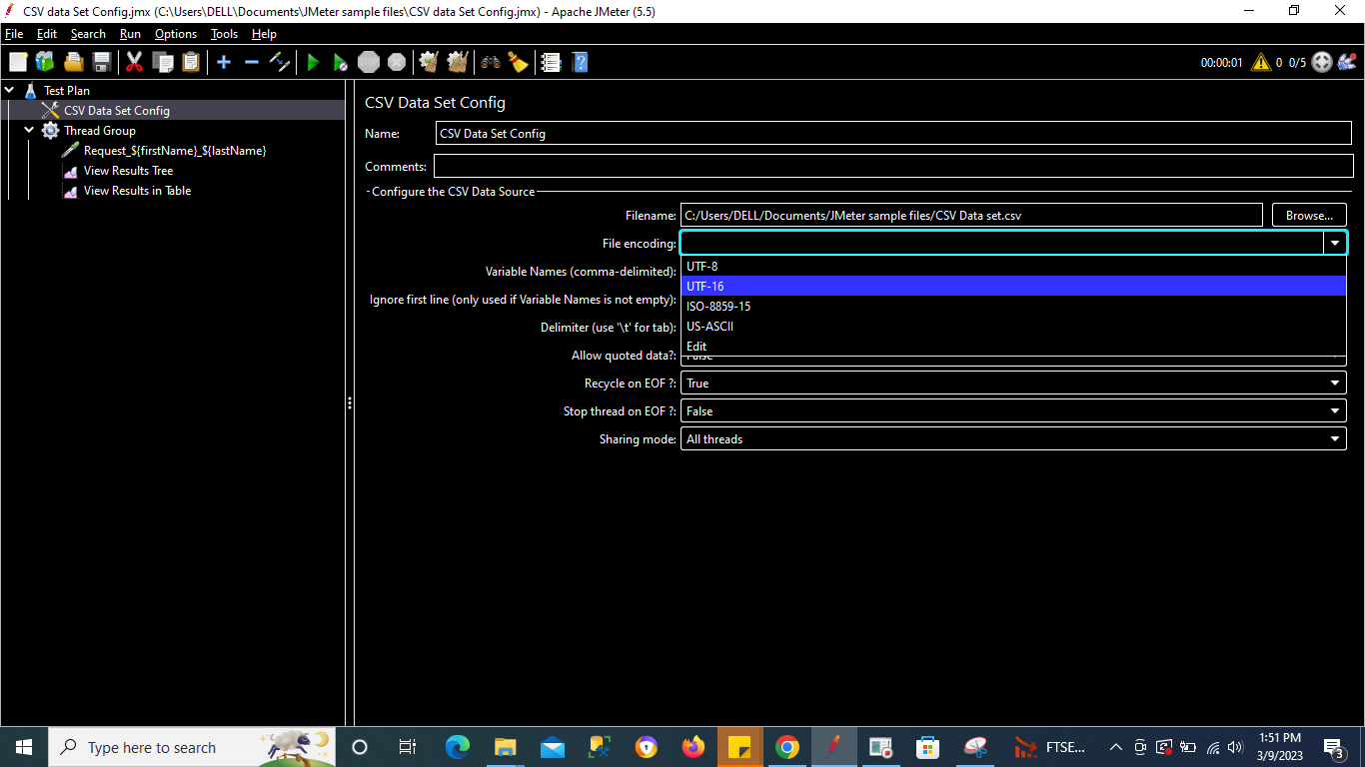

**Variable Names(comma-delimited) -** List of variable names separated by the comma. JMeter supports CSV header lines: if the variable name field empty, then the first line of the file is read and interpreted as the list of column names. The names must be separated by the delimiter character. They can be quoted using double-quotes.

JMeter allows values to be quoted; this allows the value to contain a delimiter. If “allow quoted data” is enabled, a value may be enclosed in double-quotes. These are removed. To include double-quotes within a quoted field, use two double-quotes.

For Example: 1,”2,3″,”4″”5″ will be treated as

a. 1

b. 2,3

c. 4″5

In our above example we can add the variable names of the columns(comma separated) in this field

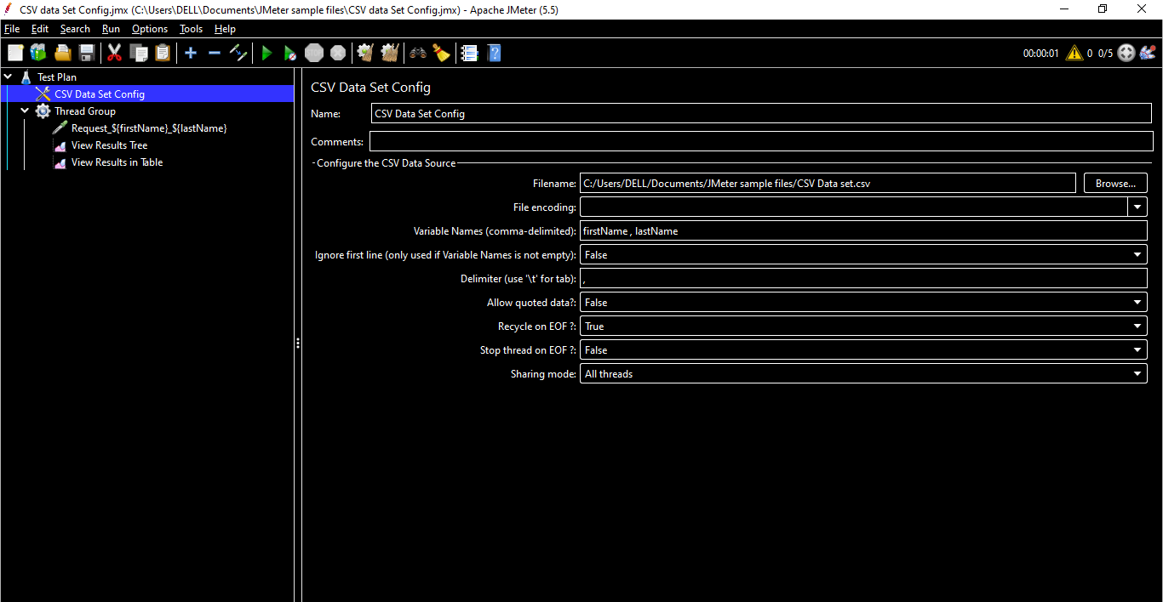

**Ignore first line(only used if Variable Name is not empty) -** This is set to True if our CSV file doesn’t have column names/headers in the file & false if we do havecolumn names/headers in the file

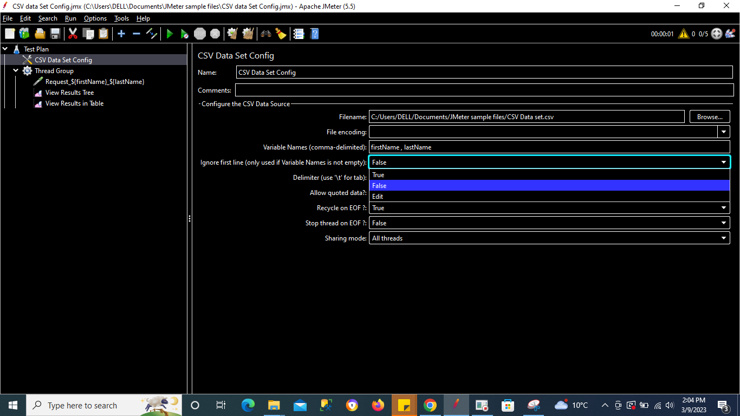

**Delimiter(use ‘\t’ for tab) -** “\t” or “,” can be used as a delimiter. The delimiter to be used to split the records in the file. If there are fewer values on the line than there are variables the remaining variables are not updated – so they will retain their previous value (if any)

**Allow quoted data? -** Whether the CSV file allows values to be quoted? If this option enabled (True), then the values can be enclosed in “” (double quote) allowing values to contain a delimiter.

**Recycle on EOF? -** To make the file re-read from the beginning on reaching the end of file (EOF). The default value is true.

**Stop thread on EOF? -** This option will stop the thread if reaches to end of file (EOF). The default value is false.

***Note:*** *If “Recycle on EOF” is false and “Stop thread on EOF” is false, then on reaching the end of the file, all the variables are set to last line values.* *If “Recycle on EOF” is false and “Stop thread on EOF” is true, then on reaching the end of file thread will stop.*

**Sharing mode -** There are 4 sharing modes options.

1. **All Threads:** The file will be shared between all the threads. This is a default value.
2. **Current Thread Group:** Each file is opened once for each thread group in which the element appears
3. **Current thread –** Each file is opened separately for each thread
4. **Edit:** all threads sharing the same identifier share the same file. So for example, if you have 4 thread groups, you could use a common id for two or more of the groups to share the file between them. Or you could use the thread number to share the file between the same thread numbers in different thread groups.

# **JMeter Config Elements - HTTP**

Let us record a test using Blazemeter & the Blazemeter will be default add the Config Elements for us

Refer to the **Blazemeter** Section for more details.

Go to URL - <https://opensource-demo.orangehrmlive.com/web/index.php/auth/login>

*Note - You can choose any url of your own*

Open the Blazemeter Extension & start Recording

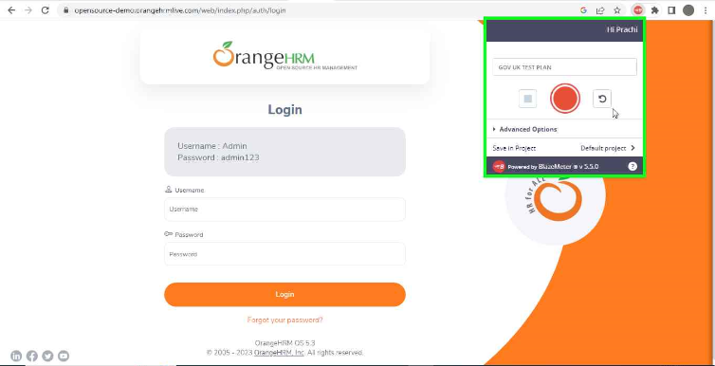

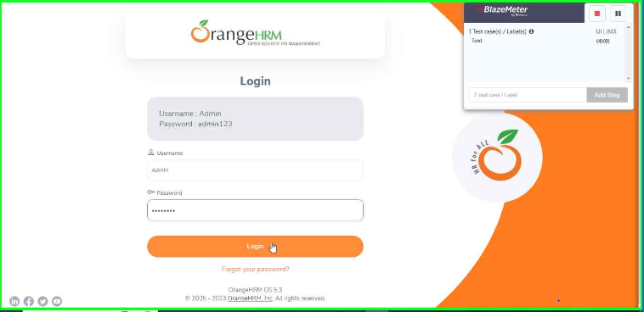

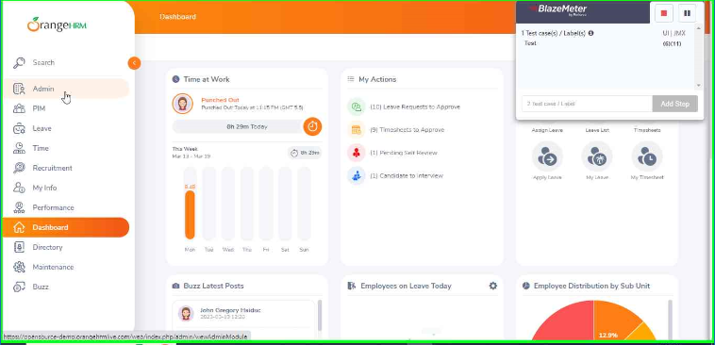

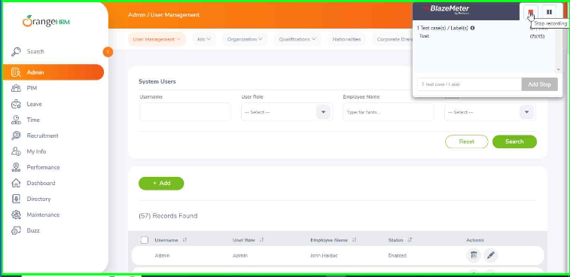

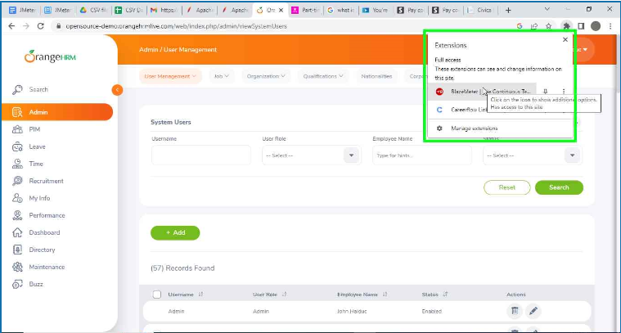

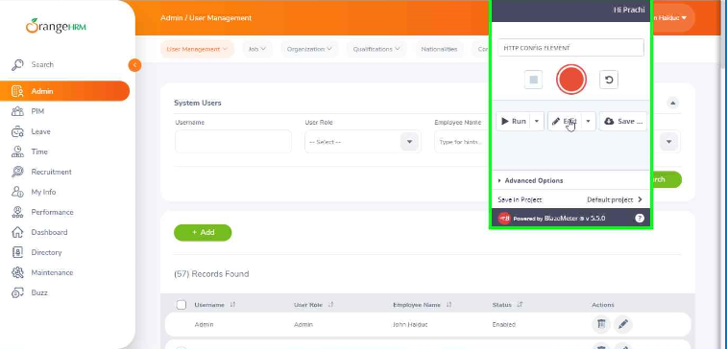

Save the JMX File

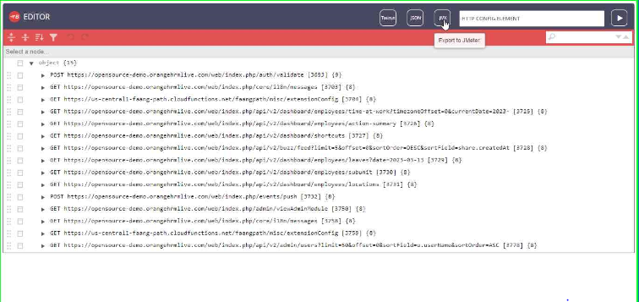

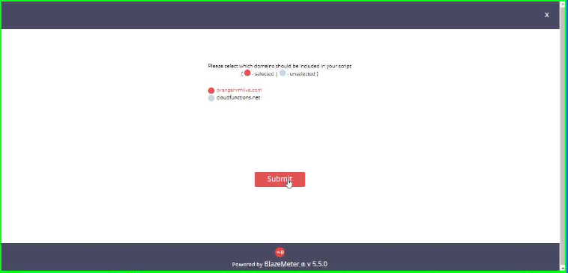

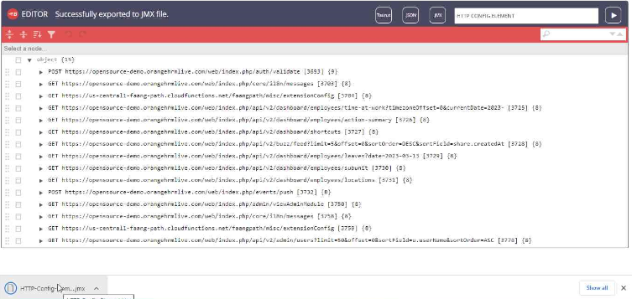

Add the JMX file to the JMeter

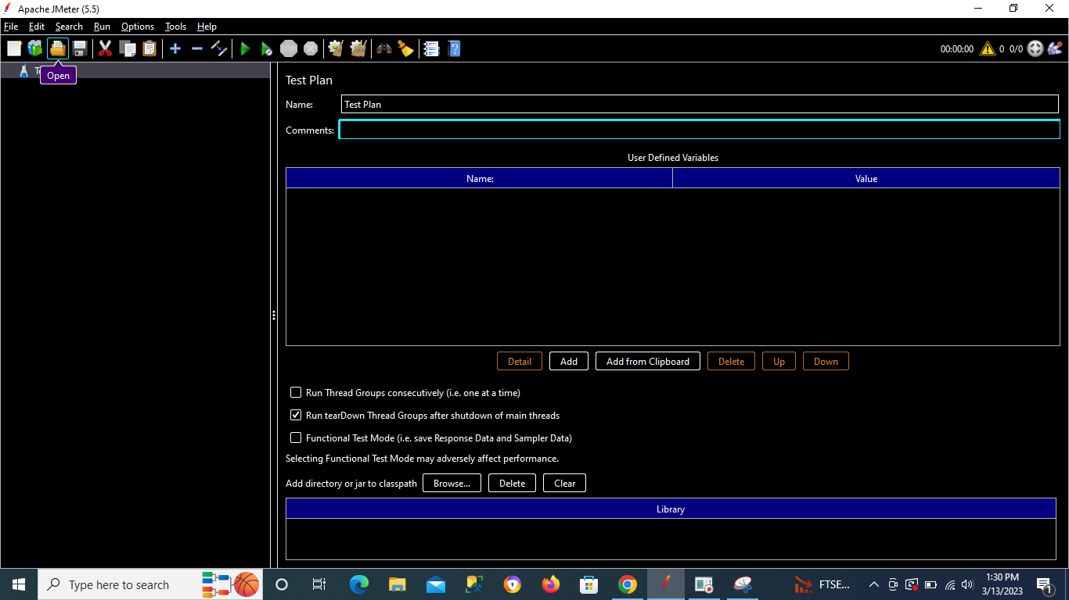

Browse the JMX Path

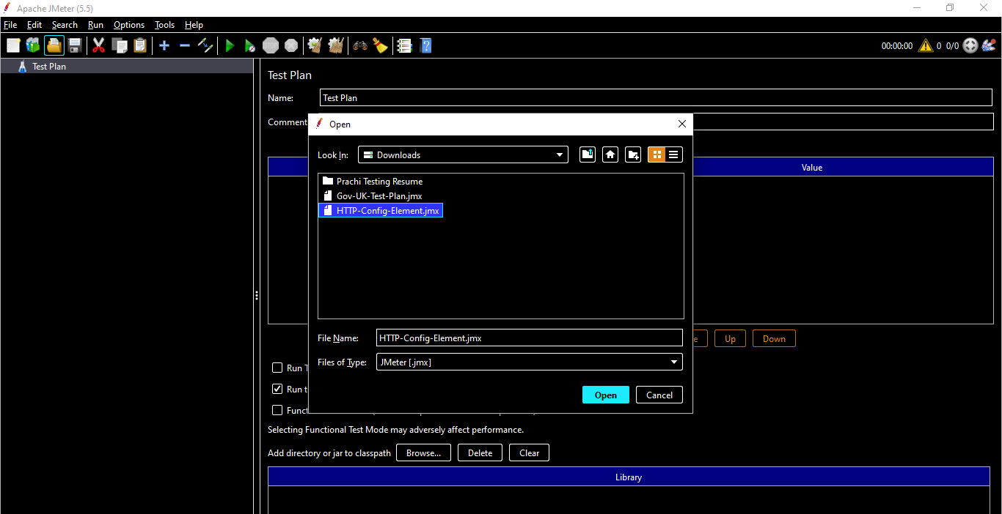

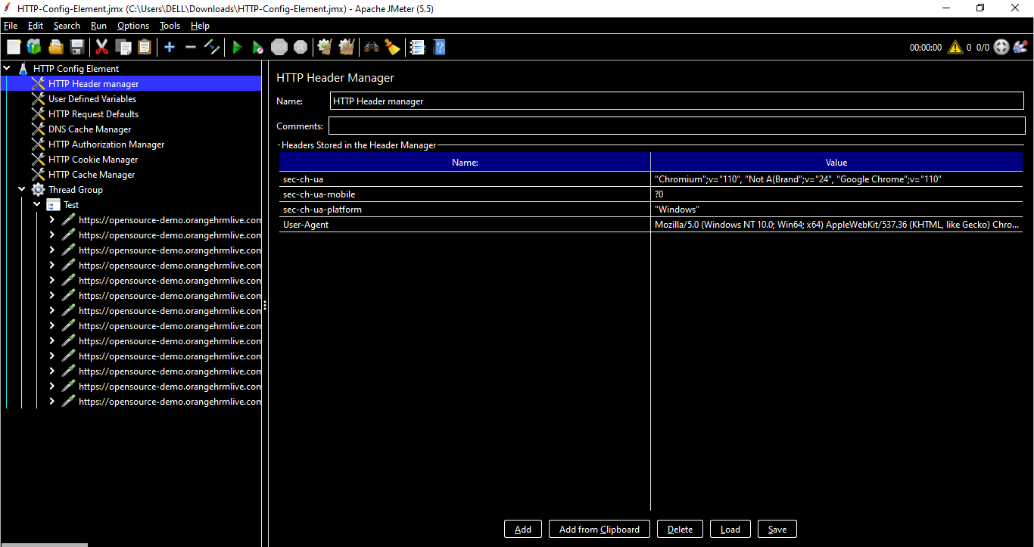

## **HTTP Header Manager**

The Header Manager lets you add or override HTTP request headers.

**JMeter now supports multiple Header Managers**. The header entries are merged to form the list for the sampler. If an entry to be merged matches an existing header name, it replaces the previous entry. This allows one to set up a default set of headers, and apply adjustments to particular samplers. Note that an empty value for a header does not remove an existing header, it just replaces its value.

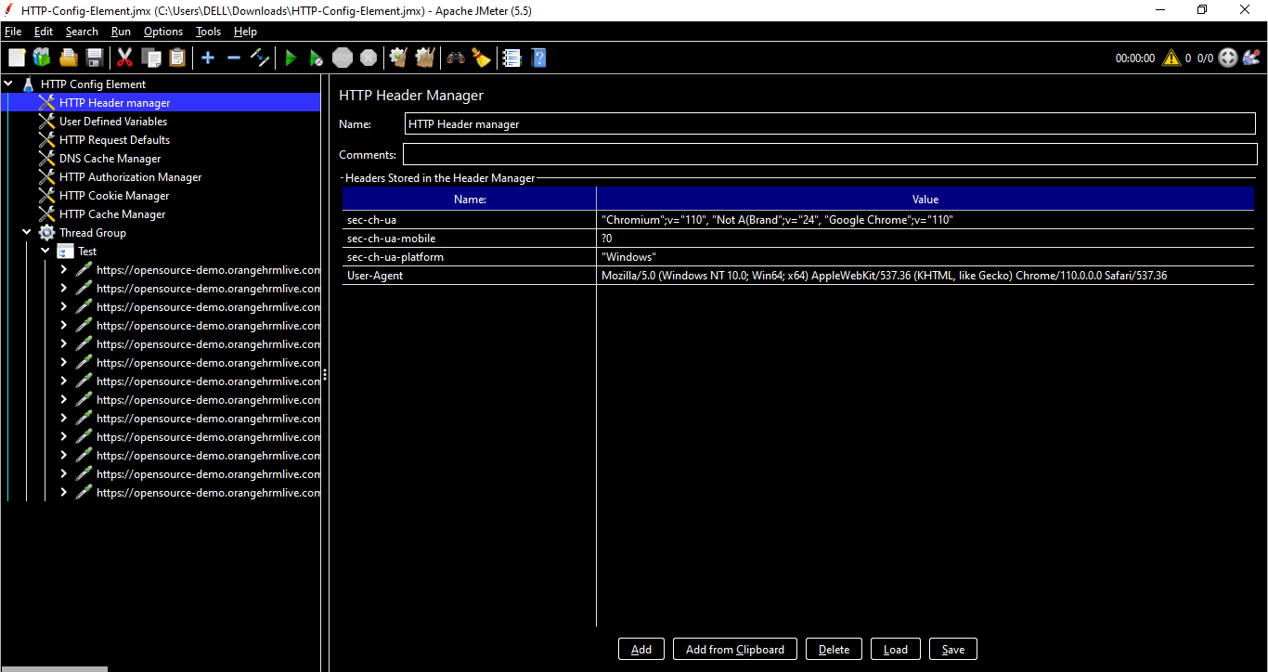

**Add -** Add an entry to the header table.

**Add from Clipboard -** You can view the raw text from a request using the developer tools in Chrome/Firefox etc. With these copied, you can add them to the HTTP Header Manager by clicking the Add from Clipboard option. This will correctly parse and format the raw text into the JMeter format

Delete - Delete the currently selected table entry.

**Load -** Load a previously saved header table and add the entries to the existing header table entries.

**Save -** Save the current header table to a file.

## **User Defined Variables**

The User Defined Variables element lets you define an initial set of variables, just as in the Test Plan.

*Note - All the UDV elements in a test plan - no matter where they are - are processed at the start.*

For simplicity, it is suggested that UDVs are placed only at the start of a Thread Group (or perhaps under the Test Plan itself).

Once the Test Plan and all UDVs have been processed, the resulting set of variables is copied to each thread to provide the initial set of variables.

If a runtime element such as a User Parameters Pre-Processor or Regular Expression Extractor defines a variable with the same name as one of the UDV variables, then this will replace the initial value, and all other test elements in the thread will see the updated value.

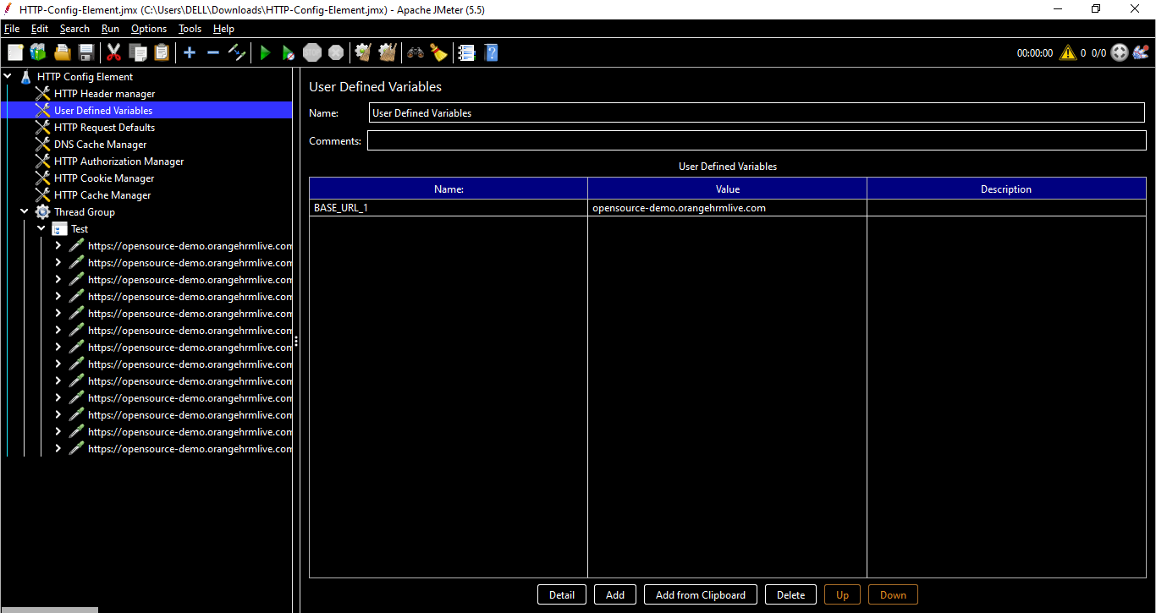

The above UDV is used in the HTTP Request as shown below with the Syntax

${BASE_URL_1} where BASE_URL_1 is a Variable name

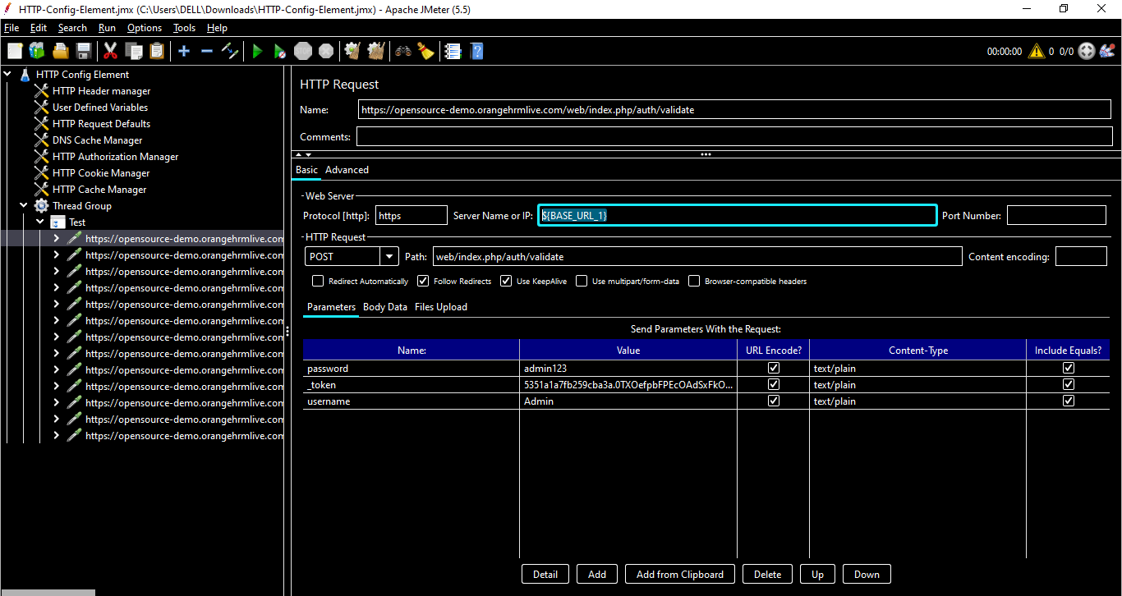

## **HTTP Request Defaults**

This element lets you set default values that your HTTP Request controllers use.

For example, if you are creating a Test Plan with 25 HTTP Request controllers and all of the requests are being sent to the same server, you could add a single HTTP Request Defaults element with the "**Server Name or IP**" field filled in. Then, when you add the 25 HTTP Request controllers, leave the "**Server Name or IP**" field empty.

The controllers will inherit this field value from the HTTP Request Defaults element.

So if we have the same set of repetitive requests , then we can use HTTP Request Defaults.

In case of our Example , we are using the Base URL in each http request.

We can remove the variable from all the HTTP Requests & add them inside HTTP Request Defaults.

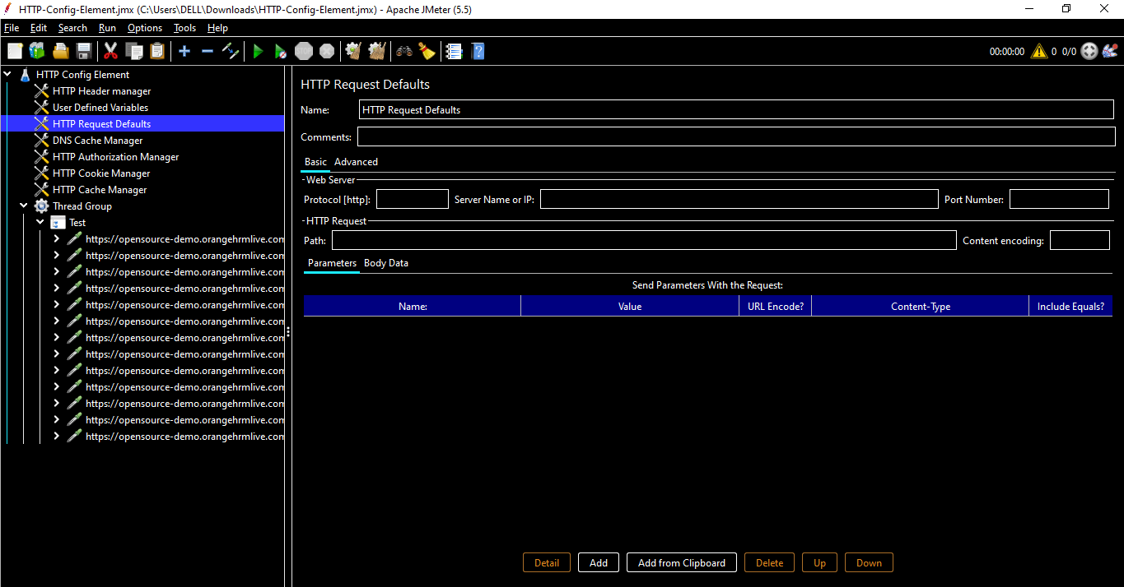

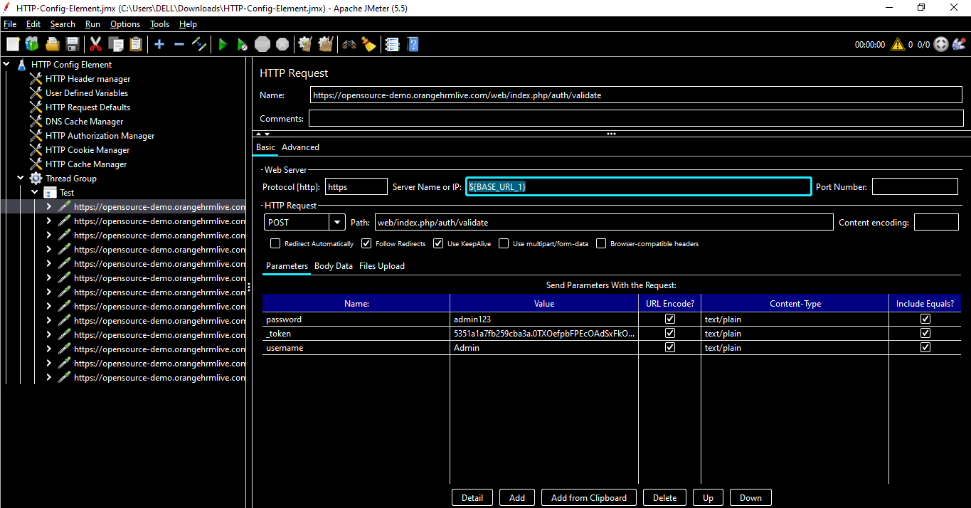

Cut & paste the BASE_URL_1 in HTTP REQUEST DEFAULTS as below

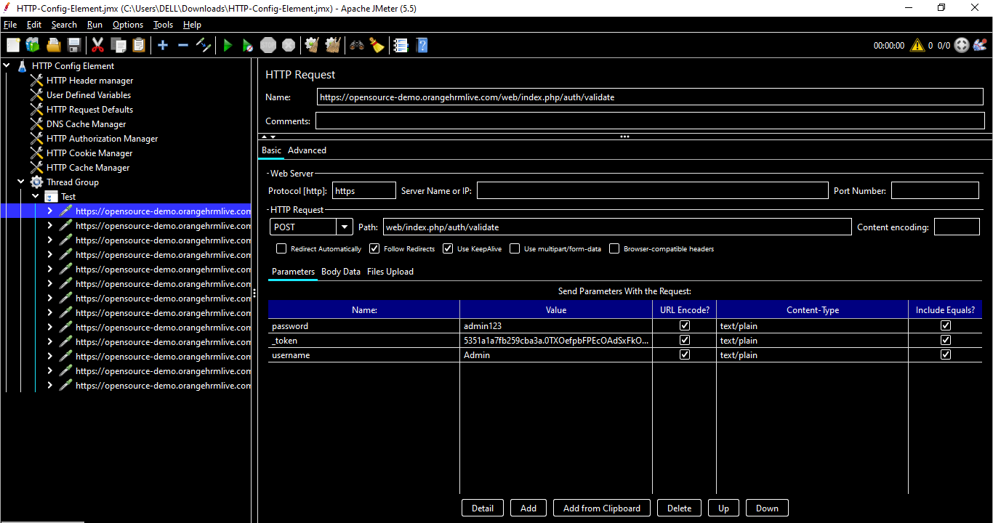

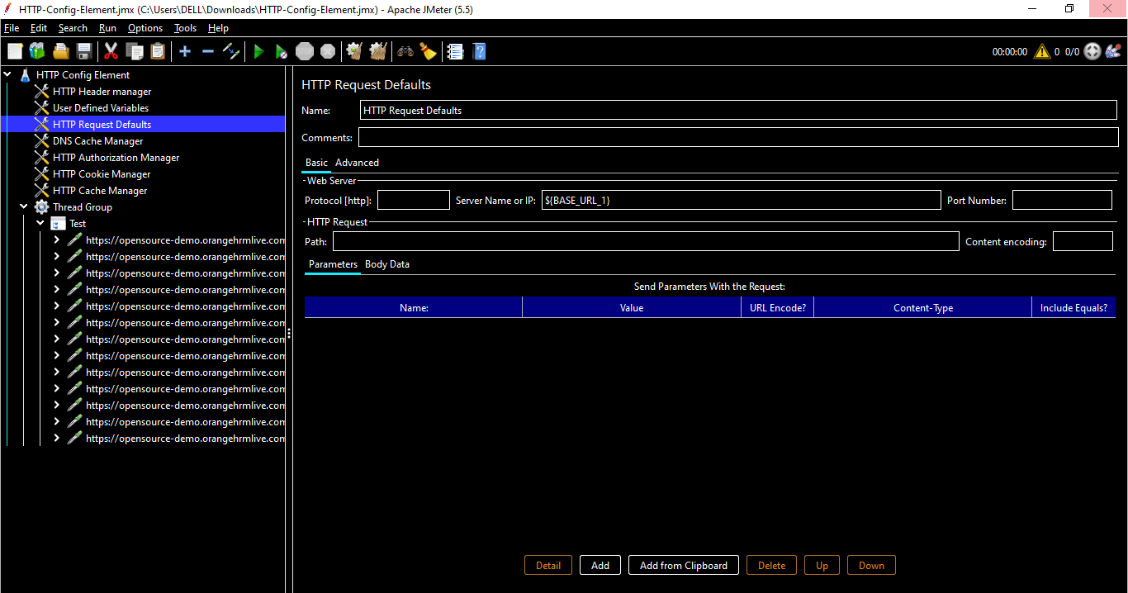

**Name** - Descriptive name for this element that is shown in the tree. No

Server Domain name or IP address of the web server. E.g. www.example.com. [Do not include the http:// prefix.

**Port -** Port the web server is listening to.

**Connect Timeout -** Connection Timeout. Number of milliseconds to wait for a connection to open.

**Response Timeout -**  Response Timeout. Number of milliseconds to wait for a response.

**Implementation -** Java, HttpClient4. If not specified the default depends on the value of the JMeter property jmeter.httpsampler, failing that, the Java implementation is used.

**Protocol -** HTTP or HTTPS.

**Content encoding -** The encoding to be used for the request.

**Path -** The path to a resource (for example, /servlets/myServlet). If the resource requires query string parameters, add them below in the "Send Parameters With the Request" section. Note that the path is the default for the full path, not a prefix to be applied to paths specified on the HTTP Request screens.

**Send Parameters With the Request -** The query string will be generated from the list of parameters you provide. Each parameter has a name and value. The query string will be generated in the correct fashion, depending on the choice of "Method" you made (i.e. if you chose GET, the query string will be appended to the URL, if POST, then it will be sent separately). Also, if you are sending a file using a multipart form, the query string will be created using the multipart form specifications.

**Server (proxy)** - Hostname or IP address of a proxy server to perform requests. [Do not include the http:// prefix.]

**Port -** Port the proxy server is listening to., unless proxy hostname is specified

**Username -** (Optional) username for proxy server.

**Password -** (Optional) password for proxy server. (N.B. this is stored unencrypted in the test plan)

**Retrieve -** All Embedded Resources from HTML Files Tell JMeter to parse the HTML file and send HTTP/HTTPS requests for all images, Java applets, JavaScript files, CSSs, etc. referenced in the file.

**Use concurrent pool -** Use a pool of concurrent connections to get embedded resources.

**Size -** Pool size for concurrent connections used to get embedded resources.

**URLs must match -** If present, this must be a regular expression that is used to match against any embedded URLs found. So if you only want to download embedded resources from http://example.invalid/, use the expression: http://example\.invalid/.

**URLs must not match -** If present, this must be a regular expression that is used to filter out any embedded URLs found. So if you don't want to download PNG or SVG files from any source, use the expression: .*\.(?i:svg|png)

## **DNS Cache Manager**

The [DNS](https://automationstepbystep.com/2020/11/27/a-story-of-dns-2/) Cache Manager element allows to test applications, which have several servers behind [load balancers](https://automationstepbystep.com/2020/04/28/a-story-what-is-load-balancer/), when a user receives content from different IP's.

By default JMeter uses JVM DNS cache. That's why only one server from the cluster receives load. DNS Cache Manager resolves names for each thread separately each iteration and saves results of resolving to its internal DNS Cache, which is independent from both JVM and OS DNS caches.

This is basically used to clear Cache in each iteration & can be discussed with Manager or Developer if we actually need to use DNS Cache Manager in our test plan or not.

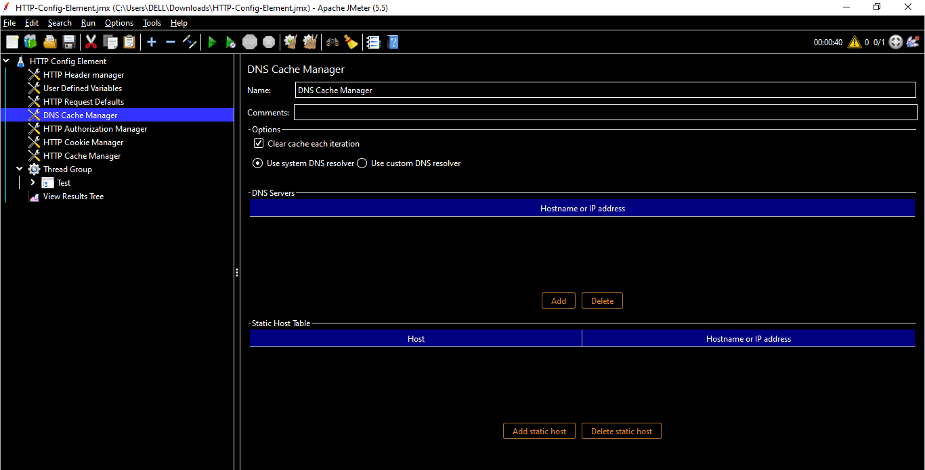

**Name *-*** Descriptive name for this element that is shown in the tree.

**Clear cache each Iteration-**  If selected, the DNS cache of every Thread is cleared each time new iteration is started.

**Use system DNS resolver -**  System DNS resolver will be used. For correct work edit **$JAVA_HOME/jre/lib/security/java.security** and add **networkaddress.cache.ttl=0**

**Use custom DNS resolver -**  Custom DNS resolver (from dnsjava library) will be used.

**Hostname or IP address -**  List of DNS servers to use. If empty, network configuration DNS will be used.

**Add Button -**  Add an entry to the DNS servers table.

**Delete Button -**  Delete the currently selected table entry.

**Host and Hostname or IP address -** Mapping of hostnames to a static host entry which will be resolved using the custom DNS resolver.

**Add static host Button -**  Add an entry to the static hosts table. N/A

**Delete static host Button -** Delete the currently selected static host in the table.

## **HTTP Authorization Manager**

The Authorization Manager lets you specify one or more user logins for web pages that are restricted using server authentication. You see this type of authentication when you use your browser to access a restricted page, and your browser displays a login dialog box. JMeter transmits the login information when it encounters this type of page.

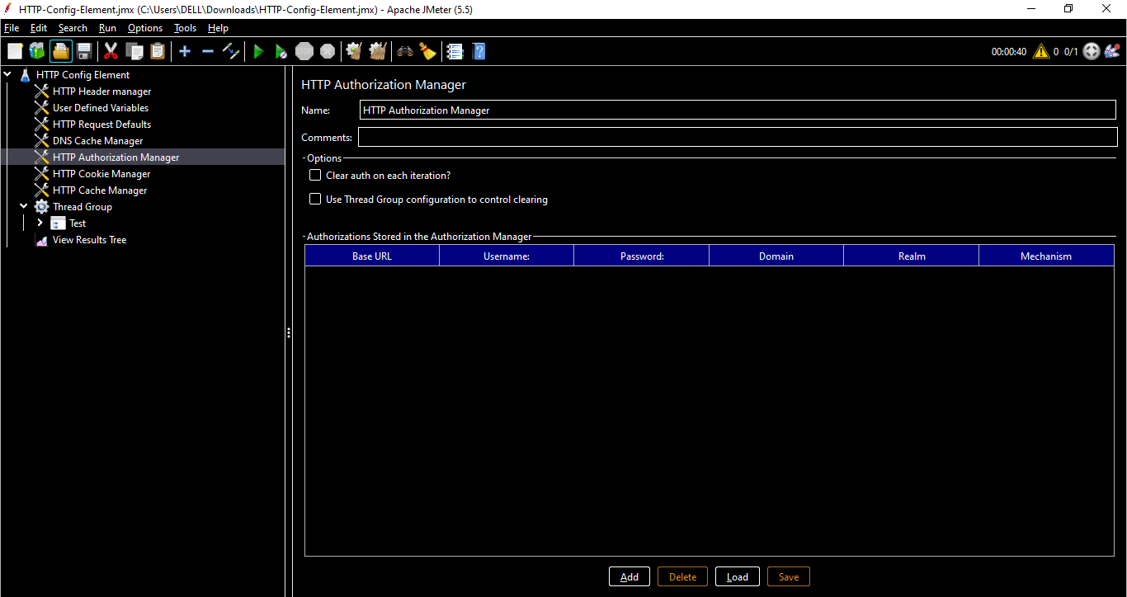

**Name -** Descriptive name for this element that is shown in the tree. No

Clear auth on each iteration? - Used by Kerberos authentication. If checked, authentication will be done on each iteration of Main Thread Group loop even if it has already been done in a previous one. This is usually useful if each main thread group iteration represents behaviour of one Virtual User. Yes

**Base URL -** A partial or complete URL that matches one or more HTTP Request URLs. As an example, say you specify a Base URL of "http://localhost/restricted/" with a Username of "jmeter" and a Password of "jmeter". If you send an HTTP request to the URL "http://localhost/restricted/ant/myPage.html", the Authorization Manager sends the login information for the user named, "jmeter". Yes

**Username -** The username to authorize. Yes

**Password -** The password for the user. (N.B. this is stored unencrypted in the test plan) Yes

**Domain -** The domain to use for NTLM. No

**Realm -** The realm to use for NTLM. No

Mechanism - Type of authentication to perform. JMeter can perform different types of authentications based on used Http Samplers:

Java

BASIC

HttpClient 4

BASIC, DIGEST and Kerberos

## **HTTP Cookie Manager**

The Cookie Manager element has two functions:

First, it stores and sends cookies just like a web browser. First, it stores and sends cookies just like a web browser. Each JMeter thread has its own "cookie storage area". So, if you are testing a web site that uses a cookie for storing session information, each JMeter thread will have its own session. Note that such cookies do not appear on the Cookie Manager display, but they can be seen using the [View Results Tree](https://jmeter.apache.org/usermanual/component_reference.html#View_Results_Tree) Listener.

This is usually recommended since it’s a good practice to clear cache each time we run a test.

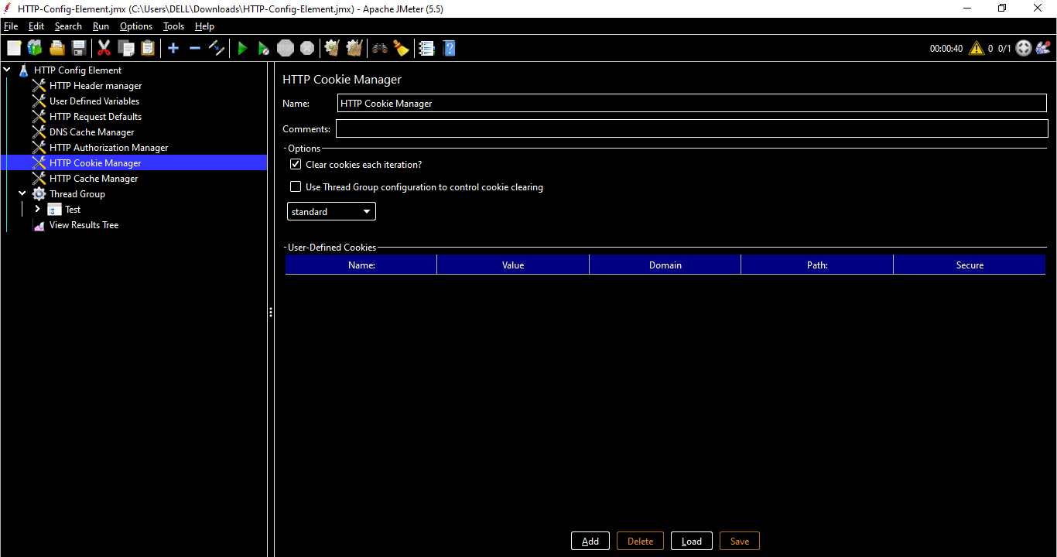

**Name -**  Descriptive name for this element that is shown in the tree.

Clear Cookies each Iteration - If selected, all server-defined cookies are cleared each time the main Thread Group loop is executed. Any cookie defined in the GUI are not cleared.

**Cookie Policy -** The cookie policy that will be used to manage the cookies. "standard" is the default since 3.0, and should work in most cases. See [Cookie specifications](https://hc.apache.org/httpcomponents-client-ga/tutorial/html/statemgmt.html#d5e515) and [CookieSpec implementations](http://hc.apache.org/httpcomponents-client-ga/httpclient/apidocs/org/apache/http/cookie/CookieSpec.html) [Note: "ignoreCookies" is equivalent to omitting the CookieManager.]

[Note: If you have a website to test with IPv6 address, choose HC4CookieHandler (IPv6 compliant)]

**User-Defined Cookies -** This gives you the opportunity to use hardcoded cookies that will be used by all threads during the test execution.

The "domain" is the hostname of the server (without http://); the port is currently ignored. (discouraged, unless you know what you're doing)

**Add Button -** Add an entry to the cookie table.

Delete Button - Delete the currently selected table entry.

**Load Button -** Load a previously saved cookie table and add the entries to the existing cookie table entries.

**Save As Button -** Save the current cookie table to a file (does not save any cookies extracted from HTTP Responses).

## **HTTP Cache Manager**

The HTTP Cache Manager is used to add caching functionality to HTTP requests within its scope to simulate browser cache feature. Each Virtual User thread has its own Cache. By default, Cache Manager will store up to 5000 items in cache per Virtual User thread, using LRU algorithm. Use property "maxSize" to modify this value. Note that the more you increase this value the more HTTP Cache Manager will consume memory, so be sure to adapt the -Xmx JVM option accordingly.

Similar to Cookie , this is recommended since it’s a good practice to clear Cache in each Iteration

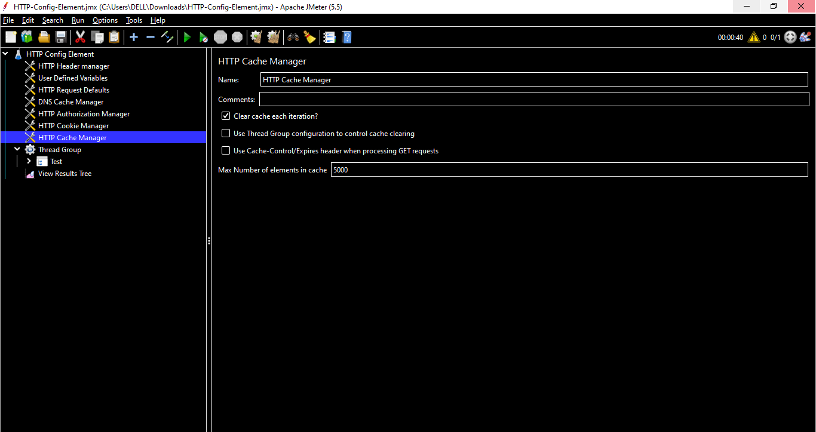

*Note : We have created the above HTTP Test plan using Blazemeter. If we want to create the Web Test Plan manually , we can do it using existing Template as below*

Click on Template Icon

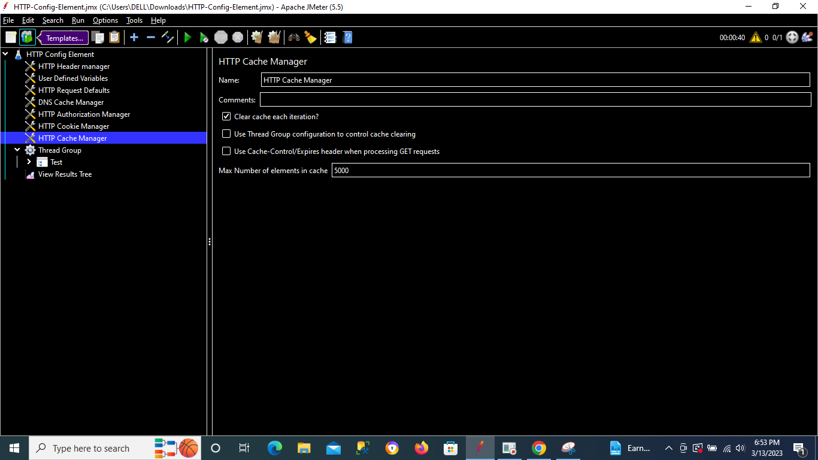

Select Advance Web Test Plan from dropdown

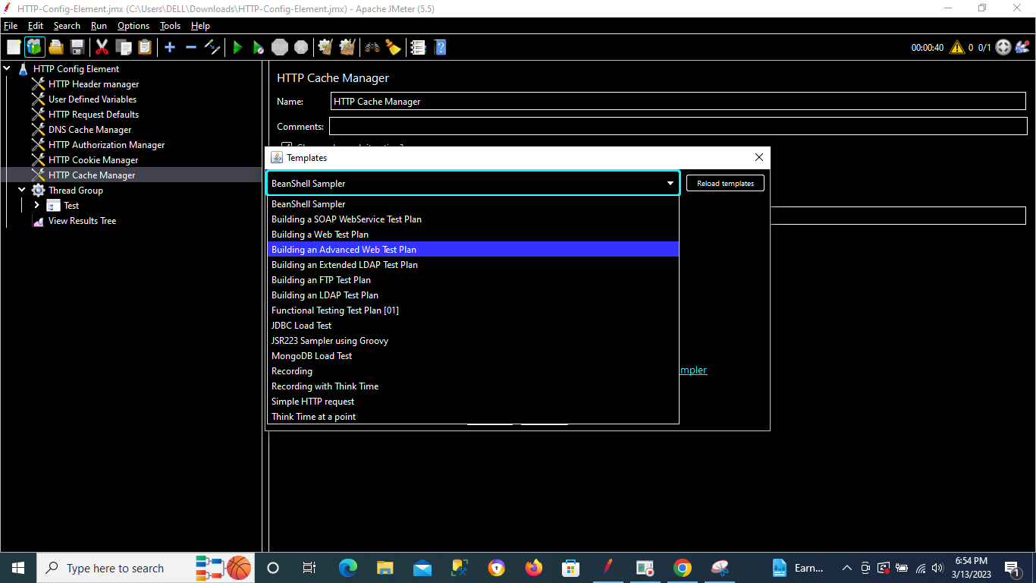

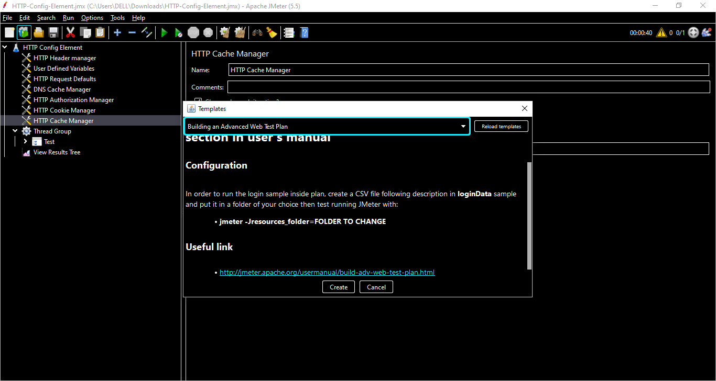

Click on Create

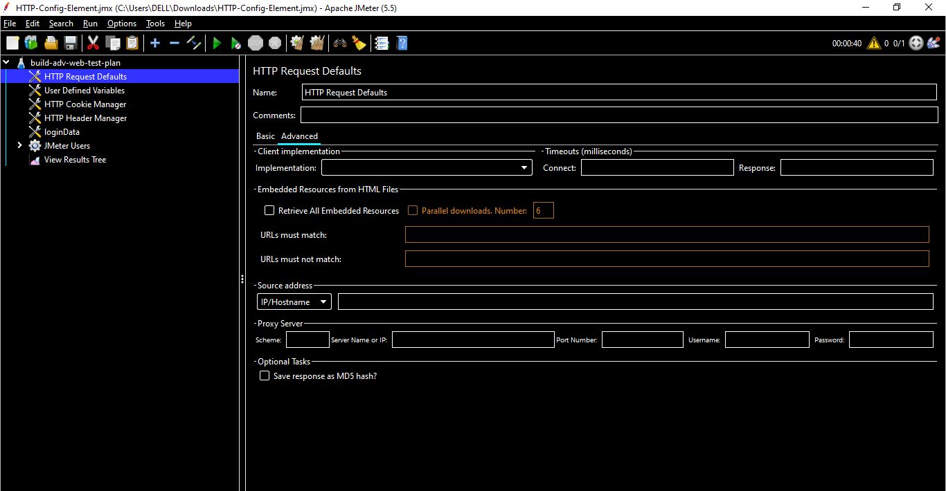

## **JMeter Commonly used Config Elements**

## **Counter : Config Elements**

Allows the user to create a counter that can be referenced anywhere in the Thread Group. The counter config lets the user configure a starting point, a maximum, and the increment. The counter will loop from the start to the max, and then start over with the start, continuing on like that until the test is ended.

**Name -** Descriptive name for this element that is shown in the tree.

*Starting value* - The starting value for the counter. The counter will equal this value during the first iteration (defaults to 0).

**Increment -** How much to increment the counter by after each iteration (defaults to 0, meaning no increment).

**Maximum value -** If the counter exceeds the maximum, then it is reset to the **Starting value**. Default is **Long.MAX_VALUE**

**Format -** Optional format, e.g. **000** will format as **001**, **002**, etc. This is passed to **DecimalFormat**, so any valid formats can be used. If there is a problem interpreting the format, then it is ignored. [The default format is generated using **Long.toString()**]

**Exported Variable Name -** This will be the variable name under which the counter value is available. If you name it **counterA**, you can then access it using **${counterA}** as explained in [user-defined values](https://jmeter.apache.org/usermanual/functions.html) (By default, it creates an empty string variable that can be accessed using **${}** but this is highly discouraged)

**Track Counter -** *Independently for each User* In other words, is this a global counter, or does each user get their own counter? If unchecked, the counter is global (i.e., user #1 will get value "**1**", and user #2 will get value "**2**" on the first iteration). If checked, each user has an independent counter.

**Reset counter on each Thread Group Iteration -** This option is only available when counter is tracked per User, if checked, counter will be reset to **Start** value on each Thread Group iteration. This can be useful when Counter is inside a Loop Controller.

**Step 1 :** Add a config element - **Counter**

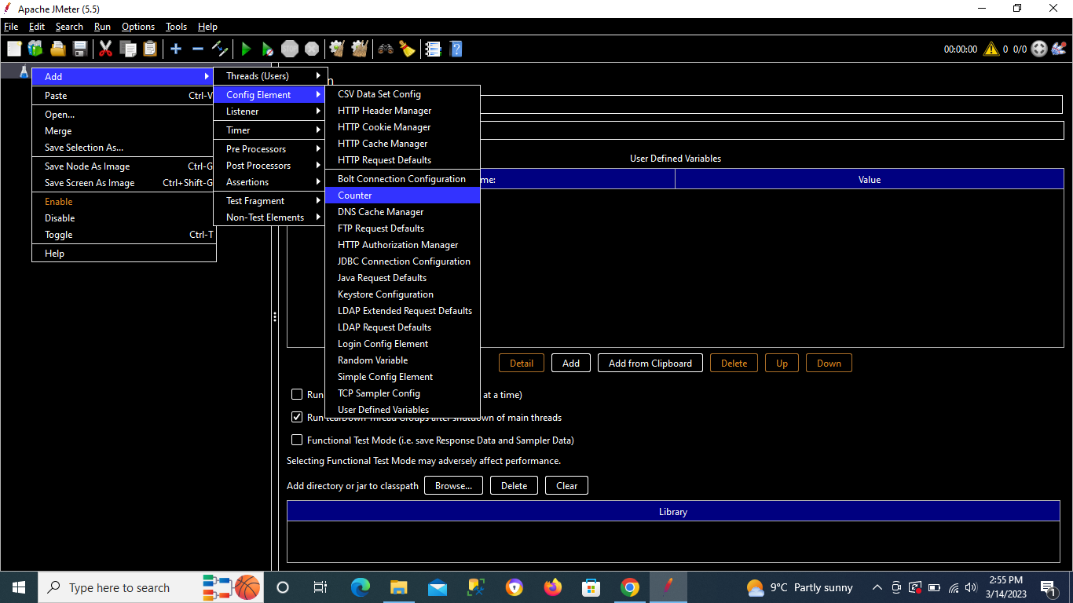

Add Starting Value , Increment ,Maximum value & Exported Variable Name as below

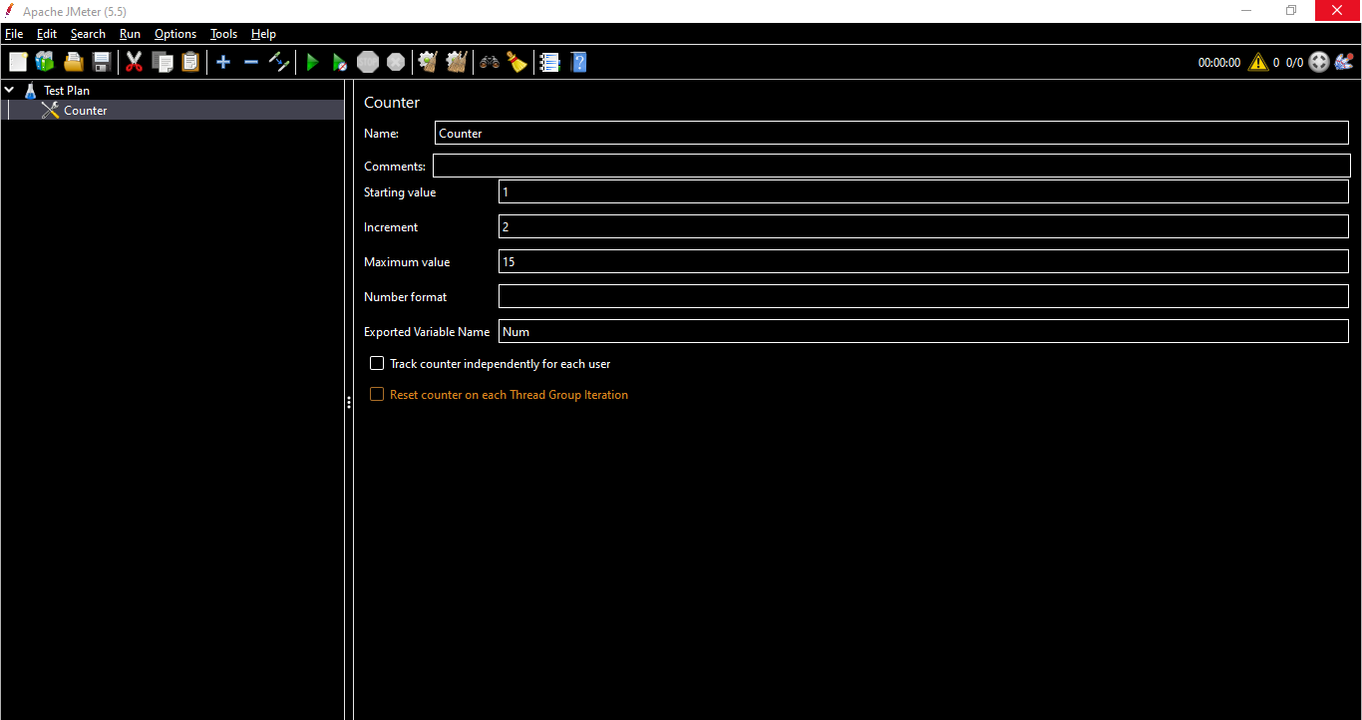

Add a Thread group

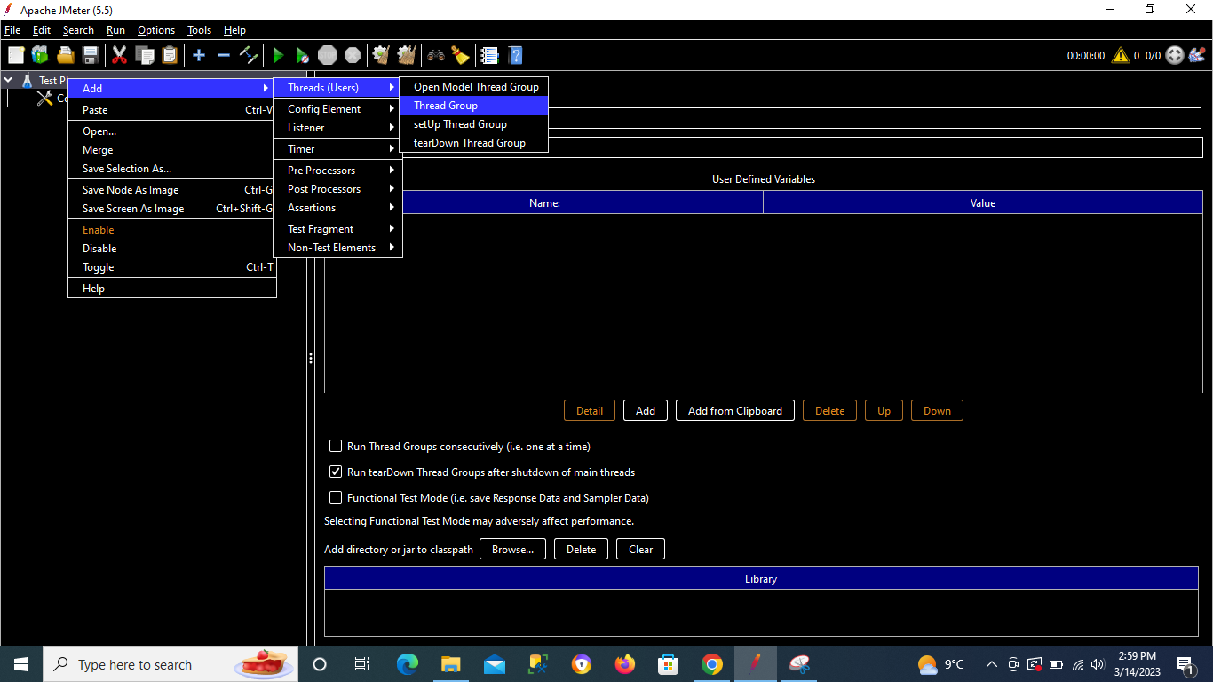

Add a Java Request (just for example , again not a practical example)

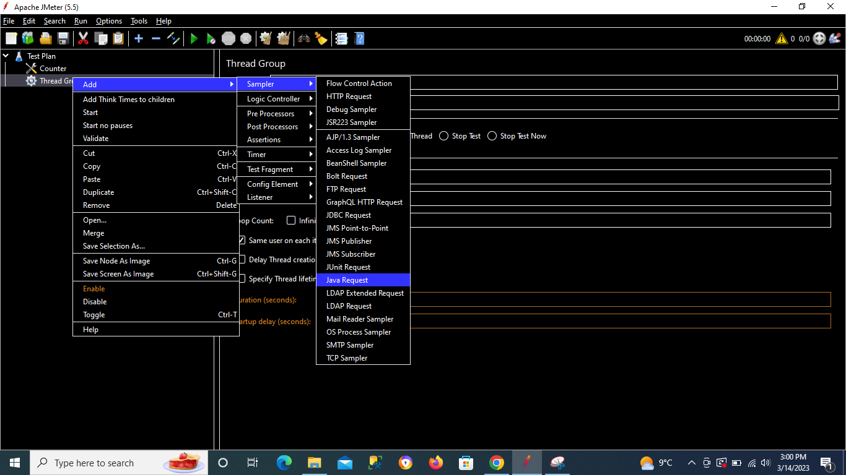

Add the variable name in Java Request

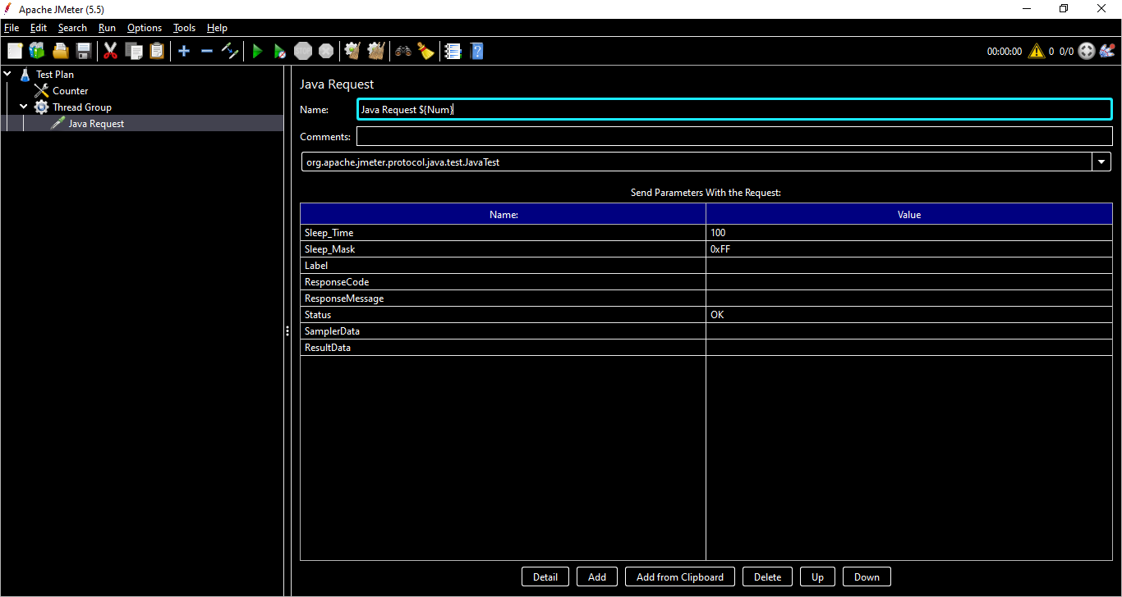

Add a Listener to see the results

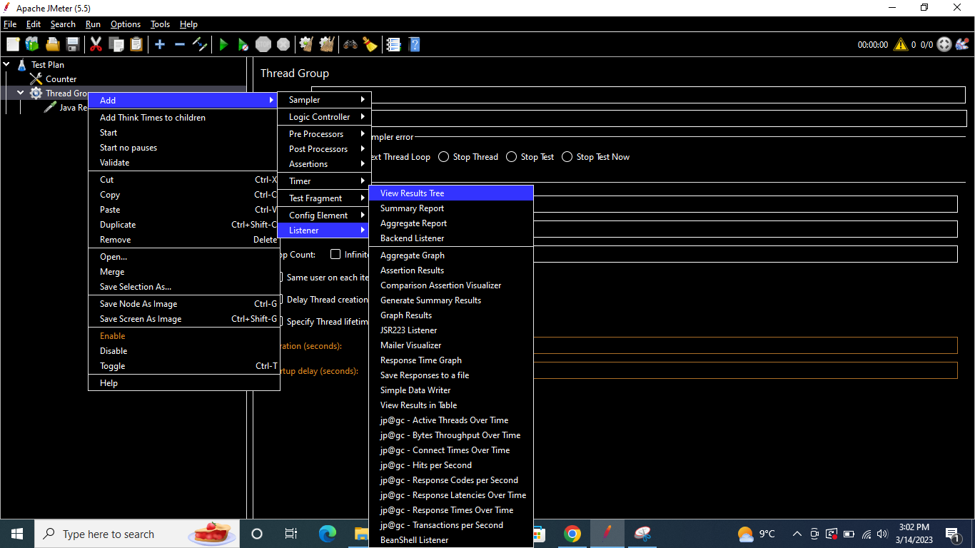

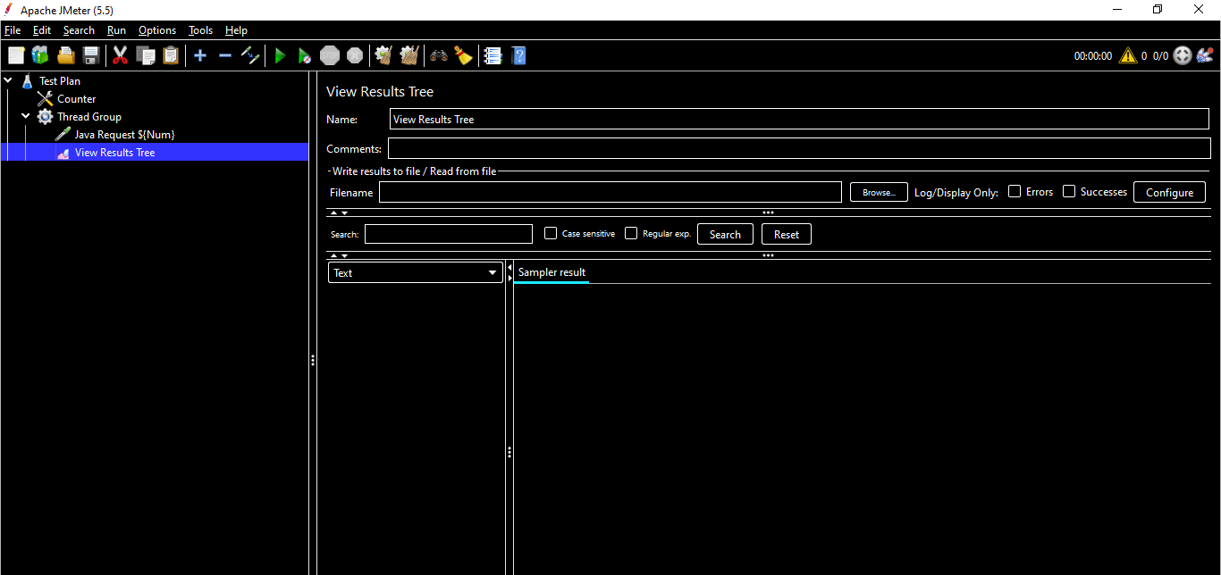

Run the Test Plan & the result should display the starting number as 1 & should increment by 2 in each iteration till maximum value 15 as per our example.

*Note - Keep the Thread Group Loop count = 15*

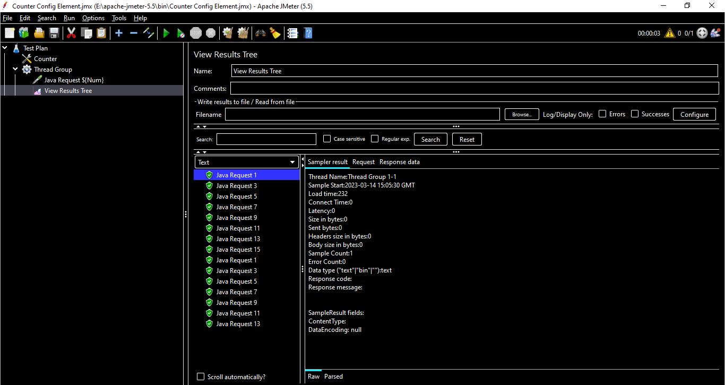

The number increments till maximum value 15 & then starts again from 1 due to Loop count in Thread Group (Loop Count can be as per the requirement)

## **FTP Request Defaults**

Like the HTTP Request Default config element, FTP Request Default **makes the user enter the repeating values in it so that all the request under the same thread group inherits the properties and makes use of them**

If we add a FTP Request Sampler which has repeating values, those can be added in FTP Request Defaults

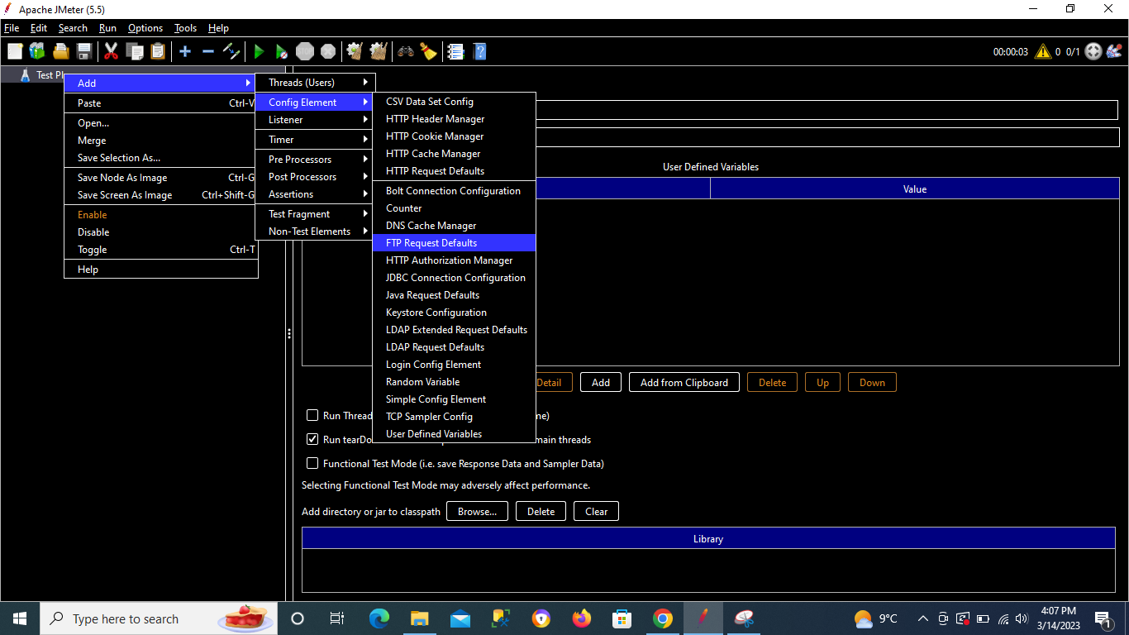

## **JDBC Connection Configuration**

Creates a database connection (used by [JDBC Request](https://jmeter.apache.org/usermanual/component_reference.html#JDBC_Request)Sampler) from the supplied JDBC Connection settings. The connection may be optionally pooled between threads. Otherwise each thread gets its own connection. The connection configuration name is used by the JDBC Sampler to select the appropriate connection

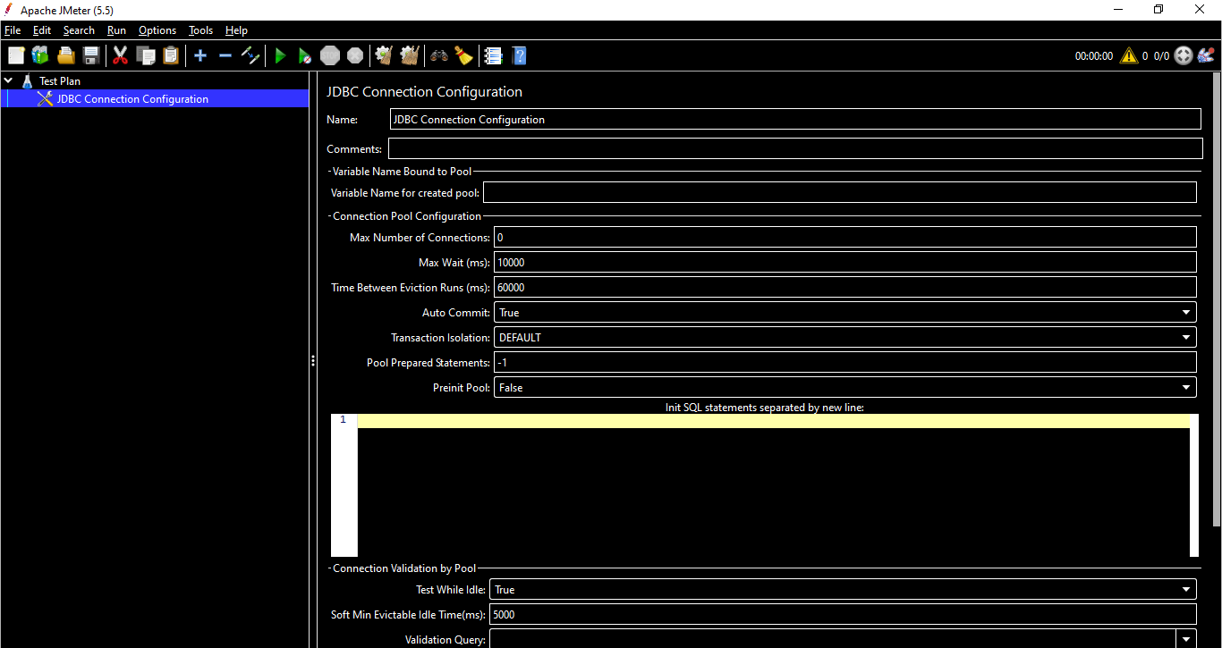

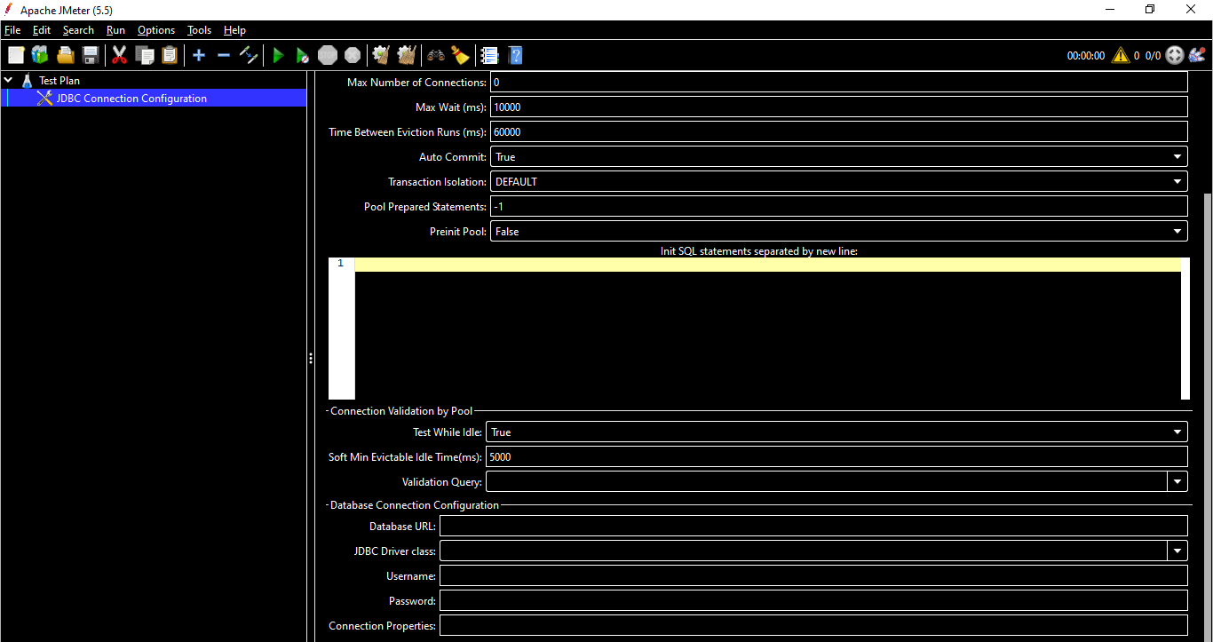

**Name -** Descriptive name for the connection configuration that is shown in the tree.

**Variable Name for created pool -** The name of the variable the connection is tied to. Multiple connections can be used, each tied to a different variable, allowing JDBC Samplers to select the appropriate connection.

Each name must be different. If there are two configuration elements using the same name, only one will be saved. JMeter logs a message if a duplicate name is detected.

**Max Number of Connections -** Maximum number of connections allowed in the pool. In most cases, **set this to zero (0)**. This means that each thread will get its own pool with a single connection in it, i.e. the connections are not shared between threads.

If you really want to use shared pooling (why?), then set the max count to the same as the number of threads to ensure threads don't wait on each other.

**Max Wait (ms) -** Pool throws an error if the timeout period is exceeded in the process of trying to retrieve a connection, see [BasicDataSource.html#getMaxWaitMillis](https://commons.apache.org/proper/commons-dbcp/api-2.1.1/org/apache/commons/dbcp2/BasicDataSource.html#getMaxWaitMillis--)

**Time Between Eviction Runs (ms) -** The number of milliseconds to sleep between runs of the idle object evictor thread. When non-positive, no idle object evictor thread will be run. (Defaults to "**60000**", 1 minute). See [BasicDataSource.html#getTimeBetweenEvictionRunsMillis](https://commons.apache.org/proper/commons-dbcp/api-2.1.1/org/apache/commons/dbcp2/BasicDataSource.html#getTimeBetweenEvictionRunsMillis--)

**Auto Commit -** Turn auto commit on or off for the connections.

**Transaction isolation -** Transaction isolation level

**Pool Prepared Statements** - Max number of Prepared Statements to pool per connection. **"-1**" disables the pooling and "**0**" means unlimited number of Prepared Statements to pool. (Defaults to "**-1**")

**Preinit Pool -** The connection pool can be initialised instantly. If set to **False** (default), the JDBC request samplers using this pool might measure higher response times for the first queries – as the connection establishment time for the whole pool is included.

**Init SQL statements separated by new line -** A Collection of SQL statements that will be used to initialise physical connections when they are first created. These statements are executed only once - when the configured connection factory creates the connection.

**Test While Idle -** Test idle connections of the pool, see [BasicDataSource.html#getTestWhileIdle](https://commons.apache.org/proper/commons-dbcp/api-2.1.1/org/apache/commons/dbcp2/BasicDataSource.html#getTestWhileIdle--). Validation Query will be used to test it.

**Soft Min Evictable Idle Time(ms) -** Minimum amount of time a connection may sit idle in the pool before it is eligible for eviction by the idle object evictor, with the extra condition that at least **minIdle** connections remain in the pool. See [BasicDataSource.html#getSoftMinEvictableIdleTimeMillis](https://commons.apache.org/proper/commons-dbcp/api-2.1.1/org/apache/commons/dbcp2/BasicDataSource.html#getSoftMinEvictableIdleTimeMillis--). Defaults to 5000 (5 seconds)

**Validation Query -** A simple query used to determine if the database is still responding. This defaults to the '**isValid()**' method of the jdbc driver, which is suitable for many databases. However some may require a different query; for example Oracle something like '**SELECT 1 FROM DUAL**' could be used.

The list of the validation queries can be configured with **jdbc.config.check.query** property and are by default:

hsqldb

**select 1 from INFORMATION_SCHEMA.SYSTEM_USERS**

Oracle

**select 1 from dual**

DB2

**select 1 from sysibm.sysdummy1**

MySQL or MariaDB

**select 1**

Microsoft SQL Server (MS JDBC driver)

**select 1**

PostgreSQL

**select 1**

Ingres

**select 1**

Derby

**values 1**

H2

**select 1**

Firebird

**select 1 from rdb$database**

Exasol

**select 1**

The list come from [stackoverflow entry on different database validation queries](https://stackoverflow.com/questions/10684244/dbcp-validationquery-for-different-databases) and it can be incorrect

Note this validation query is used on pool creation to validate it even if "**Test While Idle**" suggests query would only be used on idle connections. This is DBCP behaviour.

**Database URL -** JDBC Connection string for the database.

**JDBC Driver class -** Fully qualified name of driver class. (Must be in JMeter's classpath - easiest to copy **.jar** file into JMeter's **/lib** directory).

The list of the preconfigured jdbc driver classes can be configured with **jdbc.config.jdbc.driver.class** property and are by default:

hsqldb

org.hsqldb.jdbc.JDBCDriver

Oracle

oracle.jdbc.OracleDriver

DB2

com.ibm.db2.jcc.DB2Driver

MySQL

com.mysql.jdbc.Driver

Microsoft SQL Server (MS JDBC driver)

com.microsoft.sqlserver.jdbc.SQLServerDriver or com.microsoft.jdbc.sqlserver.SQLServerDriver

PostgreSQL

org.postgresql.Driver

Ingres

com.ingres.jdbc.IngresDriver

Derby

org.apache.derby.jdbc.ClientDriver

H2

org.h2.Driver

Firebird

org.firebirdsql.jdbc.FBDriver

Apache Derby

org.apache.derby.jdbc.ClientDriver

MariaDB

org.mariadb.jdbc.Driver

SQLite

org.sqlite.JDBC

Sybase AES

net.sourceforge.jtds.jdbc.Driver

Exasol

com.exasol.jdbc.EXADriver

**Username -** Name of user to connect as.

**Password -** Password to connect with. (N.B. this is stored unencrypted in the test plan)

**Connection Properties -** Connection Properties to set when establishing connection (like **internal_logon=sysdba** for Oracle for example)

*NOTE - If we add any JDBC Sampler, Pre Processor or Post Processor , we don’t get an option to create a connection to the database.We can do it only using JDBC Connection Configuration Element.*

## **Java Request Defaults**

The Java Request Defaults component lets you set default values for Java testing.

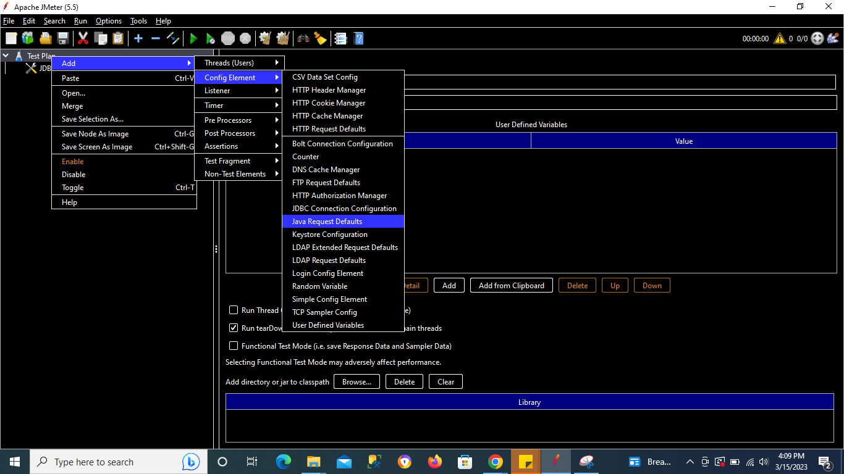

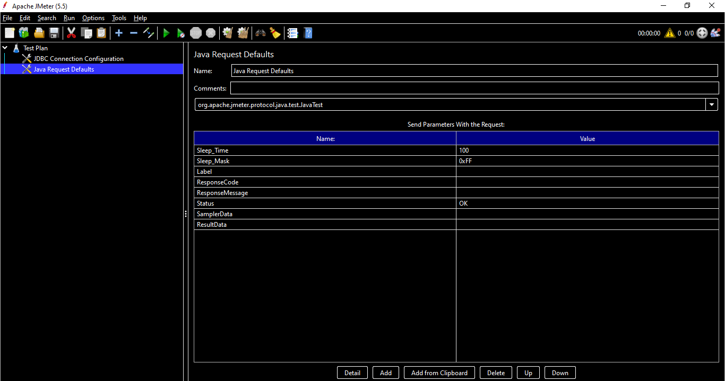

## **Keystore Configuration**

The Keystore Config Element lets you configure how Keystore will be loaded and which keys it will use. This component is typically used in HTTPS scenarios where you don't want to take into account keystore initialization into account in response time.

To use this element, you need to setup first a Java Key Store with the client certificates you want to test, to do that:

1. Create your certificates either with Java **keytool** utility or through your PKI
2. If created by PKI, import your keys in Java Key Store by converting them to a format acceptable by JKS
3. Then reference the keystore file through the two JVM properties (or add them in **system.properties**):
   * **-Djavax.net.ssl.keyStore=path_to_keystore**
   * **-Djavax.net.ssl.keyStorePassword=password_of_keystore**

To use PKCS11 as the source for the store, you need to set **javax.net.ssl.keyStoreType** to **PKCS11** and **javax.net.ssl.keyStore** to **NONE**.

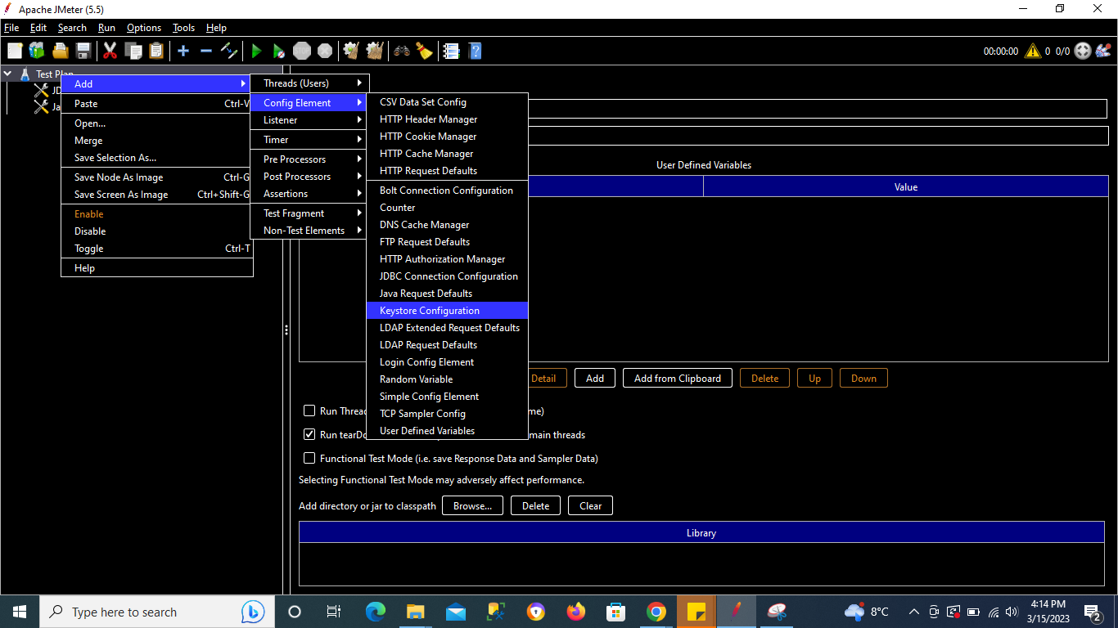

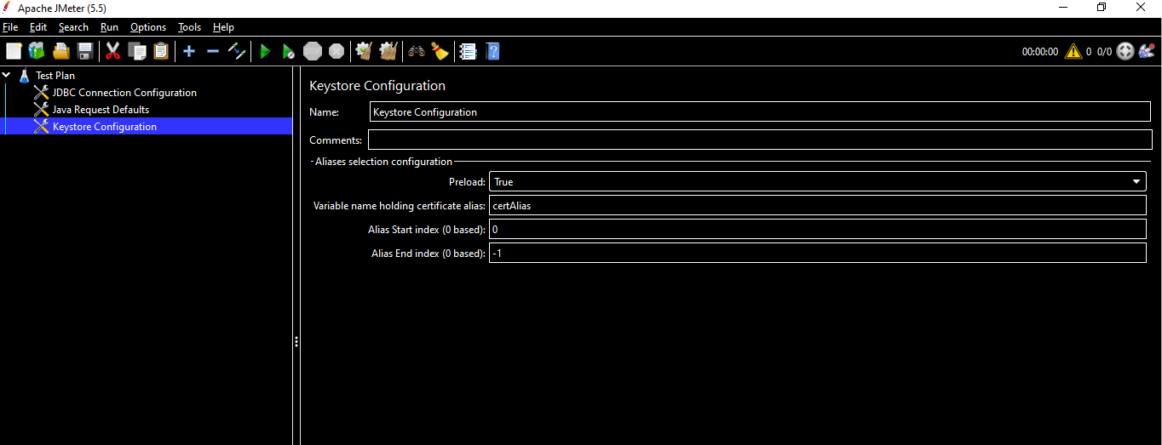

**Name -** Descriptive name for this element that is shown in the tree. No

**Preload -** Whether or not to preload Keystore. Setting it to true is usually the best option. Yes

**Variable name holding certificate alias -** Variable name that will contain the alias to use for authentication by client certificate. Variable value will be filled from the CSV Data Set for example. In the screenshot, "certificat_ssl" will also be a variable in CSV Data Set. Defaults to clientCertAliasVarName False

**Alias Start Index -** The index of the first key to use in Keystore, 0-based. Yes

**Alias End Index -** The index of the last key to use in Keystore, 0-based. When using "Variable name holding certificate alias" ensure it is large enough so that all keys are loaded at startup. Default to -1 which means load all.

NOTE - To make JMeter use more than one certificate you need to ensure that:

https.use.cached.ssl.context=false is set in jmeter.properties or user.properties

You use HTTPClient 4 implementation for HTTP Request

## **LDAP Request Defaults**

The LDAP Request Defaults component lets you set default values for LDAP testing.Basically used with LDAP Request Defaults Sampler.

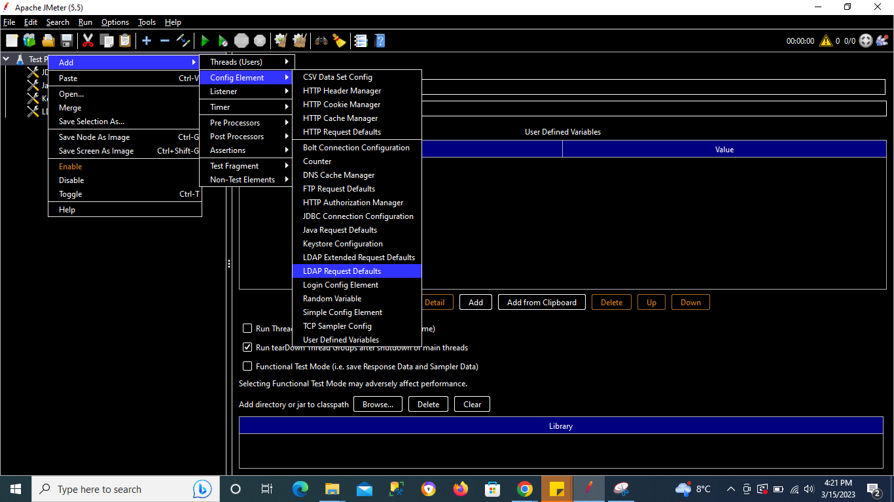

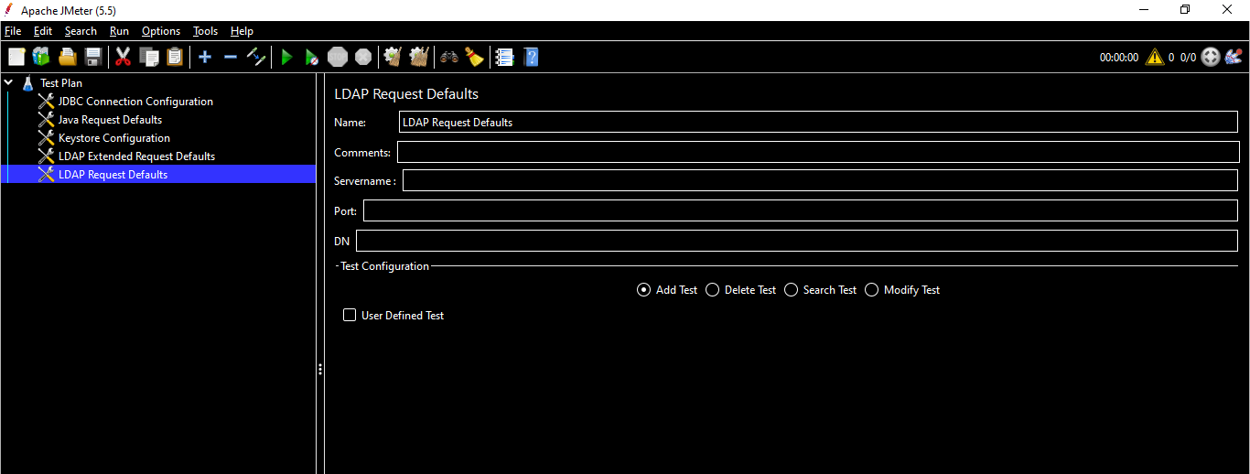

## **LDAP Extended Request Defaults**

The LDAP Extended Request Defaults component lets you set default values for extended LDAP testing. Basically used with LDAP Extended Request Defaults Sampler.

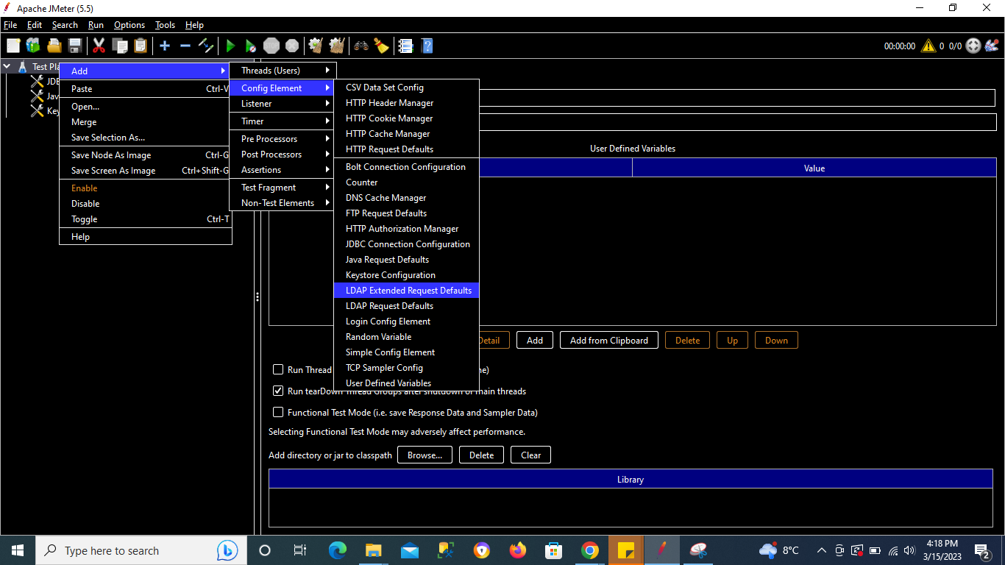

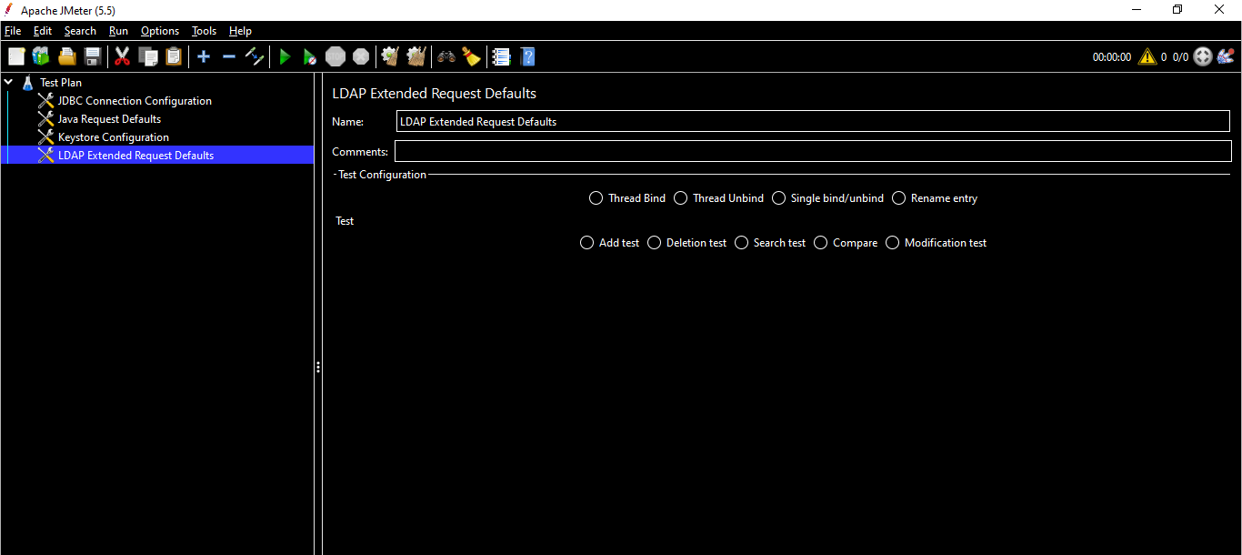

## **Random Variable**

The Random Variable Config Element is used to generate random numeric strings and store them in variable for use later.

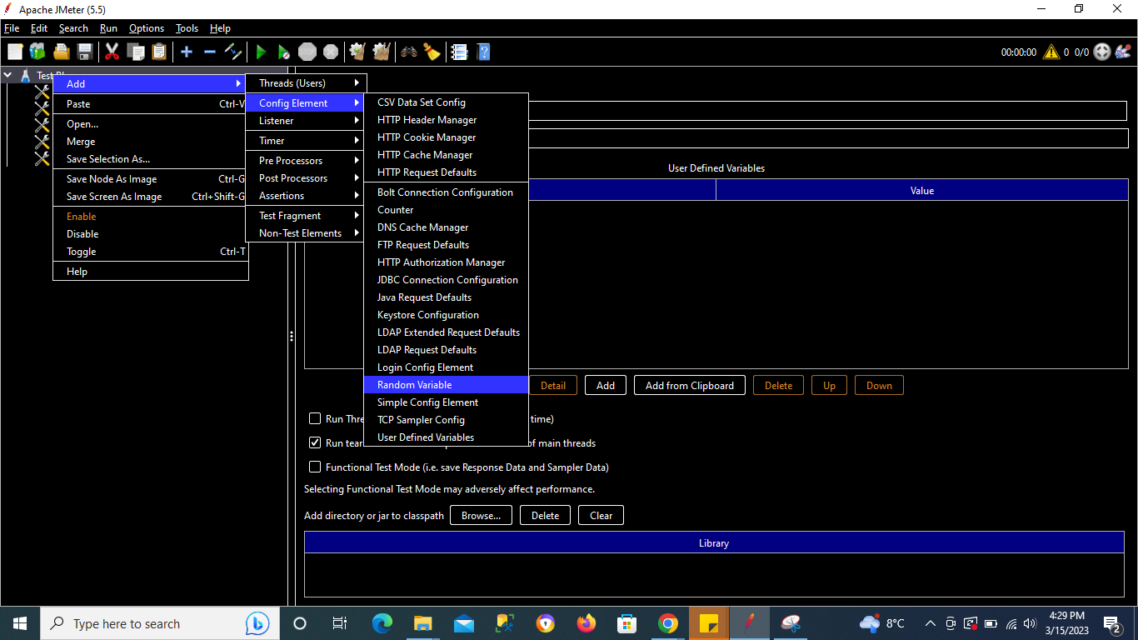

**Name -** Descriptive name for this element that is shown in the tree.

*Variable Name* - The name of the variable in which to store the random string.

**Format String -** The **java.text.DecimalFormat** format string to be used. For example "**000**" which will generate numbers with at least 3 digits, or "**USER_000**" which will generate output of the form **USER_nnn**. If not specified, the default is to generate the number using **Long.toString()**

**Minimum Value** **-** The minimum value (**long**) of the generated random number.

**Maximum Value** **-** The maximum value (**long**) of the generated random number.

**Random Seed** - The seed for the random number generator. If you use the same seed value with Per Thread set to **true**, you will get the same value for each Thread as per [Random](http://docs.oracle.com/javase/8/docs/api/java/util/Random.html) class. If no seed is set, Default constructor of Random will be used.

**Per Thread(User)? -** If **False**, the generator is shared between all threads in the thread group. If **True**, then each thread has its own random generator.

## **Simple Config Element**

The Simple Config Element lets you add or override arbitrary values in samplers. You can choose the name of the value and the value itself. Although some adventurous users might find a use for this element, it's here primarily for developers as a basic GUI that they can use while developing new JMeter components.

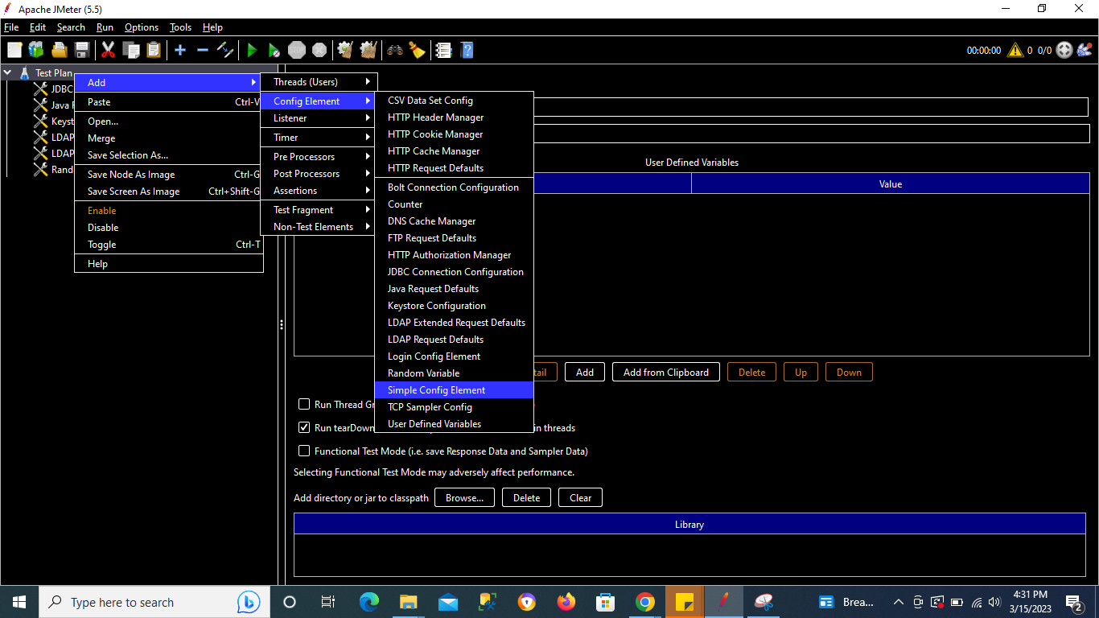

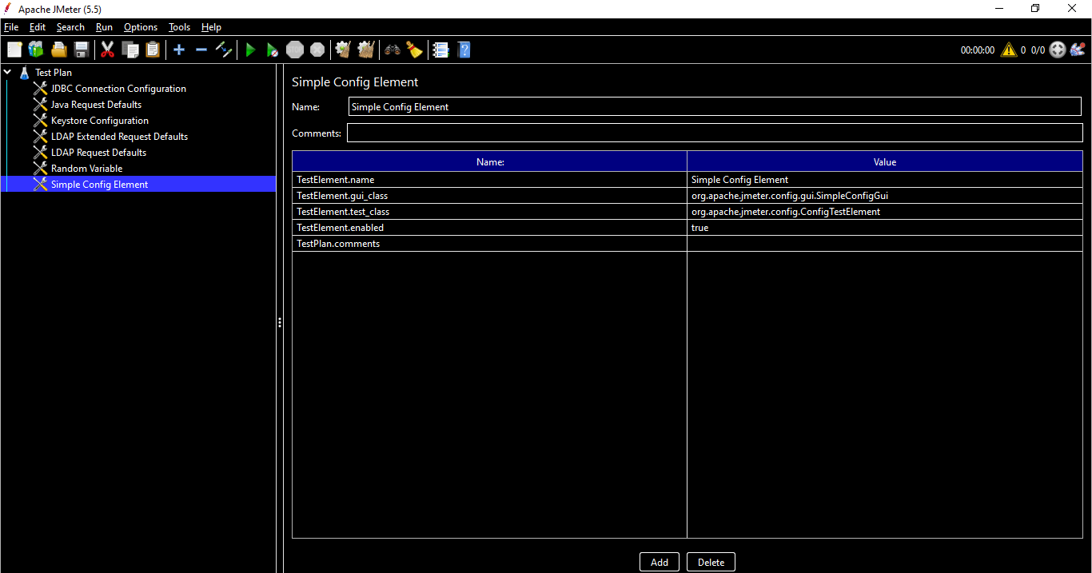

**Name -** Descriptive name for this element that is shown in the tree.

**Parameter Name -** The name of each parameter. These values are internal to JMeter's workings and are not generally documented. Only those familiar with the code will know these values.

**Parameter Value -** The value to apply to that parameter.

# **Command Line - How to run JMeter from Command Line**

## **Why is running from the command line is IMP?**

* When we run the JMeter from GUI, it is more memory consuming & hence becomes slower while using command line it’s faster since it consumes less memory.
* To integrate the performance test with external applications like CI/CD etc, we need command line

## **How to run JMeter from command line & How to log results**

Go to JMeter’s Bin folder

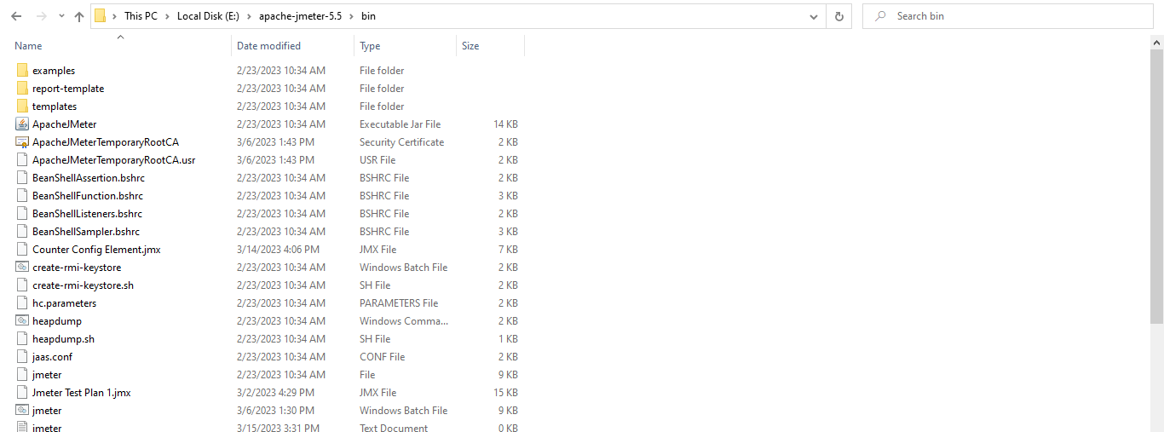

Copy the path & go to command line [Windows + R → Type cmd → Enter OR go to the address bar , type cmd & hit enter]

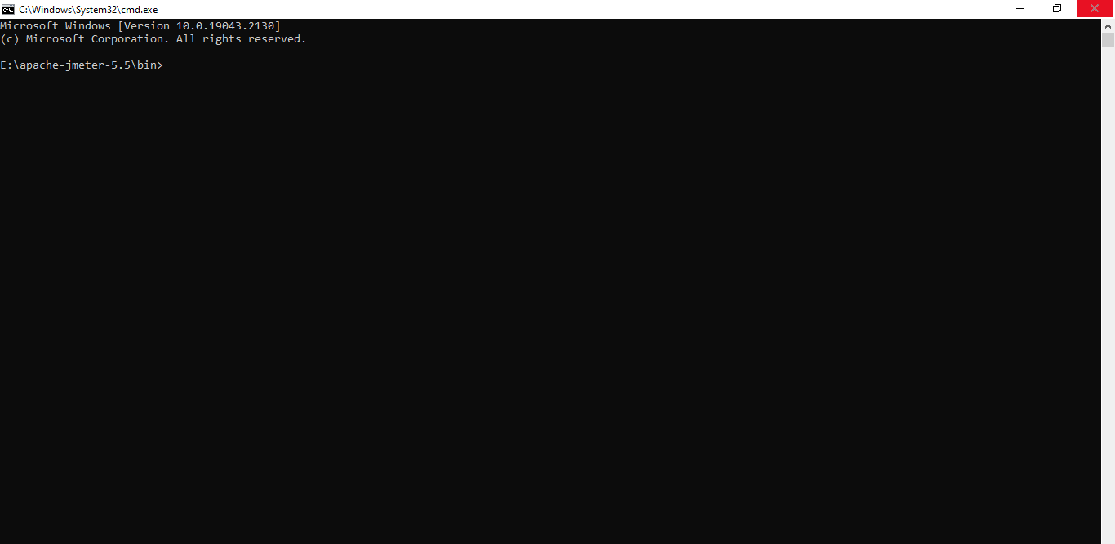

For manually doing this follow below step

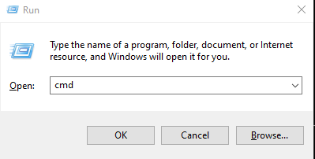

Hit Enter or click on OK

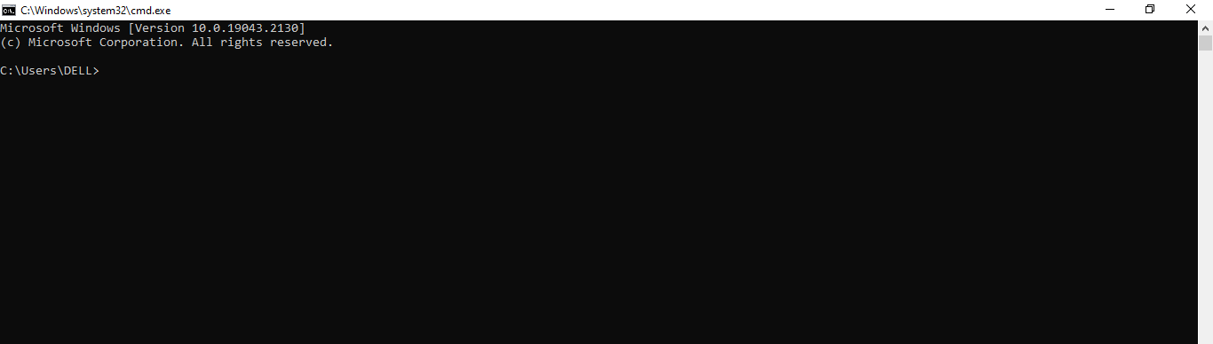

If your JMeter Bin folder is present in C directory then no need to change the directory but if it’s present in other directory then first move to that directory by typing directory : & hit enter (In our example e: since bin folder is in E: directory)

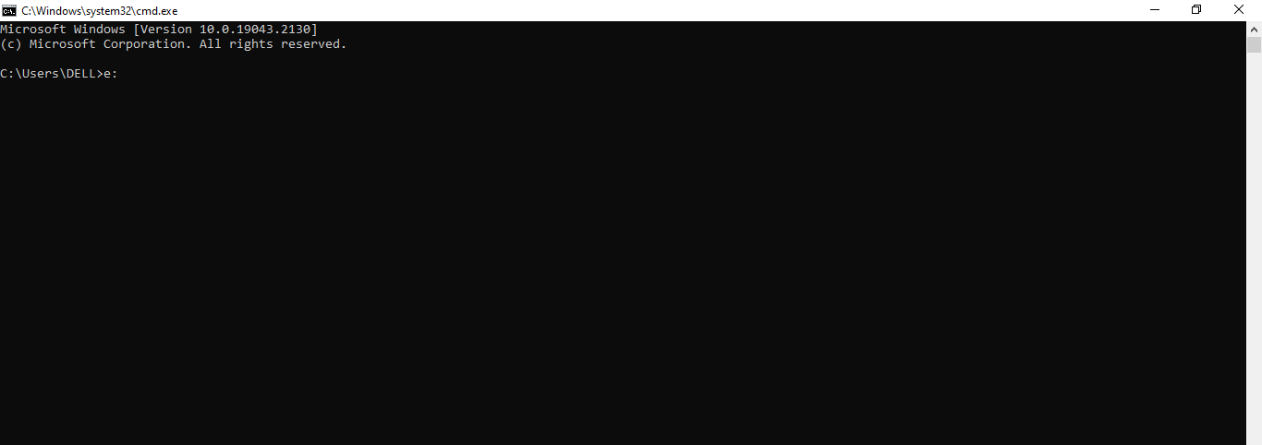

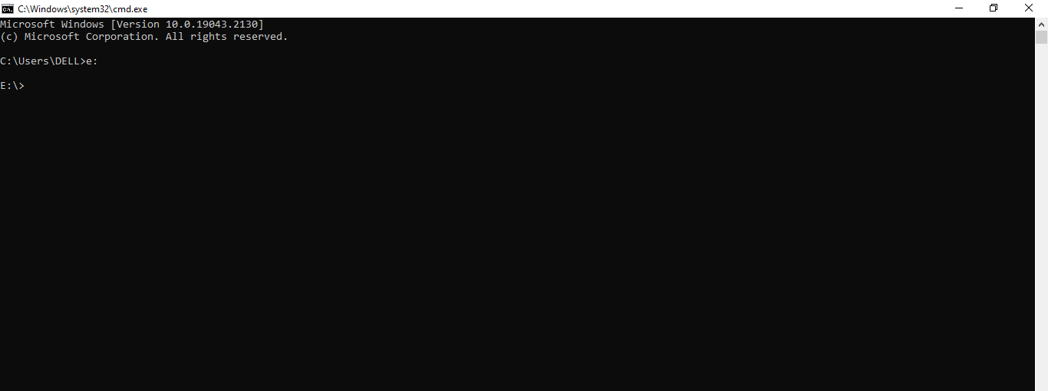

Now paste the path of JMeter’s Bin folder with cd in prefix to chance the directory

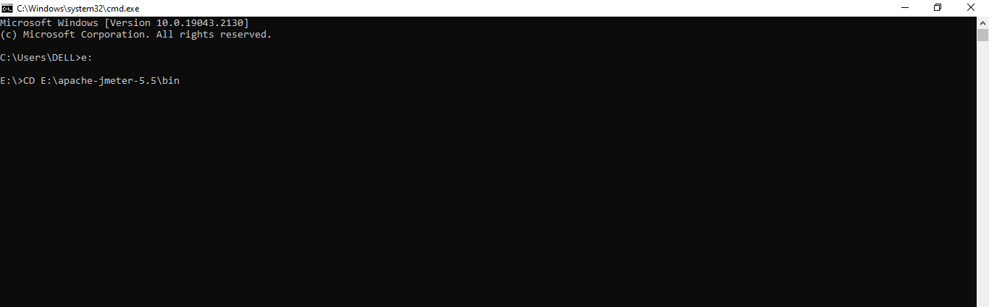

Hit Enter

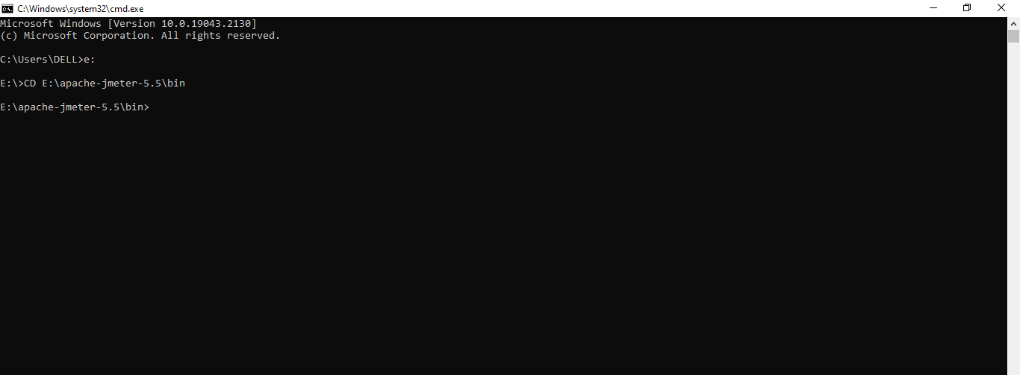

Now enter below command to run the JMeter file

jmeter -n -t <Location of your test file> -l <Location of result file>

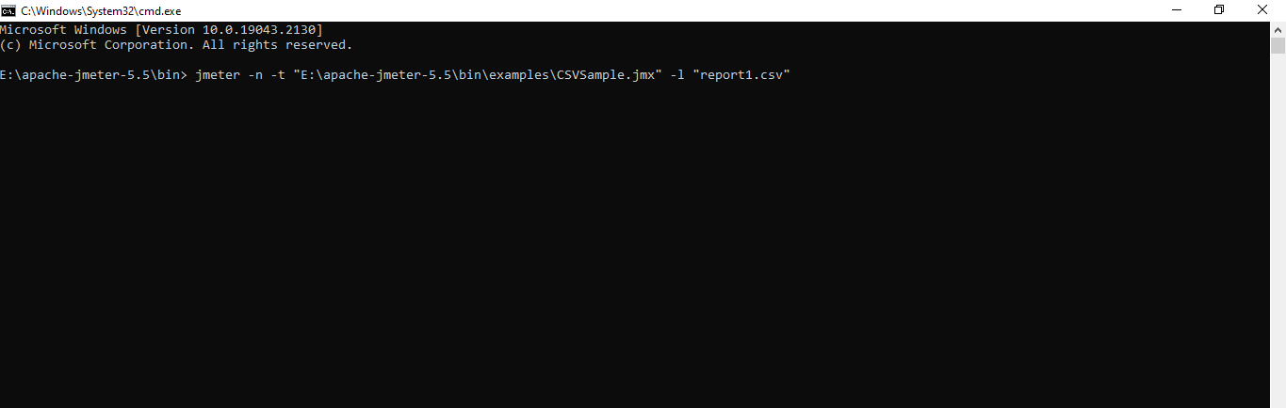

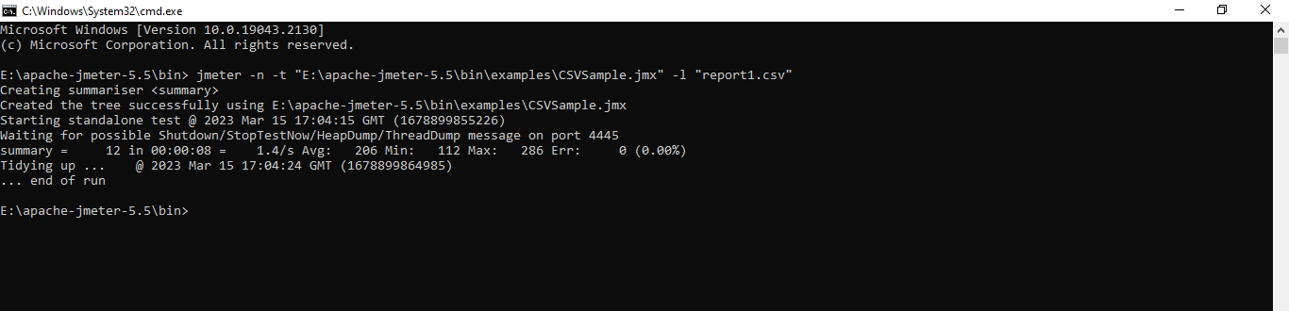

Check for the report in the BIN folder of JMeter

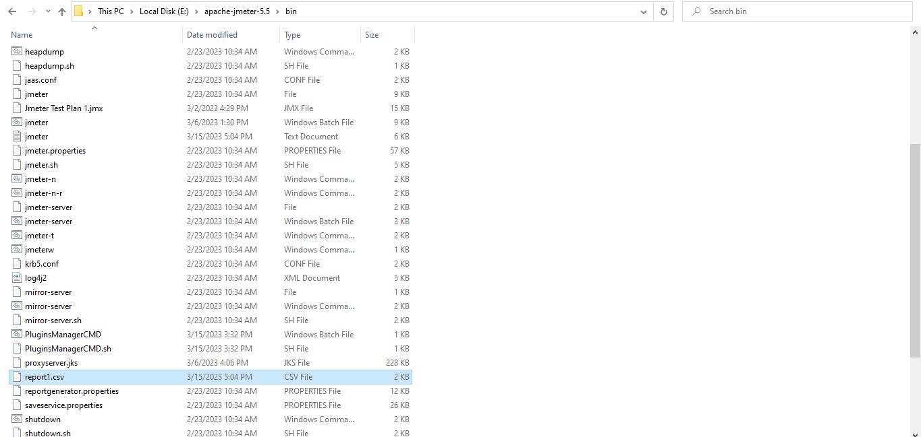

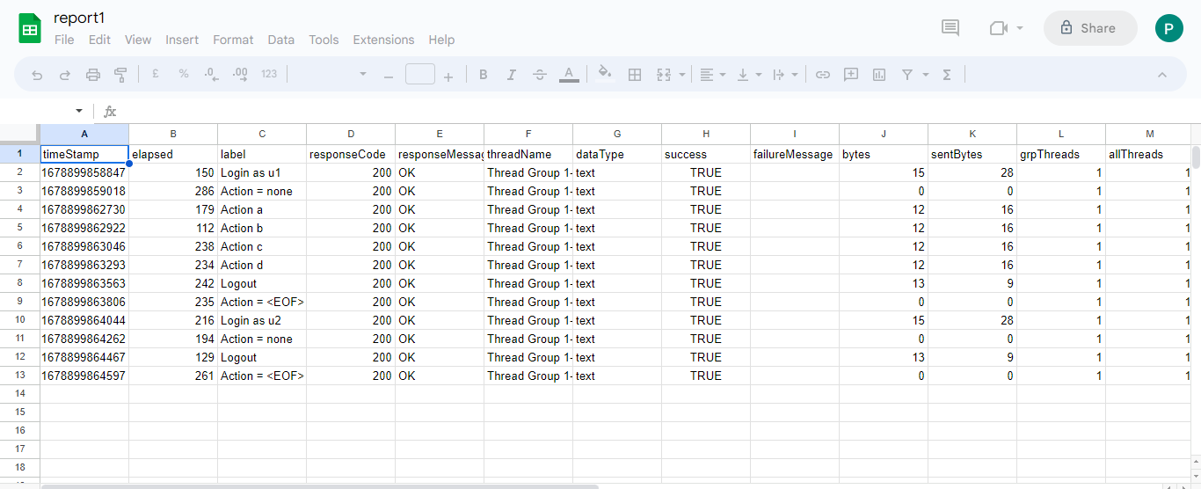

## **How to see command line help & options**

Go to Command Line & enter below either of the commands :

**Command 1 -** jmeter -h

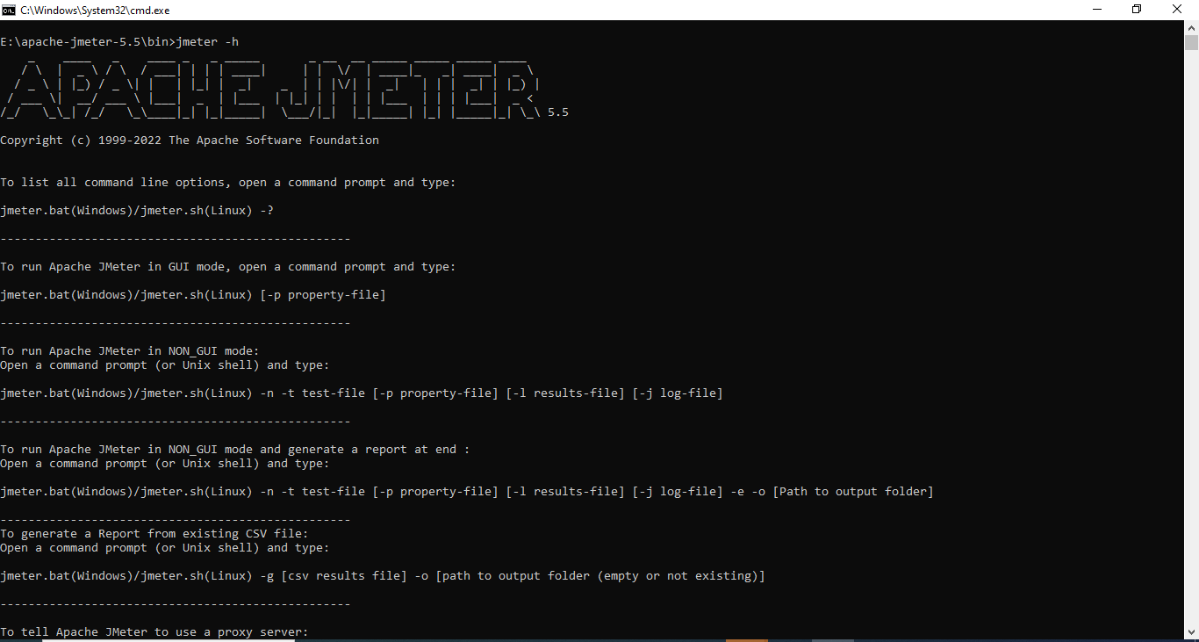

This command will give you list of all the commands that we can use

**Command 2 -** jmeter.bat -?

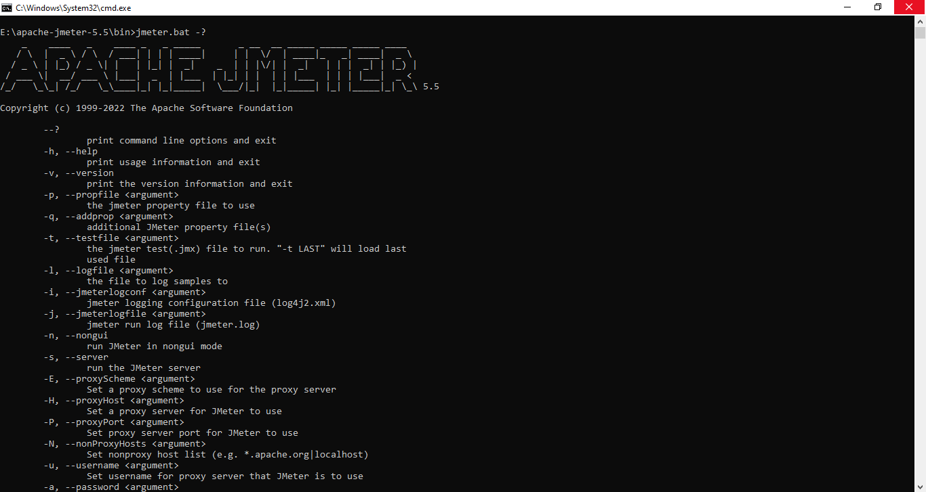

## **How to run from any location on your system (add in Path env variables)**

When we run on the command line , we navigate to JMeter’s Bin folder & then hit the required commands.

In order to run from any location , we need to set the path of JMeter’s Bin folder in the Environment variable.

**Steps to set the path of JMeter’s Bin folder in the Environment variable :**

Copy the JMeter’s Bin path & go the environment variables

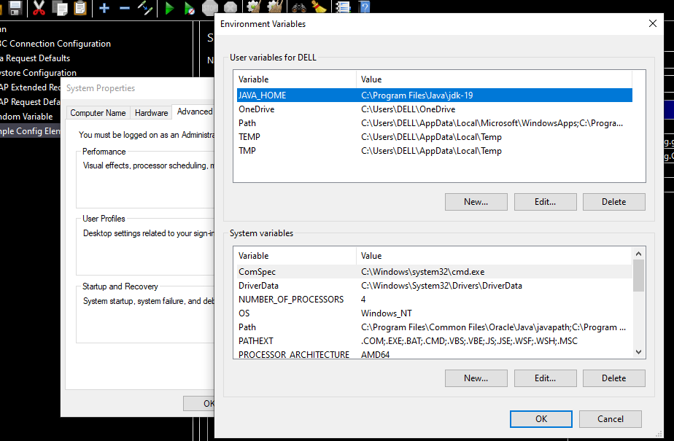

Search for Path variable in the System Variables & click on edit

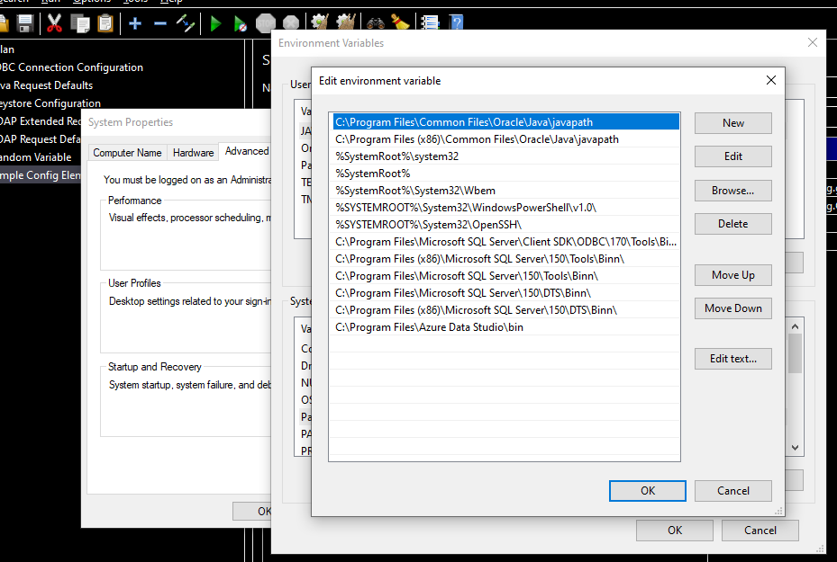

Click on New & add the path, paste the path

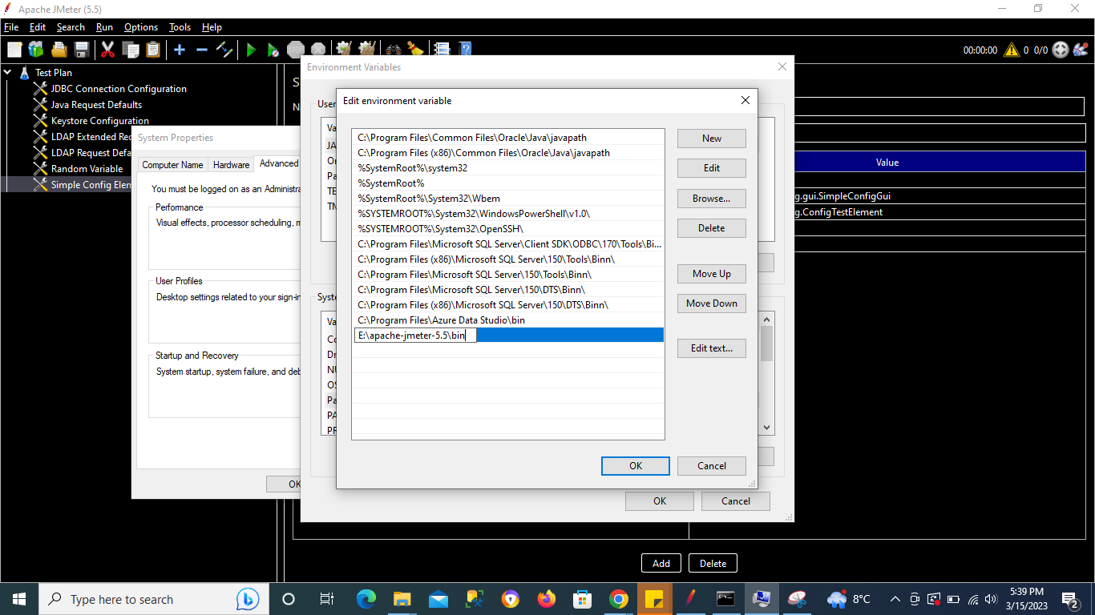

Click ok

Open the new command prompt & type your command without changing the directory & this should work

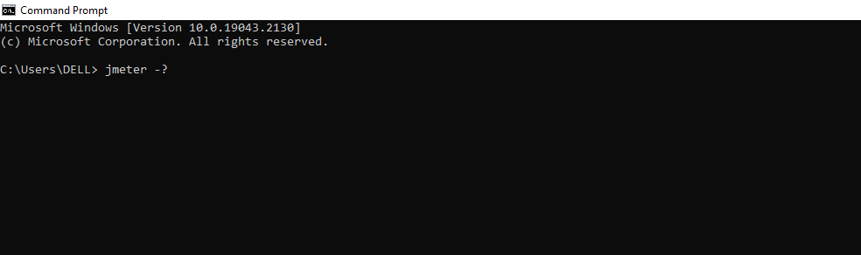

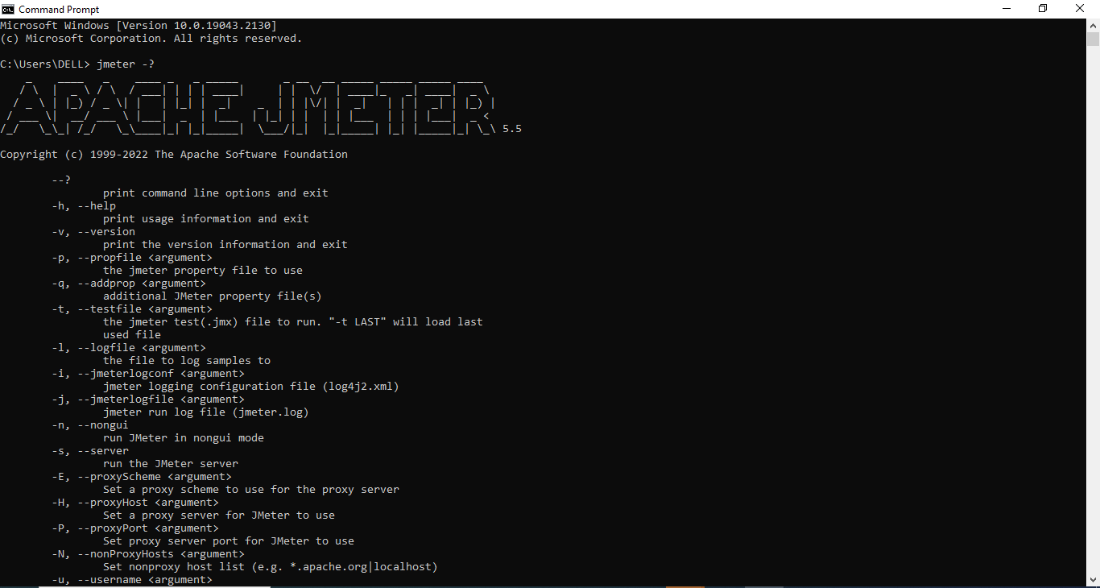

# **Create HTML Reports from CMD & GUI**

## **Create HTML Dashboard reports from Command Line**

**Step 1 - Create a Test Plan or use existing Test Plan**

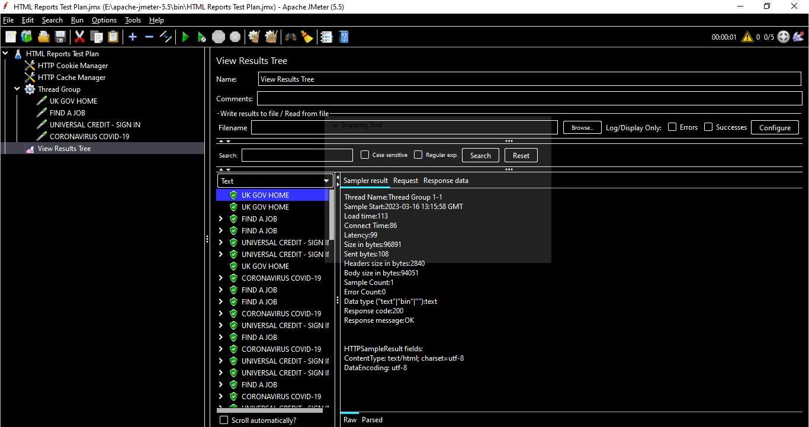

**Step 2 - Open cmd line and go to jmeter bin folder**

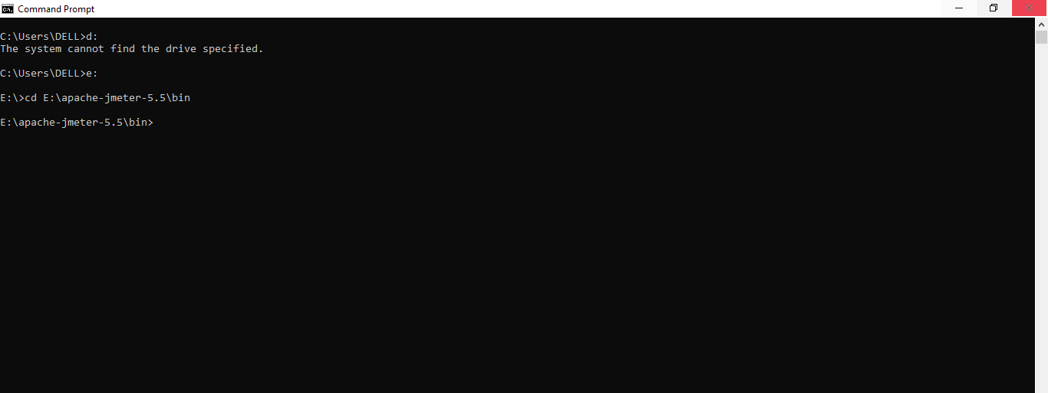

**Step 3 - Run the command**

**Command 1 - Create Report at the end of the test**

jmeter -n -t <”Location of your test file”> -l <”Location of result file”> -e -o <”Report Location”>

-e will generate the HTML reports

-o will place the reports in the folder

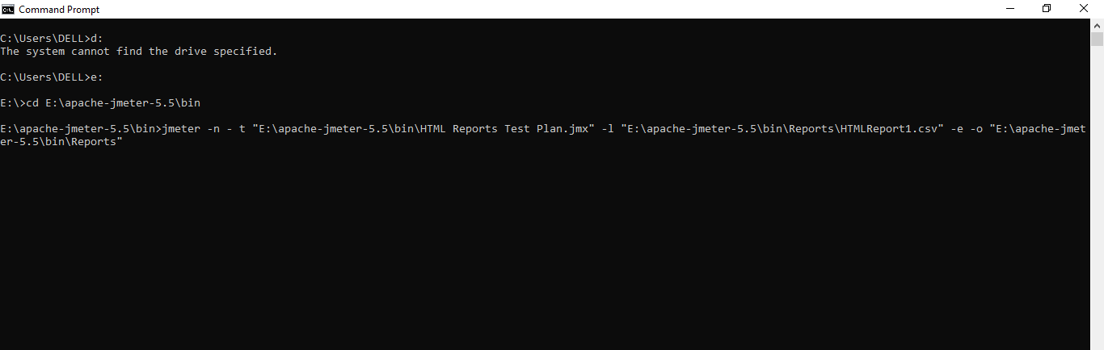

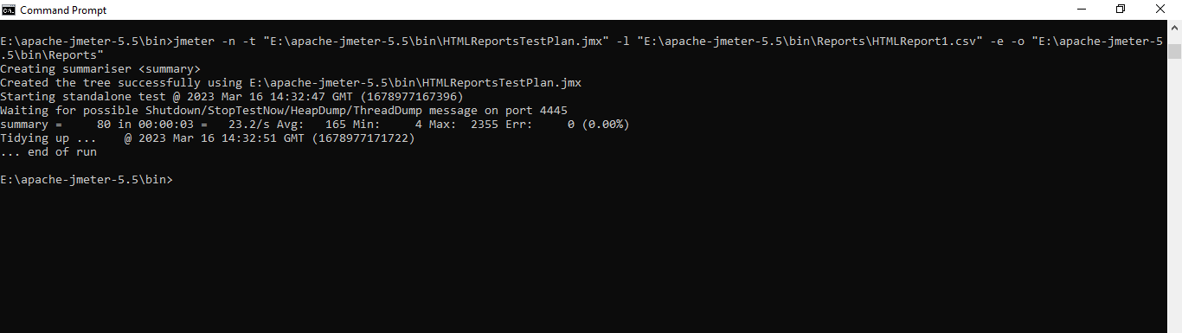

Check the CSV result & HTML Report file

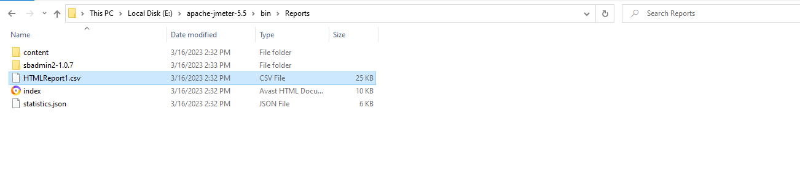

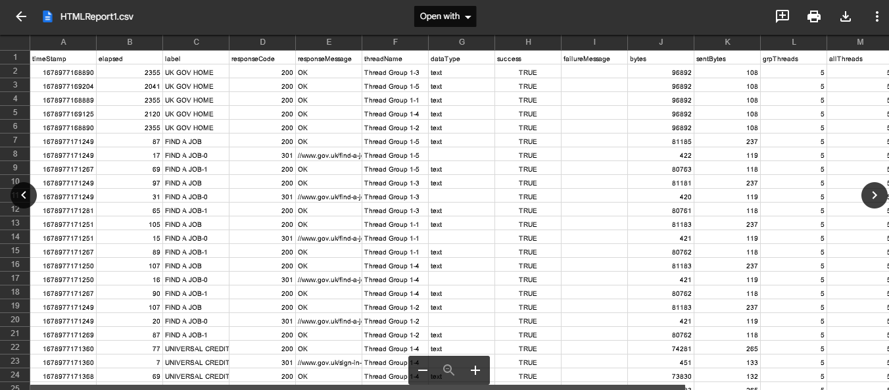

HTML Dashboard Report

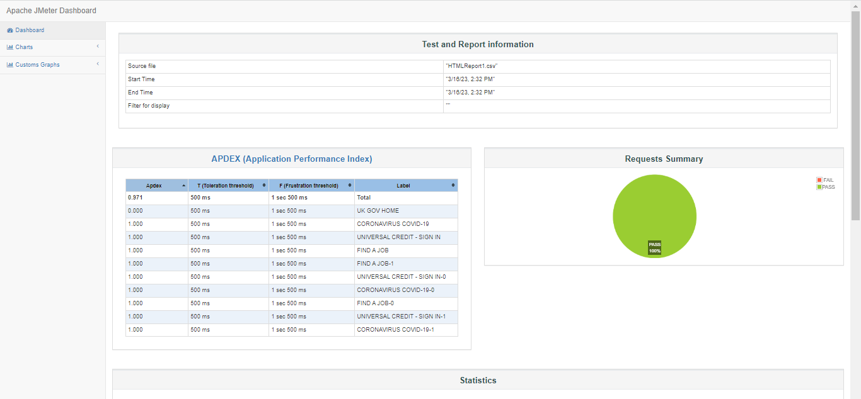

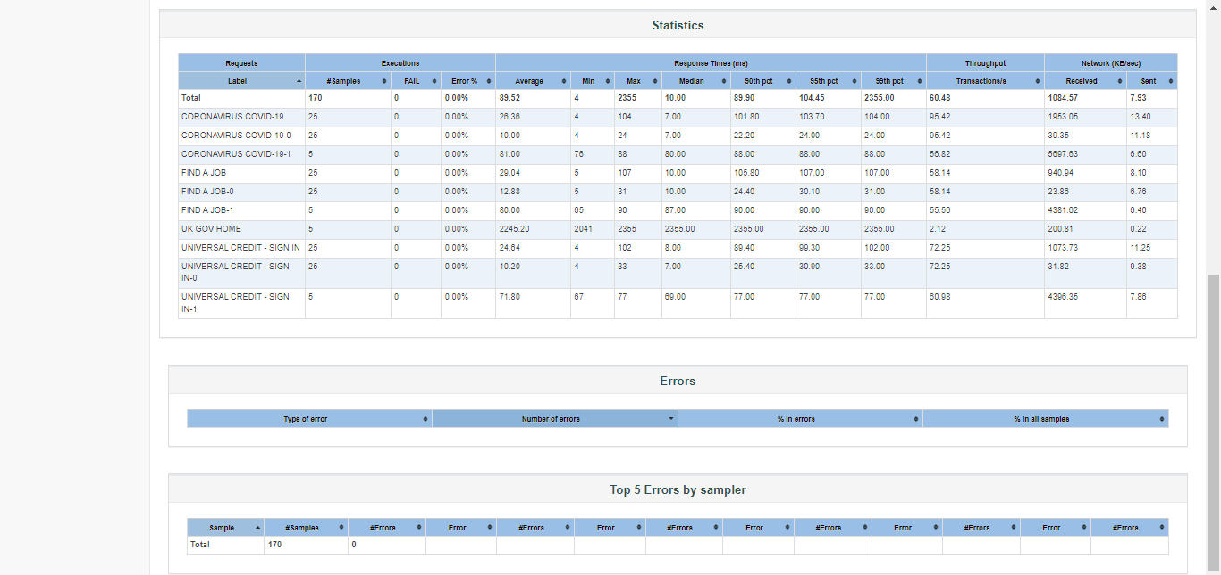

*Note - You can fail few steps & check for the results again*

**Command 2 - Create Report for a standalone CSV File**

jmeter -g <”Location of your test file”> -o <”Report Location”>

*Note - It is not necessary that the Result file or Report Location should be created before, this command will automatically generate the files*

## **Create HTML Dashboard reports from standalone CSV result file**

**Create Report for a standalone CSV File**

jmeter -g <”Location of your test file”> -o <”Report Location”>

Copy the generated Report file’s location & go to cmd line

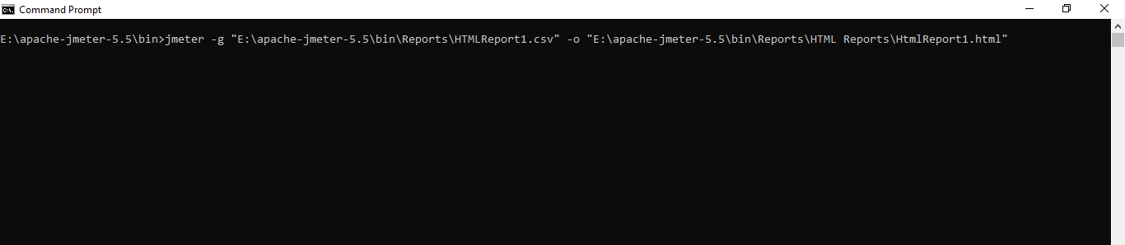

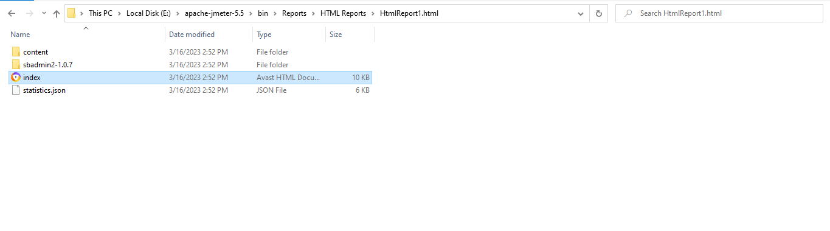

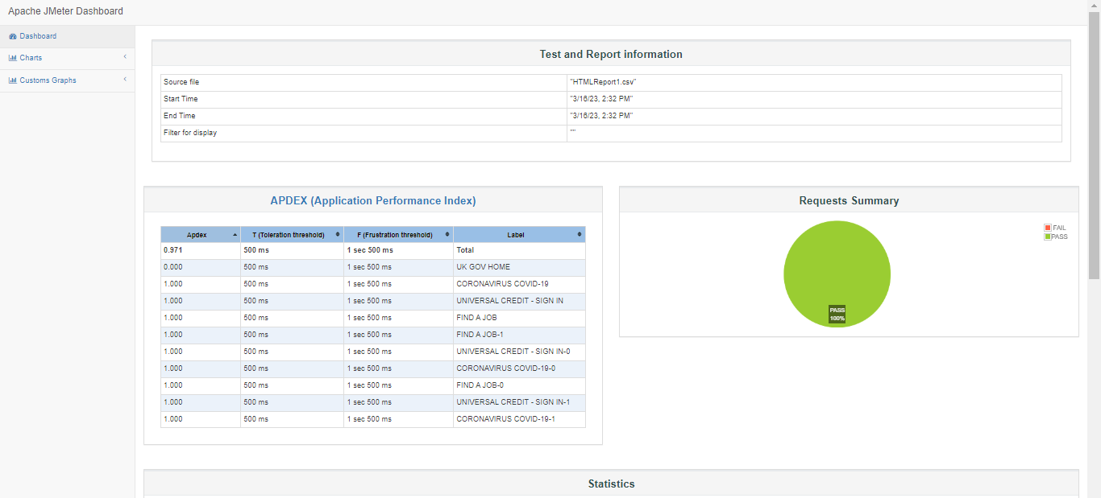

## **Study the HTML dashboard reports**

## **How to generate from GUI**

Go to JMeter GUI , Navigate to Tools & click on ***Generate HTML Report***

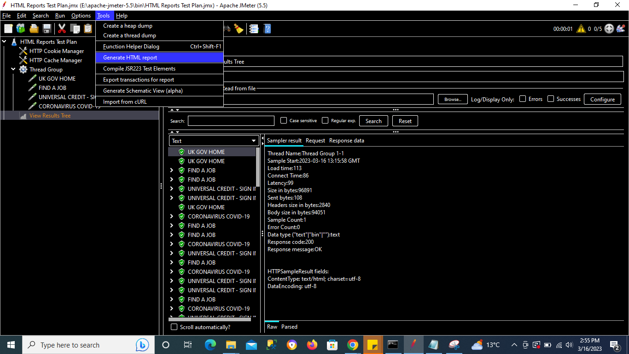

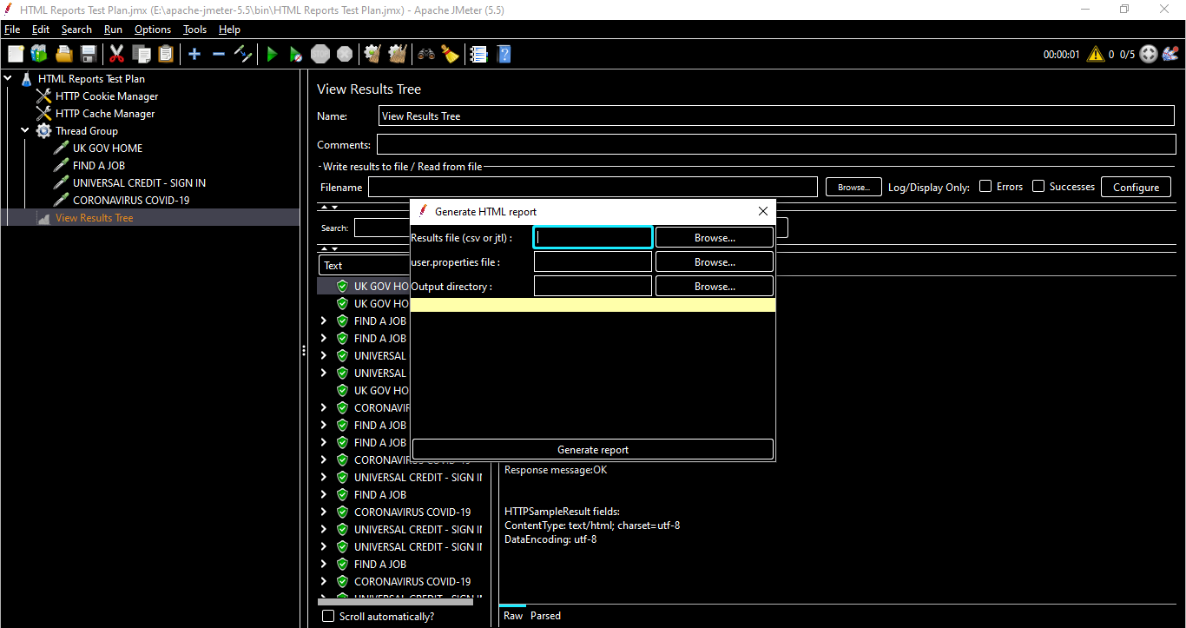

# **How to Extend JMeter | JMeter Plugins Manager**

JMeter Plugins may be defined as software functionalities used in JMeter to extend features and insert functions.

You can download the plugins from the below site

<https://jmeter-plugins.org/>

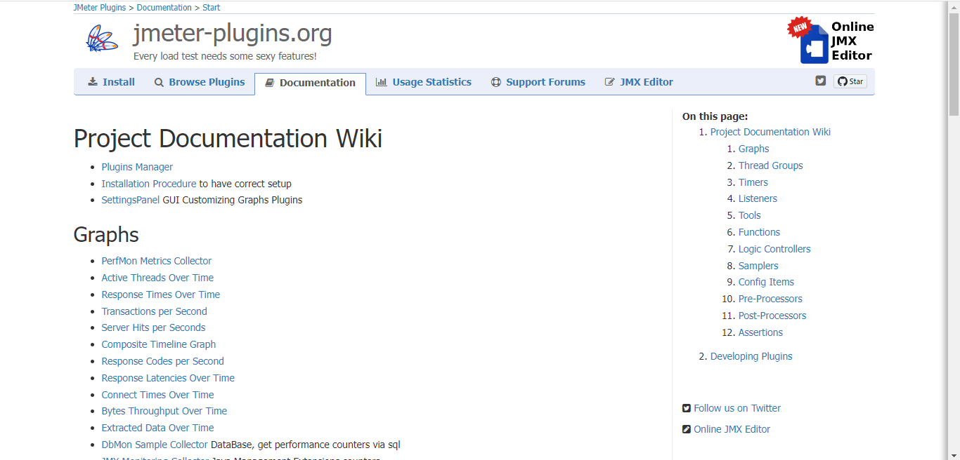

To download any plugin, click on the plugin link & click on Download button & add to the JMeter\lib\ext path

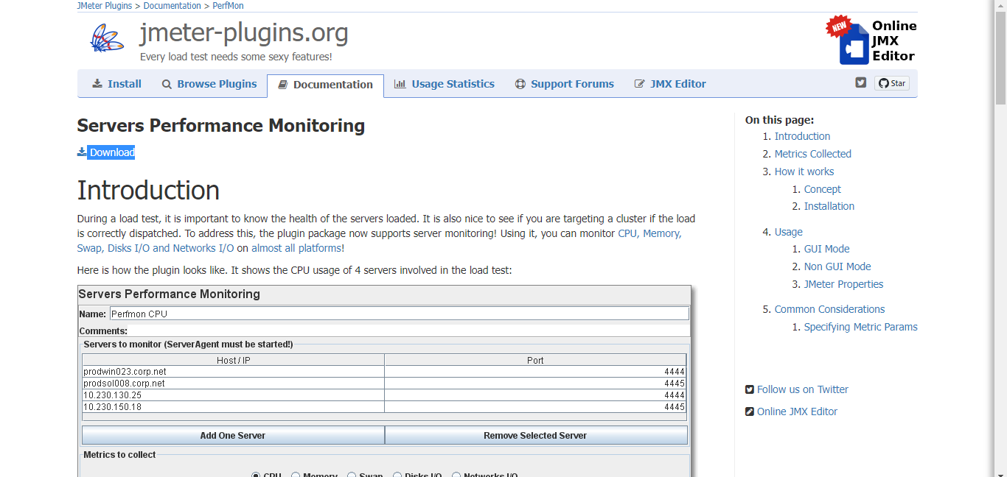

## **Plugins Manager**

The idea of JMeter Plugins Manager is simple: instead of installing various plugins manually, it will do it for you through a nice UI. No need to mess with JARs anymore. Install Plugins Manager once and it will do it all for you: installing, upgrading, uninstalling.

Another best way is to use Plugins Manager

Go to below link

<https://jmeter-plugins.org/wiki/PluginsManager/>

Download the jar file & put it into JMeter's lib/ext directory. Then start JMeter and go to the "Options" menu to access the Plugins Manager.

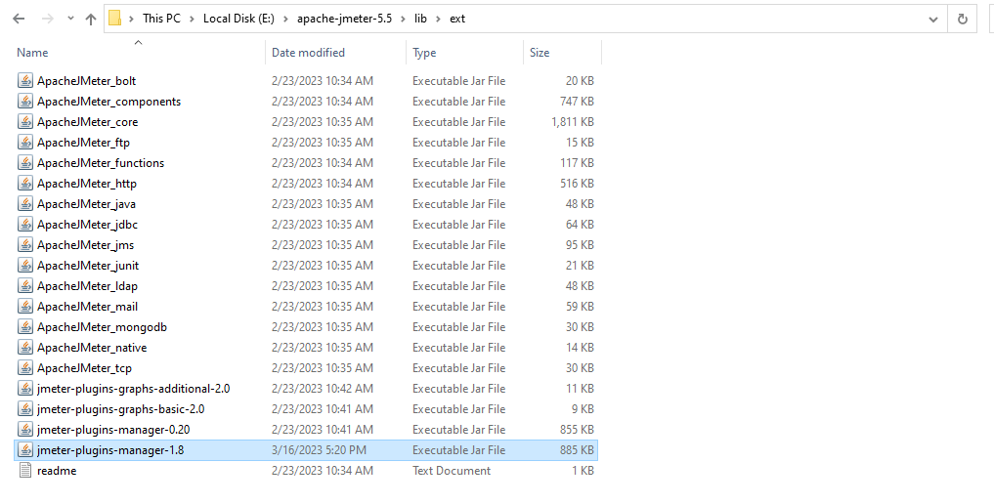

Go to JMeter GUI & restart the JMeter

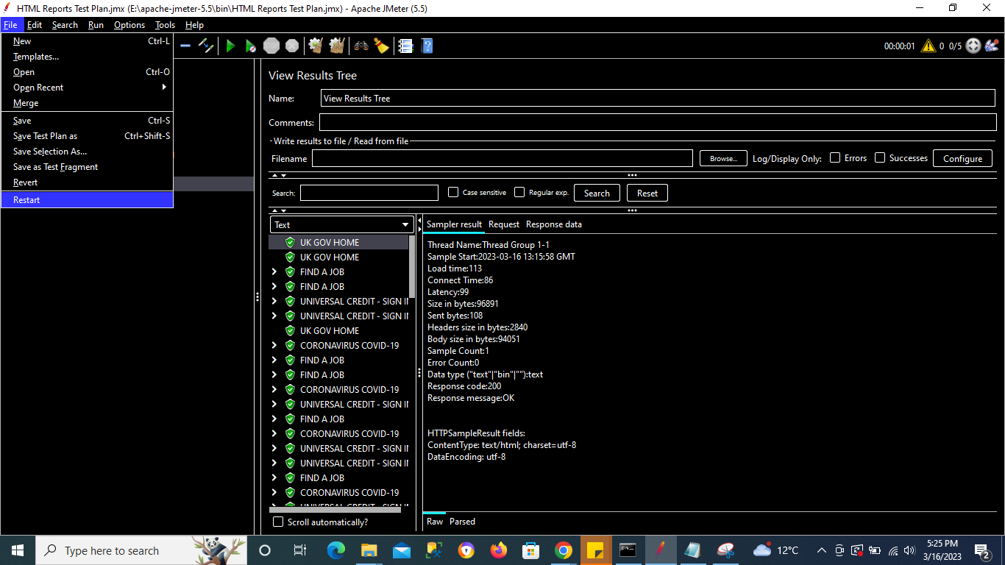

Now go to Options & click on **Plugins Manager**

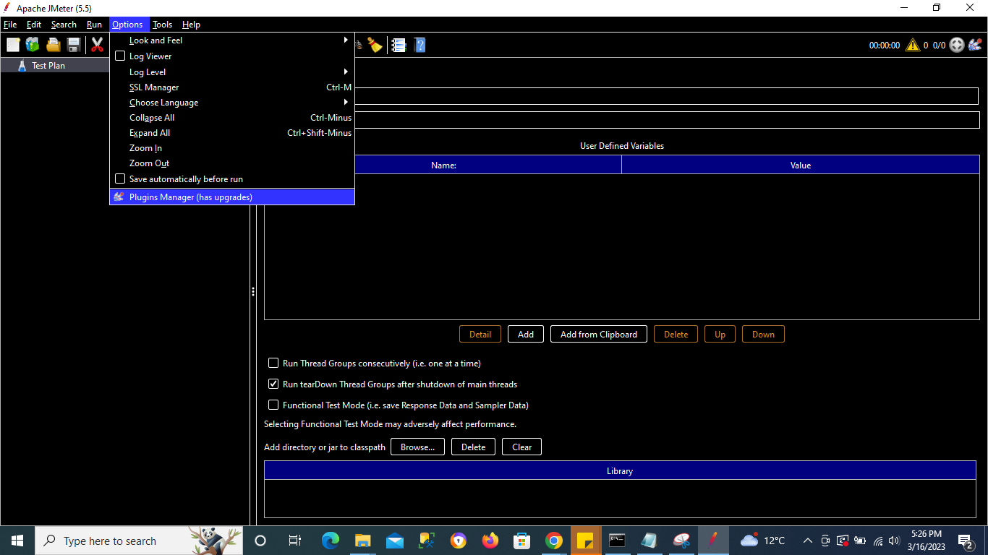

This will show list of Installed Plugins, Available plugins & Upgrades if any

Once user clicks on any installed plugin link , it will display all information for that particular plugin

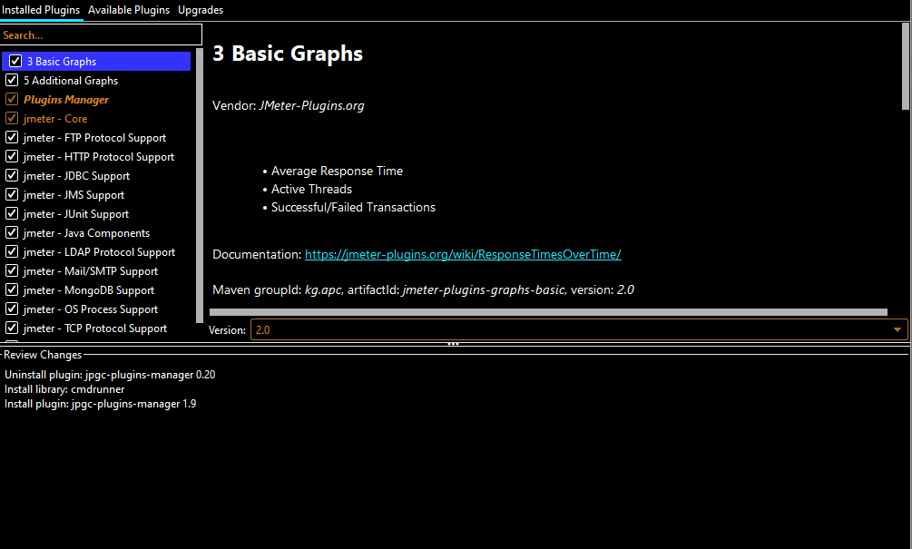

To add a new plugin , Select any plugin to be installed & click on **Apply Changes & Restart JMeter** button

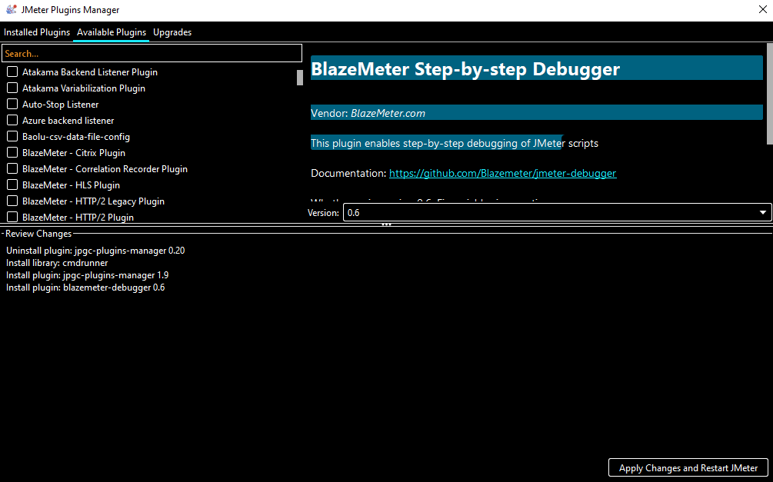

Similarly we can uninstall the plugins by navigating t Installed plugins & selecting the Plugin to be installed & click on Uninstall button

# **REST API Testing in JMeter**

## **What is REST API**

RESTful API is an interface that two computer systems use to exchange information securely over the internet. Most business applications have to communicate with other internal and third-party applications to perform various tasks.

**STEPS**

Create a test plan & add Thread Group

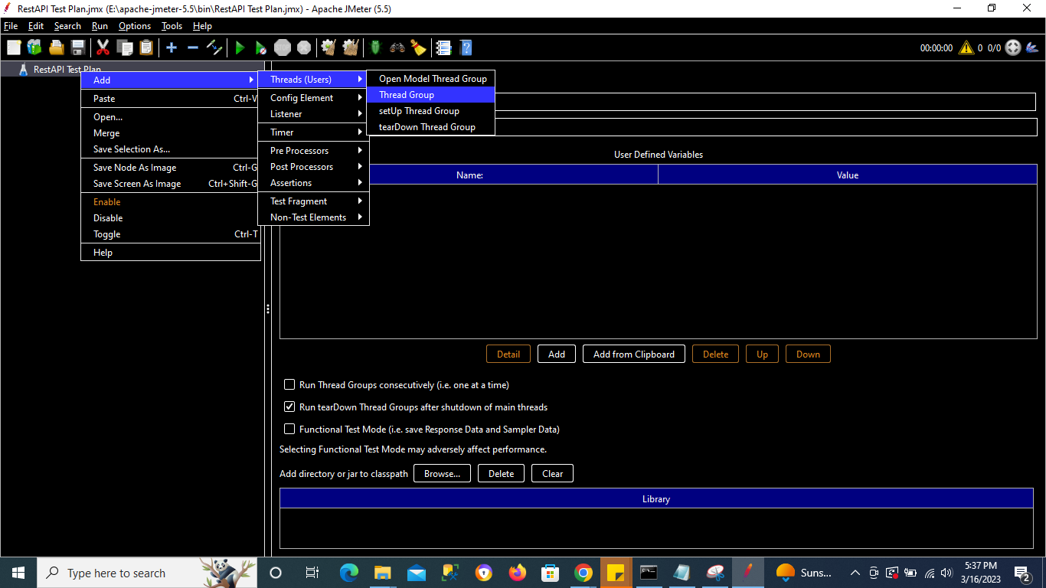

Search for sample Rest API on google for testing/demo - <https://reqres.in/>

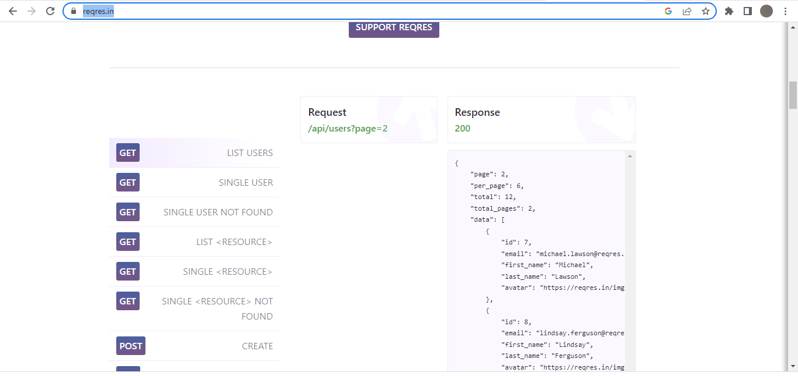

## **GET Request [Retrieve]**

Open the 1st GET API in other Tab to get the details

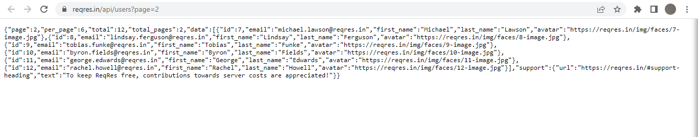

Add a HTTP Request Sampler

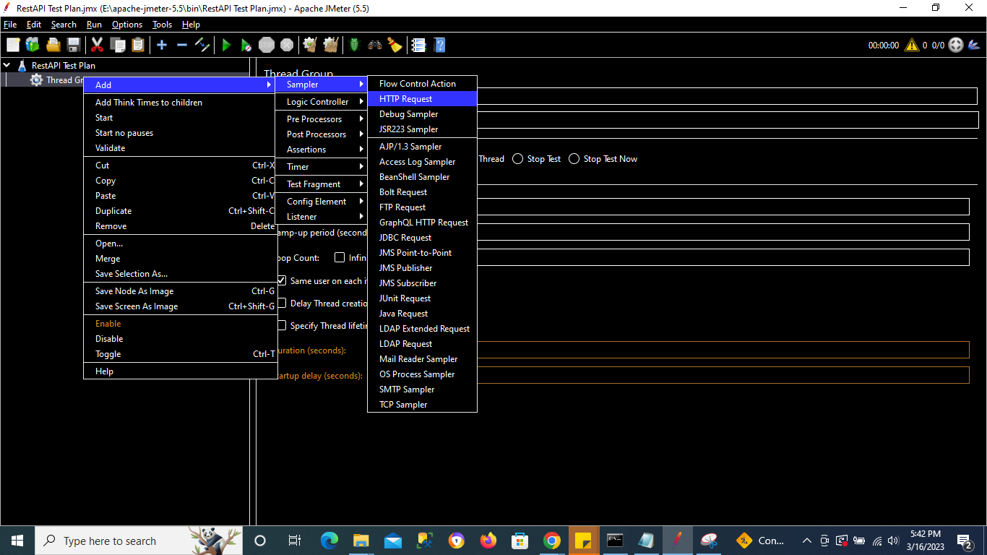

API Url - <https://reqres.in/api/users?page=2>

**https - Protocol**

**Reqres.in - Server Name or IP**

**api/users – path**

**Page =2 - Parameter**

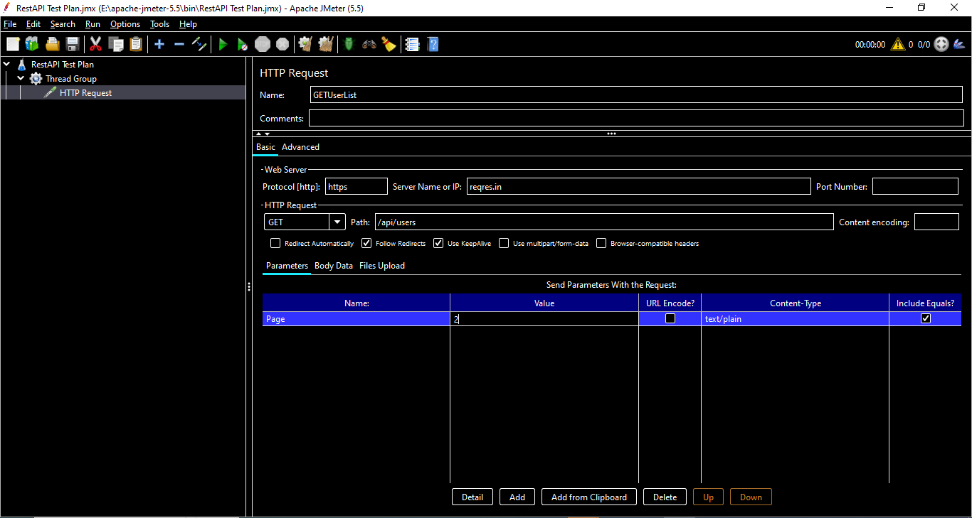

*Note - Incase the API need authentication then we should use HTTP Authorization config element & for any headers we can use HTTP Headers Manager*

Add Listeners to the test plan

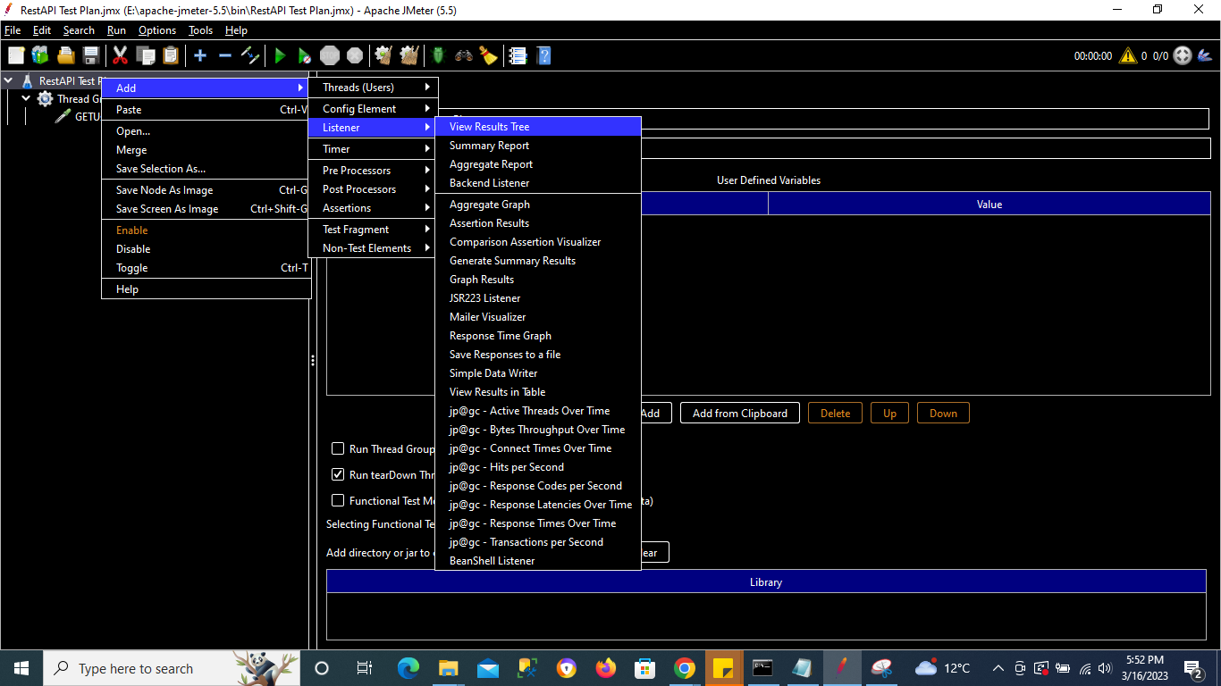

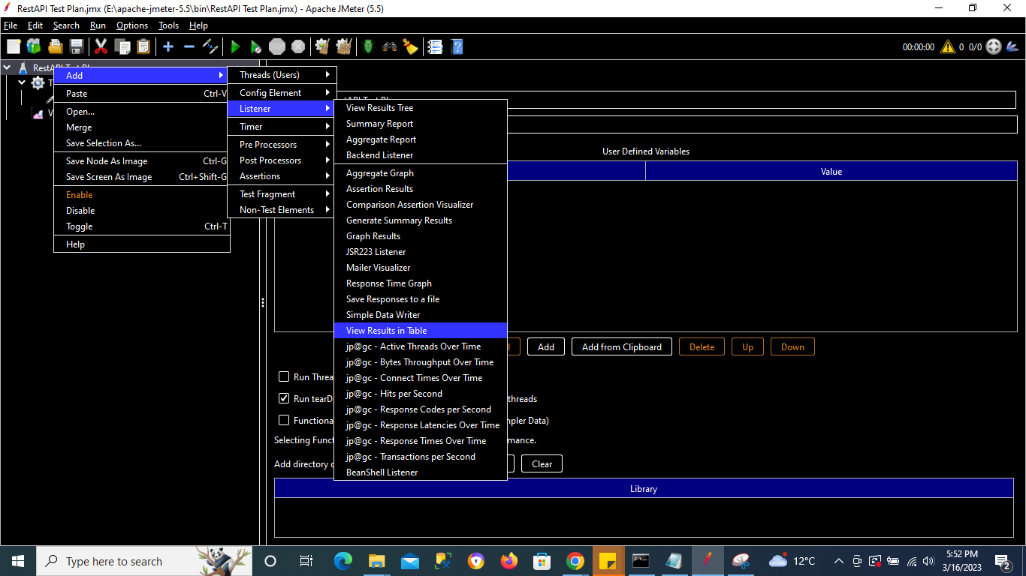

Run the Test Plan

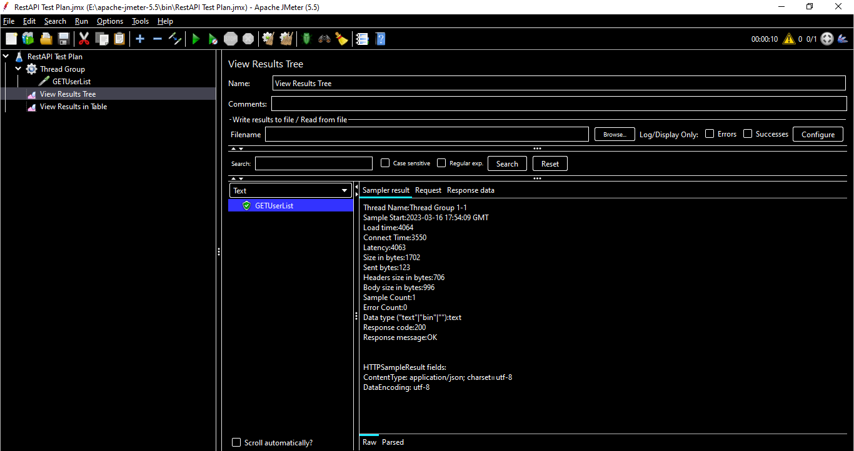

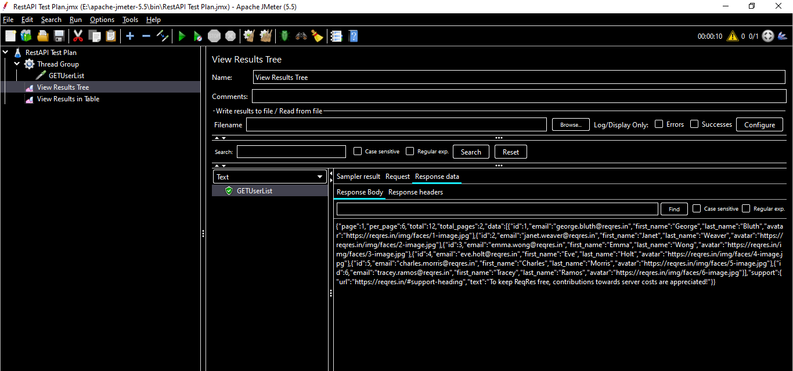

## **POST Request [CREATE]**

POST Request API url - <https://reqres.in/api/users>

**https - Protocol**

**reqres.in - Server Name or IP**

**api/users – path**

Add a **HTTP Request** Sampler

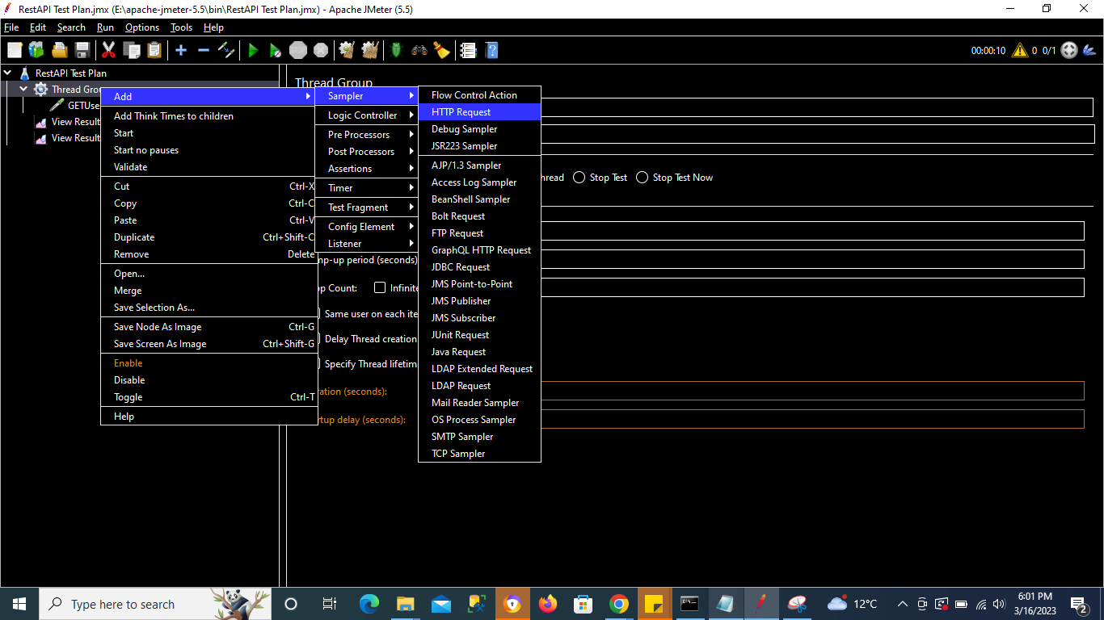

Change the method to POST

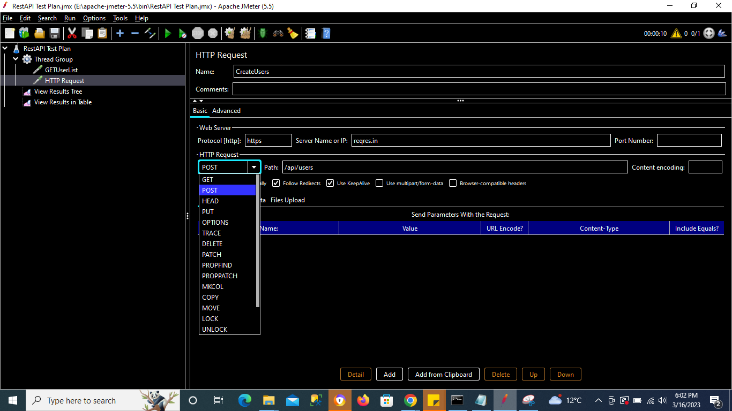

Since this is a POST Request , we will need to add Body

**API Body**

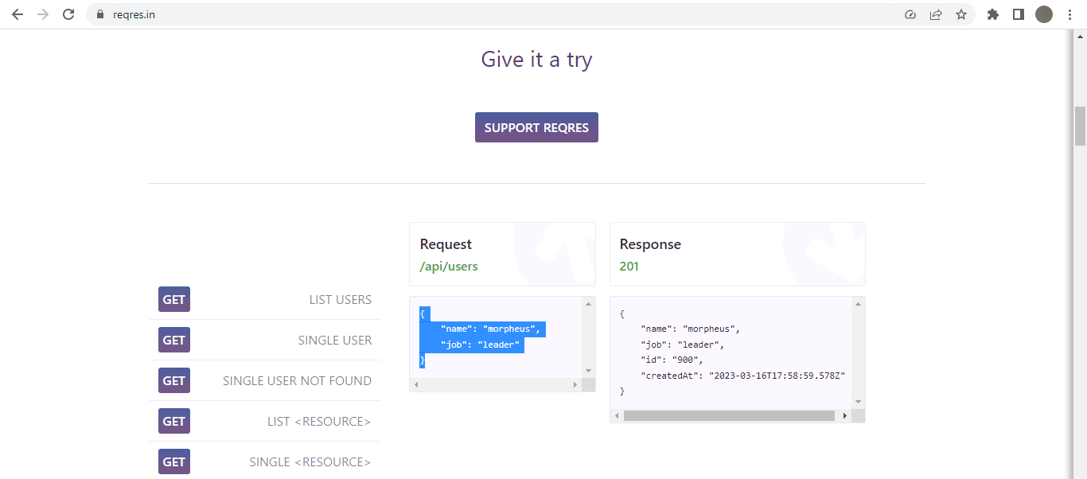

**JMeter Body Data**

Paste above data in JMeter Body Data Section

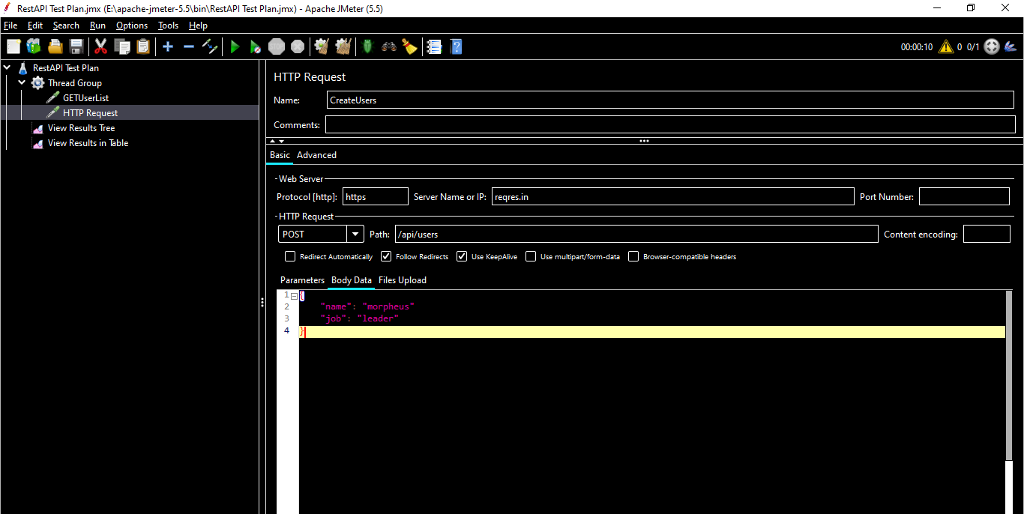

Run the Test Plan

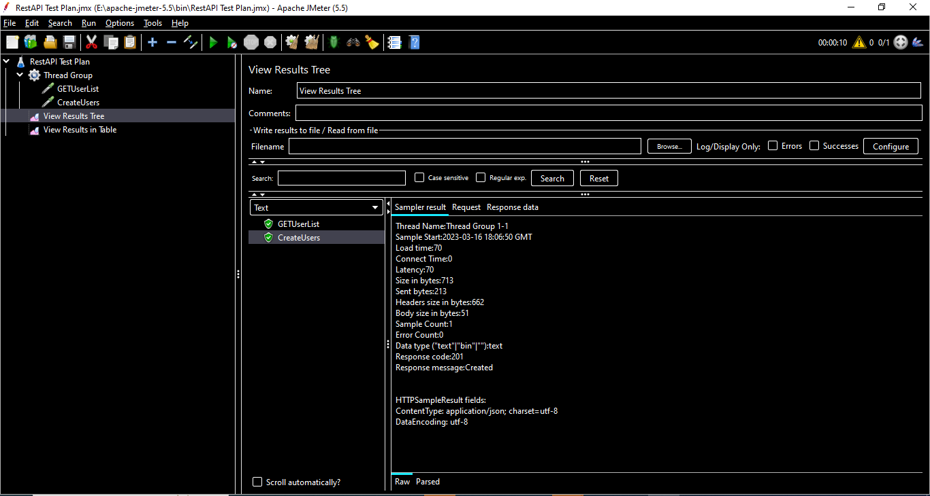

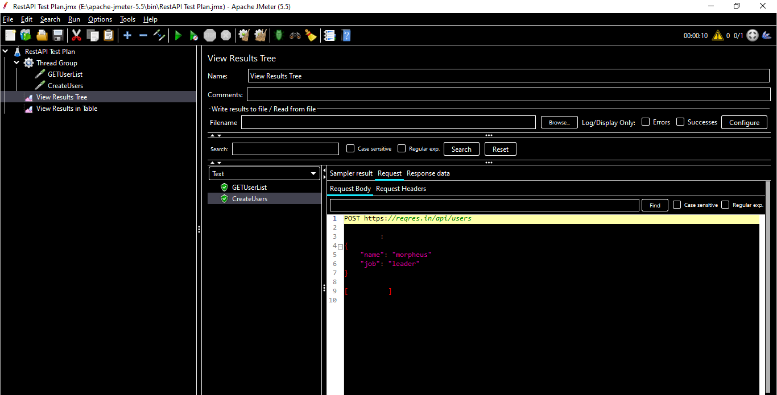

## **PUT Request [Update]**

POST Request API url - <https://reqres.in/api/users/2>

**https - Protocol**

**reqres.in - Server Name or IP**

**api/users/2 – path**

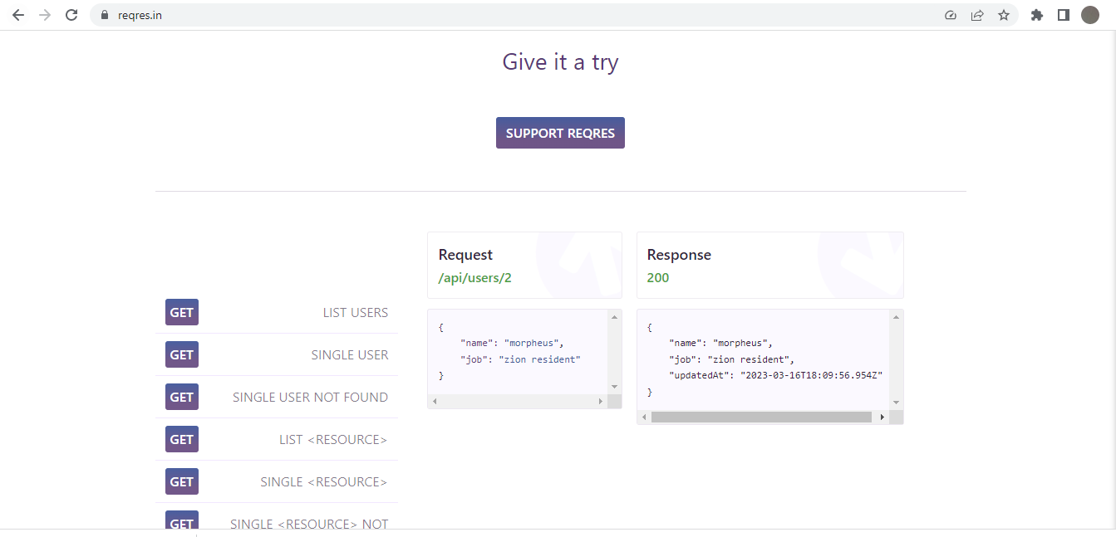

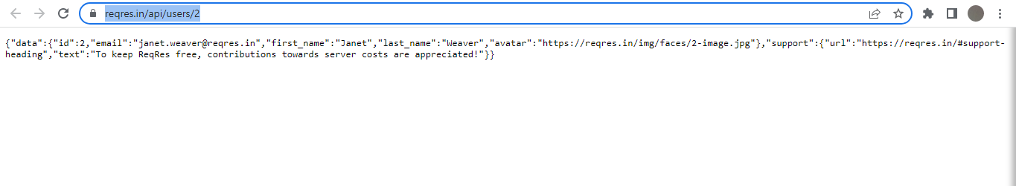

Add a **HTTP Request** Sampler

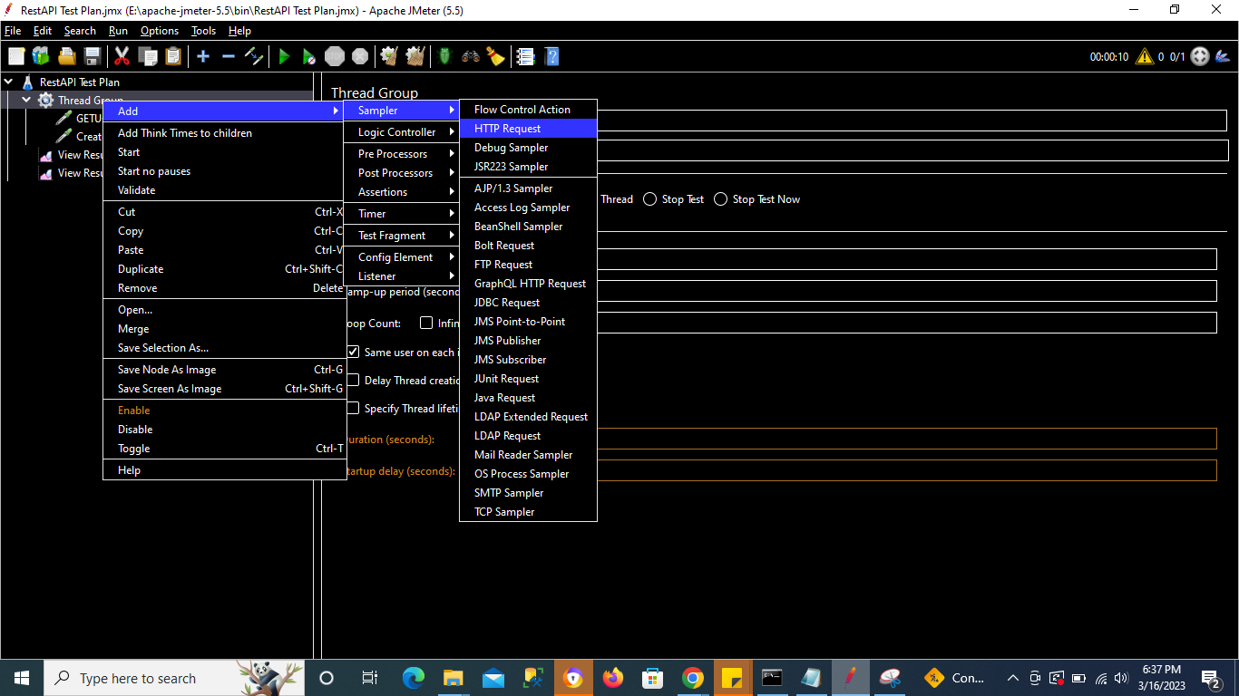

Change the method to PUT

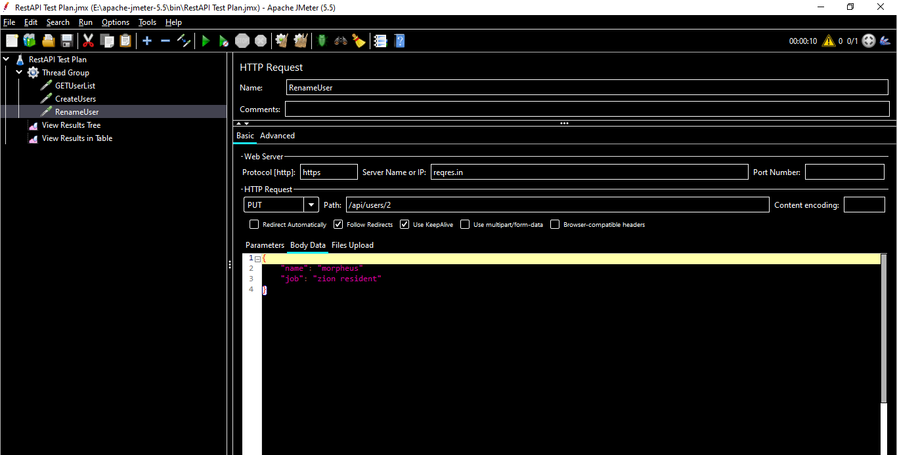

Since this is a PUT Request , we will need to add Body

**API Body**

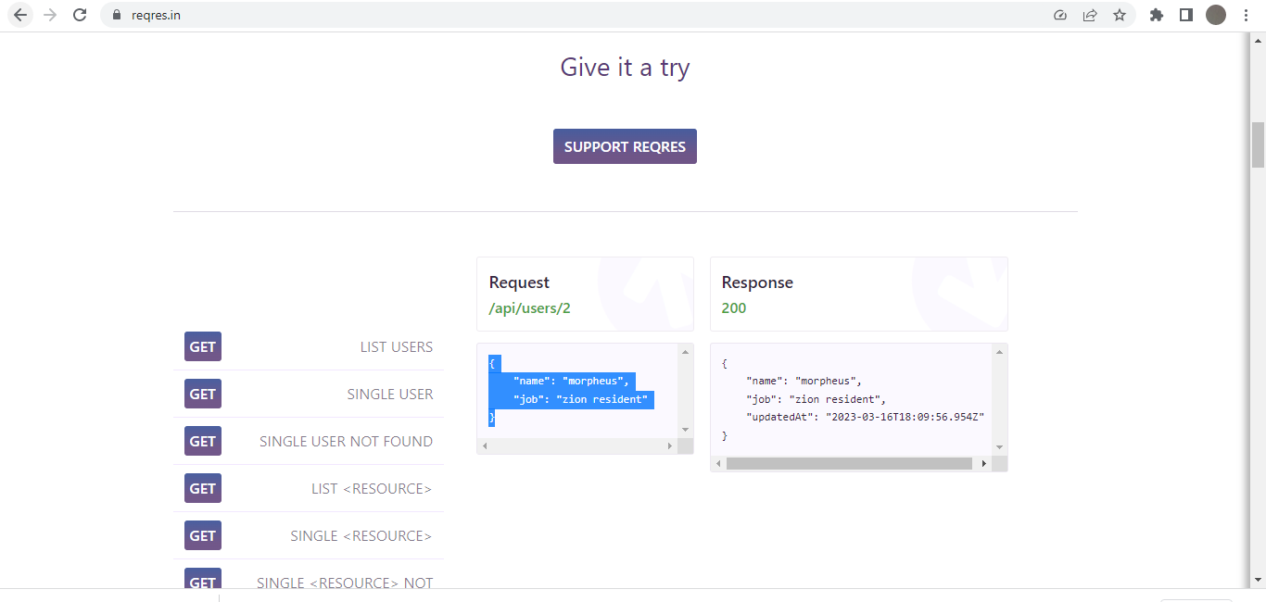

**JMeter Body Data**

Paste above data in JMeter Body Data Section



Run the Test Plan

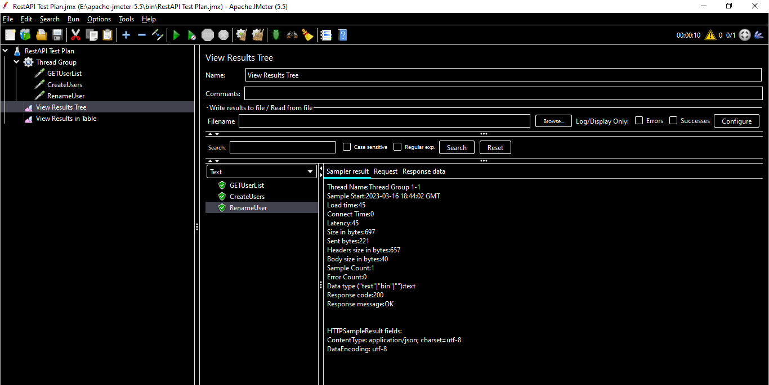

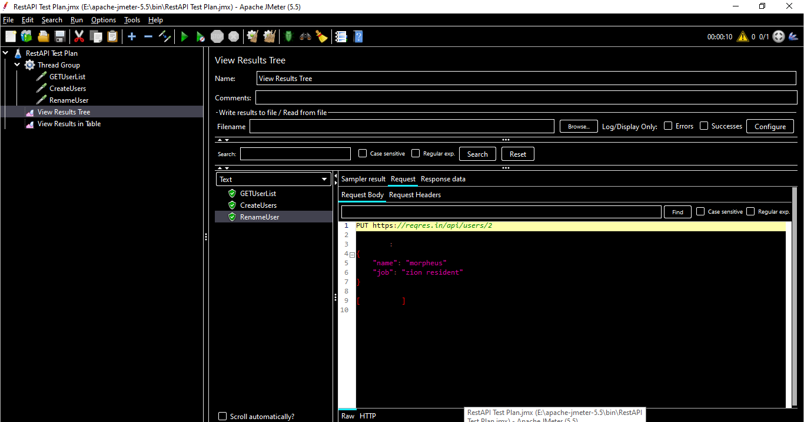

## **DELETE Request [DELETE]**

POST Request API url - <https://reqres.in/api/users/2>

**https - Protocol**

**reqres.in - Server Name or IP**

**api/users/2 – path**

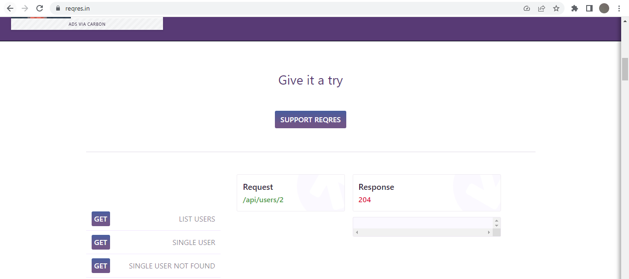

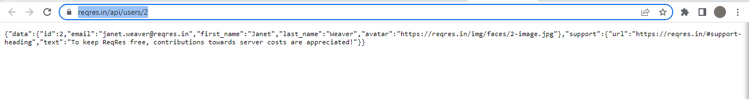

Add a **HTTP Request** Sampler

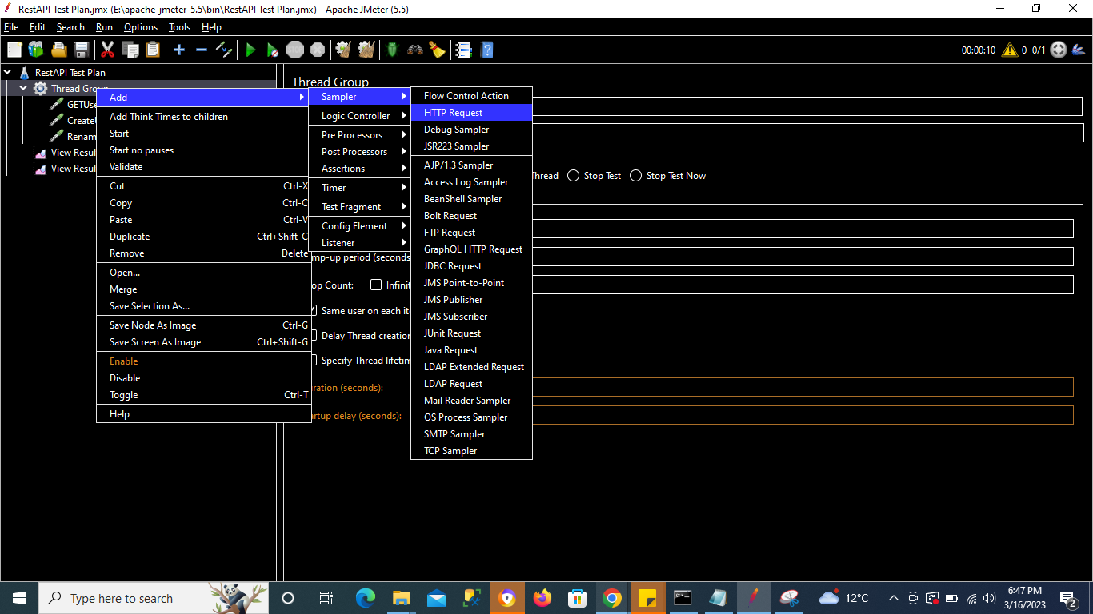

Change the method to DELETE

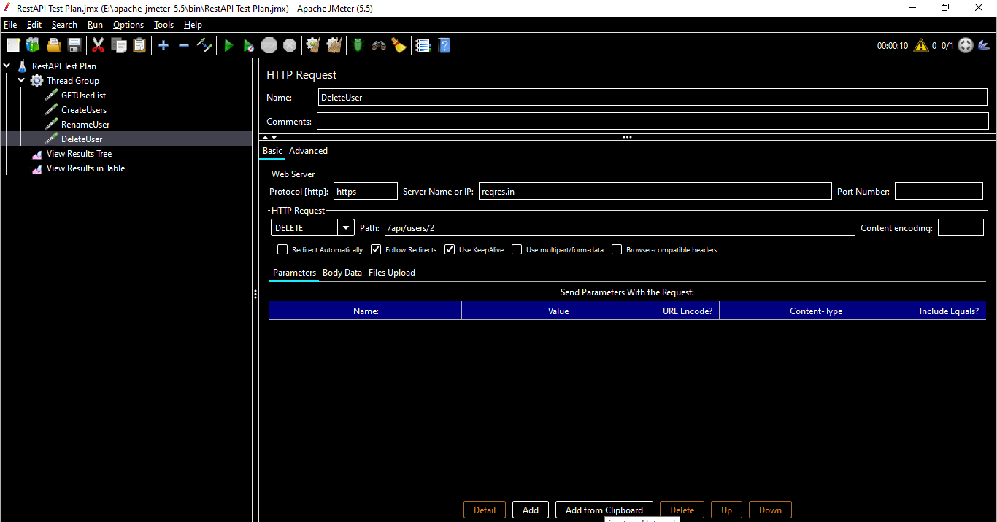

Run the Test Plan

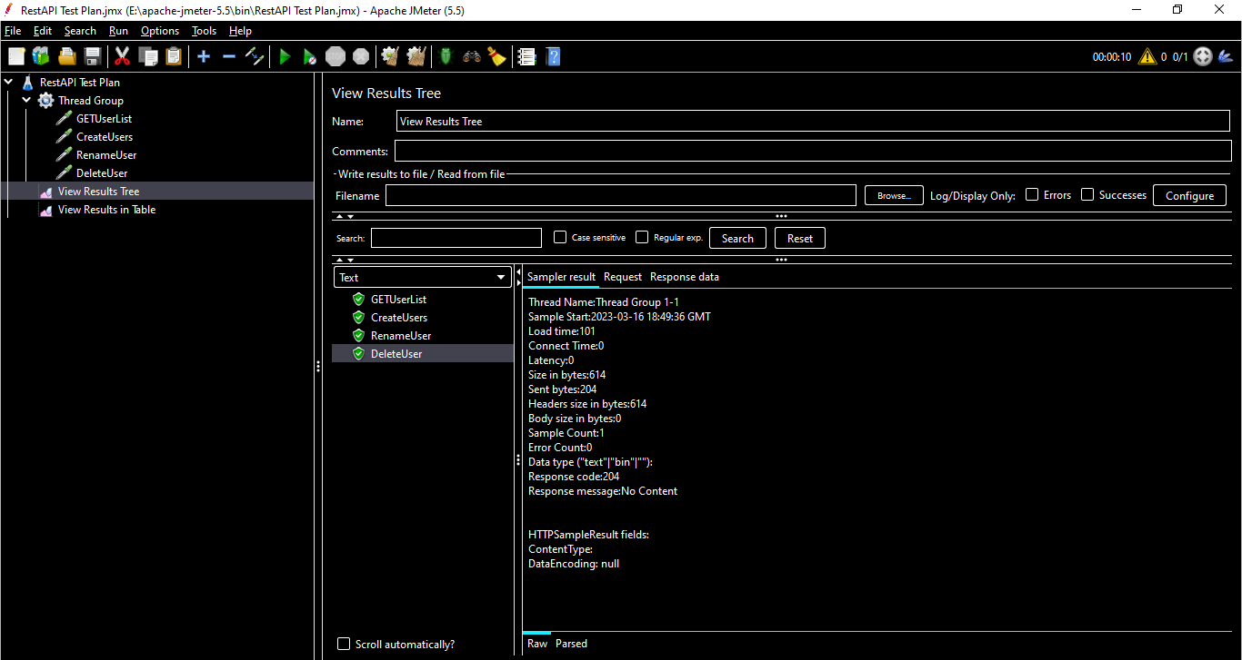

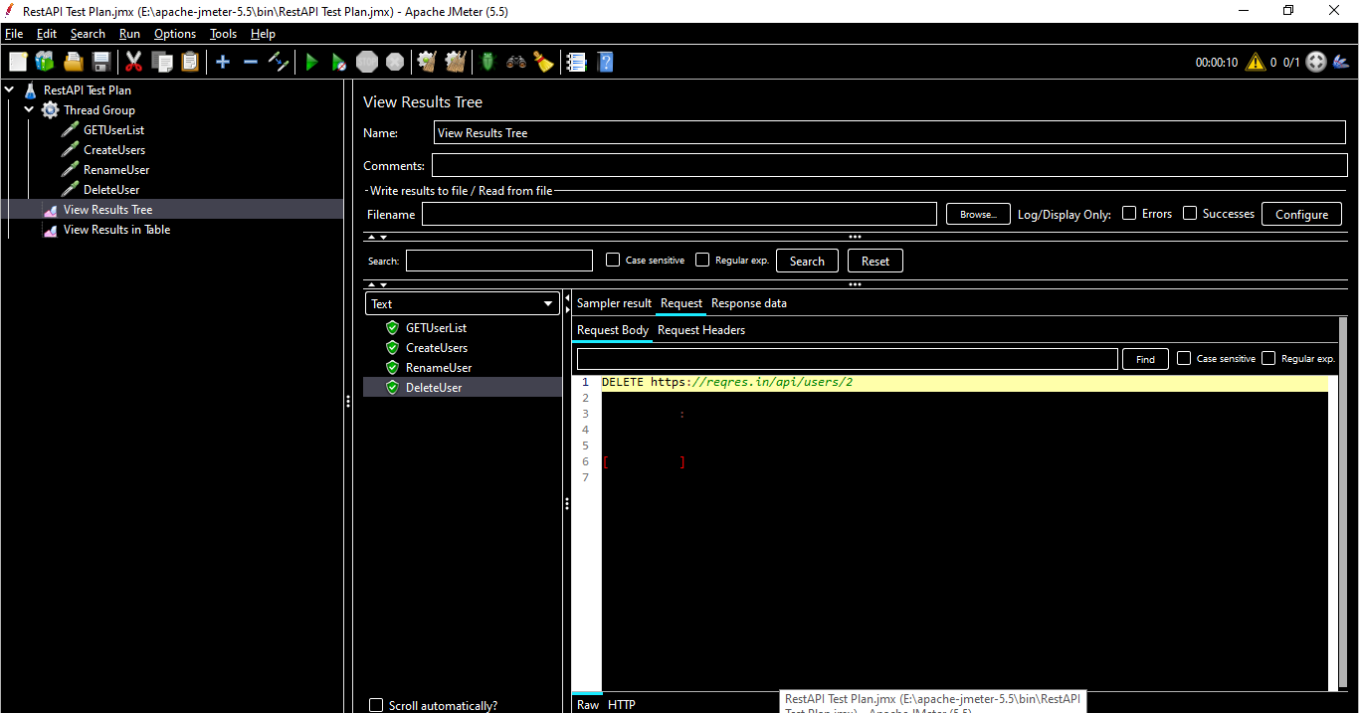

# **SOAP API Testing in JMeter**

## **What is SOAP API**

SOAP is a standard communication protocol system that permits processes using different operating systems like Linux and Windows to communicate via HTTP and its XML. SOAP based APIs are designed to create, recover, update and delete records like accounts, passwords, leads, and custom objects.

## **Difference Between SOAP & REST**

SOAP is a protocol, whereas REST is an architectural style

For example, a SOAP API that exposes functionality to create a user might include a function called "CreateUser" that would be specified in the SOAP body. A REST API would instead expose a URL /users, and a POST request towards that URL would create a user.

## **What is Web Services?**

Web Services are server-side programs that listen for messages from client applications and return specific information.

This information may come from the Web Service itself, from other components in the same domain, or from the other Web Services.

## **What is a WSDL file?**

A WSDL document contains information about the method that a Web Service supports and how they can be called.

Example Web Service link used

<http://www.dneonline.com/calculator.asmx?WSDL>

We can subtract and add using a calculator

WSDL File -

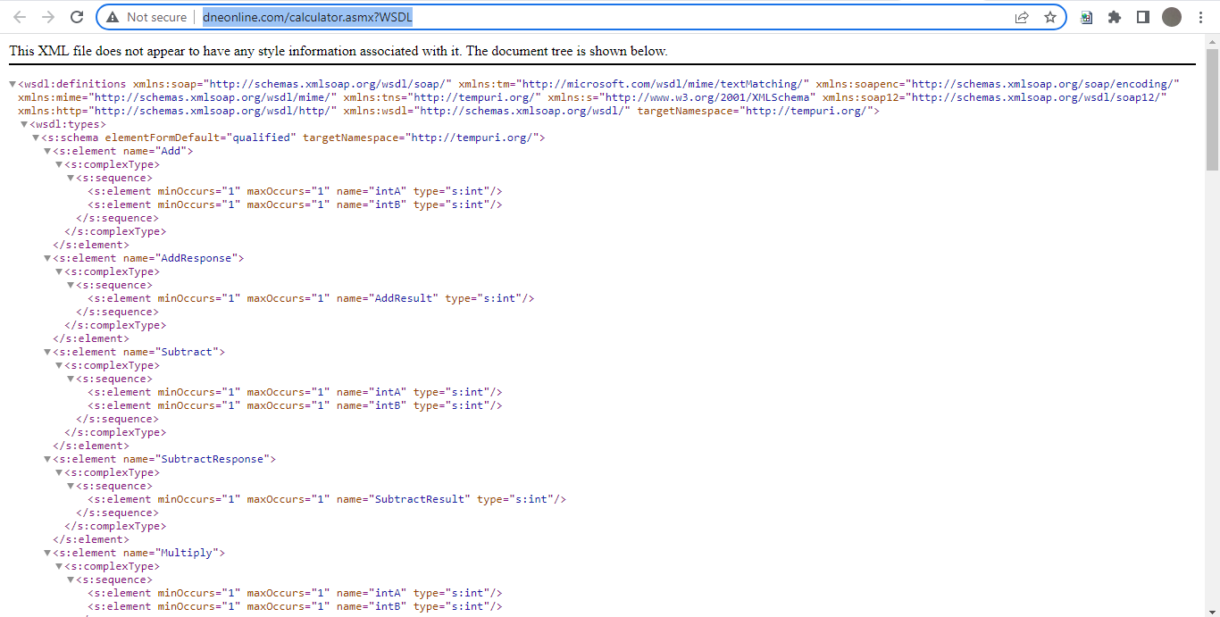

Create a Test Plan using a template

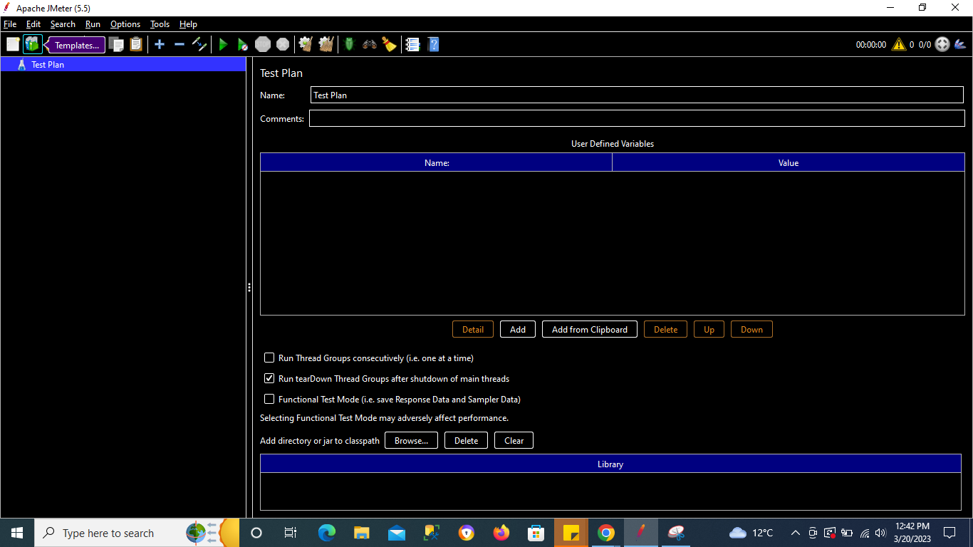

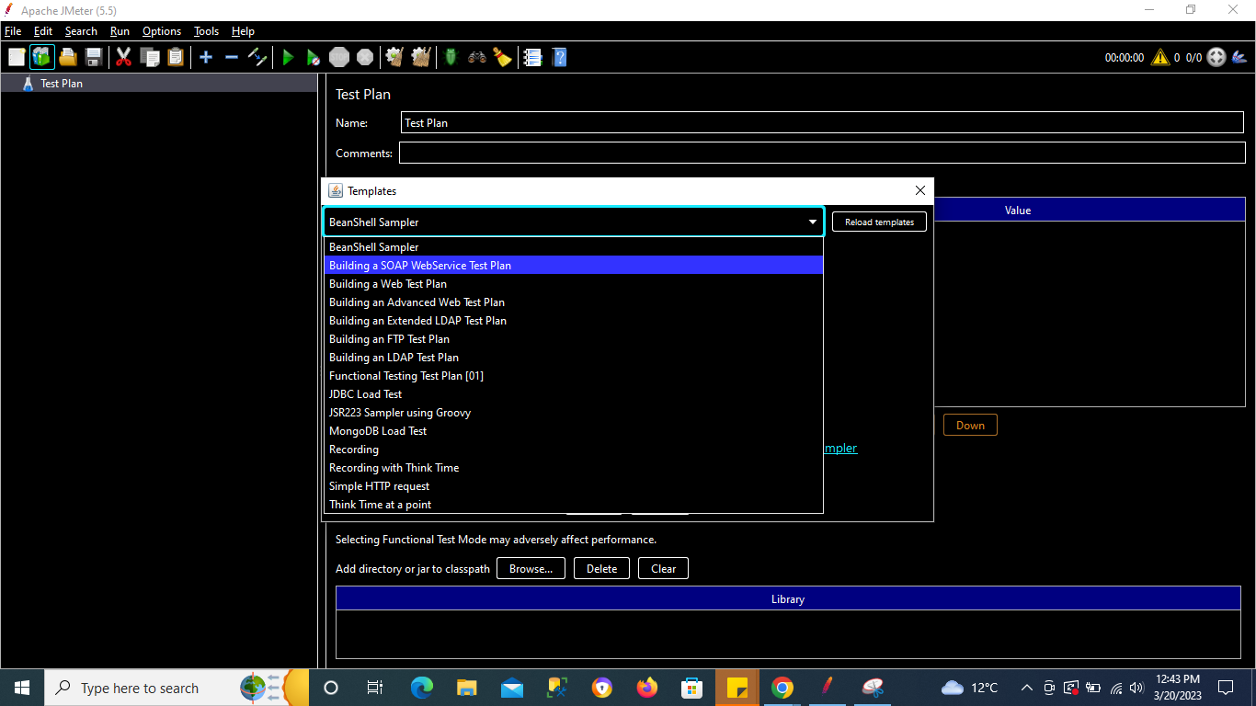

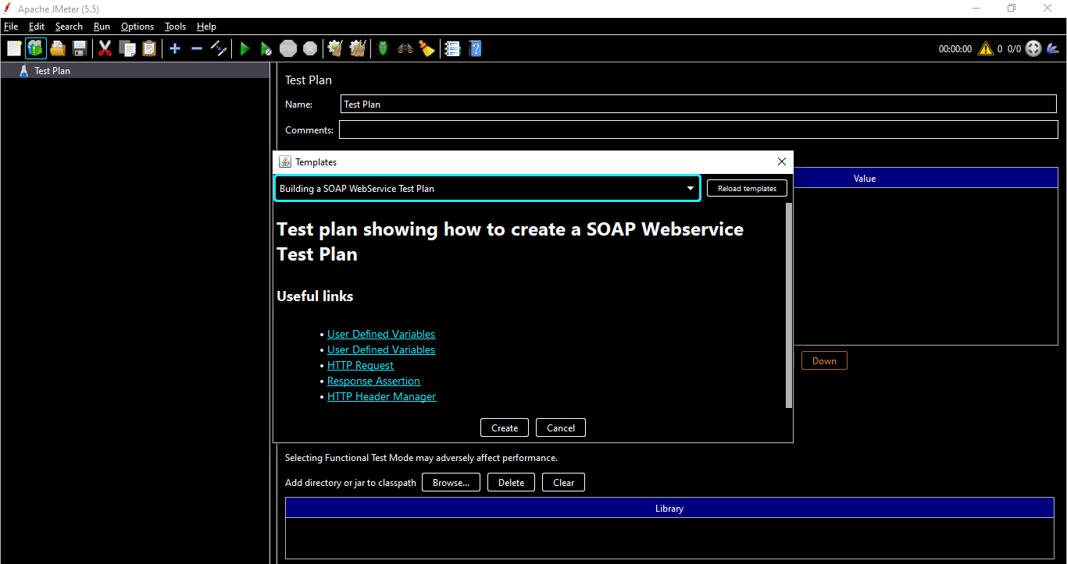

Click on **Create** button

For SOAP & REST API we add HTTP Request Config Element

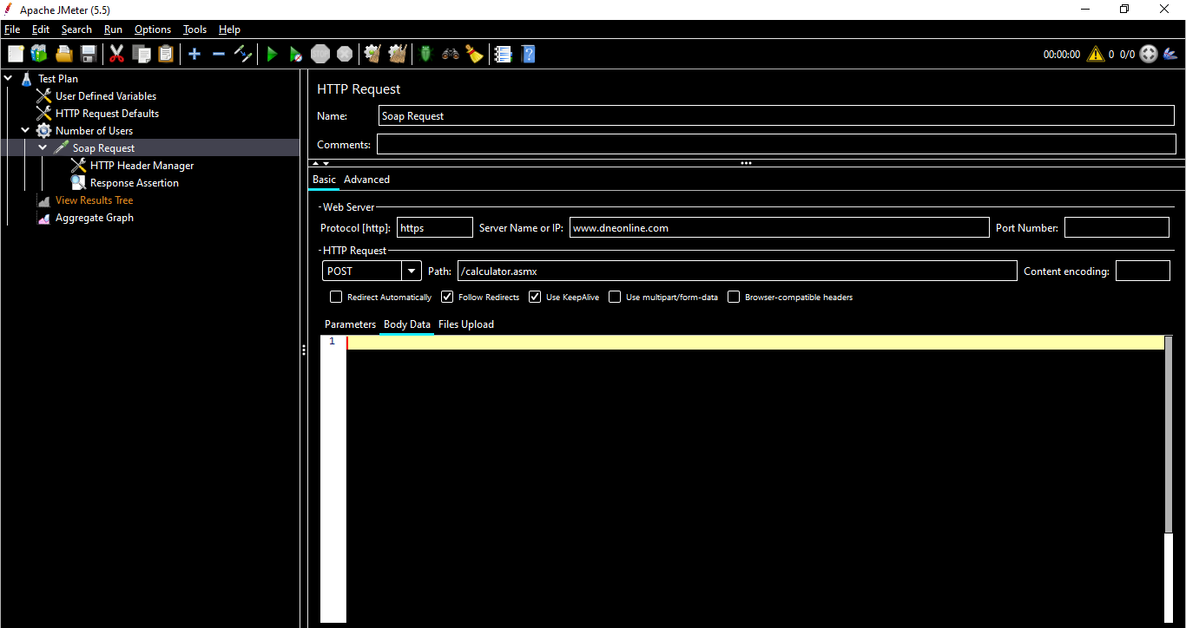

To add body data we can use a Extension called **WIZDLER**

Using Wizdler helps us to see the body data for the active wsdl url

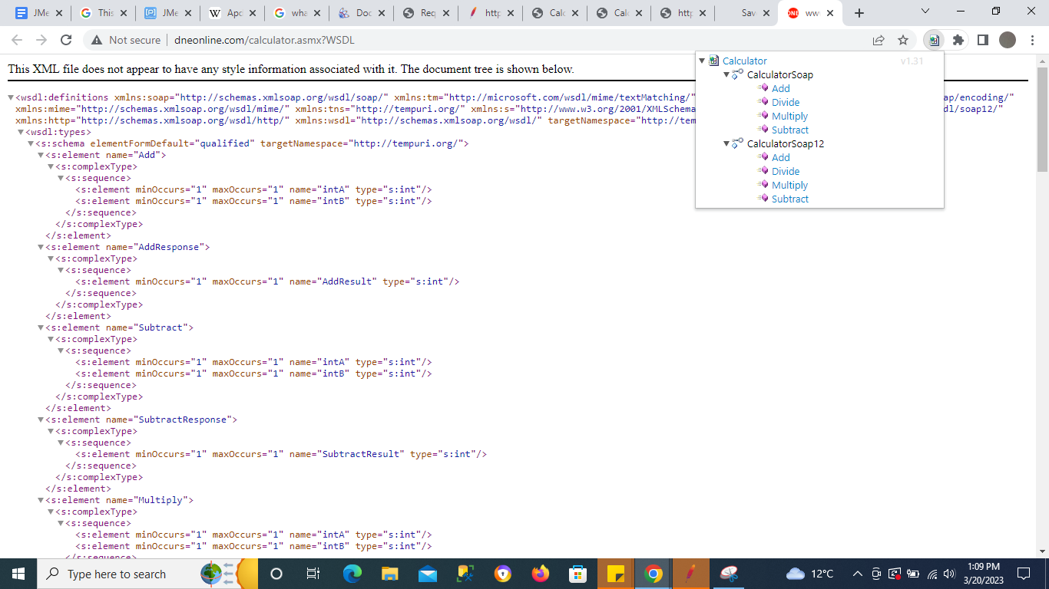

Click on Add & copy the body data

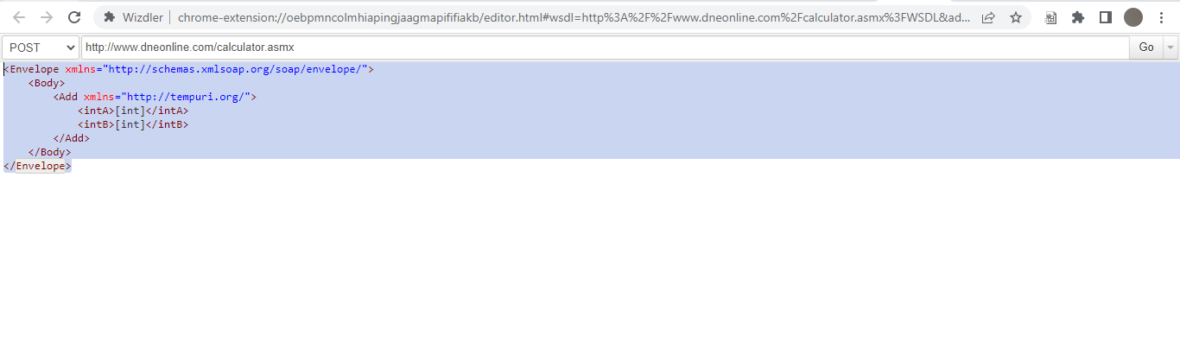

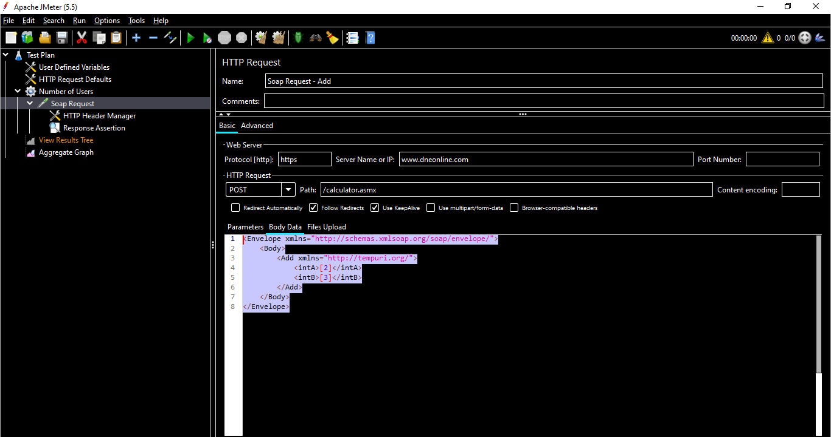

Add 2 integers [INT A = 2 & INT B = 3]

Note - Due to lack of wsdl file was unable to complete this example, will search for better example & update.

# **Functions & Variables**

## **What are Functions**

JMeter functions are special values that can populate fields of any Sampler or other element in a test tree. A function call looks like this: **${__functionName(var1,var2,var3)}** Where "__functionName" matches the name of a function.

Basically functions are methods used to populate fields in any other element of a test plan.

## **What are Variables**

JMeter variables are special placeholders that can be resolved to respective values. This means they are values that can be used inside the test and populated when the test runs. Unlike properties, variables are local to a thread and not common to all threads in the test.

Variables are containers that can store value which can be referred in any element.

**Syntax :**

**${varName}**

## **How to use Functions & Variables**

Create a Test Plan >> Add Thread Group >> Add a simple sampler - Java Request

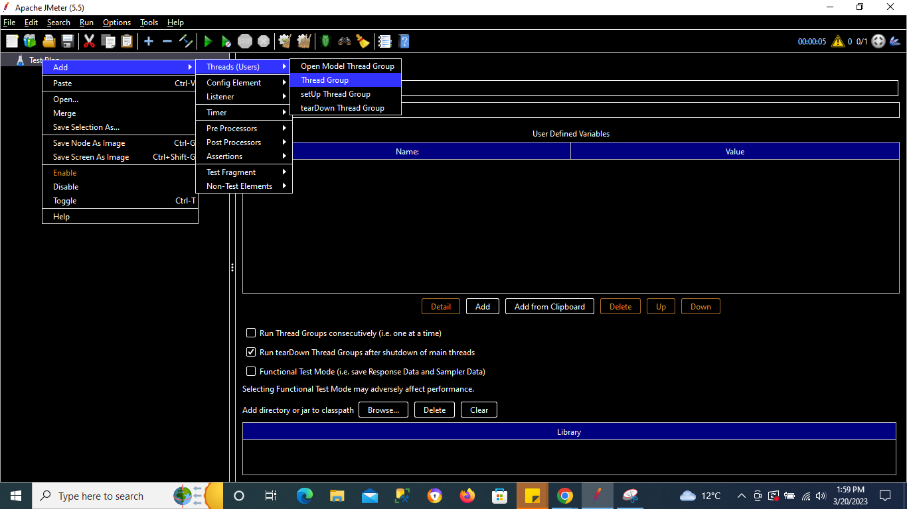

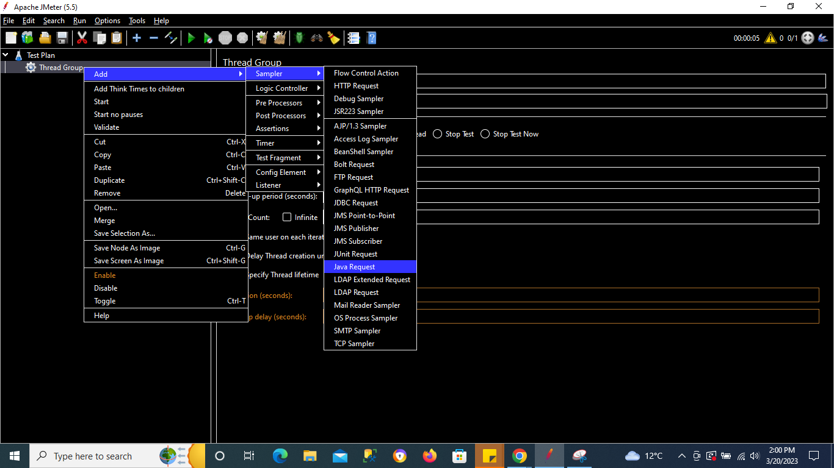

Go to Tools >> There you can see Function Helper Dialog

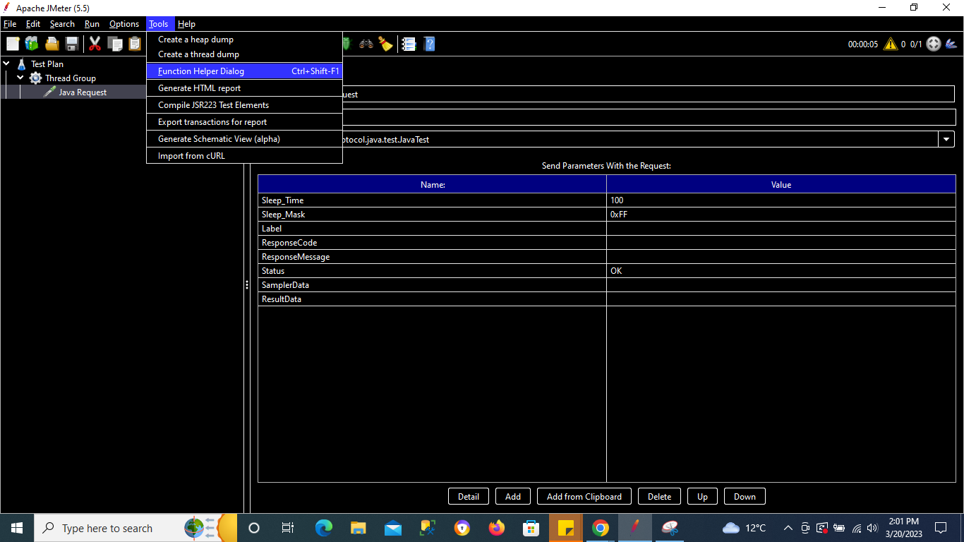

Consider a function **Log**

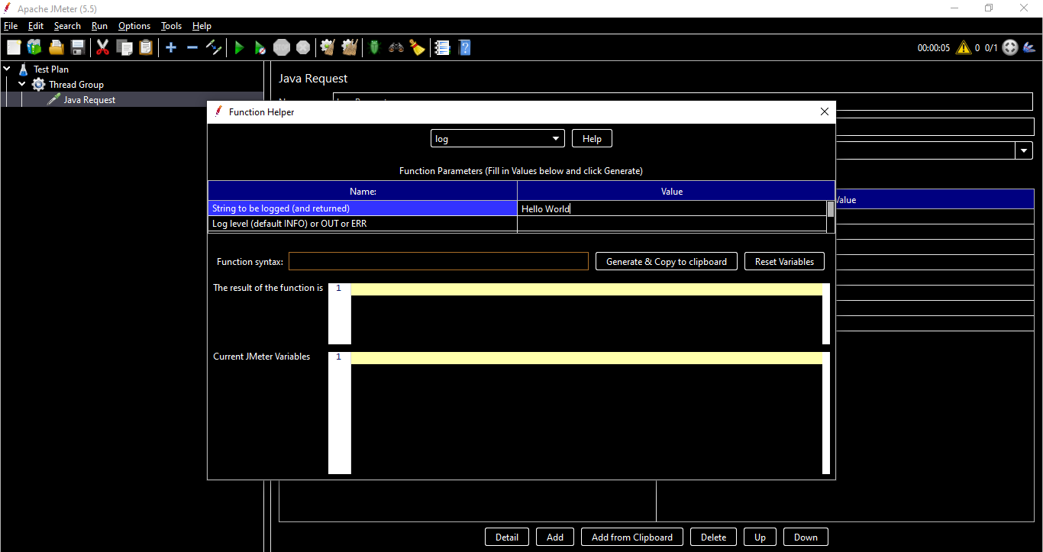

Add a string in the value & click on Generate button & this will generate the function for us

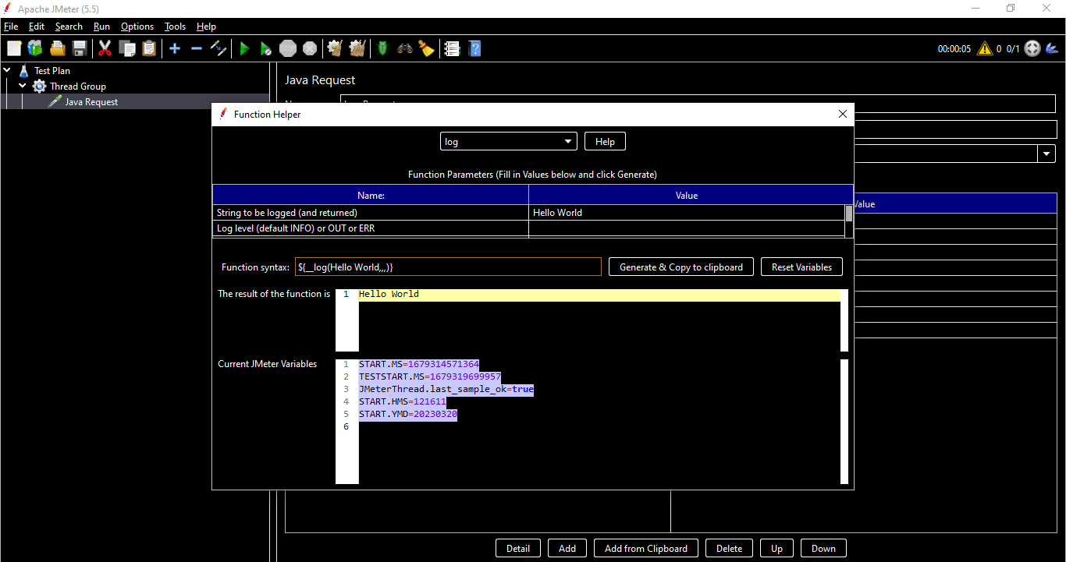

Copy the function & paste in Sampler’s name

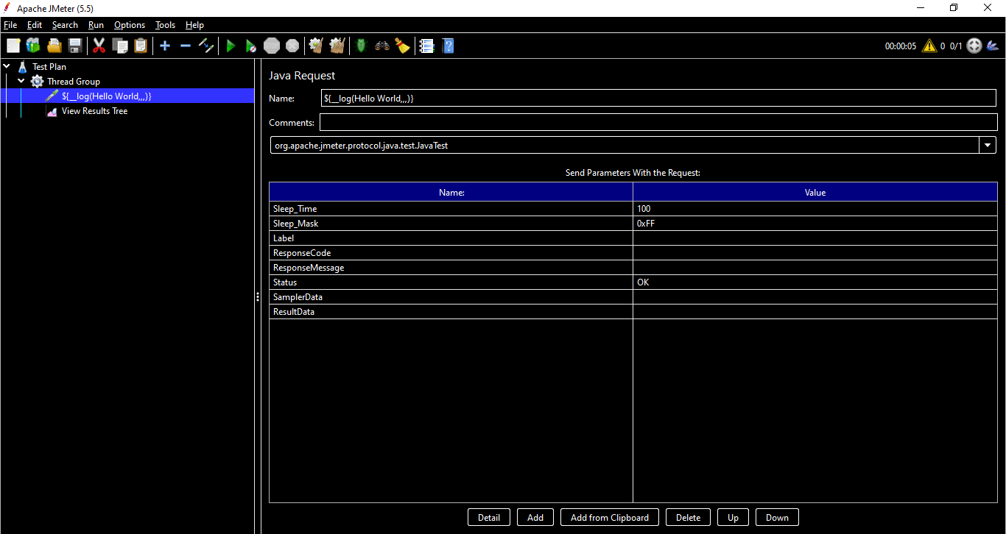

Add a listener

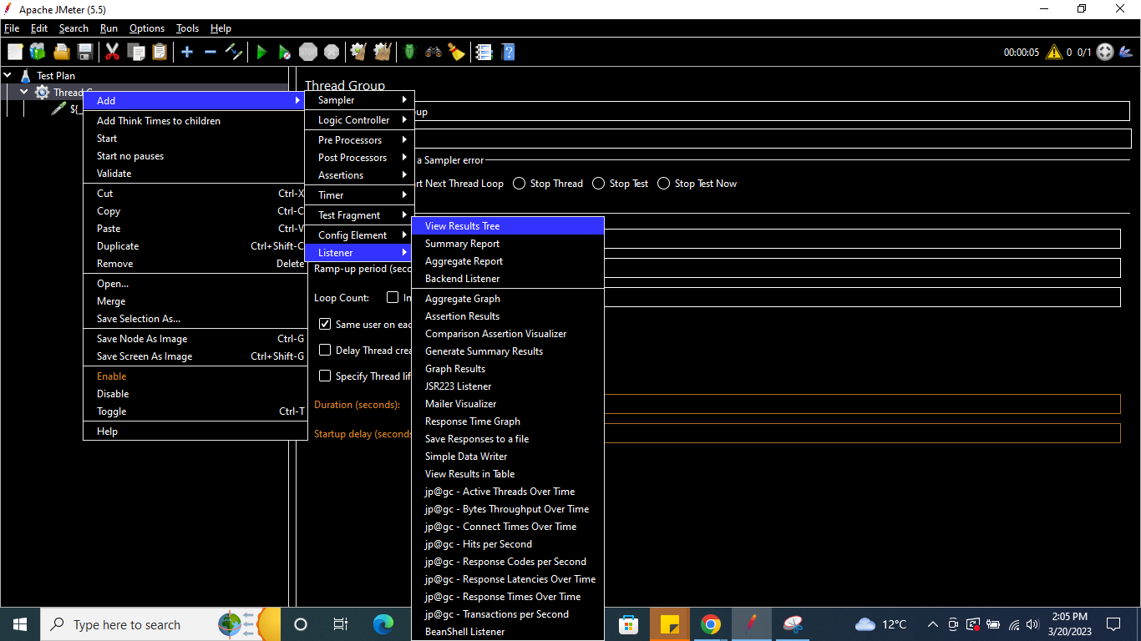

Save the test plan & run it

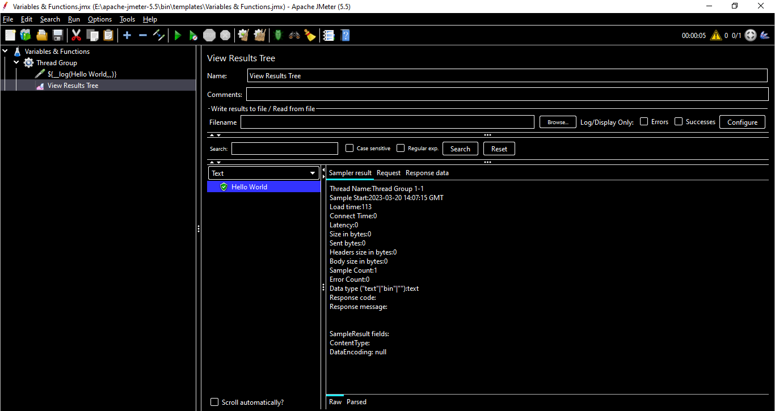

Similarly you can explore other functions

Let us try using a function intSum

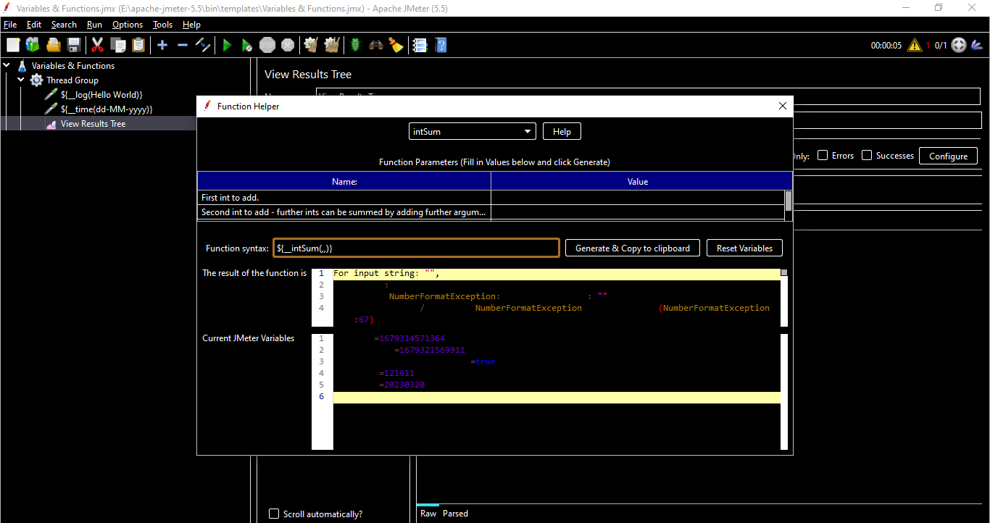

Here we are doing sum of 2,3 & storing the result in a variable called **result**

We got the result as 5

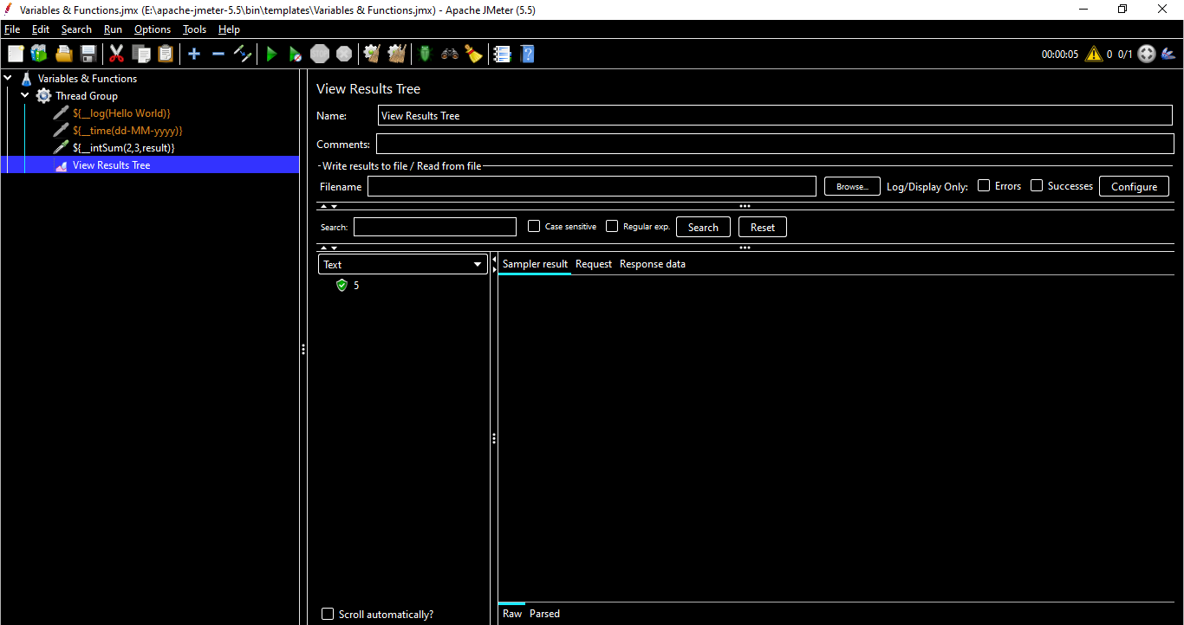

Now create another Java Request & we can add any number with result we obtained using add function previously using syntax

**${__intSum(5,${result})}**

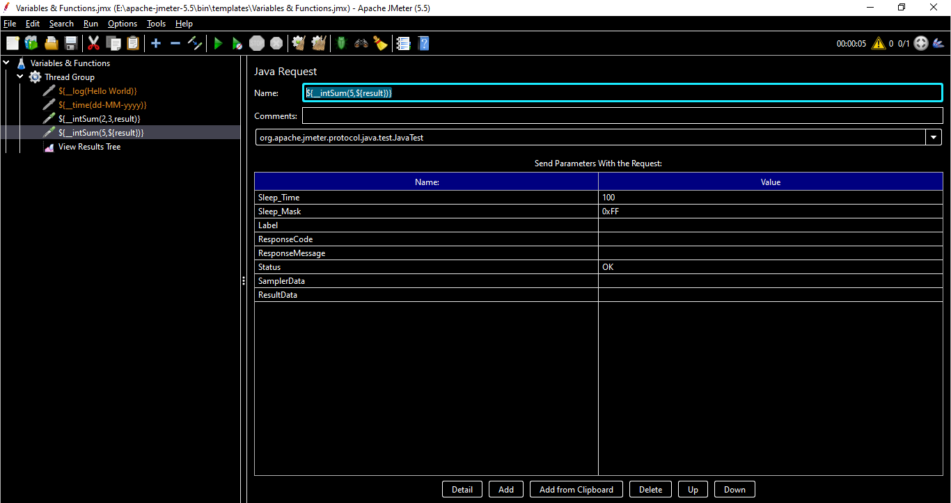

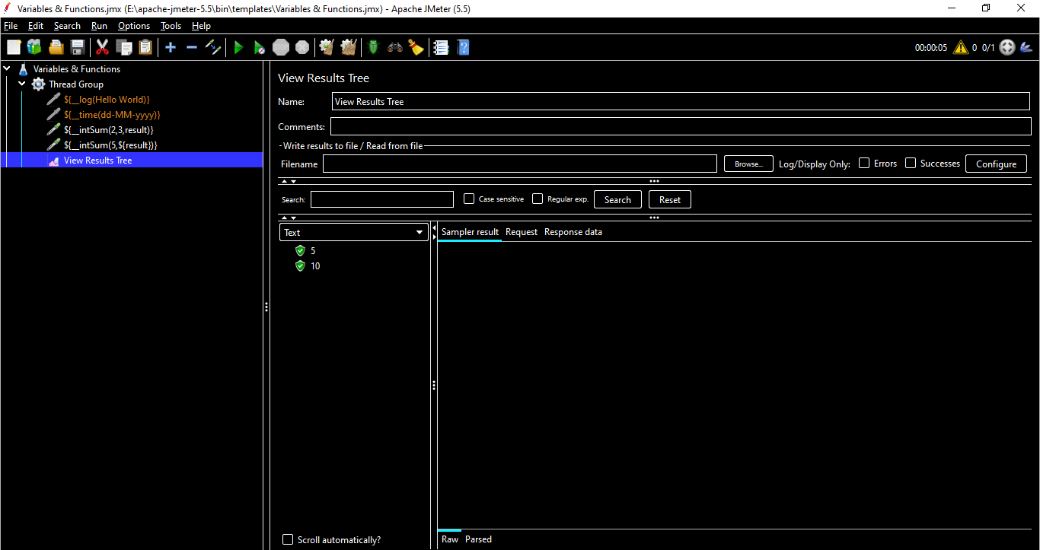

Installing JMeter Graph Plugins

Plugins within Jmeter allow you to extend the software beyond its original capabilities on graphing & displaying results after running a load test.

Plugins are installed by moving .jar files to the appropriate folder

Plugins are maintained by their respective author & not necessarily the responsibility of the Apache.

Go to website - <https://jmeter-plugins.org/>

Type “Graph” in the Search Textbox

Select the download of below two Graphs :

Basic Graph [ Download Versions: [2.0](https://jmeter-plugins.org/files/packages/jpgc-graphs-basic-2.0.zip)]

5 Additional Graphs [Download Versions: [2.0](https://jmeter-plugins.org/files/packages/jpgc-graphs-additional-2.0.zip)]

Copy the Executable Jar files from both the downloaded graphs folder to Apache LIB Folder

The Jars present in the downloaded Graph’s EXT folder need to be pasted in the Apache’s LIB >> EXT folder (No need to copy manger jar)

Basic Graphs Usage

Graphs the following Metrics :

Average Response Time

Active Threads

* Successful/failed Transactions

Five Additional Graph Usage

Graphs the following Metrics :

* Response Code
* Bytes Throughput
* Connect Times
* Latency
* HITS/s

Creating First Load Test

* To create a 1st Load test navigate to the Bin folder of your Apache Jmeter folder.
* Double click on Apache Jmeter jar
* Apache Jmeter UI would look like